Name: ………………………………………………… ADM. No. ……… Date: ………......................... CLASS…………………………………
TEACHER.CO.KE
231/3
BIOLOGY PAPER 3,
FORM 4
2022
TIME: 1 ³/₄ HOURS

Instructions to candidates
- Write your name, Admission number in the spaces provided above.
- Answer ALL questions in in the spaces provided.
- You are required to spend the first 15 minutes of the 1 ³/₄ hours reading the whole paper carefully before commencing your work.
- This paper consists of 6 printed pages
- Candidates should answer the questions in English

FOR EXAMINER’S USE ONLY:

QUESTION | MAXIMUM SCORE | CANDIDATE’S SCORE
1 | 15
2 | 12
3 | 13
TOTAL | 40

Candidates should check the question paper to ascertain that all the pages are printed as indicated and that no questions are missing

- a). You are provided with a specimen labelled Q. Slice off about 2cm²cube from the specimen. Peel it. Tie one end of the 8cm LONG transparent visking tubing provided. Place the cube and tie the other end to ENSURE THERE IS NO LEAKAGE AT BOTH ENDS OF THE TUBING.
Rinse the outside of the tubing with water. Immerse the tubing with its content in 100ml beaker containing iodine solution. Allow standing for 20 minutes.

- Record your observations in the table below. (4 marks)

 | Contents inside tubing | Iodine solution  Outside tubing
Before the experiment
After the experiment

- What was the physiological activity under test? (1 mark)

- Account for the results obtained in c (i) above. (3 marks

b). The diagram below represents two mature parasitic worms, labelled A and B, of the species
Schistosoma mansoni that causes bilharzia.

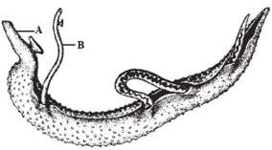

- With a reason, identify the male and the female worm in the diagram above. (3mrks)
Male ……………………………. Female……………………………….
Reason

- Name two hosts, primary and intermediate, for these parasitic worms. (2mks)
Primary host
Intermediate host

- State two ways of controlling the spread of bilharzia (2mks)

- Below is a diagram showing a type of a metamorphosis exhibited by a butterfly.

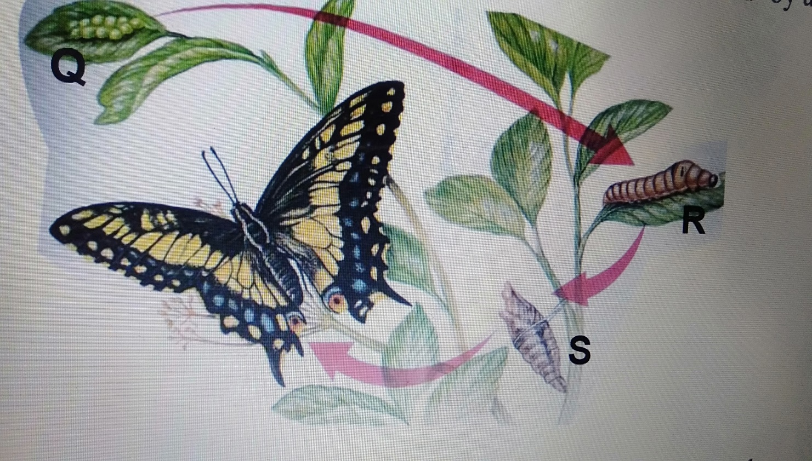

- Give the name of the type of metamorphosis in the diagram above. (1mk)

- Write down two importance of metamorphosis. (2mks)

- Name the stages Q, R and S. (3mks)
Q
R
S
- Differentiate the biological activities in the development stages R and S. (2mks)

- Name the two major hormones that are associated with metamorphosis in insects. (2mks)
- i. Name the class to which the organisms in the diagram above belongs. (1mk)

ii. Give a reason for your answer in f (i) above. (1mk)

- You are provided with specimen Q, R S T and U. Study them to answer the questions below.

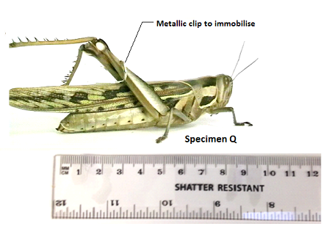.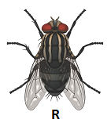
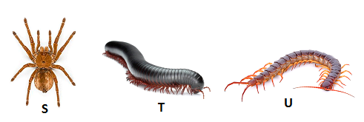

- Work the actual length of specimen T, given that the shatter resistant ruler measures Q from tip of mouth to tip of abdomen. (2 marks)

- A boy immobilised specimen Q and attempted to drawn and suffocate it in water by placing its head in water. Using observable features, explain why he couldn’t succeed. (1 mark)

- Use the features in order given below and construct a dichotomous key that can be used to identify the specimen above.
Wings, long or short hind limbs, number of legs, antenna. (8 marks)

- State two ways in which specimen Q is adapted to evade its predators in its ecological niche.
(2marks)

