NAME ………………………………………… ADM NO…….………… CLASS……………………
231/2
BIOLOGY
PAPER 2
(THEORY)
2022
2 HOURS

TEACHER.CO.KE
FORM 4 EXAMINATION, 2022

Kenya Certificate of Secondary Education (K.C.S.E)

231/2
BIOLOGY
PAPER 2
(THEORY)
2 HOURS

INSTRUCTIONS TO CANDIDATES
- Write your name, Admission Number and Class in the spaces provided above.
- This paper consists of two sections. Section A and section B.
- Answer ALL questions in section A in the spaces provided. In section B answer question 6 (compulsory) and either question 7 or 8 in the spaces provided after question 8
- This paper consists of 8 Printed pages. Candidates should check the question paper to ensure that all the papers are printed as indicated and no questions are missing
For Examiners use only.
Section | Question | Maximum score | Candidates score
A | 1 | 8
 | 2 | 8
 | 3 | 8
 | 4 | 8
 | 5 | 8
B | 6 | 20
 | 7 | 20
 | 8 | 20
 | Total score | 80

231/2
Biology
Paper 2 (Theory)

SECTION A (40 MARKS)
Answer all questions in this section in the spaces provided.
- (a) Define the term denature (1 Mark)
…………………………………………………………………………………………………………..
…………………………………………………………………………………………………………..
(b) In an experiment to investigate the action of pepsin on egg albumen, equal amounts of pepsin were
added to equal amounts of egg albumen in different test-tubes. The test tubes were placed in water baths at different temperatures. The graph below shows time taken for the enzyme to digest protein in each.
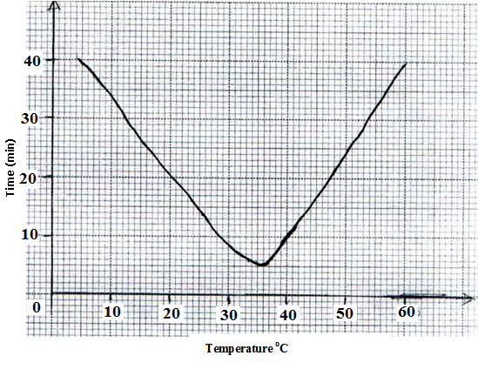

(i) What is the optimum temperature for the enzyme? (1 Mark)
…………………………………………………………………………………………………………..
…………………………………………………………………………………………………………..
(ii) Account for the time taken to digest egg albumen at 45⁰C. (1 Mark)
…………………………………………………………………………………………………………..
…………………………………………………………………………………………………………..
(c) (i) In which form is the enzyme pepsin secreted. (1 Mark)
…………………………………………………………………………………………………………..
…………………………………………………………………………………………………………..
(ii) Give a reason for your answer in c (i) above. (1 Mark)
…………………………………………………………………………………………………………..
…………………………………………………………………………………………………………..
(d) Name four plant tissues which lack chloroplast. (2 Marks)
…………………………………………………………………………………………………………..
…………………………………………………………………………………………………………..
(e) State the function of the pad of gum in herbivorous feeding. (1 Mark)
…………………………………………………………………………………………………………..
…………………………………………………………………………………………………………..
- During ecological study, students collected and marked 120 ants and released them. After 48 hours, the students captured another 90 ants, 20 of which had been marked previously.
- How many ants were there in the compound? Show your working. (3 Marks)
…………………………………………………………………………………………………………..
…………………………………………………………………………………………………………..
…………………………………………………………………………………………………………..
…………………………………………………………………………………………………………..
…………………………………………………………………………………………………………..
…………………………………………………………………………………………………………..
- What are the limitations of this method in sampling animal populations? (3 Marks)
…………………………………………………………………………………………………………..
…………………………………………………………………………………………………………..
…………………………………………………………………………………………………………..
…………………………………………………………………………………………………………..
…………………………………………………………………………………………………………..
…………………………………………………………………………………………………………..
- State two other methods which could be used to determine the population? (2 Marks)
…………………………………………………………………………………………………………..
…………………………………………………………………………………………………………..
…………………………………………………………………………………………………………..
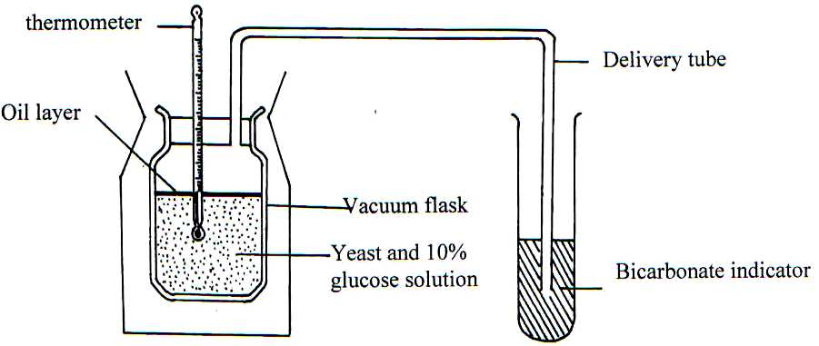
- The experiment below was set-up to investigate some physiological processes. The glucose solution was first boiled then cooled. The set-up was left for 24 hrs.

- Suggest two aims of the experiment. (2 Marks)
…………………………………………………………………………………………………………..
…………………………………………………………………………………………………………..
- (i) State the expected observations after 24 hours. (2 Marks)
…………………………………………………………………………………………………………..
…………………………………………………………………………………………………………..
(ii) Explain your observations in b (i) above. (1 Mark)
…………………………………………………………………………………………………………..
…………………………………………………………………………………………………………..
(iii) Why was glucose solution boiled then cooled? (1 Mark)
…………………………………………………………………………………………………………..
…………………………………………………………………………………………………………..
- Suggest a control for the above experiment. (1 Mark)
…………………………………………………………………………………………………………..
…………………………………………………………………………………………………………..
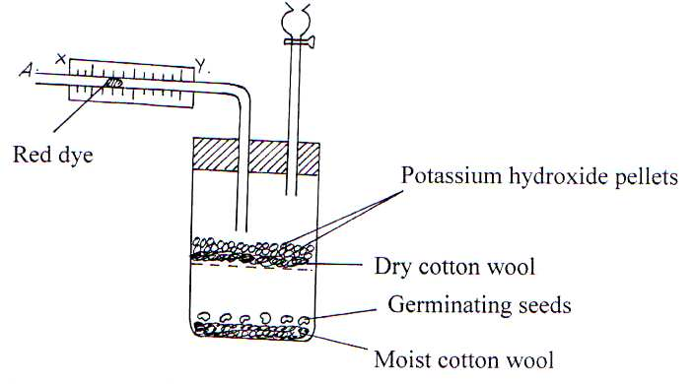
- The diagram below shows an experimental set up to investigate an aspect of germination.

- Why are the following used in this experiment?
(i) Potassium hydroxide pellets? (1mark)
…………………………………………………………………………………………………………..
…………………………………………………………………………………………………………..
(ii) Moist cotton wool? (1 mark)
…………………………………………………………………………………………………………..
…………………………………………………………………………………………………………..
- (i) With reference to points x and y state the direction the dye would move towards during the
experiment. (1 mark)
…………………………………………………………………………………………………………..
…………………………………………………………………………………………………………..
(ii) Give reasons for your answer in (b) (i) (2 Marks)
…………………………………………………………………………………………………………..
…………………………………………………………………………………………………………..
…………………………………………………………………………………………………………..
…………………………………………………………………………………………………………..
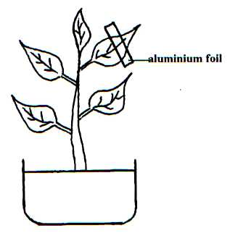
- In an experiment to investigate a factor affecting photosynthesis, a leaf of a potted plant which had been kept in the dark overnight was covered with alluminium foil as shown in the diagram below.

The set up was kept in sunlight for three hours after which a food test was carried out on the leaf.
- Which food test was carried out? (1 Mark)
…………………………………………………………………………………………………………..
- (i) State the results of the food test. (2 Marks)
…………………………………………………………………………………………………………..
…………………………………………………………………………………………………………..
(ii) Account for the result of the food test. (2 Marks)
…………………………………………………………………………………………………………..
…………………………………………………………………………………………………………..
- (i) Why was the set up kept in sunlight for three hours. (1 Mark)
…………………………………………………………………………………………………………..
…………………………………………………………………………………………………………..
(ii) Why was it necessary to keep the plant in the darkness before the experiment? (1 mark)
…………………………………………………………………………………………………………..
…………………………………………………………………………………………………………..
- Other than light state one other factor that affects the rate of photosynthesis. (1 Mark)
…………………………………………………………………………………………………………..
…………………………………………………………………………………………………………..

SECTION B – 40 MARKS
Answer question 6 (compulsory) and either 7 or 8
- In an experiment to investigate a certain process in a given plant species, the rate of carbon (IV) oxide consumption and the rate of Carbon (IV) oxide release were measured over a period of time for the day. The results of the investigation are as shown in the table below.
Time of days (hrs) | 6.00 | 8.00 | 10.00 | 12.00 | 14.00 | 16.00 | 18.00 | 20.00 | 22.00 | 24.00
CO₂ consumption mm³/min | 0 | 43 | 69 | 91 | 91 | 50 | 13 | 0 | 0 | 0
CO₂ release mm³/min | 38 | 22 | 10 | 3 | 3 | 6 | 31 | 48 | 48 | 48

- On the same axes, draw the graphs of volume of Carbon (IV) oxide consumed and Carbon (IV) oxide released against time. (7 Marks)

- Name biochemical processes represented by;
(i) Carbon (IV) oxide consumption (1 Mark)
…………………………………………………………………………………………………………..
…………………………………………………………………………………………………………..
(ii) Carbon (IV) oxide release (1 Mark)
…………………………………………………………………………………………………………..
…………………………………………………………………………………………………………..
- Account for the shape of the curve for
(i) Carbon (IV) oxide consumption. (3 Marks)
…………………………………………………………………………………………………………..
…………………………………………………………………………………………………………..
…………………………………………………………………………………………………………..
…………………………………………………………………………………………………………..
(ii) Carbon (IV) oxide release (3 Marks)
…………………………………………………………………………………………………………..
…………………………………………………………………………………………………………..
…………………………………………………………………………………………………………..
…………………………………………………………………………………………………………..
- (i) From the graph, state the time of the day when the plant attains compensation point. (1 Mark)
…………………………………………………………………………………………………………..
…………………………………………………………………………………………………………..
(ii) What is meant by compensation point. (1 Mark)
…………………………………………………………………………………………………………..
…………………………………………………………………………………………………………..
- Explain how temperature affects the rate of Carbon (IV) Oxide consumption in a plant. (3 Marks)
…………………………………………………………………………………………………………..
…………………………………………………………………………………………………………..
…………………………………………………………………………………………………………..
…………………………………………………………………………………………………………..

- (a) Name five methods of excretion in plants. (5 Marks)
(b) Give three reasons why plants lack complex excretory system. (3 Marks)
(c) State six excretory products in plants and give their economic uses. (12 Marks)
- (a) What is pollination? (2 Marks)
(b) Discuss the sequence of events that take place from the time a pollen grain falls on the stigma until a
seed is formed. (18 marks)
…………………………………………………………………………………………………………..
…………………………………………………………………………………………………………..
…………………………………………………………………………………………………………..
…………………………………………………………………………………………………………..
…………………………………………………………………………………………………………..
…………………………………………………………………………………………………………..
…………………………………………………………………………………………………………..
…………………………………………………………………………………………………………..
…………………………………………………………………………………………………………..
…………………………………………………………………………………………………………..
…………………………………………………………………………………………………………..
…………………………………………………………………………………………………………..
…………………………………………………………………………………………………………..
…………………………………………………………………………………………………………..
…………………………………………………………………………………………………………..
…………………………………………………………………………………………………………..
…………………………………………………………………………………………………………..
…………………………………………………………………………………………………………..
…………………………………………………………………………………………………………..
…………………………………………………………………………………………………………..
…………………………………………………………………………………………………………..
…………………………………………………………………………………………………………..
…………………………………………………………………………………………………………..
…………………………………………………………………………………………………………..
…………………………………………………………………………………………………………..
…………………………………………………………………………………………………………..
…………………………………………………………………………………………………………..
…………………………………………………………………………………………………………..
…………………………………………………………………………………………………………..
…………………………………………………………………………………………………………..
…………………………………………………………………………………………………………..
…………………………………………………………………………………………………………..
…………………………………………………………………………………………………………..
…………………………………………………………………………………………………………..
…………………………………………………………………………………………………………..
…………………………………………………………………………………………………………..
…………………………………………………………………………………………………………..
…………………………………………………………………………………………………………..
…………………………………………………………………………………………………………..
…………………………………………………………………………………………………………..
…………………………………………………………………………………………………………..
…………………………………………………………………………………………………………..
…………………………………………………………………………………………………………..
…………………………………………………………………………………………………………..
…………………………………………………………………………………………………………..
…………………………………………………………………………………………………………..
…………………………………………………………………………………………………………..
…………………………………………………………………………………………………………..
…………………………………………………………………………………………………………..
…………………………………………………………………………………………………………..
…………………………………………………………………………………………………………..
…………………………………………………………………………………………………………..
…………………………………………………………………………………………………………..
…………………………………………………………………………………………………………..
…………………………………………………………………………………………………………..
…………………………………………………………………………………………………………..
…………………………………………………………………………………………………………..
…………………………………………………………………………………………………………..
…………………………………………………………………………………………………………..
…………………………………………………………………………………………………………..
…………………………………………………………………………………………………………..
…………………………………………………………………………………………………………..
…………………………………………………………………………………………………………..
…………………………………………………………………………………………………………..
…………………………………………………………………………………………………………..
…………………………………………………………………………………………………………..
…………………………………………………………………………………………………………..
…………………………………………………………………………………………………………..
…………………………………………………………………………………………………………..
…………………………………………………………………………………………………………..
…………………………………………………………………………………………………………..
…………………………………………………………………………………………………………..
…………………………………………………………………………………………………………..
…………………………………………………………………………………………………………..
…………………………………………………………………………………………………………..
…………………………………………………………………………………………………………..
…………………………………………………………………………………………………………..
…………………………………………………………………………………………………………..
…………………………………………………………………………………………………………..
…………………………………………………………………………………………………………..
…………………………………………………………………………………………………………..
…………………………………………………………………………………………………………..
…………………………………………………………………………………………………………..
…………………………………………………………………………………………………………..
…………………………………………………………………………………………………………..
…………………………………………………………………………………………………………..
…………………………………………………………………………………………………………..
…………………………………………………………………………………………………………..
…………………………………………………………………………………………………………..
…………………………………………………………………………………………………………..
…………………………………………………………………………………………………………..
…………………………………………………………………………………………………………..
…………………………………………………………………………………………………………..
…………………………………………………………………………………………………………..
…………………………………………………………………………………………………………..
…………………………………………………………………………………………………………..
…………………………………………………………………………………………………………..
…………………………………………………………………………………………………………..
…………………………………………………………………………………………………………..
…………………………………………………………………………………………………………..
…………………………………………………………………………………………………………..
…………………………………………………………………………………………………………..
…………………………………………………………………………………………………………..
…………………………………………………………………………………………………………..
…………………………………………………………………………………………………………..
…………………………………………………………………………………………………………..
…………………………………………………………………………………………………………..
…………………………………………………………………………………………………………..
…………………………………………………………………………………………………………..
…………………………………………………………………………………………………………..
…………………………………………………………………………………………………………..
…………………………………………………………………………………………………………..
…………………………………………………………………………………………………………..
…………………………………………………………………………………………………………..
…………………………………………………………………………………………………………..
…………………………………………………………………………………………………………..
…………………………………………………………………………………………………………..
…………………………………………………………………………………………………………..
…………………………………………………………………………………………………………..
…………………………………………………………………………………………………………..
…………………………………………………………………………………………………………..
…………………………………………………………………………………………………………..
…………………………………………………………………………………………………………..
…………………………………………………………………………………………………………..
…………………………………………………………………………………………………………..
…………………………………………………………………………………………………………..
…………………………………………………………………………………………………………..
…………………………………………………………………………………………………………..
…………………………………………………………………………………………………………..
…………………………………………………………………………………………………………..
…………………………………………………………………………………………………………..
…………………………………………………………………………………………………………..
…………………………………………………………………………………………………………..
…………………………………………………………………………………………………………..
…………………………………………………………………………………………………………..
…………………………………………………………………………………………………………..
…………………………………………………………………………………………………………..
…………………………………………………………………………………………………………..
…………………………………………………………………………………………………………..
…………………………………………………………………………………………………………..
…………………………………………………………………………………………………………..
…………………………………………………………………………………………………………..
…………………………………………………………………………………………………………..
…………………………………………………………………………………………………………..
…………………………………………………………………………………………………………..
…………………………………………………………………………………………………………..
…………………………………………………………………………………………………………..
…………………………………………………………………………………………………………..
…………………………………………………………………………………………………………..
…………………………………………………………………………………………………………..
…………………………………………………………………………………………………………..
…………………………………………………………………………………………………………..
…………………………………………………………………………………………………………..
…………………………………………………………………………………………………………..
…………………………………………………………………………………………………………..
…………………………………………………………………………………………………………..
…………………………………………………………………………………………………………..
…………………………………………………………………………………………………………..
…………………………………………………………………………………………………………..
…………………………………………………………………………………………………………..
…………………………………………………………………………………………………………..
…………………………………………………………………………………………………………..
…………………………………………………………………………………………………………..
…………………………………………………………………………………………………………..
…………………………………………………………………………………………………………..
…………………………………………………………………………………………………………..
…………………………………………………………………………………………………………..
…………………………………………………………………………………………………………..
…………………………………………………………………………………………………………..
…………………………………………………………………………………………………………..
…………………………………………………………………………………………………………..
…………………………………………………………………………………………………………..
…………………………………………………………………………………………………………..
…………………………………………………………………………………………………………..

