**TEACHER.CO.KE**

**231/ - BIOLOGY - Paper 1 F4**

**2022 – 2 hours – TERM 1 2022**

**Name .................................................................. Index Number.............................**

**Candidate’s Signature........................................ Date.............................................**

**Instructions to Candidates:**

*(a) Write your name and Index Number in the spaces provided above.*

*(b) Sign and write the date of examination in the spaces provided above.*

*(c) Answer* ***all*** *questions in the spaces provided in this booklet.*

*(d)* ***This paper consists of 11 printed pages.***

*(e)* ***Candidates should check the question paper to ascertain that all the pages are printed as indicated and that no questions are missing.***

*(f)* ***Candidates should answer the questions in English.***

**For Examiner’s Use Only**

|  |  |  |  |  |  |  |  |  |  |  |  |  |  |  |  |
| --- | --- | --- | --- | --- | --- | --- | --- | --- | --- | --- | --- | --- | --- | --- | --- |
| **1** | **2** | **3** | **4** | **5** | **6** | **7** | **8** | **9** | **10** | **11** | **12** | **13** | **14** | **15** | **16** |
|  |  |  |  |  |  |  |  |  |  |  |  |  |  |  |  |

|  |  |  |  |  |  |  |  |  |  |  |  |  |  |
| --- | --- | --- | --- | --- | --- | --- | --- | --- | --- | --- | --- | --- | --- |
| **17** | **18** | **19** | **20** | **21** | **22** | **23** | **24** | **25** | **26** | **27** | **28** | **Grand Total**  **Turn over** |  |
|  |  |  |  |  |  |  |  |  |  |  |  |

**1**. State **FOUR** environmental problems that can be solved by studying biology. (4 marks)

…………………………………………………………………………………………………………………………………………………………………………………………………………………………………………………………………………………………………………………............................................................................................................................................……

**2**. Aerobic break down of glucose yields 2880 kJ of energy whereas anaerobic breakdown yields 150 kJ. Give an explanation to account for this difference. (4 marks)

……………………………………………………………………………………………………………………………………………………………………………………………………………………………………………………………………………………………………………………………………………………………………………………………………………………

**3**. How many of 20 micrometres animal cells would fit in a 1cm long line? (2marks)

……………………………………………………………………………………………………………………………………………………………………………………………………………………………………………………………………………………………………………………………………………………………………………………………………………………

**4**. State the function of the following apparatus;

(i) Specimen bottle . (1 mark)

…………………………………………………………………………………………………………………………………………………………………………………………………………

(ii) Bait trap. (1 mark)

…………………………………………………………………………………………………………………………………………………………………………………………………………

**5**. Name the causative agents of the following diseases:

(a) Cholera…………………………………………………………………………(1 mark)

(b) Malaria …………………….…………………………………………………..(1 mark)

**6**. Explain why young onion root tip is ideal for examining the stages of mitosis. (2 marks)

………………………………………………………………………………………………………………………………………………………………………………………………………………………………………………………………………………………………………………

**7**. The table below shows the concentration of some ions in pond water and in the cell sap of some aquatic plant growing in the pond

|  |  |  |
| --- | --- | --- |
| **Ions** | **Concentration in pond water(parts per million)** | **Concentration in cell sap(parts per million)** |
| Sodium  Potassium  Calcium  Chloride | 50  2  1.5  180 | 30  150  1  200 |

a) With a reason name the process by which each of the following ions could have been taken up by this plant

i) Sodium …………………………….......................…………………………….( 2marks)

Reason..................................................................................................................................

.............................................................................................................................................

ii) Potassium …………………………………………………...….. ......................(2marks)

Reason...................................................................................................................................

.... ..........................................................................................................................................

b) i) Which ion would cease to be absorbed if the plant was treated with a metabolic poison?

........................................................................................................................................(1mark)

ii) Give a reason for your answer (1mark)

…………………………………………………………………………………………………………………………………………………………………………………………………………

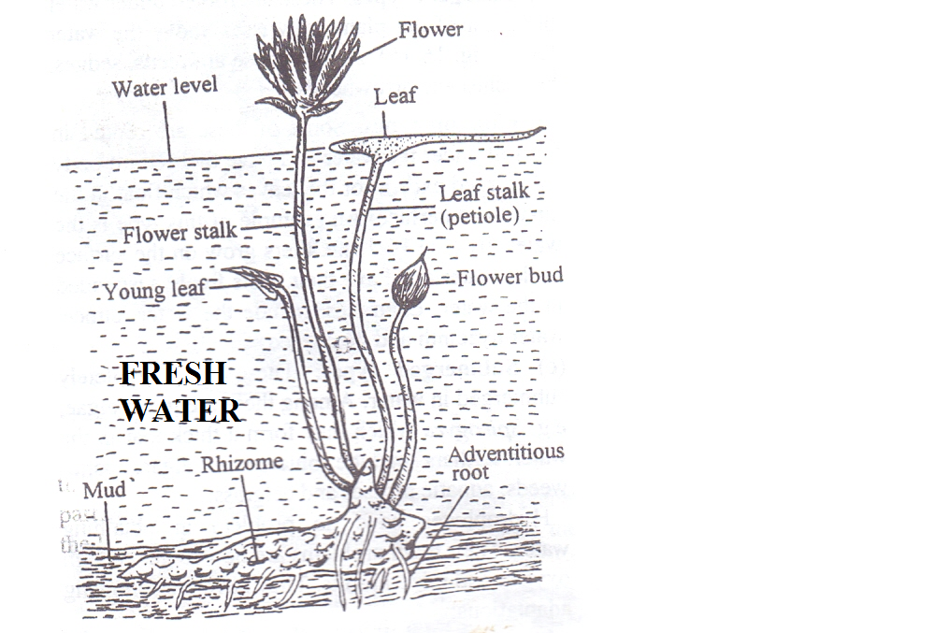**8**. The photograph illustrates an organism found in aquatic habitat.

(a) Give the type of the plant. (1 mark)

………………………………………………………………………………...................………………………

(b) Describe **three** adaptation of the organism to its habitat. (3 marks)

…………………………………………………………………………………………………………………………………………………………………………………………………………………………………………………………………………………………………………………………………………………………………………………………………………………………………………………………………………………………………………………………

**9**. A student smeared the abdomen of a locust with Vaseline.

(a) What were the likely results after ten minutes? (1 mark)

…………………………………………………………………………………………………………………………………………………………………………………………………………

(b) Account for the results obtained above. (2marks)

……………………………………………………………………………………………………………………………………………………………………………………………………………………………………………………………………………………………………………………………………………………………………………………………………………………

**10**. What is the significance of photolysis? (2 marks)

………………………………………………………………………………………………………………………………………………………………………………………………………………………………………………………………………………………………………………

**11**. The following table shows the volume of gases carried by 100cm3 of blood.

|  |  |  |
| --- | --- | --- |
| Gas | Blood entering lungs | Blood leaving lungs |
| Nitrogen | 0.9 cm3 | 0.9 cm3 |
| Oxygen | 10.6 cm3 | 19.0 cm3 |
| Carbon (iv) oxide | 58.0 cm3 | 50.0 cm3 |

1. Which blood has a higher content of carbon (IV) oxide? (1 mark)

………………………………………………………………………………………………

1. Explain the difference in the content of oxygen and carbon (IV) oxide in blood entering the lungs and that leaving the lungs. (2 marks)

………………………………………………………………………………………………………………………………………………………………………………………………………………………………………………………………………………………………………………………………………………………………………………………………

**12**. Use the illustration below to answer questions.

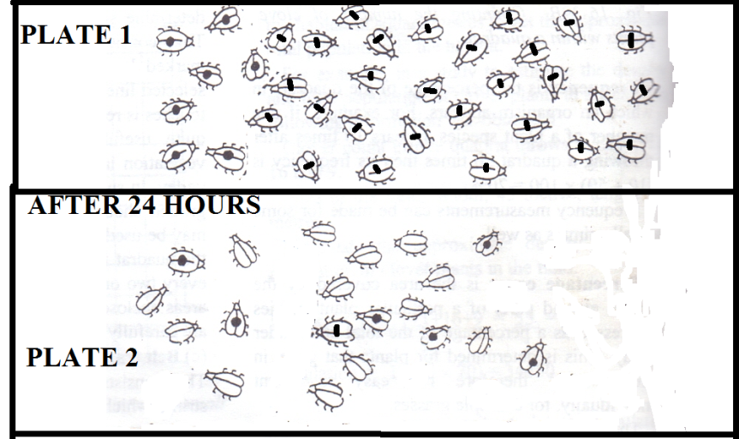

1. Identify the method of population estimation shown above. (1 mark)

…………………............................................................................................................................................................…………………………………………………………………………………

(b) Estimate the population of the beetles. (3 marks)

(c) State **one** limitation of this method. (1 mark)

…………………………………………………………………………………………………………………………………………………………………………………………………………

**13**. An investigation was carried between 1994 and 2003 to study the changes of fish population in a certain small lake. Four species of fish A,B, C and D were found to live in this lake.In 1995,A factory was built near the lake raising temperatures from 250C to 300C.In 1997,Sewage and industrial waste was diverted into the lake. The population of fish during the period of investigation is shown in the table below.

|  |  |  |  |  |  |  |  |
| --- | --- | --- | --- | --- | --- | --- | --- |
| **Fish species** | **1994** | **1996** | **1998** | **2000** | **2001** | **2002** | **2003** |
| A | 6102 | 223 | 20 | 106 | 660 | 4071 | 7512 |
| B | 208 | 30 | 11 | 22 | 63 | 311 | 405 |
| C | 36 | 100 | 0 | 0 | 0 | 0 | 0 |
| D | 4521 | 272 | 23 | 23 | 29 | 400 | 617 |

1. Explain **two** factors that could have brought the changes in the fish populations.(2 marks)

………………………………………………………………………………………………………………………………………………………………………………………………………………………………………………………………………………………………………………

**14**. State the functions of the following parts of a light microscope.

(i) Coarse adjustment knob. (1 mark)

…………………………………………………………………………………………………………………………………………………………………………………………………………

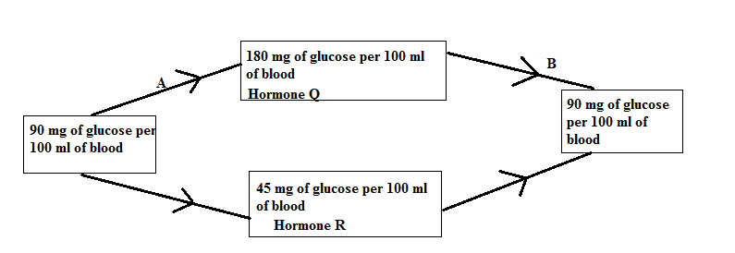**15**. Use the diagram below to answer questions that follow.

(a) Name the feedback mechanism labeled B. (1 mark)

……………………………………………………………………………………………………

(b) Identify Hormone R……………………………………………………………..…. (1 mark)

**16**. Name **three** food substances acquired by herbivores feeding on green sprouting grass exposed to maximum sunlight during the day. (3 marks)

……………………………………………………………………………………………………………………………………………………………………………………………………………………………………………………………………………………………………………………………………………………………………………………………………………………

**17**. A certain animal has no incisors, no canines,6 premolars and 6 molars in its upper jaw. In the lower jaw there are 6 incisors,2 canines,6 premolars and 6 molars.

(a) Write its dental formula. (2mark)

1. Identify the mode of nutrition of the organism. (1 mark)

………………………………………………………………………………………………………………………………………………………………………………………………

1. Give a reason for your answer in (b) above. (1 mark)

………………………………………………………………………………………………………………………………………………………………………………………………

**18.** a). Identify the following:

i) The structure that prevents backflow of blood when pressure in the ventricles fall. (1mark)

............................………………………………………………………………………………………………………………………………………………………………………………………

ii) The vessel from which coronary artery branches (1mark)

…………………………………………………………………………………………………………………………................……………………………………………………………………

b) The size of the heart is closely related to the size of the body of the organism. Generally the heart weighs 0.59 percent of the total body weight. Calculate the weight of a healthy adult if his heart weighs 0.4838Kg (2marks)

…………………………………………………………………………………………………………………………................……………………………………………………………………

…………………………………………………………………………………………………………………………................……………………………………………………………………

……………………………………………………………………………………………………

**19**. A small mammal has ears that are usually pink, but on a day when the environmental temperature is low the ears appear pale pink. Explain this observation (3marks)

…………………………………………………………………………………………………………………………................……………………………………………………………………

…………………………………………………………………………………………………………………………................……………………………………………………………………

**20**  a) State the function of the following during cell division

i) Spindle fibres (1mark)

………………………………………………………………………………………………………………………................……………………………....………………………………………

ii) Centrioles (1mark)

…………………………………………………………………………………………………………………………................……………………………………………………………………

b). What is the significance of protandry and protogyny structural features in flowering plants

.......................................................................................................................................... (2marks)

**21**. Distinguish between the Cytology and entomology. (2 mark)

…………………………………………………………………………………………………………………………………………………………………………………………………………….................................................................................................................................................…

**22**. Give the roles of the following hormones in males

(i) Follicle stimulating hormone. (1 mark)

…………………………………………………………………………………………………………………………………………………………………………………………………………

(ii) Luteinizing hormone. (1 mark)

…………………………………………………………………………………………………………………………………………………………………………………………………………

**23**. Describe how the granum is adapted to its photosynthetic function. (2 marks)

……………………………………………………………………………………………………………………………………………………………………………………………………………………………………………………………………………………………………………………………………………………………………………………………………………………

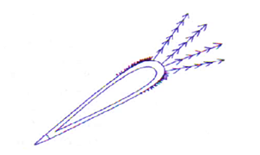**24**. Below is a photograph of a fruit.

1. State the agent of dispersal of the fruit. (1 mark)

…………………………………………………………………………………………………………………………………………………………………………………………………………

1. Give a reason for your answer in (a) above. (1 mark)

…………………………………………………………………………………………………………………………………………………………………………………………………………

**25** a). State **two** advantages of metamorphosis to the life of insects (2marks)

………………………………………………………………………………………………………………………………………………………………………………………………………………………………………………………………………………………………………………

b). Name **two** harmful effects of insects (2marks)

……………………………………………………………………………………………………………………………………………………………………………………………………………………………………………………………………………………………………………………………………………………………………………………………………………………

**26** What is the function of coleoptile in germinating maize grain? (1mark)

………………………………………………………………………………………………………………………………………………………………………………………………………………………………………………………………………………………………………………

**27** a) Define the term monohybrid inheritance (1mark)

………………………………………………………………………………………………………………………………………………………………………………………………………………………………………………………………………………………………………………

b). Differentiate between genotype and phenotype (2marks)

……………………………………………………………………………………………………………………………………………………………………………………………………………………………………………………………………………………………………………………………………………………………………………………………………………………

**28.**  In some fruit flies there exist two varieties; one with red eyes and another with white eyes. In a population of these organisms, the red eyed greatly outnumber the white eyed.

A white eyed female was crossed with a red eyed male. All the females from the cross were red eyed while all the males were white eyed. Using the given information, answer the following questions;

Which gene is

i) Dominant ..................................................................................................................(1mark)

ii) Recessive....................................................................................................................(1mark)