NAME……………………………………………………………………………………..ADM……………………CLASS………
TEACHER.CO.KE EXAMINATION
TERM 1 OPENER , 2022
FORM THREE EXAM.
TIME 1HR:45 MIN.
- Write your Name , Admission Number and your Class in the spaces provided above.
- Answer ALL questions in the spaces provided after each question.
1 What do you understand by the following terms (2mks)
- Anatomy

b)Ichthyology

2. (a) What is meant by the term Binomial nomenclature? (1mk)

(b) The scientific name of a toad is bufo regularis.
(i) Write the name correctly (1mk)

(ii) Identify the genus and species names (2mks)
    - Genus name…………………….

    - Species……………………………..

3.The two cells shown below are obtained from two different potato cylinders which were
immersed in tow different solutions P and Q.
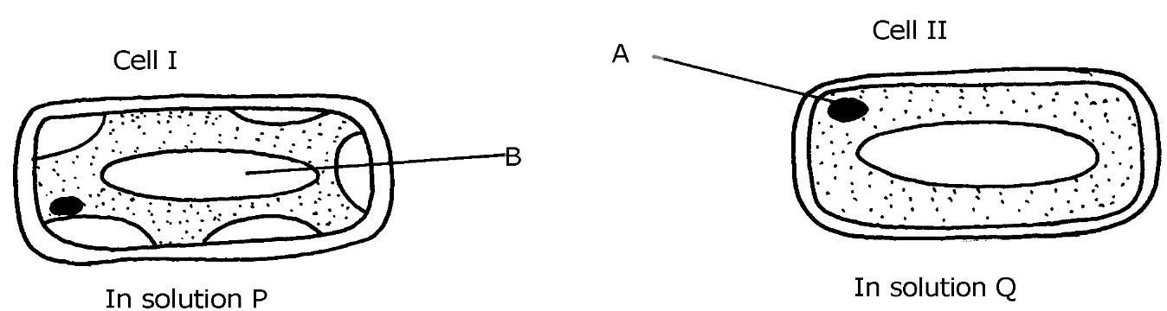

- i) Name the structure labelled A. (1mk)

ii) State the function of structure B . (1mk)

b) If eight of cell I were observed across the diameter of the filed of view of 0.5 mm.
Work out the actual diameters of each cell in micrometers. (2mks)
(1millimeter =1000micrometer)

- Suggest the identity of the solution Q. (1mk)

- Account for the change in cell I above. (2mks)

- State any one importance of the physiological process being demonstrated above in animals. (1mk)

4. Study the organelle shown below:-
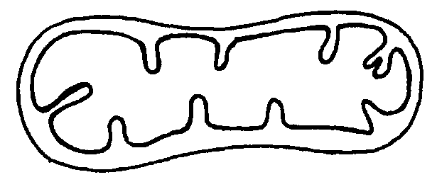
A
B

(a)Identify the cell organelle above (1mk)

(b) How is the organelle you have identified in (a) above suited to its function
(1mk)

5.An experiment shown below was set-up to investigate a certain physiological process
in plants:-
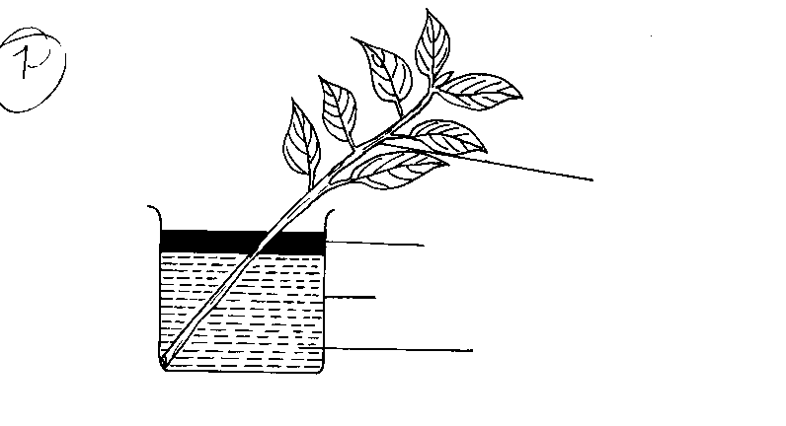
Leafy Shoot
Oil
Beaker
Water

- What process was being investigated? (1mk)

- Give the role of the oil layer in this experiment (1mk)

- (i) What observation did the students make after leaving the set-up in bright sunlight for two hours? (1mk)

(ii) Explain the observation in (c)(i) above (2mks)

(d) What effect will the following have on the observation made?:-
(i) Fanning the shoot (1mk)

(ii) Removing all the leaves from the shoot (1mk)

(iii) Placing the set-up in the dark (1mk)

6. State the function of the following cell structures:- (2mks)

a) Ribosome ;

b) Centrioles ;

7 The diagram below represents a section through a human tooth.
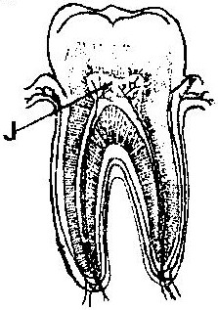

a).Name the type of tooth shown. (1mk)

b)Give a reason for your answer in (a) (i) above. (1mk)
8..Below is a process that takes place along the mammalian digestive system:

Lipids
Fatty acids + glycerol
B
A

- Name the processes represented by A and B (2mks)

A………………………………………………………

B……………………………………………………..

(b) Name part of the alimentary canal where the process B takes place (1mk)

9 .Explain why a fresh wound on the skin bleeds more on a hot sunny day than on a cold
chilly day (2mks)

10. (a) What is Respiration Quotient (RQ)? (1mk)

- (i) Calculate the R.Q of the food substance shown by the equation below. (2mks)

2C₅₁H₉₈O₆ + 145 O₂ 102CO₂ + 98H₂O + Energy

(ii) Name the food substance being oxidized in b (i) above. (1mk)

11 The diagram below represents a section of the human respiratory system:
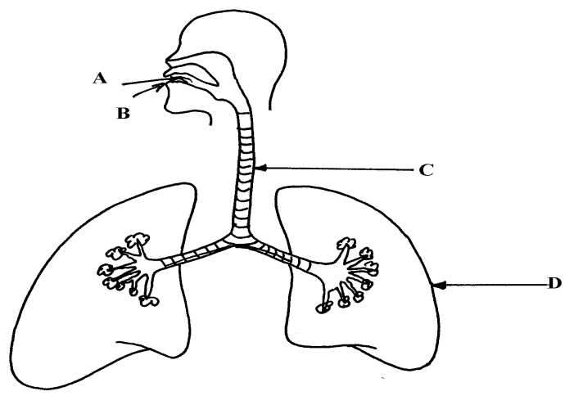

- One can inhale through path A, or B. Giving reasons, state the more appropriate path. (2mks)

- How is the part labbelled C adapted for its function? (1mk)

(c) Explain the effect of regular tobacco smoking to the functioning on the organ labelled D (1mk)

12. Define the following terms:- (2mks)
(i) Autecology

(ii) Biomass;

13. (a) State two functions of the kidney (2mks)

(b) Name two substances that are not found in urine of a healthy person (2mks)

(c) Name two diseases that affect the kidney (2mks)

14 .An experiment was set up as shown in the diagram below.

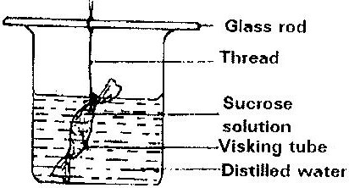

The set up was left for 30 minutes.
a) State the expected results. (1mk)

b) Explain your answer in (a) above. (1mk)

15. A solution of sugarcane was boiled with hydrochloric acid; sodium carbonate was heated with Benedict’s solution. An orange precipitate was formed.
a) Why was the solution boiled with hydrochloric acid? (1mk)

b) To which class of carbohydrates does sugarcane belong? (1mk)
c) State the form in which carbohydrates are stored in: (2mks)
i) Plants………………………………….
ii) Animals……………………………….

16 a).A patient whose blood group is A died shortly after receiving blood from a person of blood group B. Explain the possible cause of death of the patient. (2mks)

b) A person of blood group AB requires a transfusion.
i) Name the blood groups of the possible donors (2mks)

ii) Give reasons for your answer in (i) above. (1mk)

17. Anestar students wanted to estimate the number of grasshoppers in 5km² grass field near the school compound. They captured 36 grasshoppers. They used a red felt pen to mark the thorax of each insect before releasing back into the field. Three days later they made another catch of grasshoppers. They collected 45 grasshoppers of which only 4 had been marked with red mark.
a) Name the ;
    - Above method used in the population estimation (1mk)

    - The most appropriate apparatus for capturing grasshoppers (1mk)

b) Calculate the population of grasshoppers using the above data (2mks)

18.The table below shows the approximate percent concentration of various components in blood plasma entering the kidney glomerular filtrate and urine of a healthy human being.

Component | Plasma | Glomerular | Urine Filtrate
Water  Glucose  Amino Acids  Plasma proteins  Urea  In organic ions | 90  0.1  0.05  8.0  0.03  0.72 | 90  0.1  0.05  0  0.03  0.72 | 94  0  0  0  2.0  1.5

(a)Name the process responsible for the formation of glomerular filtrate. (1mk)

- What process is responsible for the absence of glucose and amino acids in urine? (1mk)

- Explain why there are no plasma proteins in the glomerular filtrate (1mk)

- Besides plasma proteins what other major component of blood is absent in the glomerular filtrate. (1mk)

19.The diagram below represents an organ from a bony fish. Study the diagram and answer the
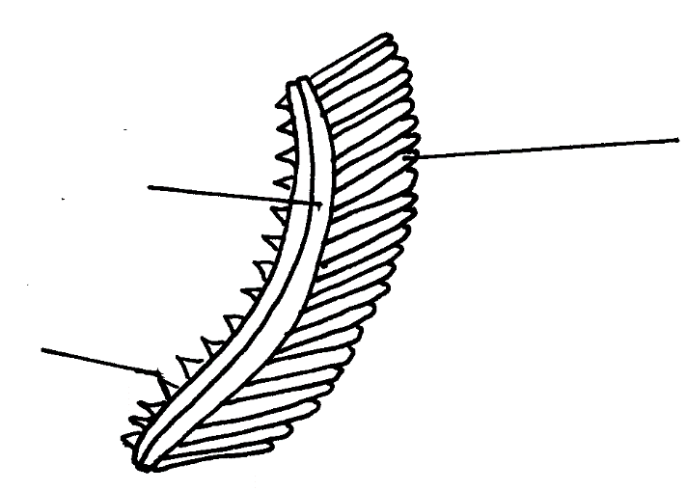
questions that follow:
B
C
A

- State the functions of each of the following (2mks)

A……………………………………………………………..

B…………………………………………………………….

(b) How is the structure labeled C adapted to its function? (1mk)

20 .State two reasons why lipids are rarely used as a respiratory substrate compound to
Carbohydrates (2mks)

