NAME:……………………………………………………………………..ADM:……….CLASS:……

ANESTAR SCHOOLS
BIOLOGY
FORM 2
TERM 1 OPENER EXAM, 2022
TIME: 1$\frac{1}{2}$ HOURS

TOTAL MARKS: 70

- Define the following terms (3mks)
- Anatomy

- Genetics

- Ecology

- (a) Name five Kingdoms used in classification. Give one example in each case. (5mks)

KINGDOM | EXAMPLE

(b) Name the taxonomic unit (taxon) whose members. (2mks)

- Have more common characteristics

- Have least characteristics in common

- Give two functions of centrioles in animal cells . (2mks)

- State the functions of the following tissues (4mks)
- Muscular tissue

- Nervous tissue

- Meristematic tissue

- Parenchyma tissue.
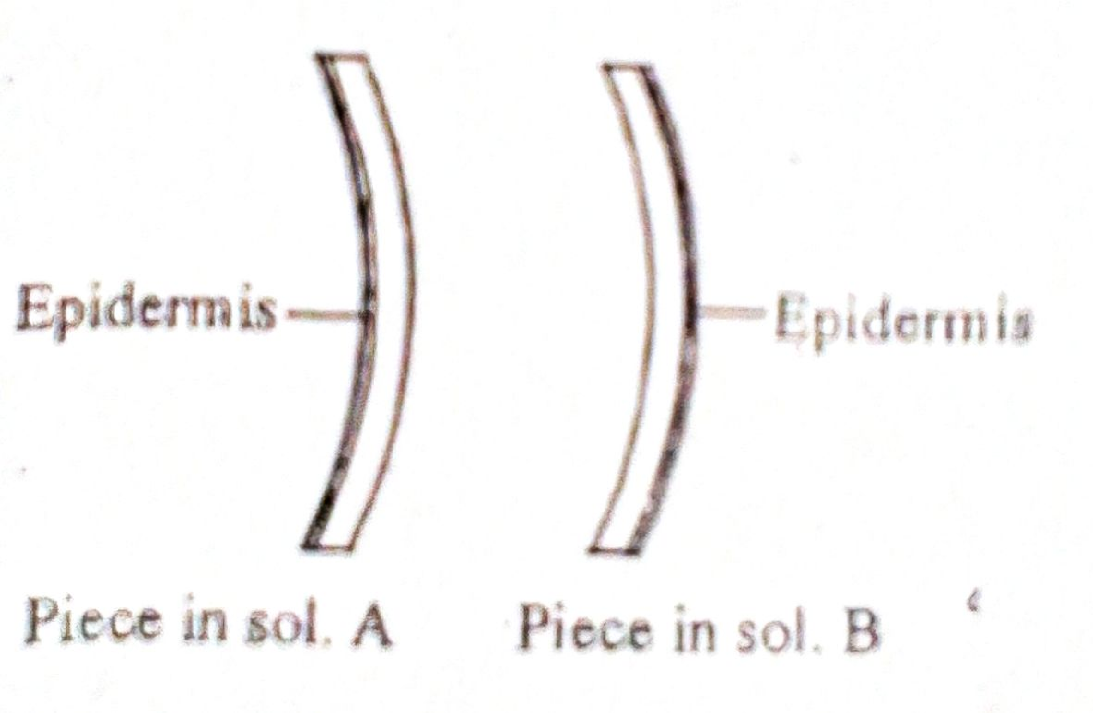

- A 4cm straight piece of stem from a herbaceous plant was split into two similar pieces. The pieces were placed into sugar solutions of different concentration for 30 minutes. Their final appearance was as shown below.

- Name the physiological process being investigated (1mk)

- Explain /account for the appearance of the piece in A. (2mks)

- Explain what would happen of red blood cells were placed in solution A (1mks)

- (a) Outline two importance of photosynthesis in nature. (2mks)

(b) (i) Write down a chemical equation that summarizes the reactions of photosynthesis. (1mks)

- State the name given to the reverse reaction of the equation you have written above. (1mk)

( c) What is the importance of light stage in photosynthesis. (1mks)

- (i) Other than temperature State two factors that affect the rate of photosynthesis. (2mks)

(ii) Explain how temperature affects the rate of photosynthesis (2mks)

- (a) State two functions of lipids in the body of organisms. (2mks)

(b) Define the term enzymes. (1mk)

(c) Outline two properties of enzymes. (2mks)

- State three elements common in carbohydrates, proteins and lipids. (3mks)

- (a) Write the dental formula of (2mks)

Man

A herbivore

- State the function of the following in herbivores (2marks)

- Horny/pad

- Diastema

- (i) Define the term digestion. (1mk)

(ii ) State three components of Saliva and their role in digestion ` (3mks)

Components | Function

- (a) State the functions of the following components of Bile. (2mks)
Bite salts

Sodium Bicarbonate

- State the role of Pancreases in digestion. (2mks)

- (a) Name the cells that secrete mucus in the digestive system .(1mk)

(b) Study the structure illustrated below

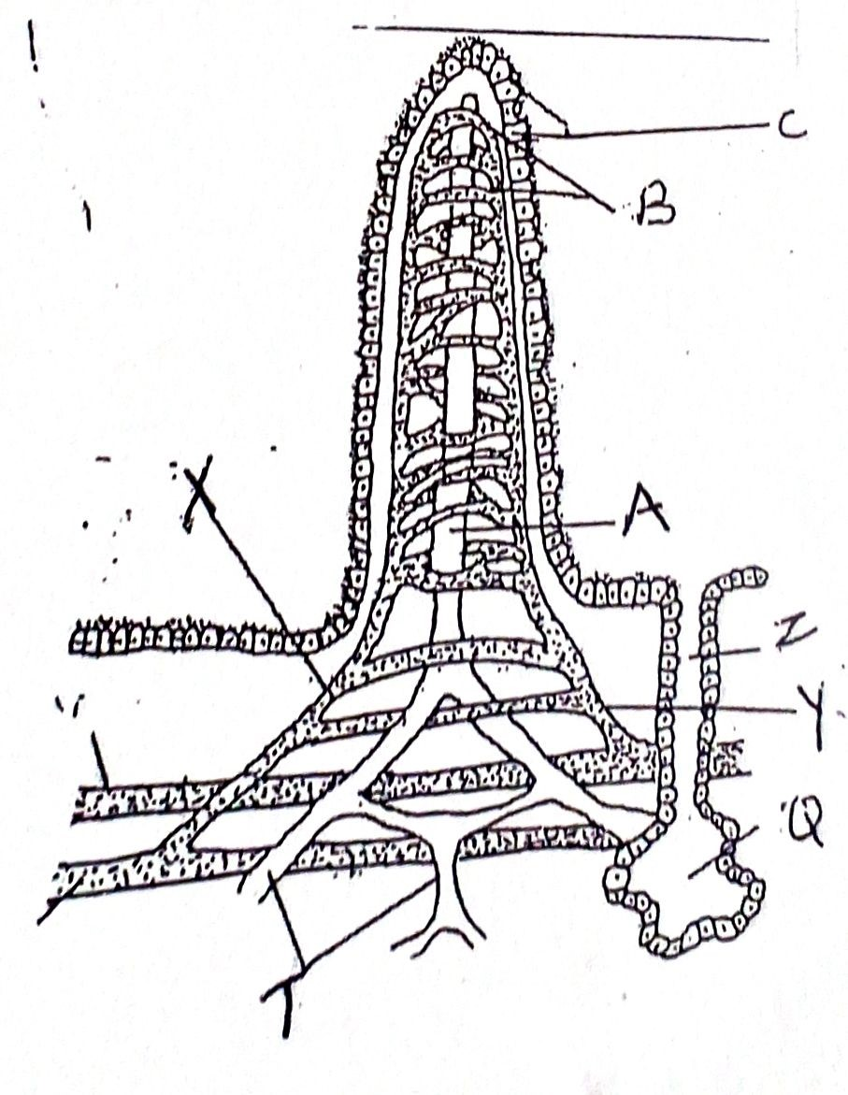

- Identify the structure (1mk)

- State the role of the structure (1mk)

- Name the parts A and B (2mks)

A

B

- (a) Define transport as used in living organisms. (1mk)

(b) State two primary functions of roots of plants (2mks)

- Study the following diagrams. (3mks

A
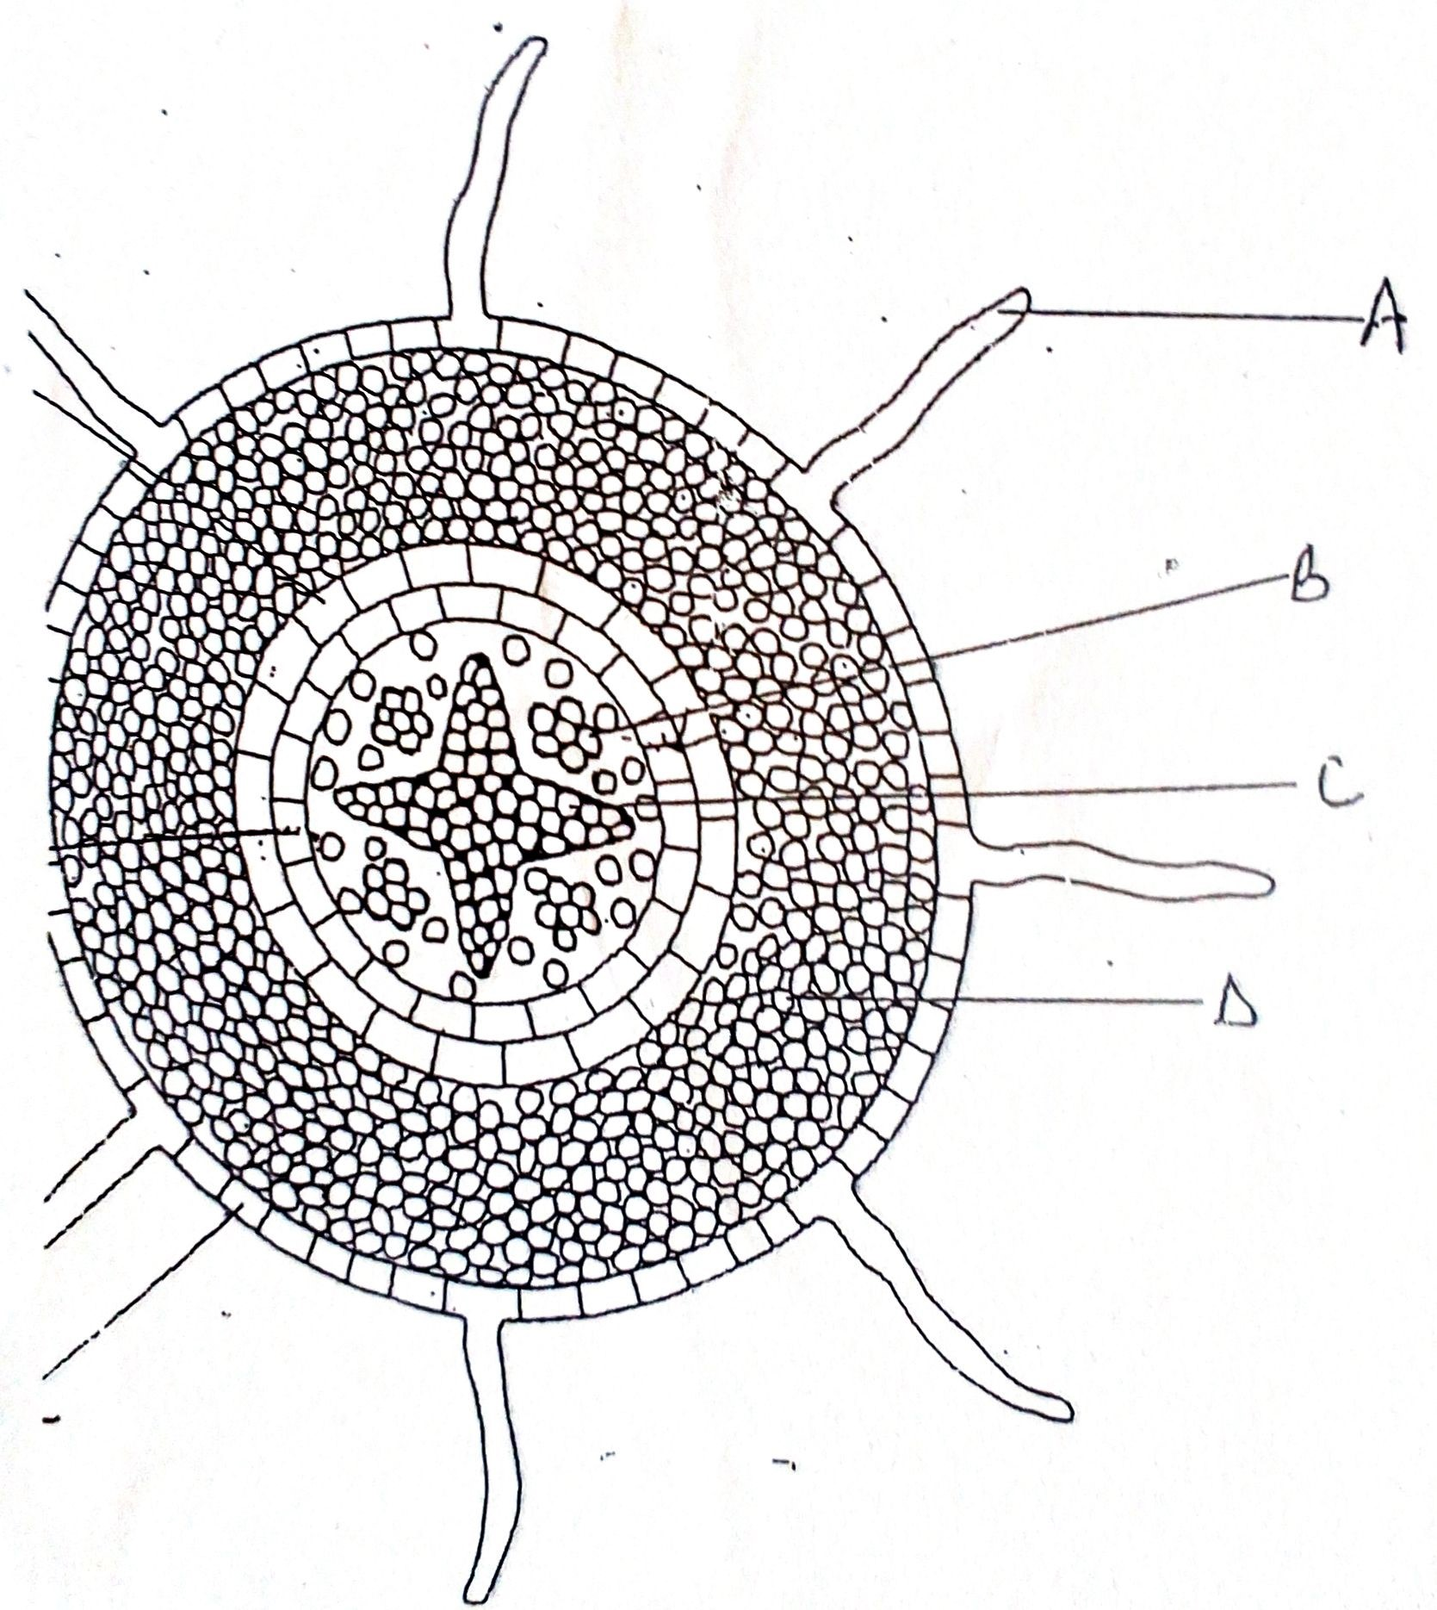

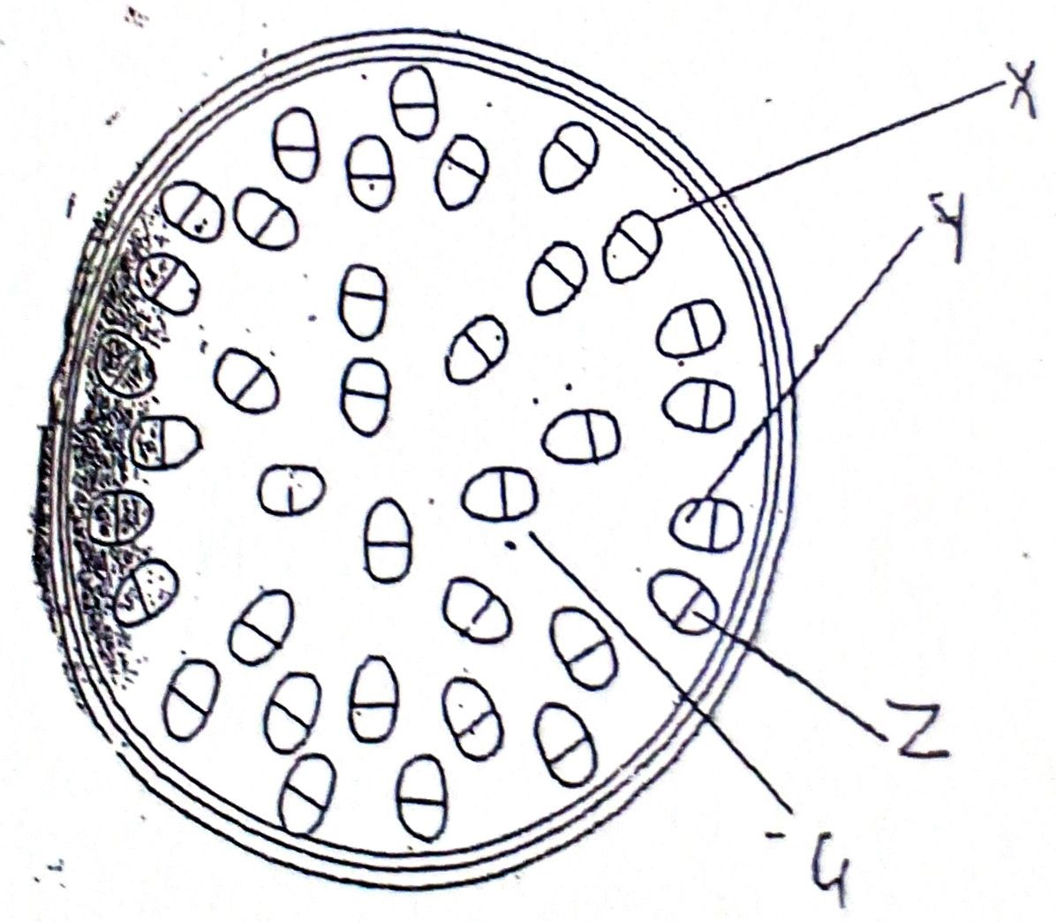
B

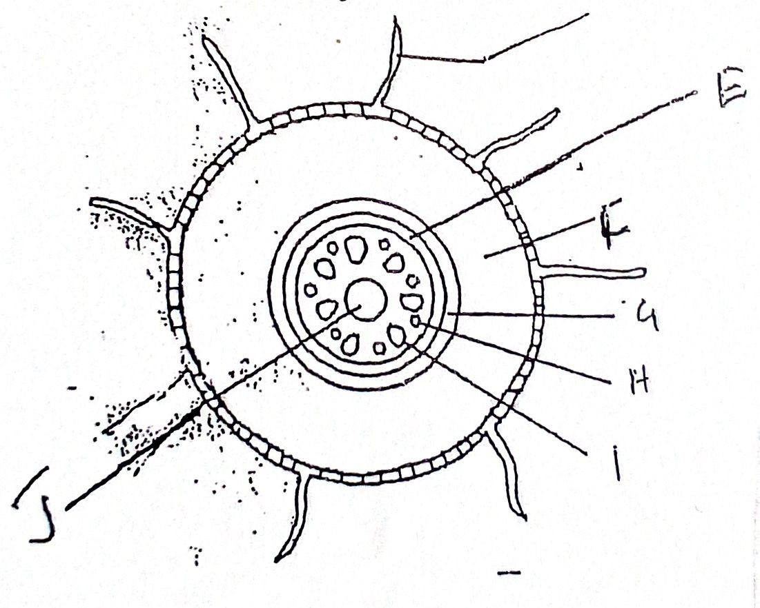
C

Identify part of plant represented by the diagrams (3mks)

A

B

C

- Outline two environmental factors that affect the rate of transpiration. (2mks)

- Name the reagent used for testing presence of (3mks)
- Starch

- Reducing sugars

- Vitamin C

- State the processes which occur in each of the following organelles. (3mks)
- Chloroplast

- Mitochondrion

- Ribosomes

- . The following diagram shows what happens in a plant leaf during photosynthesis.

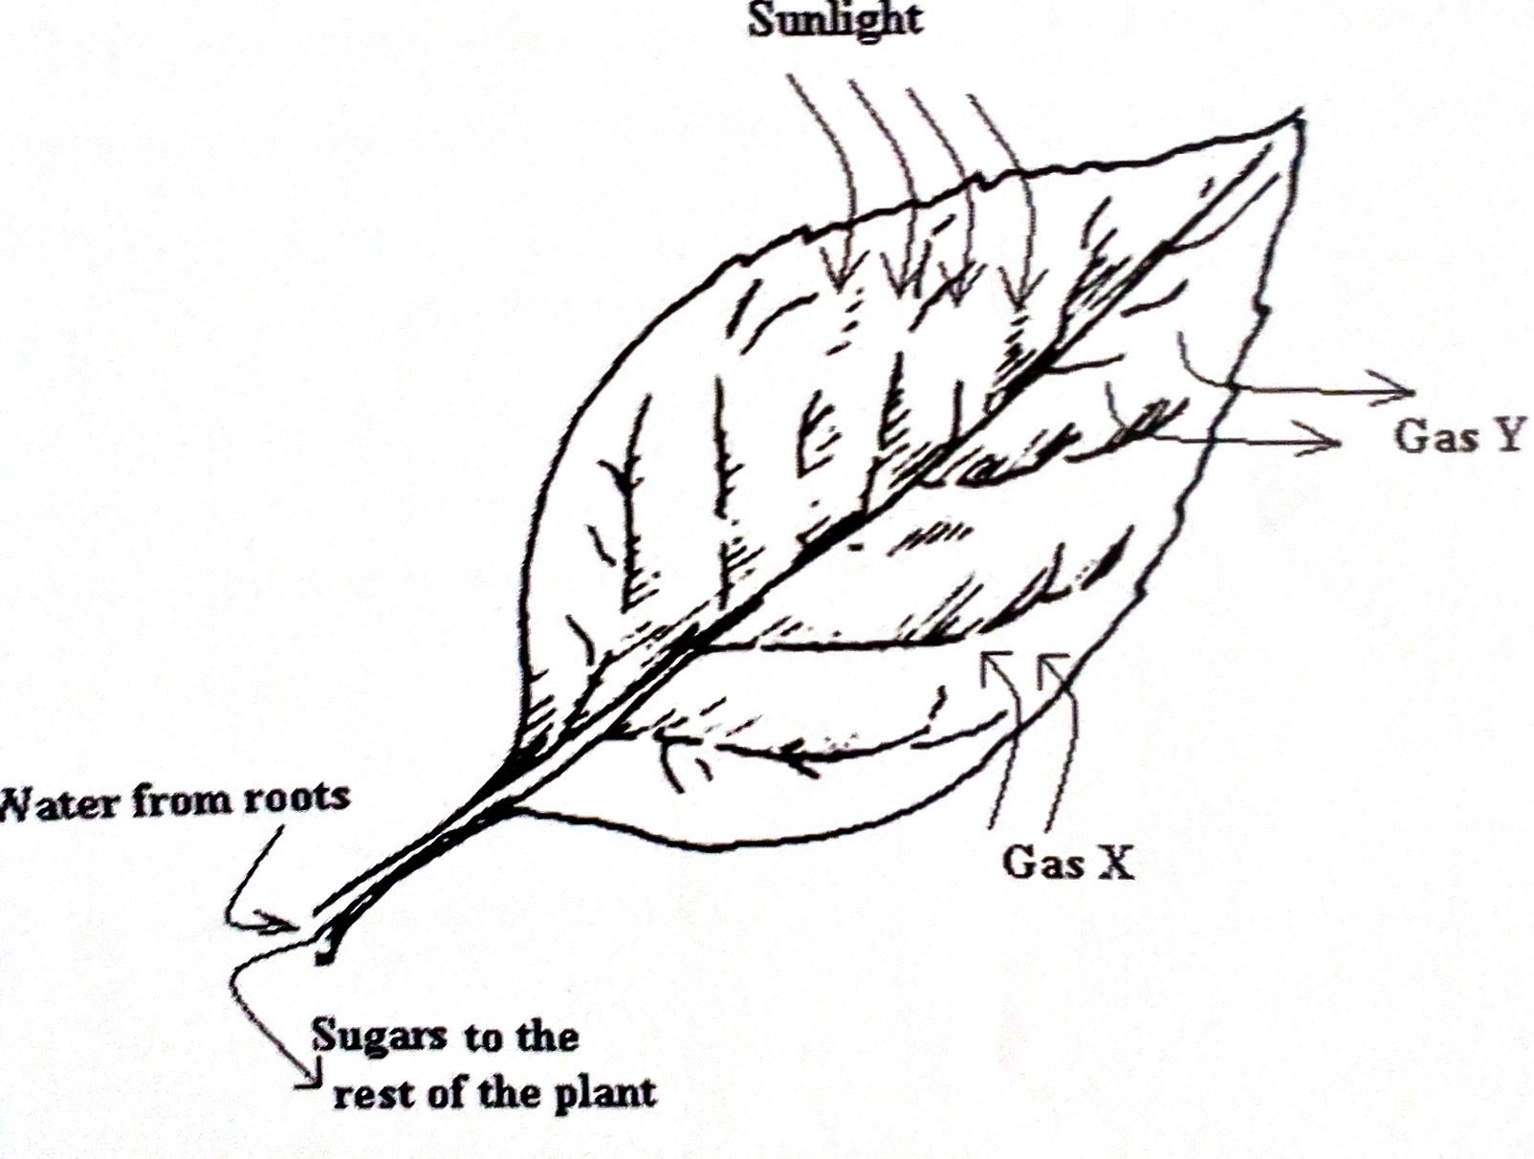

- Name the gases labelled X and Y. (2mks)

X

Y

- Name the tissue which transport:
- Water in to the leaf. (1mk)

- Sugars out of the leaf. (1mk)

