NAME ............................................................................CLASS.....................ADM ……….....…
TEACHER.CO.KE
OPENER TERM 1 EXAMS 2022
443/1
AGRICULTURE
PAPER 1
TIME: 2 HOURS
FORM 4
Instructions
- Write your name , class, admission number above
- This paper consist of three section A, B, and C
- Answer all questions in section A and B
- Answer any two questions in section C
- All answers should be written in the spaces provided
FOR EXAMINERS USE ONLY
SECTION | QUESTION | MAXIMUM SCORE | CANDIDATE SCORE
A | 1-16 | 30
B | 17-20 | 20
C |  | 20
 |  | 20
 | TOTAL SCORE | 90

SECTION A (30 MARKS
Answer all question in this section in the space provided

- Name four branches of agriculture. (2 marks)

- Name four soil constituents. (2 marks)

- State four different methods of clearing land before primary cultivation. (2 marks)

- Name four type of pumps used to lift water from its source. (2 marks)

- What are the characteristic of fertile soil? (2 marks)

- State four factors of production. (2 marks)

- Name four elements required by plants in large quantities. (2 marks)

- Name four factors to consider when selecting a nursery site. (2 marks)

- Give four characteristics of a good grain store. (2 marks)

- Name four categories of vegetables (2 marks)

- Name four land reform programs. (2 marks)

- State four type of soil erosion by water. (2 marks)

- Give four methods weed control in a crop farm. (2 marks)

- Name four factors affecting the efficiency of pesticides. (2 marks)

- Name four advantages of silage making. (2 marks)

SECTION B (20 MARKS)
Answer all the questions in this section in the spaces provided

- The diagram below illustrates a maize cob attacked by a disease. Study it carefully and answer the questions that follow.
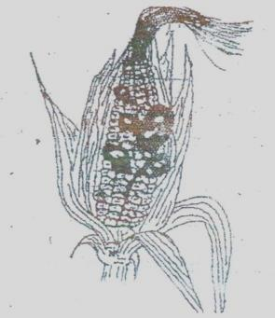
- Identify the disease. (1 mark)

- Apart from maize give four other crops that may be attacked by the disease. (2 marks)

- State four methods of controlling the disease. (2 marks)

- The diagram below is an illustration a tomato crop pest. Study it and answer the question that follows.

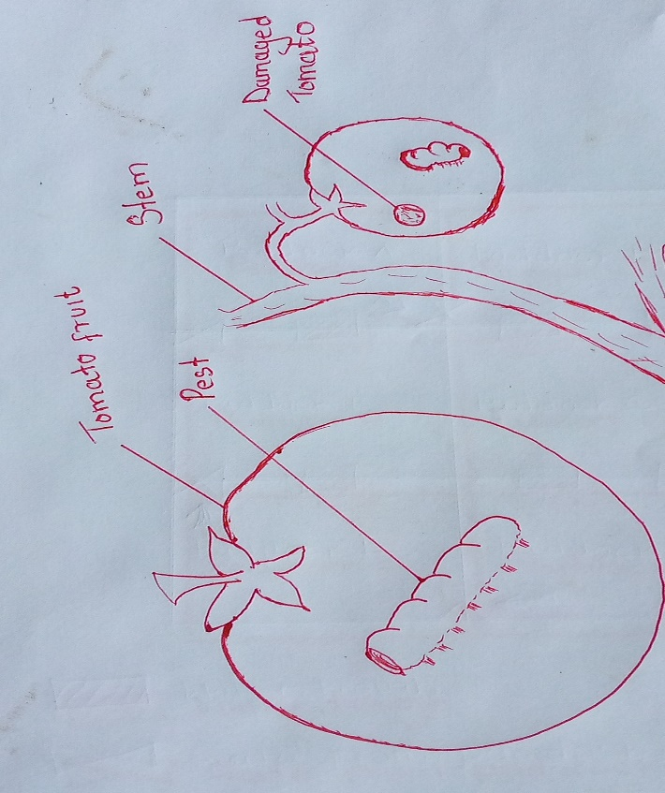

- Identify the pest. (1mark)

- How can a farmer control the pest named in (a) above. (1 mark)

- Name other three minor tomato pest. (3 marks)

- The diagrams below show a set-up of an experiment to study an aspect of soil. Study it and answer the question that follows.
- State the aim of the experiment. (1 mark)

- If the volume of water illustrated in the measuring cylinder was observed after one hour identify the soil sample labeled A and B.
Soil sample A. (1 mark)

Soil sample B. (1 mark)

- State two ways in which the soil structure of the sample labeled C above can be improved.(2 marks)

- The diagram below illustrates a grazing system. Study it carefully and answer the question that follows.

- Identify the grazing system illustrated above (1mark)

- State four advantages of the grazing system illustrated above. (4 marks)

SECTION C (40MARKS)
Answer any two questions in this section in the spaces provided

- (a) Describe the cultural methods used to control pest in the farm. (10mks)
(b) State and explain five biotic factors influencing agriculture. (10mks)

- a) Explain why settlement schemes were established in Kenya soon after independence. (10 marks)
b) State the uses of farm records (10 marks)

22. a) Explain the factors considered in choosing seed rates (8mks)

- Describe the production of cabbages under the following sub headings
i) Nursery establishment and management (6 marks)
ii) Transplanting (6marks)

