NAME………………………………………………………………….ADM…………………
DATE…………………………………………………………………SIGN………………….
TEACHER.CO.KE AGRICULTURE FORM THREE
TERM ONE OPENER EXAM 2022
TIME 1 HOUR 30 MINUTES
INSTRUCTIONS TO STUDENTS
Answer ALL the questions in the spaces provided

- Differentiate between under-sowing and over-sowing (1mk)
……………………………………………………………………………………………………………………………………………………………………………………………………………………………………………………………………………….
- Name four methods of farming (2mks)
…………………………………………………………………………………………………………………………………………………………………………………………………………………………………………………………………………………………………………………………………………………………………………
- State four categories of vegetables. (2 mks )
…………………………………………………………………………………………………………………………………………………………………………………………………………………………………………………………………………………………………………………………………………………………………………..
- List four human factors that influence agriculture (2mks)
…………………………………………………………………………………………………………………………………………………………………………………………………………………………………………………………………………………………………………………………………………………………………………..

- Give four reasons for treating water for use on the farm (2mks)
……………………………………………………………………………………………………………………………………………………………………………………………………………………………………………………………………………..
- State the function of the following parts in digestive system of poultry (1¹_{/2} mks)
Crop………………………………………………………………………………
Gizzard…………………………………………………………………………
Caecum ……………………………………………………………………………
- State four precautions that should be observed when using workshop tools (2mks)
…………………………………………………………………………………………………………………………………………………………………………………………………………………………………………………………………………………………………………………………………………………………………………..
- Give four reasons why burning is discouraged as a method of land clearing (2mks)
…………………………………………………………………………………………………………………………………………………………………………………………………………………………………………………………………………………………………………………………………………………………………………..
- Name four practices that enhance minimum tillage (2mks)
…………………………………………………………………………………………………………………………………………………………………………………………………………………………………………………………………………………………………………………………………………………………………………..
- Give three sources of underground water (1^{1/}₂)
…………………………………………………………………………………………………………………………………………………………………………………….
…………………………………………………………………………………………
- State four characteristics of a fertile soil (2mks)
………………………………………………………………………………………………………………………………………………………………………………………………………………………………………………………………………………………………………………………………………………………………………….
- Name four breeds of dairy goats (2mks)
………………………………………………………………………………………………………………………………………………………………………………………………………………………………………………………………………………………………………………………………………………………………………….
- Name two types of Inventory records (1mk)
……………………………………………………………………………………………………………………………………………………………………………………
- List four symptoms of Nitrogen deficiency in plants (2mks)
…………………………………………………………………………………………………………………………………………………………………………………………………………………………………………………………………………………………………………………………………………………………………………
- Name two vegetative materials used to propagate pineapples (1mk)
……………………………………………………………………………………………………………………………………………………………………………………
- Outline four factors considered when selecting a nursery site (2mks)
…………………………………………………………………………………………………………………………………………………………………………………………………………………………………………………………………………………………………………………………………………………………………………
- State four characteristics of a good grain store (2mks)
………………………………………………………………………………………………………………………………………………………………………………………………………………………………………………………………………………
- The following is a list of plant nutrients; copper, calcium, nitrogen, zinc, molybdenum, phosphorus, carbon, sulphur, iron and magnesium.
Which of the above nutrients are?
- Macro elements (2mks)
…………………………………………………………………………………………………………………………………………………………………………………….
- Micro elements (1mk)
………………………………………………………………………………………….

- Fertilizer elements (1mk)
…………………………………………………………………………………………
- Liming elements (1mk)
…………………………………………………………………………………………

- The diagram below illustrates a livestock parasite
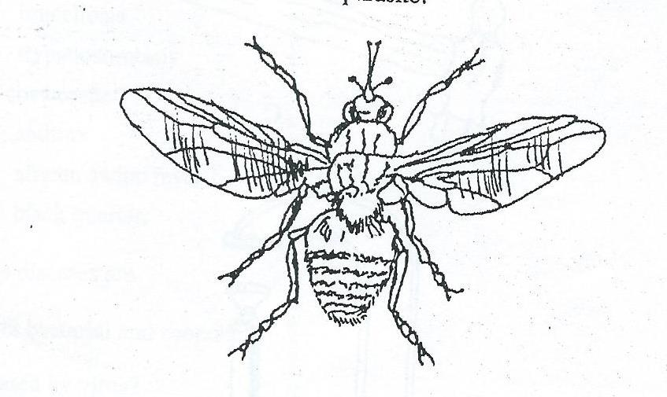

- Identify the parasite illustrated above (1mk)
…………………………………………………………………………………………
- State the major harmful effect of the parasite (1mk)
…………………………………………………………………………………………
- Explain three control measures of the parasite (3mk)
………………………………………………………………………………………………………………………………………………………………………………………………………………………………………………………………………………
…………………………………………………………………………………………

20. The diagram below is an illustration a tomato crop pest. Study it and answer the question that follows.

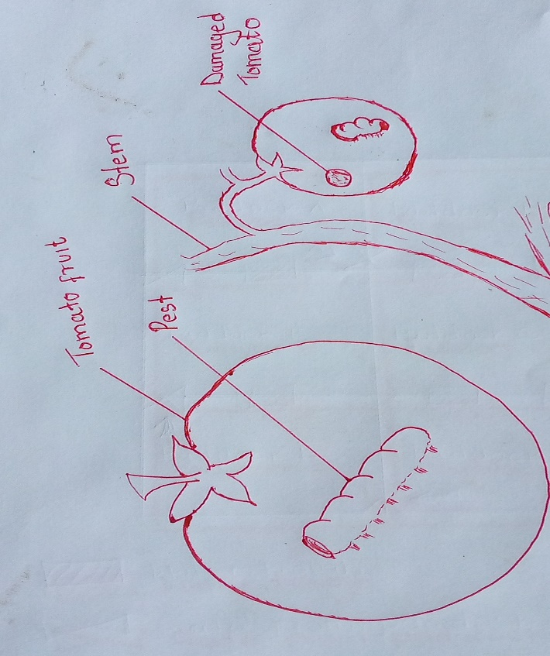

- Identify the pest. (1mark)
………………………………………………………………………………………………………………………………………………………………………………………………………………………………………………………………………

- How can a farmer control the pest named in (a) above. (1 mark)
………………………………………………………………………………………………………………………………………………………………………………………………………………………………………………………………………………

- Name other three minor tomato pest. (3 marks)
………………………………………………………………………………………………………………………………………………………………………………………………………………………………………………………………………………………………………………………………………………………………
21a) State the importance of vegetables to a farmer (5mks)
……………………………………………………………………………………………………………………………………………………………………………………………………………………………………………………………………………………………………………………………………………………………………………………………………………………………………………………………………………………………………………………………………………………………………………………………………………..
- Briefly describe the production of onions under the following sub-headings
i) Varieties (1mk)
……………………………………………………………………………………………………………………………………………………………………………………………………
ii) Ecological requirements (3mks)
………………………………………………………………………………………………………………………………………………………………………………………………………………………………………………………………………………………………………
……………………………………………………………………………………………………………………………………………………………………………………………………
…………………………………………………………………………………………………
22a) Define the following terms as used in livestock health (2mks)
- Disease……………………………………………………………………………………………………………………………………………………………………………
…………………………………………………………………………………………
- Health……………………………………………………………………………………………………………………………………………………………………………
………………………………………………………………………………………..
- Differentiate between digestion in ruminant and non-ruminants(5mks)
………………………………………………………………………………………………………………………………………………………………………………………………………………………………………………………………………………………………………………………………………………………………………………………………………………………………………………………………………………………………………………………………………………………………..
…………………………………………………………………………………………
……………………………………………………………………………………………………………………………………………………………………………………

- A farmer wanted to prepare 200kg of calf rearing ration containing 20 % DCP, using the person’s square method calculate the amount of maize containing 18% DCP and sunflower containing 35% DCP the framer would need to prepare.
(4mks show your working)
……………………………………………………………………………………………………………………………………………………………………………………………………………………………………………………………………………………………………………………………………………………………………………………………………………………………………………………………………..
……………………………………………………………………………………………………………………………………………………………………………………
……………………………………………………………………………………………………………………………………………………………………………………
23. Describe 5 factors to consider when selecting nursery site (5mks)
…………………………………………………………………………………………………………………………………………………………………………………………………………………………………………………………………………………………………………………………………………………………………………………………………………………………………………………………………………………………………………………………………………………………………………………………………………………………………………………………………………………………………………………………………………………………………………………………………………………………………………………………………………………………………………………………………………
……………………………………………………………………………………………………………………………………………………………………………………………………………………………………………………………………………………………………………………………………………………………………………………………………………………………………………………………………………………………………………………………………………………………………………………………………………………………………………………………………………………………………………………………………………………

