312/2 ─GEOGRAPHY─ Paper 2

TIME: 2 Hrs 45Mins
DECEMBER, 2021

SAMIA SUB-COUNTY JOINT EXAMINATION
Kenya Certificate of Secondary Education

Name:…………………………………..…………… Index No ………………..……
Candidate’s Signature………………………………. Adm. NO. …………………….
School:………………………………………………. Stream:……………………..

Instructions to candidates

- Write your Name and Index Number in the spaces provided above,
- Sign and Write the Admission number in the spaces provided above;
- This paper consists of two Sections; A and B.
- Answer all the questions in Section A.
- Answer question6 and any other two questions from Section B.
- Answers must be written in the spaces provided at the end of question 10.
- This paper consists of 4 printed pages,
- Candidates should check the question paper to ascertain that all the pages are printed as indicated and that no questions are missing.
- Candidates should answer the questions in English.

For Examiner’s use only
Section | Question | Maximum score | Candidate’s score
A | 1 – 5 | 25
B | 6 | 25
 |  | 25
 |  | 25
TOTAL SCORE

SECTION A (25 MARKS)
ANSWER ALL THE QUESTIONS IN THIS SECTION
1.a). Define the term energy crisis (2mks)
b) State three limitations of using solar energy (3mks)
2. a)Give two problems facing river transport in African. (2 marks)
(b)The diagram below shows the Great Lakes and the St. Lawrence sea way.
Use it to answer the questions below.

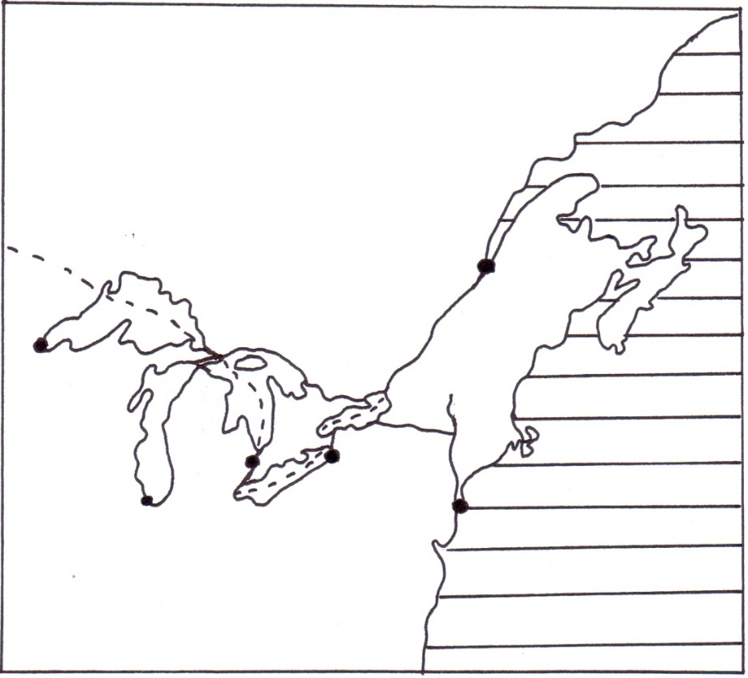
R
Q

CANADA
U.S.A
Lake Huron
River St. Lawrence
River Hudson
Atlantic Ocean
New York
Quebec
Chicago
M
Name the lakes M, Q and R. (3mks)

3. a) Apart from tropical hardwood forests name two other types of natural forests (2mks)
b) State three problems experienced in exploitation of tropical hardwood forests (3mks)
4. a) Give three physical factors that favour coffee growing in Kenya highlands (3mks)
b) State two problems facing coffee farming in Kenya (2mks)
5. a) Give three types of fish (3mks)
b) List two traditional methods of fishing (2mks)
SECTION B

Answer question 6 and any other two questions from this section

6. The table below shows crops production in Kenya for a period of five years in 1000 kilograms. Use it to answer question (a)
CROP/YEAR | 2005 | 2006 | 2007 | 2008 | 2009
Coffee | 1000 | 900 | 800 | 700 | 800
Tea | 700 | 700 | 600 | 680 | 600
Cotton | 500 | 400 | 300 | 600 | 350
Pyrethrum | 300 | 200 | 300 | 440 | 450

(a) (i) Using a scale of 1 cm represent 200 kilograms present the above data using a compound bar graph. (9 marks)
(ii) List two advantages of using a compound bar graph to represent statistical data. (2mks)
(b)(i)Other than Ghana, name other two countries West Africa where cocoa is grown (2mks)
(ii) State three physical conditions that favor the growth of cocoa in Ghana. (3mks)
(c) Describe how cocoa is processed in Ghana (6mks)
(d)Give three importance of cocoa production to the economy of Ghana.(3mks)

7 . Study the photograph shown below and use it to answer the following questions.
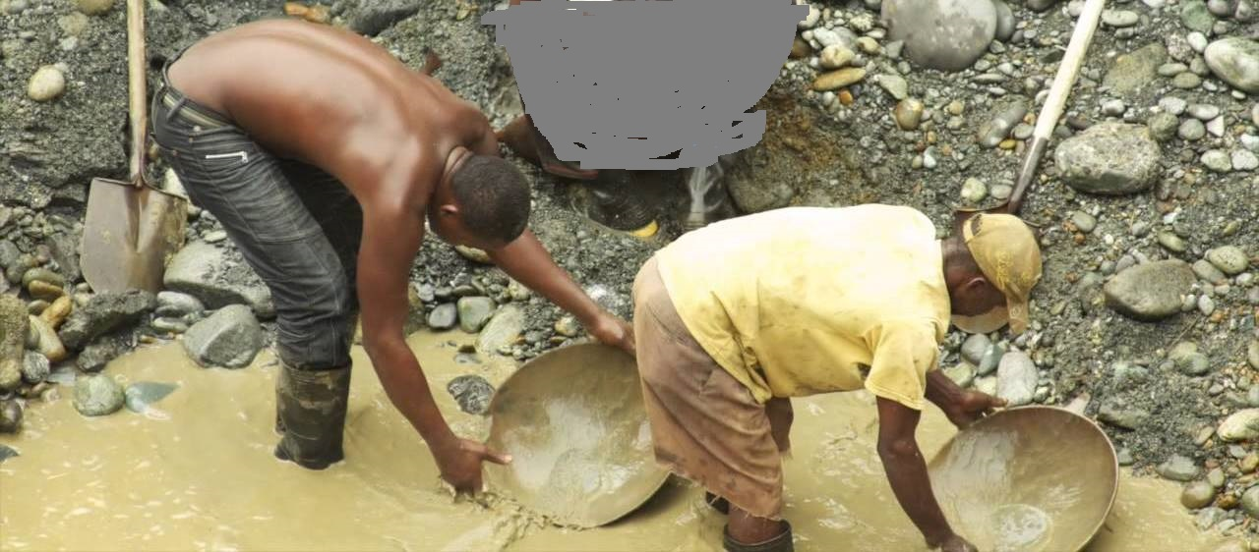
a) i) Identify the type of the photograph shown above. (1mks)
ii) Identify two characteristic of the photograph shown above. (2mks)
iii) Give three parts of a photograph. (3mks)
b) Name the type of mining method shown above. (1mks)
c) Explain how the method named above (b) is carried out. (6mks)
d) Explain four negative effects of the above method of mining on the environment. (8mks)
e) Draw a sketch diagram to represent the photograph shown above. (4mks)

- a) (i) Define the term land rehabilitation (2 marks)
ii) Apart from irrigation, name three other methods of land reclamation in Kenya. (3 marks)
b) Explain three problems facing irrigation farming in Kenya. (6 marks) c) Describe the stages of polderization in the Netherlands (5 marks)
d) You intend to carry out a field study on irrigation farming in Mwea Tebere irrigation scheme
i)Identify the two types of hypothesis you would develop for the study (2mks)
ii) Name five crops grown in the scheme that you are likely to identify (5mks)
iii) Give two reasons why you need to sample the area of study (2mks)

- (a) i) Define the term industrial inertia (2mks)

ii) Give three causes of industrial inertia (3mks)

b) Name three agricultural non-food processing industries in Kenya (3mks)

c) i) What is cottage industry (2mks)
ii) List four ways in which Jua Kali industries is important to the Kenyan economy (4mks)
d) i) State three problems facing cottage industry in India (3mks)

ii) Explain four factors that led to the development of iron and steel industry in the Ruhr region of Germany (8mks)

- a) i)What is environmental management (2mks)
ii) Give four reasons why it is necessary for Kenya to conserve her environment (4mks)
b) Explain four measures that can be taken to combat pollution (8mks)
c) i) Name five types of wastes found in urban areas (5mks)ii) Explain three ways in which wastes in urban centres can be managed (6mks)

