Name…………………………………………………………Index No……… …..
Ccandidate’s sign……………… Date …………………………..

AGRICULTURE PAPER 2
443/2
Time: 2 Hours
SAMIA SUB - COUNTY EXAMINATION - FORM FOUR 2021
Kenya Certificate of Secondary Education (KCSE)

.
INSTRUCTIONS TO CANDIDATES
[i]Write your name and index number in the spaces provided at the top of this page .
[ii]Sign and write the date of the examination in the spaces provided above.
[iii]This paper consists of three sections A, B, andC.
[iv]Answer all the questions in sections A and B .Answer two questions in section C
[v]Answers should be written in the spaces provided on the question paper.

FOR EXAMINERS USE ONLY.
SECTION | QUESTIONS | MAX.SCORE | CANDIDATES SCORE
A | 1-18 | 30
B | 19-21 | 20
C | 22-24 | 40
TOTAL SCORE |  | 90

Section A (30marks)
- Give tworeasons for docking in sheep production. (1mk)
………………………………………………………………………………………………………………………………………………………………………………………………
- Give four ideal qualities of a good calf pen (2mks)
………………………………………………………………………………………………………………………………………………………………………………………………………………………………………………………………………………………………………………………………………………………………………………………………
- Outline four characteristics of Romney marsh sheep breed (2mks)
………………………………………………………………………………………………………………………………………………………………………………………………………………………………………………………………………………………………………………………………………………………………………………………………
- (a) State two disadvantages of using metal frames in construction of farm buildings(1mk)
………………………………………………………………………………………………………………………………………………………………………………………………
(b) Give two reasons for seasoning timber (1mk)
………………………………………………………………………………………………………………………………………………………………………………………………
5. Outline four reasons for swarming of bees (2mks)
………………………………………………………………………………………………………………………………………………………………………………………………………………………………………………………………………………………………………………………………………………………………………………………………
6. List two methods that can be used to preserve fish (1mk)
………………………………………………………………………………………………………………………………………………………………………………………………
7. (a) What is a notiafiable disease?(1mk)
………………………………………………………………………………………………………………………………………………………………………………………………
(b) Name four examples of notifiable diseases in livestock (2mks)
………………………………………………………………………………………………………………………………………………………………………………………………………………………………………………………………………………………………………………………………………………………………………………………………
8. Nametwomajor physical differences between Bactrian and Dromedary breeds of camel. (1mk)
……………………………………………………………………………………………………………………………………………………………………………………………..
9. State two characteristics of heavy poultry breeds (1mk)
………………………………………………………………………………………………………………………………………………………………………………………………
10. List two maintenance practices of a wood chisel (1mk)
………………………………………………………………………………………………………………………………………………………………………………………………
11. State four ways of controlling tsetse flies (2mks)
………………………………………………………………………………………………………………………………………………………………………………………………………………………………………………………………………………………………………………………………………………………………………………………………
12. State four characteristics of livestock roughage feedstuff (2mks)
………………………………………………………………………………………………………………………………………………………………………………………………………………………………………………………………………………………………………………………………………………………………………………………………
13. List two equipment used in handling cattle during agricultural exhibition (1mk)
………………………………………………………………………………………………………………………………………………………………………………………………
14. State the gestation period of the livestock animals given below
(a) rabbit ( ½mk)
……………………………………………………………………………………………
(b) goat (½mk)
……………………………………………………………………………………………
15. State four disadvantages of natural mating (2mks)
………………………………………………………………………………………………………………………………………………………………………………………………………………………………………………………………………………………………………………………………………………………………………………………………
16. State one egg content added to it at the magnum during egg formation process(1mk)
……………………………………………………………………………………………
17. State four methods used to control cannibalism in a deep litter system (2mks)
………………………………………………………………………………………………………………………………………………………………………………………………………………………………………………………………………………………………………………………………………………………………………………………………
18. (a) Give three uses of Biogas in the farm(1 ½ mks)
………………………………………………………………………………………………………………………………………………………………………………………………………………………………………………………………………………………………
(b) State three reasons why the use of wind power on the farm is limited(1 ½mks)
………………………………………………………………………………………………………………………………………………………………………………………………………………………………………………………………………………………………

Section B: (20marks)
Answer ALL questions in this section.
19. (a) The illustration below represents equipment used in poultry production. Study it carefully and answer the questions that follow:
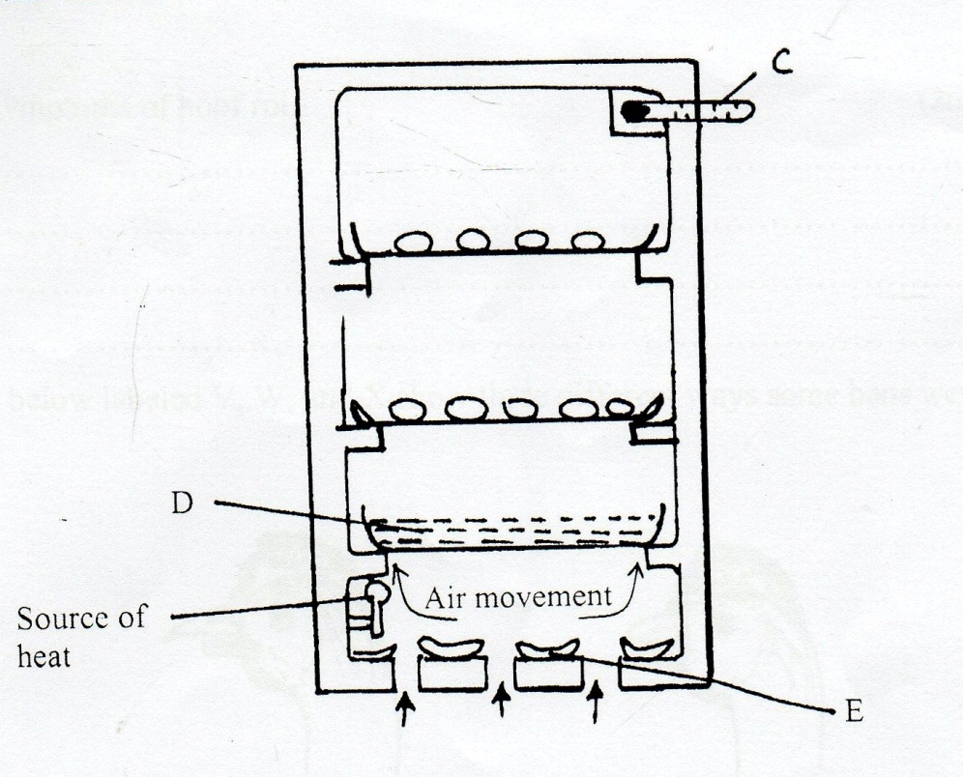
i) Identify the equipment illustrated above. (1mk)
………………………………………………………………………………………………
ii) Name the parts labeled C,D and E on the diagram of the equipment illustrated on the equipment in a ) above (1 ½mks)
C ………………………………………………….
D ……………………………………………….
E ………………………………………………..
iii) What are the functions of the parts labeled C,D and E (3mks)
C ……………………………………………………………………………………………….
D…………………………………………………………………………………………………..
E……………………………………………………………………………………………………
(iv) Why is it important to turn the eggs around 180 oc every 6- 8 hours? (1mk)
………………………………………………………………………………………………
(b).The diagram bellows shows the reproductive system of a cow. Study it and answer the questions that follow

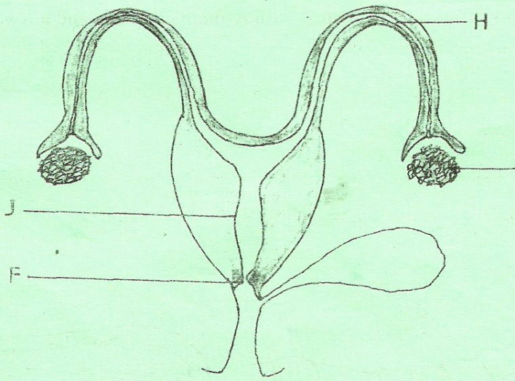
- Name the parts labeled J , F and H. (1.5mks)
J ……………………………………………………………………………………..

F ……………………………………………………………………………………..

H ……………………………………………………………………………………

- State one function of each of the parts labeled J and H

J ……………………………………………………………………………….. (1mk)

H ……………………………………………………………………………… (1mk)

- Name three reproductive hormones in dairy cattle (3mks)
……………………………………………………………………………………………………………………………………………………………………………………………………………………………………………………………………………….
20 (a) The illustrations below labeled V,W, and X show three different ways some hens were debeaked.
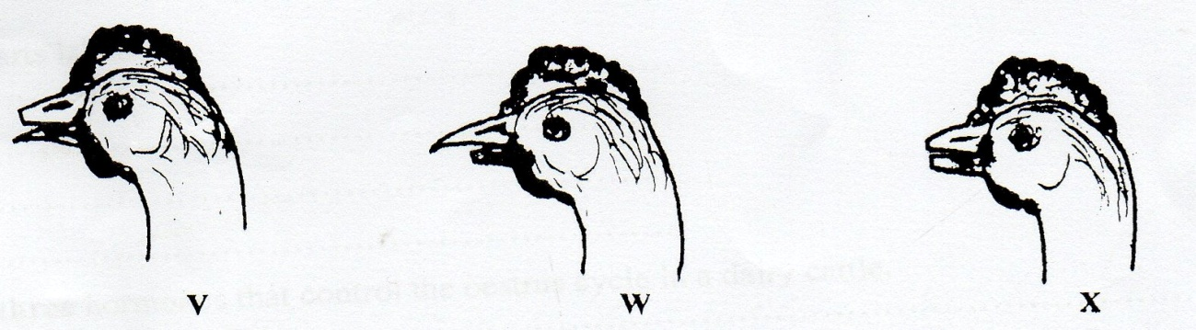
i) Which hen was correctly debeaked ? (1mk)
………………………………………………………………………………………………………………………………………………………………………………………………………………………………………………………………………………………………………………………………………………………………………………………………
ii) state two reasons for your choice in (i) above (1mk)
………………………………………………………………………………………………………………………………………………………………………………………………
(b) Name any two tools which would be used for debeaking. (2mks)
………………………………………………………………………………………………………………………………………………………………………………………………
21.Boran Dam X FRIESIAN SIRE – f1 heifer x charolais
(a) What type of breeding system is shown above? (1mk)
……………………………………………………………………………………………
(b) Why would you recommend such a breeding system? (1mk)
………………………………………………………………………………………………
(c) What characteristic in the heifer are you improving by using such a breeding system? (1mk)
………………………………………………………………………………………………

SECTION C: (Answer any two questions)
22 (a)outline ten differences between a tractor drawn mould plough and an ox mouldboard(10mks)
(b) describe management of growers to point of lay (10mks)
23. (a) (i) Give three factors considered in siting a farm structure (3mks)
(ii) Describe the functions of each of the following parts of a plunge dip (7mks)
- Foot bath
- Entrance race
- Roof
- Drainage race
- Jump
- Dip tank
- Exit step
(b) Describe the procedure of constructing a barbed wire fence (10mks)
24. (a) (i) Give three factors affecting the amount of food given to an animal (3mks)
(ii) State and explain seven essential of clean milk production (7mks)
(b) Describe digestion of grass in the rumen of a cow (10mks)
…………………………………………………………………………………………………………………………………………………………………………………………………………………………………………………………………………………………………………………………………………………………………………………………………………………………………………………………………………………………………………………………………………………………………………………………………………………………………………………………………………………………………………………………………………………………………………………………………………………………………………………………………………………………………………………………………………………………………………………………………………………………………………………………………………………………………………………………………………………………………………………………………………………………………………………………………………………………………………………………………………………………………………………………………………………………………………………………………………………………………………………………………………………………………………………………………………………………………………………………………………………………………………………………………………………………………………………………………………………………………………………………………………………………………………………………………………………………………………………………………………………………………………………………………………………………………………………………………………………………………………………………………………………………………………………………………………………………………………………………………………………………………………………………………………………………………………………………………………………………………………………………………………………………………………………………………………………………………………………………………………………………………………………………………………………………………………………………………………………………………………………………………………………………………………………………………………………………………………………………………………………………………………………………………………………………………………………………………….…………………………………………………………………………………………………………………………………………………………………………………………………………………………………………………………………………………………………………………………………………………………………………………………………………………………………………………………………………………………………………………………………………………………………………………………………………………………………………………………………………………………………………………………………………………………………………………………………………………………………………………………………………………………………………………………………………………………………………………………………………………………………………………………………………………………………………………………………………………………………………………………………………………………………………………………………………………………………………………………………………………………………………………………………………………………………………………………………………………………………………………………………………………………………………………………………………………………………………………………………………………………………………………………………………………………………………………………………………………………………………………………………………………………………………………………………………………………………………………………………………………………………………………………………………………………………………………………………………………………………………………………………………………………………………………………………………………………………………………………………………………………………………………………………………………………………………………………………………………………………………………………………………………………………………………………………………………………………………………………………………………………………………………………………………………………………………………………………………………………………………………………………………………………………………………………………………………………………………………………………………………………………………………………………………………………………………………………………….…………………………………………………………………………………………………………………………………………………………………………………………………………………………………………………………………………………………………………………………………………………………………………………………………………………………………………………………………………………………………………………………………………………………………………………………………………………………………………………………………………………………………………………………………………………………………………………………………………………………………………………………………………………………………………………………………………………………………………………………………………………………………………………………………………………………………………………………………………………………………………………………………………………………………………………………………………………………………………………………………………………………………………………………………………………………………………………………………………………………………………………………………………………………………………………………………………………………………………………………………………………………………………………………………………………………………………………………………………………………………………………………………………………………………………………………………………………………………………………………………………………………………………………………………………………………………………………………………………………………………………………………………………………………………………………………………………………………………………………………………………………………………………………………………………………………………………………………………………………………………………………………………………………………………………………………………………………………………………………………………………………………………………………………………………………………………………………………………………………………………………………………………………………………………………………………………………………………………………………………………………………………………………………………………………………………………………………………………….…………………………………………………………………………………………………………………………………………………………………………………………………………………………………………………………………………………………………………………………………………………………………………………………………………………………………………………………………………………………………………………………………………………………………………………………………………………………………………………………………………………………………………………………………………………………………………………………………………………………………………………………………………………………………………………………………………………………………………………………………………………………………………………………………………………………………………………………………………………………………………………………………………………………………………………………………………………………………………………………………………………………………………………………………………………………………………………………………………………………………………………………………………………………………………………………………………………………………………………………………………………………………………………………………………………………………………………………………………………………………………………………………………………………………………………………………………………………………………………………………………………………………………………………………………………………………………………………………………………………………………………………………………………………………………………………………………………………………………………………………………………………………………………………………………………………………………………………………………………………………………………………………………………………………………………………………………………………………………………………………………………………………………………………………………………………………………………………………………………………………………………………………………………………………………………………………………………………………………………………………………………………………………………………………………………………………………………………………….…………………………………………………………………………………………………………………………………………………………………………………………………………………………………………………………………………………………………………………………………………………………………………………………………………………………………………………………………………………………………………………………………………………………………………………………………………………………………………………………………………………………………………………………………………………………………………………………………………………………………………………………………………………………………………………………………………………………………………………………………………………………………………………………………………………………………………………………………………………………………………………………………………………………………………………………………………………………………………………………………………………………………………………………………………………………………………………………………………………………………………………………………………………………………………………………………………………………………………………………………………………………………………………………………………………………………………………………………………………………………………………………………………………………………………………………………………………………………………………………………………………………………………………………………………………………………………………………………………………………………………………………………………………………………………………………………………………………………………………………………………………………………………………………………………………………………………………………………………………………………………………………………………………………………………………………………………………………………………………………………………………………………………………………………………………………………………………………………………………………………………………………………………………………………………………………………………………………………………………………………………………………………………………………………………………………………………………………………….………………………………………………………………………………………………………………………………………………………………………………………………………………………………………………………………………………………………………………………………………………………………………………………………………………………………………………………………………………………………………………………………………………………………………………………………………………………………………………………………………………………………………………………………………………………………………………………………………………………………………………………………………………………………………………………………………………………………………………………………………………………………………………………………………………………………………………………………………………………………………………………………………………………………………………………………………………………………………………………………………………………………………………………………………………………………………………………………………………………………………………………………………………………………………………………………………………………………………………………………………………………………………………………………………………………………………………………………………………………………………………………………………………………………………………………………………………………………………………………………………………………………………………………………………………………………………………………………………………………………………………………………………………………………………………………………………………………………………………………………………………………………………………………………………………………………………………………………………………………………………………………………………………………………………………………………………………………………………………………………………………………………………………………………………………………………………………………………………………………………………………………………………………………………………………………………………………………………………………………………………………………………

