PAVEMENT NATIONAL EXAMINATION
OPENER EXAMINATIONS 2021/2022
FORM IV PHYSICS PP1 (MS) 232 / 1

QN 1. Main scale reading = 8.30 cm ₊
Vernier scale reading = 0.08 cm
8.38 cm 1

QN 2. Resultant force F = Reaction – weight 1
F +W =R
$R = ma + mg 1 = m(a+g)$
= 60 kg (10ms⁻² + 3ms ⁻²) = 780N 1
QN 3. a) – be incompressible
- Not corrosive
- Have low freezing point and high boiling point
b) The force applied on the foot pedal exerts pressure on the master cylinder 1.The pressure is
Transmitted by the brake fluid to the slave cylinder 1. This causes the slave cylinder to open the brake shoe and hence the brake lining presses the drum 1. The rotation of the wheel is thus resisted.
QN 4. a) V.R = 6 1
b) M.A = 800 = 2.941 1
. 272
E = M.A x 100% = 2.941 x100 1 = 49.017 % 1
V.R 6
QN 5. The motion of the particles increase 1
QN 6. The volume of a fixed mass of gas is directly proportional to its absolute temperature if the
pressure is kept constant. 1
QN7. – Its density reduces 1
- Because during expansion the volume increases and its mass remains constant.
QN 8 - A 1
- In B some heat will be required to melt the ice hence the temperature will be slightly lower.

QN9. 7.5 N 5cm Work done = ½ $×$force $×$ extension 1

? 8cm
= ½ $×$12 $×$ $\frac{8}{100}$ = 0.48 J 1
$\frac{7.5}{5}$ $×$ 8 = 12.0 N 1

QN 10. Pressure applied at one point of a liquid is transmitted equally to all other parts of enclosed liquid 1
QN 11. K.E = ½ MV ²
= ½ $×$920 $×$ 30 ² 1 = 414000J 1
QN12. Because the horizontal force acting on the bullet is zero. 1
SECTION B (55 MARKS)
QN 13. (a) i)- A, has higher viscosity. 1
- Because in fluid A a lower terminal velocity is registered due to the higher resistance of the fluid molecules to the movement of the sphere through it. 1
ii)
velocity (ms⁻¹ )
Time (s)

V t_{B} …………………. B
1
V t_{A} …………………… A

b) (i) A₁ V₁ = A₂V₂ 1
100x 2 = 60 V₂
V₂ = $\frac{200}{60}$ = 3.33 m/s 1

- - Liquid is non –viscous 1
- Liquid is incompressible 1
- - As the ball rises, the atmospheric pressure on the ball reduces. 1
- At higher altitude the pressure outside is relatively lower, thus the pressure inside the balloon exceeds the one outside causing it to become fully inflated. 1

QN 14. a) The pressure of a fixed mass of a gas is inversely proportional to its volume, provided the
temperature is kept constant. 1
b) (i)

1 x 10⁻² (mm) -  L | ½  2.44 | ½  3.33 | ½  3.64 | ½  4.55 | ½  5.56 | ½  6.25 | ½  8.00 | ½  9.10
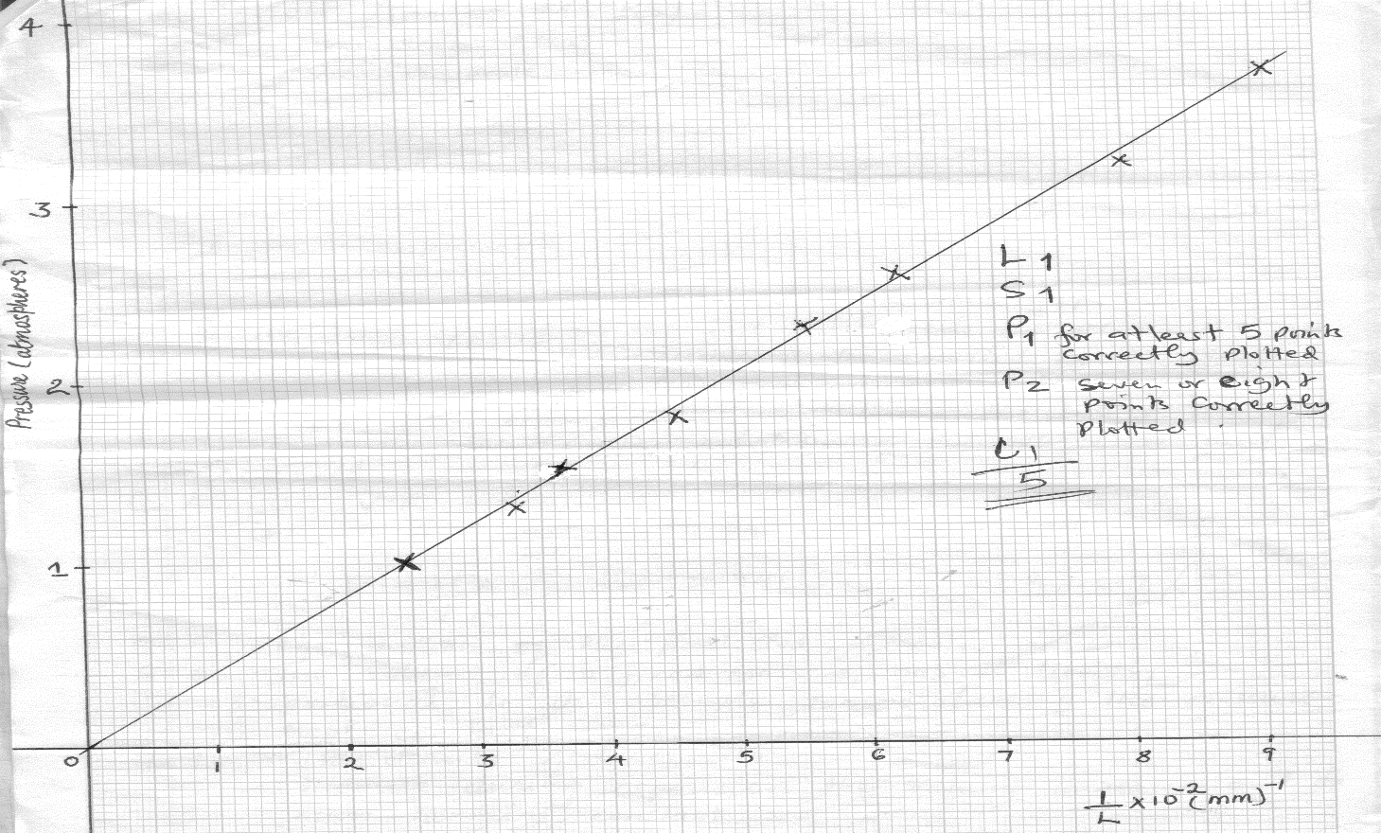
(ii) Check graph paper
(iii) Pressure of the air column when the length, L of air is zero
P= 0 atmospheres 1

QN 15 a) (i) is the collision in which objects combine after impact and move in one direction or become
Stationery
- Momentum is the quantity of motion of a body given by the product of mass and velocity
- Momentum before impact = collision after impact
$$\left(\frac{20}{1000}×100\right)+\left(12×0\right)=\left(12+\frac{120}{1000}\right)v$$

$20 = 12.02 v$

$v = 1.66 m / s$

- i) S = ut + ½ at²
$$t=\sqrt{\frac{2s}{a}}$$
$= \sqrt{\frac{2×200}{1 }}$
$$=20s$$

- $F = ma$
$$=0.2 ×1$$
$=0.2 N$
$$Fr= 0.6-0.2$$
$=0.4 N$
- $μ = \frac{Fr}{R}$
$= \frac{0.4}{0.2}$
$=2$

- When it is pulled there is tensional force on the string

QN 16. a) The quantity of heat required to change the state of a given mass of substance without change in
Temperature. 1
b) (i) Because of the hanging weights, the wire exerts pressure on the ice beneath 1 it and
therefore makes it melt at a temperature lower that its melting point. 1. Once the ice has melted, the water formed flows over the wire and immediately solidifies since it is no longer under pressure 1
As it solidifies, the latent heat of fusion is released and conducted by the copper wire to melt the ice below the wire 1. The process continues until the wire cuts through leaving the block intact 1.
(ii) The cotton thread would not cut through the ice at all 1. This is because cotton is a poor conductor of heat 1 hence it would not conduct the latent heat of fusion released by the
Solidifying ice to melt the ice below.

c) (i) Heat lost by hot water = Heat gained by cold water

M_{h}C = McC ₂ 1
3 ( -20) = 9 (20-10) 1
-20 = 30
= 50⁰ C 1
d) P= V² 1 R = V² = 240 x 240V 1
R P 90 w

= 640 Ω 1

QN 17 a. (i) at equilibrium, the sum of clockwise moments a point is equal to the sum of the anti-clockwise moments about the same point. 1
(ii) Clockwise moments = Anti-clockwise moment 1
W x 50cm = 55 x F 1
F= 3N $×$ $\frac{50}{55}$ = 2.73N 1

b) (i) T = $\frac{1}{f}$= $\frac{1}{100}Hz$ = 0.01 s 1

(ii) $Average velocity = \frac{total distance}{total time} 1$
$$=\frac{40}{12×0.01s} 1$$
$$=33.33cm/s 1 or$$
= 0.33m/s

