Name: …………………………………………………………… Index No. …………………………
School: …………………………………………………………. Candidate’s Sign. …………............
Date: ………………………………............................................

232/3
PHYSICS
PAPER 3
2021
TIME: 2 ½ HOURS
PAVEMENT FORM 4 TRIAL 2 EXAMINATION 2021/2022
Kenya certificate of secondary education (K.C.S.E)

Kenya Certificate of Secondary Education (K.C.S.E.)
Physics
Paper 3

INSTRUCTIONS TO CANDIDATES:
- Write your name and index number in the spaces provided above.
- Sign and write the date of the examination in the spaces provided above.
- You are supposed to spend the first 15 minutes of the 2 ½ hours allowed for this paper reading the whole paper carefully before commencing your work.
- Marks are given for a clear record of the observation actually made, their suitability, accuracy and the use made of them.
- Candidates are advised to record their observations as soon as they are made
- Non-programmable silent electronic calculators may be used.
- Candidates should check the question paper to ascertain that all the pages are printed and that no questions are missing.

For Examiner’s Use Only.

Question | Maximum score | Candidate’s score
1 | 20
2 | 20
Total | 40

This paper consists of 6 printed pages candidates should check the questions to ascertain that all pages are printed as indicated and that no questions are missing

Question1
You are provided with the following apparatus
- One stand with the clamp and the boss
- One 100g mass
- 100cm long thread
- Two pieces of wood
- Stop watch
- Set up the apparatus as shown below.

Piece of wood
Mass m
L
displacement

- Adjust the length L of the thread so that $L=70cm$. Give the mass m a slight displacement and release so that it oscillates freely. Measure the time t for twenty oscillations and record in the table below.
- Repeat the procedure above for other values of L as shown and complete the table.

Length L (cm) | 70 | 60 | 50 | 40 | 30 | 20
Length L(m)
Time for 20 oscillation
Period T(s)
$$T^{2}{(s}^{2})$$
(9 marks)

- On the grid provided plot a graph of $T^{2}\left(s^{2}\right)(y-axis)$ against L(cm) (5 marks)

- Determine the slope of the graph (3 marks)
........................................................................................................................................................................................................................................................................................................................................................................................................................................................................................................................
........................................................................................................................................................................
- Given that $T^{2}=\frac{4{}^{2}l}{g}$ determine the value of the constant g (3 marks)
........................................................................................................................................................................................................................................................................................................................................................................................................................................................................................................................................................................................................................................................................................................................................................................................................................................................................

. QUESTION 2
You are provided with the following apparatus
- A wire mounted on a mm scale
- A voltmeter (0-3 or 0- 5.v)
- An ammeter
- A switch
- Two dry cells and a cell holder.
- Six connecting wire with at least two crocodile clips.
- A micrometer screw gauge

Procedure.
- Using the micrometer screw gauge, determine the diameter d of the wire at three different points.
d₁=……………………………………mm, d₂=……………………………….mm, d₃…………………………………… mm,
Average d = ………………………………..m (2 marks)
- Calculate the cross- sectional area A of the wire in m² (2 marks)

- Set up the circuit as shown below.
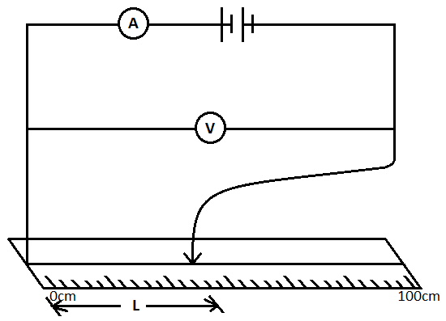
- Vary the length by using the crocodile clip along the wire from (when L =0). Record the voltmeter and ammeter readings in the table below. (5 marks)
Length L (cm) | 80cm | 60cm | 40cm | 20cm | 0cm
Current I (A)
Voltage (V)

- Plot the graph of voltage V against current I (A) (5 marks)
- Determine the slope of the graph. (2 marks)
........................................................................................................................................................................................................................................................................................................................................................................................................................................................................................................................................................................................................................................................................ ..................................................................................................................................................................
- Given that $V =-Ir +E$,
- calculate the internal resistance of the cell. (2 marks)
.........................................................................................................................................................................................................................................................................................................................................................................................................................................................................................................................................................................................................................................................................................................................................................................................................................................

- Determine the emf (E) of the battery. (2marks)
..........................................................................................................................................................................................................................................................................................................................................................................................................................................................................................................................................................................................................................................................................................................................................................................................................................................

