NAME:……………………………………………………… INDEX NO:…………………………
SCHOOL:………………………………………………….. DATE:……………………………….
SIGN:………………………………..
121/2
MATHEMATICS
PAPER 2
TRIAL 1 – 2020/21
TIME: 2 ½ HOURS
PAVEMENT FORM 4 TRIAL 1 EXAMINATION 2020/2021
Kenya certificate of secondary education (K.C.S.E)
INSTRUCTIONS TO CANDIDATES
- Write your name and Index number in the spaces provided above.
- The paper contains two sections. Section I and II.
- Answer all the questions in section I and only any FIVE questions from section II.
- All answers and working must be shown on the question paper in the spaces below each question.
- Show all steps in your calculations, giving answers at each stage.
- Marks may be given for each correct working even if the answer is wrong.
- Non-programmable silent electronic calculators and KNEC mathematical tables may be used.
FOR EXAMINER’S USE ONLY
SECTION I
1 | 2 | 3 | 4 | 5 | 6 | 7 | 8 | 9 | 10 | 11 | 12 | 13 | 14 | 15 | 16 | TOTAL
SECTION II GRAND TOTAL
17 | 18 | 19 | 20 | 21 | 22 | 23 | 24 | TOTAL

This paper consists of 17 printed pages. Candidates should check the question paper to ascertain that all pages are printed as indicated and that no questions are missing.

SECTION I (50 Marks)
Answer ALL Questions in this Section

- Use logarithm tables to evaluate. (4 Marks)
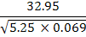

- A two digit number is such that the sum of its digits is 9. If the digits are reversed the new number formed exceeds the original number by 9. Find the number. (3 Marks)

- The perimeter of a triangular field is 120m. Two of the sides are 21m and 40m. Calculate the largest angle of the field. (3 Marks)

- Solve for in the logarithmic equation.
(3 Marks)

- Given that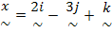, 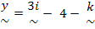, and 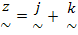 and that 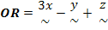. Find the magnitude of vector OR correct to 3 significant figures. (3 Marks)

- Make the subject of the equation. 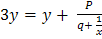 (3 Marks)

- Two letters are selected from the word ECONOMICS, find the probability that the letters are a constant and a vowel in that order (2 Marks)

- In the circle below, and. B
A 3cm
X
3cm C
6cm D
O
Find the value of x. (3 Marks)

- Simplify and leave your answer in surd form. (3 Marks)
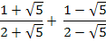

- Omolo bought a new car for Ksh.800, 000. After 5 years he sold it through a second hand car dealer. The dealer charged a commission of 4% for the sale of the car. If Omolo received Ksh.480, 000, calculate the annual rate of depreciation of the car. (3 Marks)

- Expand upto the fourth term, hence evaluate to 2 significant figures.
(4 Marks)

- A trader has 3 grades of tea P, Q and R. Grade P costs Shs.140 per kg, grade Q costs Shs.160 per kg and grade R costs sh.256 per kg. The trader mixes grade P and grade Q in the ratio 5:3 to make a brand of tea which he sells at Shs.180 per kg. Calculate the percentage profit he makes. (3 Marks)

- Each interior angle of a regular polygon of sides exceeds each exterior angle of regular polygon of sides by 8⁰. Find the value of . (3 Marks)

- A quantity P is partly constant and partly varies as the square root of Q.
- Using constants and , write down an equation connecting P and Q. (1 Mark)

- If Q = 25 when P = 20 and Q = 49, when Q = 30; find the values of and . (2 Marks)

- Use matrix method to find the point of intersection of lines and (3 Marks)

- The equation of a circle centre is . Find the value of and . (3 Marks)

SECTION II (50 Marks)
Answer any FIVE Questions in this Section.

- A church has a sitting capacity of 468 people with the members sitting in rows which have 3 long benches and 2 short ones. The long bench takes 2 people more than the short bench. Let the number of people sitting on the short bench be .
- Form an expression in for the number of rows of benches. (2 Marks)

- A new pastor finds this arrangement crowded and decides that by having one more person on each long bench, he can take out some rows and still sit the same number of people. Find an expression in x for the new number of rows of benches. (2 Marks)

- If one row of benches was taken out, find the original number of people per row. (6 Marks)

- A form three class has 32 students. They are distributed between four houses as follows: -
House | Boys | Girls
Chania  Athi  Tana  Mara | 6  3  4  5 | 2  3  6  3

Two students are selected at random from the class. Find the probability that both students will be: -

- From Chania (3 Marks)

- Girls (2 Marks)

- Boys of Tana House (2 Marks)

- Either boys or from Mara House (3 Marks)

- A tank is filled by tap A in 16 minutes. Tap B can empty the same tank in 24 minutes. Starting with an empty tank, both taps are turned on for 8 minutes and then tap B is turned off. Find: -
- The time taken to fill the tank. (6 Marks)

- The capacity of the tank if A delivered 18400 litres. (4 Marks)

- In the diagram below TA and TB are tangents to the circle at A and B respectively. TBR is a straight line. The straight lines AB and QP intersect at K. ∠QAB=38°, ∠PBT=44° and ∠ATB=62°.

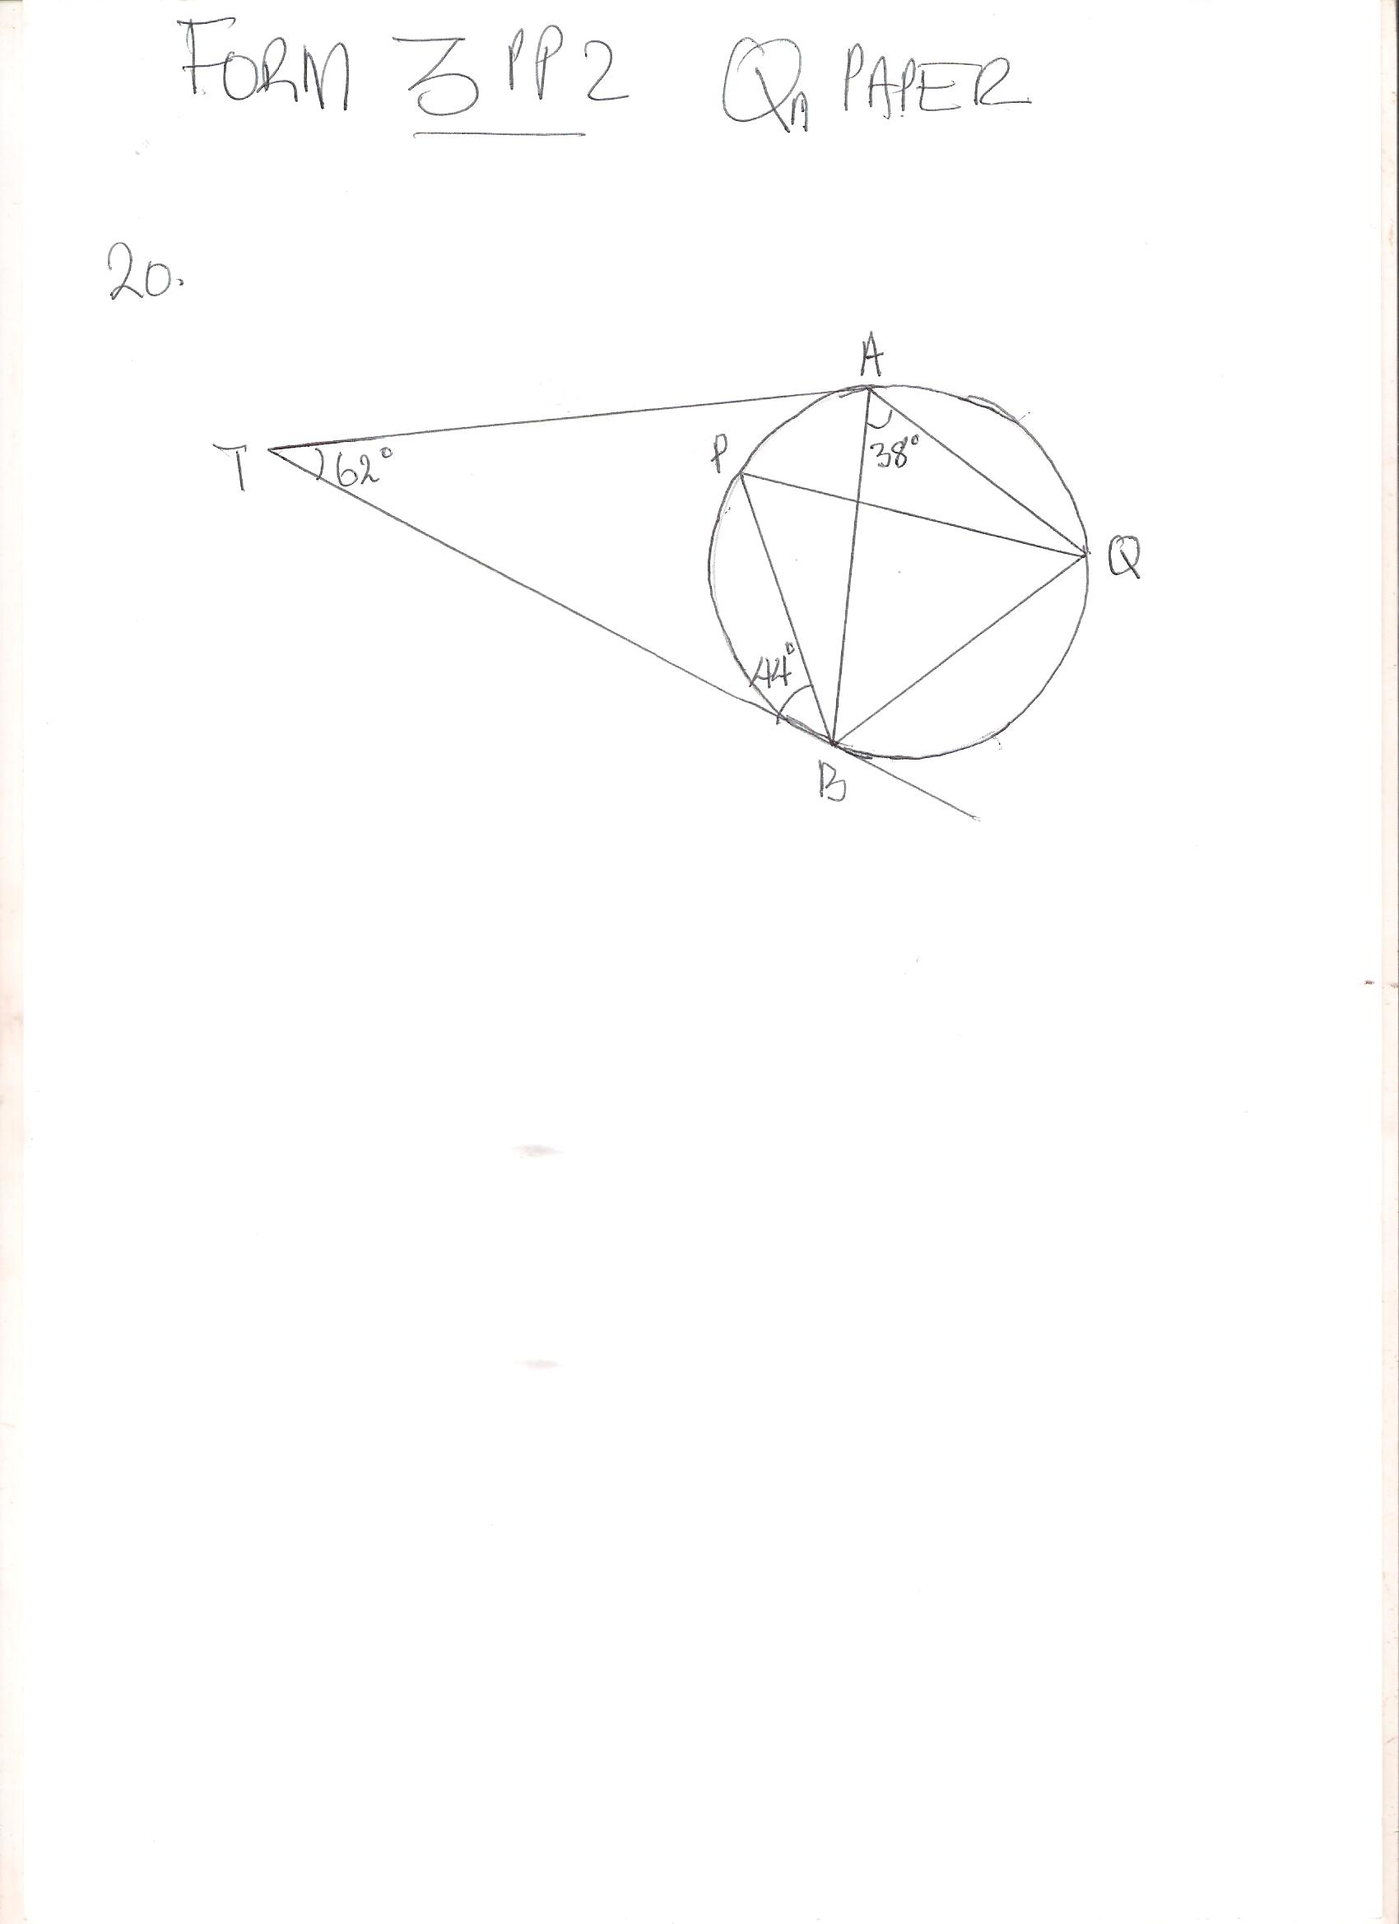
Calculate:
- ∠PAB (1 Mark)

- ∠PBA (2Marks)

- ∠ABQ (2 Marks)

- ∠AKP (3 Marks)

- If AK=KB=3cm and KQ=2cm, calculate the length QP. (3 Marks)

- The data collected from an experiment involving two variables X and Y was recorded as shown below.
X | 1.1 | 1.2 | 1.3 | 1.4 | 1.5 | 1.6
Y | -0.3 | 0.5 | 1.4 | 2.5 | 3.8 | 5.2

The variables are known to satisfy a relation of the form where and are constants.

- For each value of in the table above, write down the value of x³ (2 Marks)

- By drawing a suitable straight line graph, estimate the value of and (6 Marks)

- Write down the relationship connecting and. (2 Marks)

- The table below shows income tax rates for the year 2011.
Taxable Income (Sh. p.a.) | Tax Rate (%)
1 – 121 968  121 696 – 236 880  236 881 – 351 792  351 793 – 466 704  Above 466704 | 10  15  20  25  30

In the year 2011, Ole Sayeye’s monthly earnings were as follows: -
Basic salary Sh.42,800
House allowance Sh.15,000
Medical allowance Sh.2,880
Transport allowance Sh.2,664
Hardship allowance 30% of Basic salary

Mr. Ole Sayeye was entitled to a monthly tax relief of Sh.1,162. Calulate: -
- His annual taxable income. (2 Marks)

- The monthly tax paid by Ole Sayeye. (5 Marks)

- Ole Sayeye got a salary increment equal to 50% of the year 2011 allowances. Calculate the percentage increase in the tax paid. (3 Marks)

- a) The first term of an arithmetic progression (AP) is 2. The sum of the first 8 terms of the AP is 156.
- Find the common difference of the AP. (2 Marks)

- Given that the sum of the first terms of the AP is 416, find . (4 Marks)

b) The 3rd, 5th and 8th terms of another AP form the first three terms of geometric progression
(GP). If the common difference of the AP is 3, find: -

The 1st term of the G.P. (4 Marks)

- a) The weight of a metal rod varies jointly as the square of its length and inversely as the square root of its radius. Given that the length of the metal rod was increased by 5% and the radius decreased by 36%, what was the percentage change in weight. (6 Marks)

b) If the weight of the metal rod is 6N when the length is 12cm and radius 25cm, find the
weight of the metal rod when the length is 15cm and radius 81cm. (4 Marks)

