312/2
GEOGRAPHY
PAPER 2
JAN / FEB 2020/2021
TIME: 2¾ HOURS

PAVEMENT FORM 4 TRIAL 1 EXAMINATION 2021/2022
Kenya certificate of secondary education (K.C.S.E)

GEOGRAPHY
PAPER 2
JAN/FEBRUARY
TIME: 2¾ HOURS

INSTRUCTIONS TO CANDIDATES:

- This paper consists of two sections A and B.
- Answer ALL questions in Section A.
- In section B answer question 6 (compulsory) and any other two questions.
- All answers must be written in the answer booklet provided.

SECTION A
Answer ALL Questions.

- (a) Define the term ranching as used in livestock farming. (2mks)
(b) State three economic factors influencing agriculture. (3mks)

- (a) Differentiate between market gardening and horticulture. (2mks)
(b) Give two reasons why market gardening is practiced near major urban centres. (2mks)

- (a) What is land reclamation? (2mks)
(b) State three physical problems experienced by farmers at Mwea-Tebere irrigation scheme. (3mks)
(c) Apart from irrigation, give two methods used to reclaim land in Kenya. (2mks)
4. (a)Apart from drought, identify any two other types of natural hazards in Kenya. (2marks)
(b) State three problems associated with drought. (3marks)
5. (a) Other than Ghana identify two other countries producing cocoa in Africa. (3marks)
(b)Name two ports through which cocoa is exported from Ghana. (2marks)

SECTION B
Answer question 6 and any other two questions from this section.

6.The table below shows statistics for major oil producers in the middle East in 2012 in ,000 barrels per day.
Country | Oil production | Exports | Domestic consumption
Iran | 3589 | 1880 | 1709
Iraq | 3087 | 2235 | 852
Kuwait | 2797 | 2414 | 406
Saudi Arabia | 11726 | 8865 | 2861
UAE | 3213 | 2595 | 618

- (i) Draw a divided rectangle 15cm long to illustrate oil production in Middle East. (6mks)
(ii) Calculate the total amount of oil exported from the region. (2mks)
- Which country had the highest rate of domestic consumption. (3mks)

- Explain four benefits of Soda Ash mining to the economy of Kenya. (8mks)
- Explain three negative effects of mining on the environment. (6mks)

7. (a) (i) What is forestry? (2mks)
(ii) Explain four factors favouring forestry in highland areas of Kenya. (8mks)

(b) Compare forestry in Kenya and Canada. (8mks)

(c) (i) Name three hardwood tree species grown in Kenya. (3mks)
(ii) Give four problems facing forestry in Kenya. (4mks)

8.(a) (i) Name two varieties of coffee grown in Kenya. (2mks)
(ii) Explain how the following problems have affected coffee growing in Kenya:
- Inadequate capital (2mks)
- Fluctuation of prices of coffee in world market. (2mks)

(b) Describe the stages involved in coffee growing from land preparation is harvesting. (6mks)
(c) (i) List three exotic dairy breeds reared in Kenya. (3mks)
(ii) Explain three physical conditions that favour dairy farming in Denmark. (6mks)

(d) (i) Name two dairy products. (2mks)
(ii) Name two ports through which beef is exported from Argentina. (2mks)

9.(a) Name two types of fisheries. (2mks)
(b) Study the world map below and use it to answer the questions that follow.
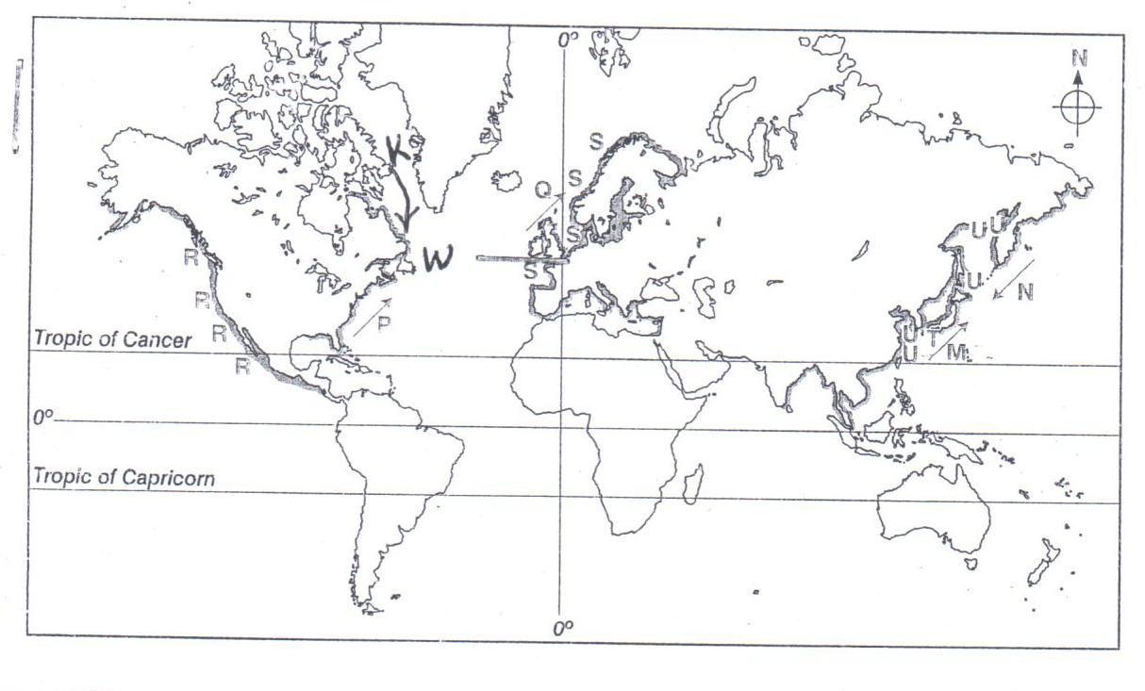

- Name the fishing grounds marked U and S. (2mks)
- Give two fish species cangut in the fishing ground marked W. (2mks)
- Explain why major fishing grounds of the world are located in the temperate latitude of
the Northern Hemisphere. (6mks)

(c) Describe trawling as a method of fishing. (5mks)
(d) Explain four ways in which the Kenya government is promoting the fishing industry in
the country. (8mks)

- (a) (i) Apart from petroleum, name two other non-renewable sources of energy. (2mks)
(ii) State three conditions that are necessary for the formation of petroleum. (3mks)
(b) Use the map of Africa below to answer questions that follow.
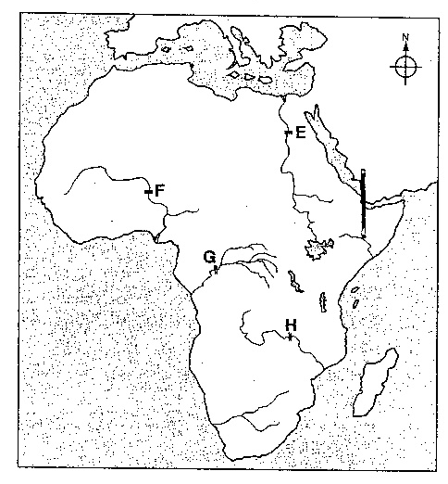

Name the power projects marked E, F, G and H. (4mks)
(c) Explain four physical factors that influence the location of a Hydro-electric power station. (8mks)
(d) Explain four benefits that have resulted from rural electrification in Kenya. (8mks)

