**233/2**

**CHEMISTRY**

**PAPER 2**

**TIME: 2 HOURS**

**PAVEMENT FORM 4 TRIAL 2 EXAMINATION 2021/2022**

**Kenya certificate of secondary education (K.C.S.E)**

INSTRUCTIONS TO CANDIDATES

*Answer all questions in the spaces provided*

*Electronic calculators may be used*

FOR EXAMINER’S USE

|  |  |  |
| --- | --- | --- |
| QUESTION | MAXIMUM SCORE | CANDIDATES SCORE |
| 1 | 11 |  |
| 2 | 13 |  |
| 3 | 10 |  |
| 4 | 10 |  |
| 5 | 11 |  |
| 6 | 10 |  |
| 7 | 15 |  |
|  | 80 |  |

*This paper consists of* ***11*** *printed pages. Candidates should check to ascertain that all pages are printed as indicated and that no questions are missing.*

1. The grid below shows part of the periodic table. Study it and answer the questions that follow. The letters are not the actual symbols of the elements.

|  |  |  |  |  |  |  |  |  |
| --- | --- | --- | --- | --- | --- | --- | --- | --- |
|  |  | | | | | | |  |
|  |  |  | A |  |  | B | C | D |
| E | F |  |  |  |  |  |  |
|  |  |  |  |  |  | G |  |
| H |  |  |  |  |  |  |  |

1. Give the name of the family to which element F belongs. **(1mark)**
2. Identify an element which forms a stable divalent anion **(1mark)**
3. Give the formula of:
4. The compound formed between A and B **(½mark)**
5. The sulphate of H **(½mark)**
6. Using dot (.) and cross(x) diagram, show the bonding in the compound formed between E and C. **(2marks)**
7. Compare the atomic radii of elements C and D. Explain. **(2marks)**
8. Select the element that has the lowest ionization energy. Explain. **(1mark)**
9. 0.081g of element A reacts with 20cm3 of dilute hydrochloric acid. Calculate the molarity of the hydrochloric acid. (R.A.M = 27) **(3marks)**
10. The graph below shows the trend of the melting points and the boiling points of the family to which element G belongs. Explain the trend in the melting points. **(2marks)**

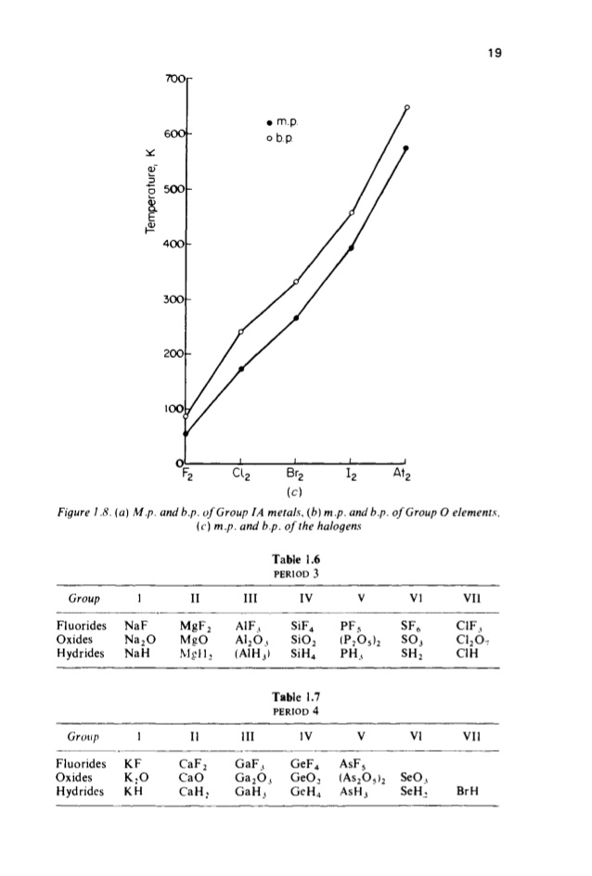

1. (a) (i) What is a fuel?  **(1 mark)**

(ii) Calculate the heating value of propane, C3H8, given that its molar enthalpy of   
 combustion is 2200 kJ mol-1. . **(2 marks)**

(C=12, H=1)

(b) (i) Define molar enthalpy of combustion. **(1 mark)**

(ii) Use the information provided by the thermochemical equations below to calculate the   
 molar enthalpy of combustion of ethyne. **(3 marks)**

C(s) + O2(g) CO2(g) ∆H= -394 kJ mol-1

H2(g) + ½O2(g) H2O(g) ∆H= -286 kJ mol-1

2C(s) + H2(g) C2H2(g) ∆H= +226 kJ mol-1

(c) Study the data given below and answer the questions that follow.

|  |  |
| --- | --- |
| Substance/ion | Enthalpy change |
| CaCl2(s) | Lattice energy = -2237 kJ mol-1 |
| Ca2+(g) | Hydration energy = -1650 kJ mol-1 |
| Cl-(g) | Hydration energy = -364 kJ mol-1 |

1. Determine the molar enthalpy of solution of calcium chloride in water. **(2 marks)**
2. Draw an energy level diagram for the dissolution of calcium chloride in water.  **(3 marks)**
3. (a) The diagram below shows the preparation of an oxide of nitrogen. Study the diagram and answer the questions that follow.

Gas jar

Flask M

Heat

Mixture of ammonium sulphate and solid D

Oxide of nitrogen

(Gas L)

1. Name the solid D. **(1mark)**
2. Write the equation for the reaction in the flask M **(1mark)**
3. Burning magnesium ribbon was lowered into the gas jar containing gas L. State and explain the observations made. **(2marks)**
4. Write the two equations for the reactions taking place in (iii) above. **(2marks)**

I.

II.

1. A drop of water was added to the product formed in (iii) above. A colourless gas **K** with a choking smell was produced. Write the chemical equation for the production of gas **K (1mark)**
2. (i) Give **two** uses for nitric (V) acid.  **(2marks)**

(ii) A factory uses nitric (V) acid and ammonia gas as the only reactants for the preparation of ammonium nitrate. If the daily production of the ammonium nitrate is 4800kg, calculate the mass of ammonia gas used daily in kg. (N=14.0, O = 16.0 H= 1.0) **(3 marks)**

1. A group of form four students of Cockelbet Secondary School carried out an experiment to determine the solubility of potassium chlorate. The table below shows the results obtained.

|  |  |  |  |  |  |
| --- | --- | --- | --- | --- | --- |
| Total volume of water added(cm3) | 10.0 | 20.0 | 30.0 | 40.0 | 50.0 |
| Mass of KClO3(g) | 5.0 | 5.0 | 5.0 | 5.0 | 5.0 |
| Temperature at which crystals appear(0C) | 80.0 | 65.0 | 55.0 | 45.0 | 30.0 |
| Solubility of KClO3(g/100gH2O) |  |  |  |  |  |

1. Complete the table to show the solubility of KClO3 at different temperatures. **(3marks)**
2. Plot a graph of mass of KClO3 per 100g water against temperature at which crystals form.

**(3marks)**



1. From the graph, determine ;
2. The solubility of KClO3 at 40oC. **(1mark)**
3. The temperature at which the solubility of KClO3 is 35g/100g water. **(1mark)**
4. Explain the shape of the graph. **(1mark)**
5. State **one** application of solubility and solubility curves. **(1mark)**

5. The set up below is used to prepare Nitric (V) acid in the laboratory. Study it and answer the questions that follow.

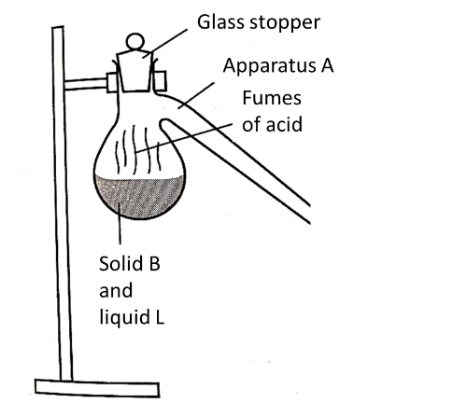

(a) Complete the set-up.  **(3 marks)**

(b) Name substances

B………………………………………………….. L ………………………**(2 marks)**

(c) Name apparatus A……………………………………………………………… **(1 mark)**

(d) Write an equation between substances B and L **(1 mark)**

(e) During preparation of hydrogen gas Nitric (V) acid is not used. Explain **(2 marks)**

(f) Give two commercial use of Nitrogen **(2 marks)**

1. The flow chart below is a simplified version of the steps in the manufacture of Sodium carbonate.

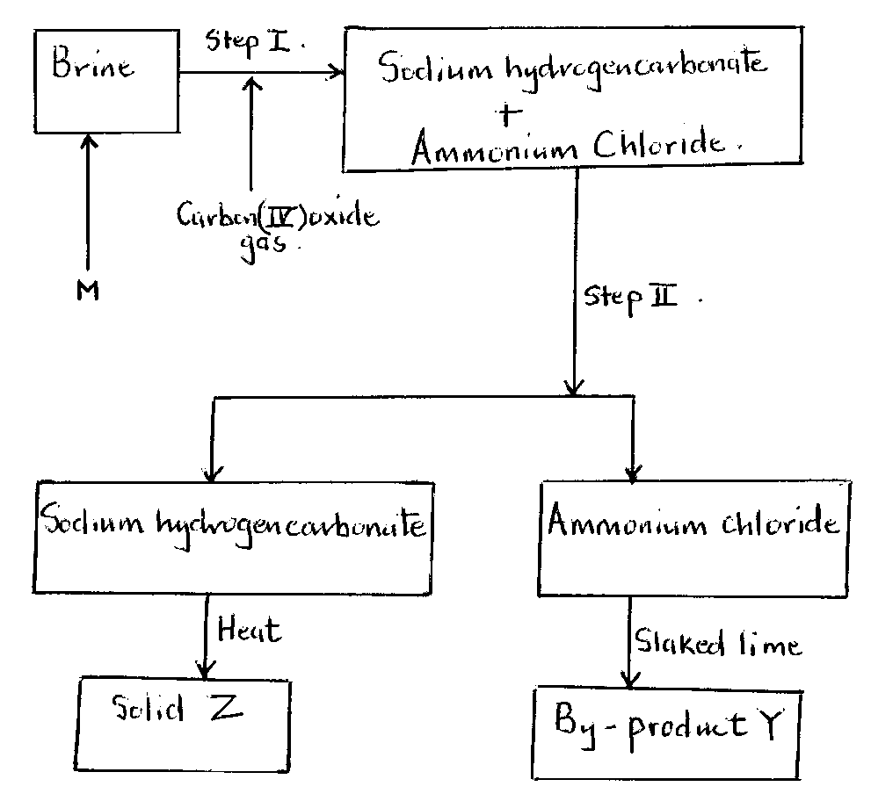

a) Name three main raw materials of the above process. **(3 marks)**

b) Name substance M. **(1 mark)**

c) Name the process taking place in step II. **(1 mark)**

d) Write a balanced chemical equation to show how product Y is formed. **(1 mark)**

e) 98.123 Kg of Sodium hydrogen carbonate was manufactured in this process.

i) Write a chemical equation for the formation of solid Z. **(1 mark)**

ii) Determine in Kilograms, how much of solid Z was produced in this process.

(Na = 23, H = 1, O = 16, C = 12) **(3 marks)**

1. (a) Draw and name all the isomers of C4H6 **(2marks)**

(b) The following monomers react to form a polymer:

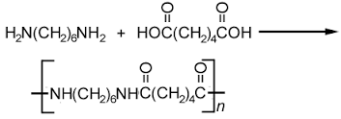

Draw and name the structure of the polymer **(2marks)**

(c) Chlorofluorocarbons have a wide range of uses. However they have been linked to depletion of ozone.

(i) Explain the problem caused by depletion of ozone layer. **(1mark)**

(ii) Give one other environmental problem caused by chlorofluorocarbons. **(1mark)**

(d) Study the flow chart below and use it to answer the questions that follow.

Heat

NaOH(s)

NaOH(aq)

Process W

Heat

Conc. H3PO4

Propanol

Gas A

Propanoic acid

B

C

(i) Name:

I: Process W **(½mark)**

II: Substances A, B and C **(1½marks)**

A:

B:

C:

(ii) Write an equation for the combustion of substance C **(1mark)**

(iii) Give one use of gas A **(1mark)**

(e) Explain how a sample of propan-1-ol could be distinguished from a sample of propanoic acid by means of a chemical reaction **(2marks)**