**NAME……………………………………………………………INDEX NO…………..**

233/1 CANDIDATES SIGN………..

CHEMISTRY DATE…………………

PAPER I

(THEORY)

TIME: 2 HOURS

**PAVEMENT FORM 4 TRIAL 1 EXAMINATION 2021/2022**

**Kenya certificate of secondary education (K.C.S.E)**

INSTRUCTIONS TO CANDIDATES

1. Write your name and index number in the spaces provided above.
2. Sign and write the date of examination in the spaces provided above
3. Answer all the questions in the spaces provided
4. Mathematical tables and electronic calculators may be used
5. All working must be clearly shown where necessary.

**FOR EXAMINERS USE ONLY**

|  |  |  |
| --- | --- | --- |
| QUESTION | MAXIMUM SCORE | CANDIDATES SCORE |
| 1 - 29 | 80 |  |

*This paper consists of 11 printed pages. Candidates should check to ascertain that all pages are printed as indicated and that no questions are missing.*

1. Study the diagram below then use it to answer the questions that follow.



1. Draw the wooden splint at the end of the experiment. If it was slipped then removed **(1 mark)**

b) Explain the appearance of the wooden splint in (a) above. **(2 marks)**

2. Starting with copper metal, describe how a solid sample of copper (II) carbonate can be prepared. **(3 marks)**

3 a) In terms of bonding, Explain why sulphur is a solid while oxygen is a gas at room temperature.

**(2 marks)**

1. In an attempt to prepare sulphur (IV) oxide gas, dilute sulphuric acid was reacted with barium carbonate. The yield of sulphur dioxide was found to be negligible. Explain **(2marks)**
2. What is allotropy? **(1 marks)**
3. Name two allotropes of sulphur. **(2marks)**
4. Explain why the bleaching action of chlorine is permanent while bleaching by Sulphur (IV) Oxide is temporary. **(2marks)**

f) The diagram below represents pipes used in Frasch pump for the extraction of sulpur Which substance passes through tube?

1. ____________________________

2. ____________________________

3. ____________________________ **(3marks)**

1

2

3

1

4. You are provided with water and the usual laboratory apparatus. Describe how you would fully separate solid lead II carbonate from a mixture of lead II Carbonate, iron fillings and sodium carbonate**. (3marks)**

5. The set-up below was used to obtain a sample of iron.

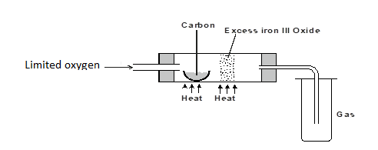

   Write two equations for the reactions which occur in the combustion tube. **(2 marks)**

6. Study the scheme below and answer the questions that follow.



**FeSO4 (aq)**

a) Write the formula of the cation present in solution D.  **(1 mark)**

b) What property of chlorine is shown in step 1. **(1 mark)**

c) Write an equation for the reaction which occurred in step III. **(1 mark)**

7. A mass of 0.63g of lead powder were dissolved in excess nitric (V) acid to form lead (II) nitrate solution. All the lead (II) nitrate was then reacted with sodium sulphate solution.

a) Write an ionic equation for the reaction between sodium sulphate solution and lead (II) nitrate solution. **(1 mark)**

b) Determine the mass of the lead salt formed in the reaction in (a) above

(Pb = 207, S = 32, O = 16) **(2 marks)**

8 (a) State the Gay Lussac's Law. **(1 mark)**

(b) 10cm3 of a gaseous hydrocarbon, C2HX required 30cm3 of oxygen for complete combustion. If steam

and 20cm3 of carbon (IV) oxide were produced, what is the value of X? **(2 marks)**

9. The table below gives the atomic numbers of elements W, X, Y and Z.

|  |  |  |  |  |
| --- | --- | --- | --- | --- |
| Element | W | X | Y | Z |
| Atomic number | 14 | 17 | 16 | 19 |

Name the type of bonding that exist in the compound formed when X and Z reacts. **(1mark)**

Select the letter representing the strongest reducing agent. Give a reason for your answer. **(2marks)**

(a)Give one reason some of the laboratory apparatus are made of ceramics. **(1 mark)**

(b) Name two apparatus that can be used to measure approximately 75 cm3 of dilute sulphuric (VI) acid. **(2marks)**

10. The number of protons, neutrons and electrons in atoms A to F are given in the table below the letters do not represent the actual symbol of the elements:-

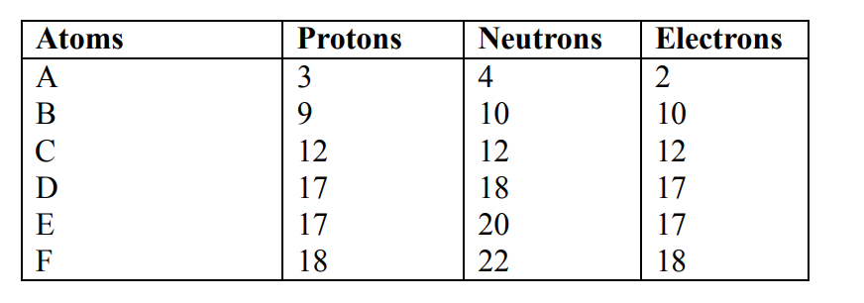

(a) Choose from the table the letters that represent:

(i) An atom of a metal ...........................................................................

(ii) A neutral atom of a non-metal.......................................................

(iii) An atom of a noble gas ...........................................................

(iv) A pair of isotopes ...............................................................................

(v) A cation ...............................................................................

(b) The grid below shows a part of the periodic table. The letters do not represent the actual symbols. Use it to answer the questions that follow:-

|  |  |  |  |  |  |  |  |  |  |
| --- | --- | --- | --- | --- | --- | --- | --- | --- | --- |
|  |  |  |  |  |  |  |  |  |  |
|  |  |  |  |  |  |  |  | U |  |
| K |  |  |  |  |  |  | C |  |  |
|  | X |  |  |  |  |  |  | Y |  |
|  |  |  |  |  |  |  |  |  |  |

c) How do the atomic radius of element X and Y compare?  **(2marks)**

(d) (i) Using crosses (X) to represent electrons, draw the atomic structure of element C  **(2marks)**

(ii) State the period and the group to which element C belong  **(1 mark)**

­­­

(iii The ionic configuration of element G is 2.8 G forms an ion of the type G-1 . Indicate on the grid, the position of element G. **(1 mark)**

(iv To which chemical family does element G belong? **(1 mark)**

(v) State one use of element U **(1 mark)**

(vi) What is the nature of the compound formed between K and U.  **(1 mark)**

11. A fixed mass of gas occupies 200 cm3 at a temperature of 230c and a pressure of 740 mm Hg. Calculate the volume of the gas at -250c and 790 mm Hg pressure. **(3marks)**

12 (a) State the Graham’s law **(1mark)**

b) 100cm3 of Carbon (IV) oxide gas diffused through a porous partition in 30seconds. How long would it take 150cm3 of Nitrogen (IV) oxide to diffuse through the same partition under the same conditions? (C = 12.0, N = 14.0, O = 16.0) **(3marks)**

c) A solution was made by dissolving 7.5g of sodium hydroxide containing inert impurities in water and making it to 250cm3 of solution. If 20cm3 of this solution is neutralized exactly by 13cm3 of 1M hydrochloric acid, calculate the percentage purity of sodium hydroxide. (Na=23; O=16; H=1)

**(2marks)**

d) Zinc metal and hydrochloric acid react according to the following equation Zn(s) + 2HCl(aq) ZnCl(aq) + H2(g) 1.96g of zinc were reacted with 100cm3 of 0.2M Hydrochloric acid, (a) Determine the reagent that was in excess. **(3 marks)**

1. Calculate the total volume of hydrogen gas that was liberated at S.T.P conditions (Zn = 65.4, molar gas volume = 22.4 litres at S.T.P) **(2marks)**

13. a) 9.42g of an organic acid RCOOH is dissolved in 600cm3. 25.0cm3 of this solution was found to require of 0.207M potassium hydroxide solution for complete neutralization. ( C = 12.0, O = 16.0, H = 1.0) i) Determine the formula mass of the acid. **(3marks)**

b) Hence the value of R.  **(2marks)**

14. Magnesium was burnt in air forming a white residue T. When put in a boiling tube with water effervescence was noticed and colourless gas D with a characteristic pungent smell was evolved. The gas turned a wet red litmus paper blue.

(a) Identify

(i) Residue T  **(1mark)** …………………………………………………………………………………………… ……………………………………………………………………………………………

(ii) Gas D **(1mark)** …………………………………………………………………………………………… ……………………………………………………………………………………………

(b) Write an equation for liberation of gas D. **(1mark)**

15.(a) Using the oxidation state of nitrogen state the change in copper and nitric (v) acid reaction below.

**(2marks)**

Cu(s) + HNO3(a q) ⎯→ Cu NO3 2(a q) + 4H2O(l)+ NO(g )

1. State the observations made during the experiment in (a) above. (1mark) ………………………………………………………………………………………………… …………………………………………………………………………………………………
2. Give two uses of nitrogem **(2marks)**