**Name:……………………………………………..…......................Index No……....………… Signature……………….................. Date: ……………......**

**231/2**

**BIOLOGY**

**PAPER 2**

**(THEORY)**

**TIME: 2 HOURS**

PAVEMENT FORM 4 TRIAL 2 EXAMINATION 2021/2022

Kenya certificate of secondary education (K.C.S.E)

**INSTRUCTIONS TO CANDIDATES**

* *Write your name, school and index number in the spaces provided above.*
* *This paper consist of* ***TWO*** *sections;* ***A*** *and* ***B****.*
* *Answer* ***all*** *the questions in the section* ***A*** *in the spaces provided.*
* *In section* ***B*** *answer Question* ***6(compulsory)*** *and either question* ***7*** *or* ***8*** *in the space provided after question* ***8***.
* *Check to ascertain that all pages are printed and that no questions are missing.*

|  |  |  |  |
| --- | --- | --- | --- |
| **SECTION** | **QUESTIONS** | **MAXIMUM SCORE** | **CANDIDATES SCORE** |
| A | 1 | 8 |  |
| 2 | 8 |  |
| 3 | 8 |  |
| 4 | 8 |  |
| 5 | 8 |  |
| **B** | 6 | 20 |  |
| 7 | 20 |  |
| 8 | 20 |  |
| **TOTAL** | **80** |  |

*Candidates should check the question paper to ascertain that all the pages are printed as indicated and that no questions are missing*

**SECTION A (40 MARKS)**

1. The set below was used to investigate a certain physiological activity in plants. The two set ups were left under a hot sun for several hours. Study it carefully to answer the questions that follow.

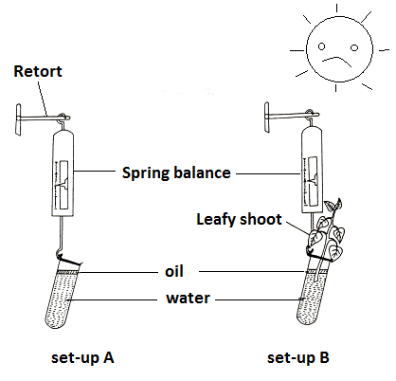

1. What physiological process was being investigated? **(1 mark)**

……………………………………………………………………………………………………………………………………………………………………………………………………

1. What was observed in set-up A and B at the end of the experiment **(2 marks)**

A………………………………………………………………………………………………..………………………………………………………………………………………………… B…………………………………………………………………………………………………………………………………………………………………………………………………

1. Explain your answer in the (d) above for set-up B. **(2 marks)**

……………………………………………………………………………………………………………………………………………………………………………………………………

1. What do you understand by the terminology guttation? **(1 mark)**

…………………………………………………………………………………………………

1. Explain how wilting of leaves during a hot day is advantageous to a plant. **(2marks)**

.………………………………………………………………………………………………………………………………………………………………………………………………………………………………………………………………………………………………………

1. The diagram below illustrates the structure in the human eye.

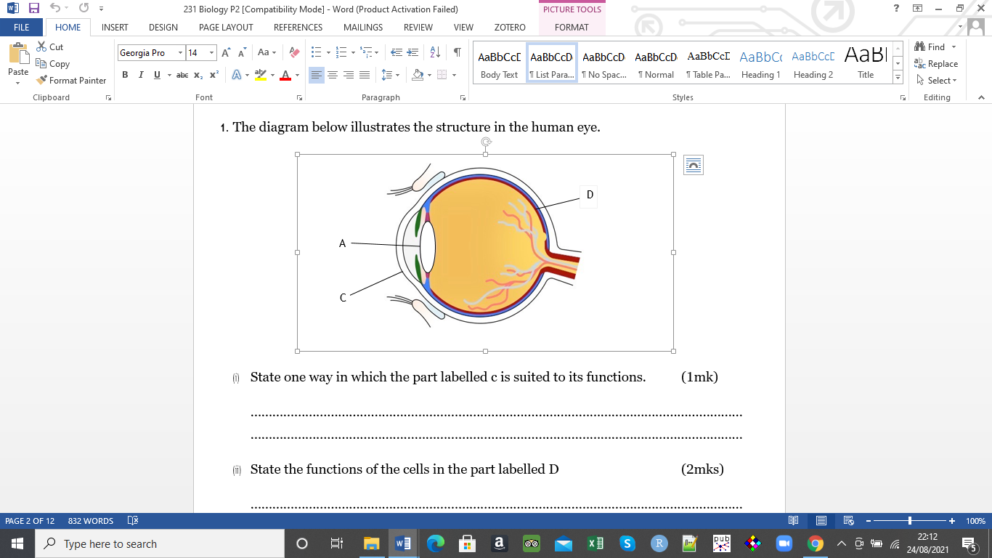

1. State one way in which the part labelled c is suited to its functions. **(1mark)**

……………………………………………………………………………………………………………………………………………………………………………………………………

1. State the functions of the cells in the part labelled D **(2marks)**

………………………………………………………………………………………………………………………………………………………………………………………………………………………………………………………………………………………………………………………………………………………………………………………………………………………………………………………………………………………………………………………………………………………………………………………………………………

1. State the changes that occur in part A to facilitate vision of a distance object. **(2marks)**

…………………………………………………………………………………………………………………………………………………………………………………………………………………………………………………………………………………………………………………………………………………………………………………………………………

b) A student set up an experiment as shown below.

Light

Maize coleoptile

Box

Pot

The set up was left for three days.

Account for the expected results after three days **(3marks)**

……………………………………………………………………………………………………………………………………………………………………………………………………………………………………………………………………………………………………………………………………………………………………………………………………………………………………………………………………………………………………………

1. Tongue rolling is dominant over the inability to roll tongue. The father of a family can roll his tongue while the mother cannot. Half of their children can roll the tongue while the other half cannot. Use letter R to denote the tongue rolling trait.
2. Explain with the help of a diagram why only half of the children in the case above inherit the tongue rolling trait from their father. **(4 marks)**

…………………………………………………………………………………………………………………………………………………………………………………………………………………………………………………………………………………………………………………………………………………………………………………………………………………………………………………………………………………………………………………………………………………………………………………………………………………………………………………………………………………………………………………

……………………………………………………………………………………………………………………………………………………………………………………………………

…………………………………………………………………………………………………

…………………………………………………………………………………………………

1. If all children could roll the tongue, then what would be the genotype of the mother and father? Explain your answer using a punnet square. **(4 marks)**

…………………………………………………………………………………………………………………………………………………………………………………………………………………………………………………………………………………………………………………………………………………………………………………………………………………………………………………………………………………………………………………………………………………………………………………………………………………………………………………………………………………………………………………………………………………………………………………………………………………………………………………………………………………………………………………………………………………………………………………………………………………………

1. The micrographs below are of a tissue showing mitosis. Examine it and answer the questions.

**R T**

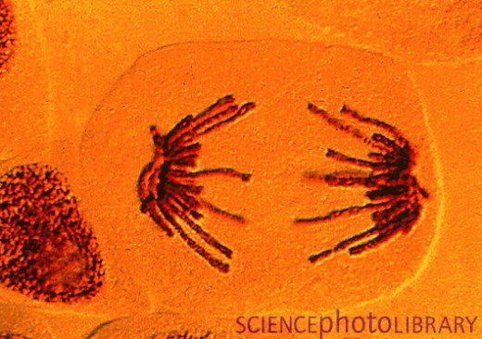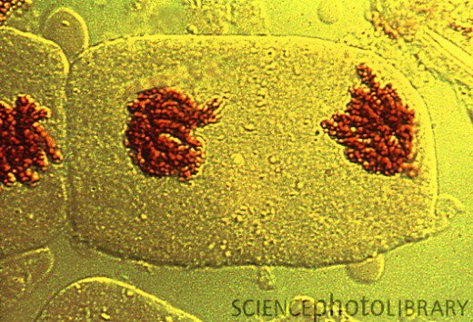

a.) i. Identify the tissue from which the micrographs were obtained **(1mark)**

…………………………………………………………………………………………………..…………………………………………………………………………………………………..

ii. Give a reason for your answer in a) i above **(1mark)**

……………………………………………………………………………………………………………………………………………………………………………………………………………………………………………………………………………………………………..

Name the stages represented by **R** and **T**. **(2marks)**

R………………………………………………………………………………………………

T………………………………………………………………………………………………

b.) State two significance of mitosis to an organism. **(2 marks)**

………………………………………………………………………………………………………………………………………………………………………………………………………………………………………………………………………………………………………

c.) Name two regions in higher plants where cells actively undergo mitosis. **(2marks)**

…………………………………………………………………………………………………………………………………………………………………………………………………

d) During a laboratory investigation, a scientist extracted gastric juice from the mammalian stomach. He used it to carry out tests on a food sample B which was suspected to contain proteins. He divided the food sample B into three portions and treated them as below.

I. On the 1st portion of B, he added Gastric juice and mixed them thoroughly before adding sodium hydroxide followed with copper (II) sulphate drop by drop.

II. On the 2nd portion of B, he added boiled gastric juice and mixed them thoroughly before adding sodium hydroxide followed with copper (II) sulphate drop by drop.

III. On the 3rd portion of B, he added Gastric juice, sodium bi-carbonate and mixed them thoroughly before adding sodium hydroxide followed with copper (II) sulphate drop by drop.

1. State the observations he made in each set up. **(3marks)**

1stportion……………………………………………………………………………………

2ndportion…………………………………………………………………………………

3rdportion……………………………………………………………………………………… b) Why was the experiment on the 1st portion included in the tests? **(1mark)** …………………………………………………………………………………………………………………………………………………………………………………………………....

c) Name the property of the chemical being investigated in these tests. **(1mark)** ………………………………………………………………………………………………… …………………………………………………………………………………………………

d) Account for the observations made in 2 (a) above. **(3marks**) ………………………………………………………………………………………………… ………………………………………………………………………………………………… ………………………………………………………………………………………………… …………………………………………………………………………………………………

**SECTION B (40MARKS)**

Answer question 6 **(compulsory)** then choose any between question 7 and 8

1. An experiment was carried out to investigate the effects of dilute sulphuric acid on the growth of plant seedlings. Batches of seedlings were grown in glass dishes on filter paper to which dilute sulphuric acid was added. The dishes were then incubated. The root and shoot lengths were measured after 65 hours. The results obtained are shown in the table below.

|  |  |  |
| --- | --- | --- |
| Sulphuric acid concentration  (mol/dm-3) | Mean root length (mm) | Mean shoot length (mm) |
| 0  1 x 10-3  3 x 10-3  4 x 10-3  6 x 10-3  7 x 10-3  8 x 10-3  9 x 10-3  10 x 10-3 | 55.5  63.4  6.5  2.0  1.8  1.5  1.3  1.3  1.0 | 25.2  18.4  9.5  4.6  0.8  0.5  0.3  0.0  0.0 |

1. Plot a graph of the mean root length and the mean shoot length against the sulphuric acid concentration on the same grid.  **(7 marks)**

(b) Describe the relationship between the concentration of sulphuric acid and the:-

(i) Growth of shoots **(2 marks)**

…………………………………………………………………………………………………..

…………………………………………………………………………………………………..

…………………………………………………………………………………………………..

(ii) Growth of the roots (2 marks)

………………………………………………………………………………………………………………………………………………………………………………………………………………………………………………………………………………………………………

(c) Estimate the mean root and the mean shoot lengths when the concentration of sulphuric acid is 5 x 10-3  **(2 marks)**

……..…………..…………………………………………………………………………………………………………………………………………………………………………………

…………………………………………………………………………………………….……

(d) State **two** other effects of acid rain. **(2 marks)**

……………………………………………………………………………………………………………………………………………………………………………………………………………………………………………………………………………………………………..

(e) State **three** ways of preventing acid rain.  **(3 marks)**

……………………………………………………………………………………………………………………………………………………………………………………………………………………………………………………………………………………………………………………………………………………………………………………………..…………

(f) Name two other gases with the same effect Sulphur (IV) oxide gas in the atmosphere.

**(2 marks)**

…………………………………………………………………………………………………..………………………………………………………………………………………………….

7. a) Describe the mechanism of inhalation and exhalation in mammals **(14marks)**

b). Explain **three** factors that affect rate of breathing **(6marks)**

1. a) Describe the process of double fertilization in flowering plants. **(15marks)**

b) Describe what happens to the various parts of a flower after fertilization. **(5 marks)**

………………………………………………………………………………………………………………………………………………………………………………………………………………………………………………………………………………………………………………………………………………………………………………………………………………………………………………………………………………………………………………………………………………………………………………………………………………………………………………………………………………………………………………………………………………………………………………………………………………………………………………………………………………………………………………………………………………………………………………………………………………………………………………………………………………………………………………………………………………………………………………………………………………………………………………………………………………………………………………………………………………………………………………………………………………………………………………………………………………………………………………………………………………………………………………………………………………………………………………………………………………………………………………………………………………………………………………………………………………………………………………………………………………………………………………………………………………………………………………………………………………………………………………………………………………………………………………………………………………………………………………………………………………………………………………………………………………………………………………………………………………………………………………………………………………………………………………………………………………………………………………………………………………………………………………………………………………………………………………………………………………………………………………………………………………………………………………………………………………………………………………………………………………………………………………………………………………………………………………………………………………………………………………………………………………………………………………………………………………………………………………………………………………………………………………………………………………………………………………………………………………………………………………………………………………………………………………………………………………………………………………………………………………………………………………………………………………………………………………………………………………………………………………………………………………………………………………………………………………………………………………………………………………………………………………………………………………………………………………………………………………………………………………………………………………………………………………………………………………………………………………………………………………………………………………………………………………………………………………………………………………………………………………………………………………………………………………………………………………………………………………………………………………………………………………………………………………………………………………………………………………………………………………………………………………………………………………………………………………………………………………………………………………………………………………………………………………………………………………………………………………………………………………………………………………………………………………………………………………………………………………………………………………………………………………………………………………………………………………………………………………………………………………………………………………………………………………………………………………………………………………………………………………………………………………………………………………………………………………………………………………………………………………………………………………………………………………………………………………………………………………………………………………………………………………………………………………………………………………………………………………………………………………………………………………………………………………………………………………………………………………………………………………………………………………………………………………………………………………………………………………………………………………………………………………………………………………………………………

………………………………………………………………………………………………..............................................................................................................................................................................................................................................................................................................................................................................................................................................................................................................................................................................................................................................................................................................................................................................................................................................................................................................................................................................................................................................................................................................................................................................................................................................................................................................................................................................................................................................................................................................................................................................................................................................................................................................................................................................................................................................................................