Name:……………………………………………..…......................Index No……....………… Signature……………….................. Date: ……………......
231/1 (THEORY)
BIOLOGY PAPER 1
TIME: 2 HOUR

PAVEMENT FORM 4 TRIAL 1 EXAMINATION 2021/2022
Kenya certificate of secondary education (K.C.S.E)

- Write your Name and Index Number in the spaces provided above.
- Sign and write the date of examination in the spaces provided above.
- This paper consists of TWO sections: A and B.
- Answer ALL the questions in section A in the spaces provided after each question
- In Section B, answer question 6 (compulsory) in the spaces provided and either question 7 or 8 in the spaces provided after question 8.
- Answers must be written in English only.

For Examiner’s Use Only
Questions | Maximum score | Candidate’s score
1-24 | 80

This paper consists of 8 printed pages. Candidates should check the question paper to ensure that all the pages are printed as indicated and no question is missing.
- (a) What is meant by the term binomial nomenclature? (1mark)
………………………………………………………………………………………………………………………………………………………………………………………………………………………………
(b) Give two reasons why classification is important (2 marks)
………………………………………………………………………………………………………………………………………………………………………………………………………………………………………………………………………………………………………………………………………………………………………………………………………………………………………………………………
- (a) What is the formula for calculating linear magnification of a specimen when using a hand lens? (1mark)
………………………………………………………………………………………………………………………………………………………………………………………………………………………………………………………………………………………………………………………………………………………………………………………………………………………………………………………………
(b) Give a reason why staining is necessary when preparing specimens for observation under the microscope (1 mark)
………………………………………………………………………………………………………………………………………………………………………………………………………………………………………………………………………………………………………………………………………………
- Plant cells do not burst when immersed in distilled water. Explain (2marks)
………………………………………………………………………………………………………………………………………………………………………………………………………………………………………………………………………………………………………………………………………………
- State three functions of Golgi apparatus. (3 marks)
………………………………………………………………………………………………………………………………………………………………………………………………………………………………………………………………………………………………………………………………………………………………………………………………………………………………………………………………

- Distinguish between diffusion and osmosis. (2 marks)
………………………………………………………………………………………………………………………………………………………………………………………………………………………………………………………………………………………………………………………………………………………………………………………………………………………………………………………………………………………………………………………………………………………………………………
- Describe what happens during the light stage of photosynthesis. (3 marks)
………………………………………………………………………………………………………………………………………………………………………………………………………………………………………………………………………………………………………………………………………………………………………………………………………………………………………………………………
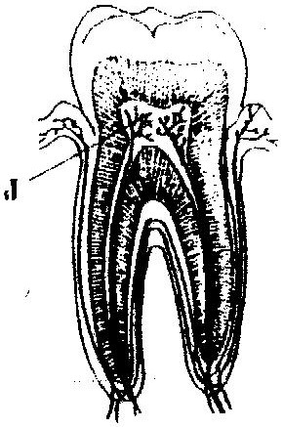
- The diagram below represents a section though a human tooth

(a) (i) Name the type of tooth shown (1 mark)
………………………………………………………………………………………………………………
(ii) Give a reason for your answer in (a) (i) above (1 mark)
……………………………………………………………………………………………………………………………………………………………………………………………………………………………………………………………………………………………………………………………………………...
(b) State the functions of the structures found in part labeled J (2 marks)
………………………………………………………………………………………………………………………………………………………………………………………………………………………………………………………………………………………………………………………………………………
- (a) Name a fat soluble vitamin manufactured by the human body. (1 mark)
……………………………………………………………………………………………………………………………………………………………………………………………………………………………………………………………………………………………………………………………………………… (b) State two functions of potassium in the human body . (2 marks)
……………………………………………………………………………………………………………………………………………………………………………………………………………………………………………………………………………………………………………………………………………
- State two ways in which the root hairs are adapted to their function. (2 marks)
………………………………………………………………………………………………………………………………………………………………………………………………………………………………………………………………………………………………………………………………………………
- a) State the functions of cristae in mitochondria. (1mark)
………………………………………………………………………………………………………………………………………………………………………………………………………………………………………………………………………………………………………………………………………………
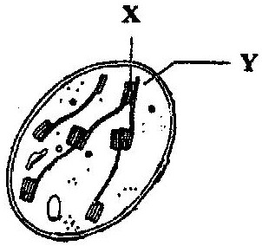
b) The diagram below represents a cell organelle.

- Name the part labeled Y. (1mark)
……………………………………………………………………………………………………………………………………………………………………………………………………………………………………………………………………………………………………………………...
(ii) State the functions of the part labeled X. (1mark)
………………………………………………………………………………………………………………………………………………………………………………………………………………………………………………………………………………………………………………………
- Name the part of the flower that develops into (2marks)
a)Seed………………………………………………………………………………………………………
b)Fruit………………………………………………………………………………………………………
- a) Name the fluid that is produced by sebaceous glands. (1mark)
……………………………………………………………………………………………………………………………………………………………………………………………………………………………..
b)What is the role of sweat in human skin? (2marks)
………………………………………………………………………………………………………………………………………………………………………………………………………………………………………………………………………………………………………………………………………………
- State two ways in which floating leaves of aquatic plants are adapted to gaseous exchange.
(2marks)
…………………………………………………………………………………………………………………………………………………………………………………………………………………………………………………………………………………………………………………………………………………………………………………………………………………………………………………………………………
- a) State three characteristics of Monera that are not found in other kingdoms. (3marks)
…………………………………………………………………………………………………………………………………………………………………………………………………………………………………………………………………………………………………………………………………………………………………………………………………………………………………………………………………………
b) Name the class to which a termite belongs (1mark)
……………………………………………………………………………………………………………………………………………………………………………………………………………………………………
- a) Name one defect of circulatory system in humans. (1mark)
……………………………………………………………………………………………………………………………………………………………………………………………………………………………………

b) State three functions of blood other than transport. (3marks)
………………………………………………………………………………………………………………………………………………………………………………………………………………………………………………………………………………………………………………………………………………………………………………………………………………………………………………………………
- State the role of vitamin C in humans. (1mark)
……………………………………………………………………………………………………………………………………………………………………………………………………………………………………………………………………………………………………………………………………………………….
- a) State two processes which occur during anaphase of mitosis. (2marks)
……………………………………………………………………………………………………………………………………………………………………………………………………………………………………
b) What is significance of meiosis? (2marks)
………………………………………………………………………………………………………………………………………………………………………………………………………………………………………………………………………………………………………………………………………………………………………………………………………………………………………………………………
- State the role of insulin in human body. (1marks)
…………………………………………………………………………………………………………………………………………………………………………..........................................................................................
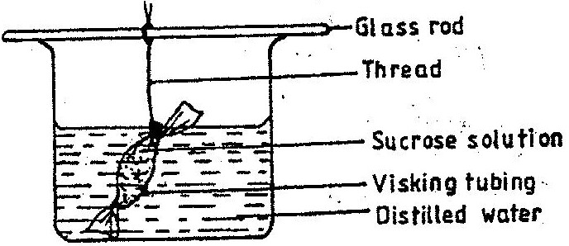
- An experiment was set up in the experiment as show below.

The set up was left for 30 minutes.
a) State the expected results. (1mark)
………………………………………………………………………………………………………………………………………………………………………………………………………………………………
b) Explain your answer in (a) above (3marks)
………………………………………………………………………………………………………………………………………………………………………………………………………………………………………………………………………………………………………………………………………………………………………………………………………………………………………………………………
- a)In what form is energy stored in muscles (1mark)
…………………………………………………………………………………………………………………………………………………………………………………………………………………………………..
b) State the economic importance of anaerobic respiration in plants. (2marks)
………………………………………………………………………………………………………………………………………………………………………………………………………………………………………………………………………………………………………………………………………………………………………………………………………………………………………………………………
- a) Distinguish between epigeal and hypogeal germination. (2marks)
……………………………………………………………………………………………………………………………………………………………………………………………………………………………………
b) Why is oxygen necessary in the germination of seeds? (2marks)
………………………………………………………………………………………………………………………………………………………………………………………………………………………………………………………………………………………………………………………………………………
- (a)What prevents blood in veins from flowing backwards? (1 mark)
……………………………………………………………………………………………………………………………………………………………………………………………………………………………………

(b) State two ways in which the red blood cells are adapted to their function (2 marks)
………………………………………………………………………………………………………………………………………………………………………………………………………………………………………………………………………………………………………………………………………………………………………………………………………………………………………………………………
- What is the importance of the following in an ecosystem? (2marks)
- Decomposers ……………………………………………………………………………………………………………………………………………………………………………………………………………………
- Predation
………………………………………………………………………………………………………………………………………………………………………………………………………………………………………………………………………………………………………………………………………………
- a) Distinguish between the terms homodont and heterodont. (1mark)
………………………………………………………………………………………………………………………………………………………………………………………………………………………………
b) What is the function of carnassials teeth? (1mark)
……………………………………………………………………………………………………………………………………………………………………………………………………………………………..
c) A certain animal has no incisors, no canines, 6 premolars and 6 Molars in its upper jaw. In the lower jaw there are 6 incisors, 2 canines, 6Premolars and six molars. Write its dental formula. (2marks)
…………………………………………………………………………………………………………………………………………………………………………………………………………………………………………………………………………………………………………………………………………………………………………………………………………………………………………………………………………
- a) State two functions of bile juice in the digestion of food. (2marks)
……………………………………………………………………………………………………………………………………………………………………………………………………………………………………………………………………………………………………………………………………………………...
b) How does substrate concentration affect the rate of enzyme action? (1mark)
………………………………………………………………………………………………………………………………………………………………………………………………………………………………………………………………………………………………………………………………………………………
- a) Explain how the following prevent self-pollination. (2marks)
(i) Protandry …………………………………………………………………………………………………………………………………………………………………………………………………………………………………………………………………………………………………………………………………………………….
(ii) Self – sterility. ………………………………………………………………………………………………………………………………………………………………………………………………………………………………………………………………………………………………………………………………………………………
b) Give three advantages of cross pollination. (3marks)
………………………………………………………………………………………………………………………………………………………………………………………………………………………………………………………………………………………………………………………………………………………………………………………………………………………………………………………………
27. State four ways in which respiratory surfaces are suited to their function. (4marks)
………………………………………………………………………………………………………………………………………………………………………………………………………………………………………………………………………………………………………………………………………………………………………………………………………………………………………………………………………………………………………………………………………………………………………………………………………………………………………………………………………………………………………………………………………………………………………………………………………………………………………………………………………………………………………………………………

