Name…………………………………………………….Admission Number……………
Date……………………..
Signature………………..
443/1
AGRICULTURE PAPER ONE
FORM 4
2 HOURS
PAVEMENT FORM 4 TRIAL 2 EXAMINATION 2021/2022
Kenya certificate of secondary education (K.C.S.E)
Instructions:
- Write your name, admission number and class in the spaces provided above.
- Sign and write the date of the examination in the spaces provided above.
- This paper consists of three sections : A, B and C
- Answer all questions in A and B
- Answer any two questions in section C.
- All answers should be written in the spaces provided.
- This paper consists of 6 printed pages
- Students should check the question paper to ascertain that all pages are printed as indicated and that no question is missing.
- Candidates should answer the questions in English.
FOR EXAMINER’S USE ONLY
Section | Questions | Max score | Candidates score
A | 1-17 | 30
B | 18-21 | 20
C | 22 | 20
 | 23 | 20
 | 24 | 20
 | Total | 90
SECTION A (30MARKS)
Answer All the questions in this section in the spaces provided
- Name two methods of farming that are considered outdated (1mark)
……………………………………………………………………………………………………………………………………………………………………………………………………………………………….
- State three symptoms of potassium deficiency in plants (1 ½ marks)
………………………………………………………………………………………………………………………………………………………………………………………………………………………………………………………………………………………………………………………………………………
- State two ways of controlling late blight in tomatoes (1marks)
……………………………………………………………………………………………………………………………………………………………………………………………………………………………..
- Name three financial documents in farm accounts (1½ marks)
………………………………………………………………………………………………………………………………………………………………………………………………………………………………………………………………………………………………………………………………………………
- State four farming practices which can enhance proper light penetration in a crop. (2marks)
……………………………………………………………………………………………………………….
……………………………………………………………………………………………………………….
………………………………………………………………………………………………………………
……………………………………………………………………………………………………………….
- Give four factors which determine the method of weed control in crop production (2marks)
……………………………………………………………………………………………………………….
……………………………………………………………………………………………………………….
………………………………………………………………………………………………………………
……………………………………………………………………………………………………………….
- State four causes of seed dormancy (2marks)
……………………………………………………………………………………………………………..……………………………………………………………………………………………………………….
……………………………………………………………………………………………………………….
………………………………………………………………………………………………………………
……………………………………………………………………………………………………………….

- List four effects of weeds on pastures (2marks)
……………………………………………………………………………………………………………….
……………………………………………………………………………………………………………….
……………………………………………………………………………………………………………………………………………………………………………………………………………………………………
……………………………………………………………………………………………………………….
- State four qualities to be considered when selecting seeds for planting (2marks)
……………………………………………………………………………………………………………….
………………………………………………………………………………………………………………………………………………………………………………………………………………………………
………………………………………………………………………………………………………………
……………………………………………………………………………………………………………….
- State three farming practices which may lead to multiplication of pests (1 ½ marks)
……………………………………………………………………………………………………………..………………………………………………………………………………………………………………………………………………………………………………………………………………………………………………………………………………………………………………………………………………
- Give three pieces of information to be found in a master roll (1 ½ mark)
……………………………………………………………………………………………………………….
……………………………………………………………………………………………………………….
………………………………………………………………………………………………………………
- State three objectives of land reform (1 ½ marks)
……………………………………………………………………………………………………………………………………………………………………………………………………………………………………………………………………………………………………………………………………………..……………………………………………………………………………………………………………….
- Why is it important to weed early in crop production (2marks)
i) …………………………………………………………………………………………………………….
…………………………………………………………………………………………………………….
ii) ……………………………………………………………………………………………………………
……………………………………………………………………………………………………………
- State three effects of late defoliation in pasture management (1½ marks)
………………………………………………………………………………………………………………………………………………………………………………………………………………………………………………………………………………………………………………………………………………

- Differentiate between undersowing and oversowing as used in forage Production. (2marks)
………………………………………………………………………………………………………………………………………………………………………………………………………………………………………………………………………………………………………………………………………………
- State three functions of a farm manager (1½ marks)
……………………………………………………………………………………………………………………………………………………………………………………………………………………………………………………………………………………………………………………………………………..
- State two ways of overcoming the effects of excess water in crop production. (2marks)
………………………………………………………………………………………………………………………………………………………………………………………………………………………………………………………………………………………………………………………………………………
- Give three symptoms of viral infections in crops (1 ½ marks)
……………………………………………………………………………………………………………………………………………………………………………………………………………………………………………………………………………………………………………………………………………….
SECTION B (20MARKS)
Answer All the questions in this section in the spaces provided

- (a) A farmer planted seeds at the rate of one seed per hole at the spacing of 90cmx30cm in his piece of land measuring 120m x100m.Calculate the plant population in the whole field if all the seeds germinated (show your working) (2marks)
……………………………………………………………………………………………………………………………………………………………………………………………………………………………………………………………………………………………………………………………………………………………………………………………………………………………………………………………………………………………………………………………………………………………………………………………
(b) State how the following factors influence spacing in crops (2marks)
- Fertile soil
…………………………………………………………………………………………………………
…………………………………………………………………………………………………………
- High moisture content in the soil
…………………………………………………………………………………………………………
…………………………………………………………………………………………………………

- The diagram below illustrates a feature observed after digging the soil several metres deep. Study the diagram carefully and answer the questions that follow
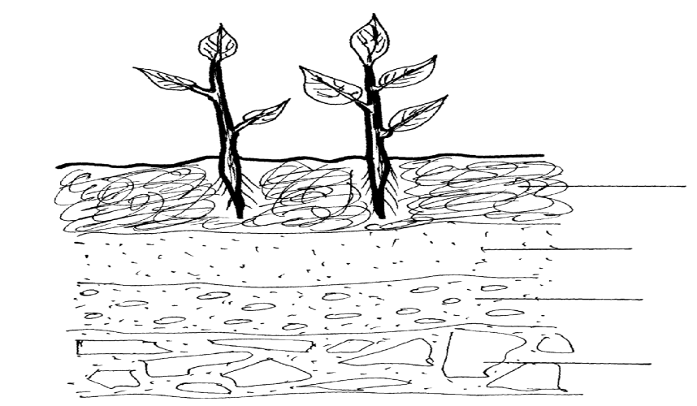

A

B
C

D

- Identify the feature that the diagram above represents (½ mark)
……………………………………………………………………………………………………………………………………………………………………………………………………………………………………

- Name the parts of the diagram labeled B,C and D (1½ mark)
B…………………………………………………………………………
C……………………………………………………………………….
D……………………………………………………………………….
- Outline three characteristics of the part labeled A (3marks)
…………………………………………………………………………………………………………………………………………………………………………………………………………………………
…………………………………………………………………………………………………………….
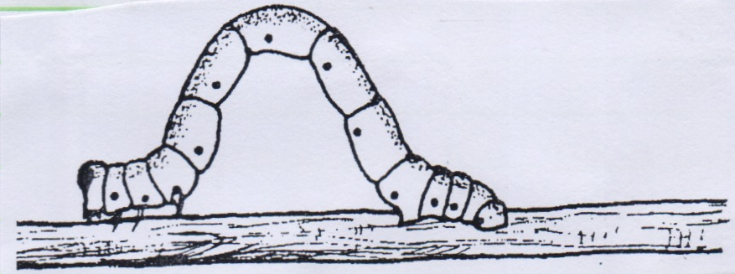
- Use the diagram below of a pest to answer the questions that follow

i) Identify the pest (1mark)
……………………………………………………………………………….
ii) Name the crop and part attacked by the pest (2marks)
Crop | Part attacked

iii) Mention the most suitable method of controlling the pest (1mark)
…………………………………………………………………………………………………………
- (a) Describe the harvesting of sugar cane (3marks)
……………………………………………………………………………………………………………………………………………………………………………………………………………………………………………………………………………………………………………………………………………………………………………………………………………………………………………………………………………………………………………………………………………………………………………………………………………………………………………………………………………………………………………………………………………………………………………………………………………………………………………………………………………………………………………………………………………………………………………………………………………………………………………………………………… (b) List any two diseases of sugar cane (2marks)
……………………………………………………………………………………………………………………………………………………………………………………………………………………………………
SECTION C(40MARKS)
Answer any two questions from this section in the spaces provided
- a) Describe the production of dry beans under the following subheadings
i) Land preparation (4marks)
ii) Planting (6marks)
iii) Control of Anthracnose disease (5marks)
(b) Outline five advantages of planning and budgeting in agriculture (5marks)
- (a) Explain the cultural methods of soil and water conservation (10marks)
(b) State and explain how various practices carried out in crop production help to control pests
(10marks)
- Study the table below showing quantities of fertilizers used and yield of maize obtained over a period of years and answer the questions that follow.

Land (in ha) | DAP fertilizers  (in 20kg units) | Yield  (90kg bags) | Marginal production(mp)  (in 90 kg bags) | Average production(AP)  (in 90 kg bags)
1 | 0 | 2
1 | 1 | 10
1 | 2 | 24
1 | 3 | 42
1 | 4 | 56
1 | 5 | 62
1 | 6 | 60
1 | 7 | 56

(a) i) Fill in the marginal and average product columns in the table (4marks)
ii) Using the graph paper provided draw the production function curve (6marks)
iii) Show the three zones of production on the graph (3marks)
b) Outline any seven activities carried out in organic farming (7marks)
………………………………………………………………………………………………………………..
………………………………………………………………………………………………………………..
………………………………………………………………………………………………………………...
………………………………………………………………………………………………………………..
………………………………………………………………………………………………………………..
………………………………………………………………………………………………………………...
………………………………………………………………………………………………………………..
………………………………………………………………………………………………………………..
………………………………………………………………………………………………………………...
………………………………………………………………………………………………………………..
………………………………………………………………………………………………………………..
………………………………………………………………………………………………………………...
………………………………………………………………………………………………………………..
………………………………………………………………………………………………………………..
………………………………………………………………………………………………………………...
………………………………………………………………………………………………………………..
………………………………………………………………………………………………………………..
………………………………………………………………………………………………………………...
………………………………………………………………………………………………………………..
………………………………………………………………………………………………………………..
………………………………………………………………………………………………………………...
………………………………………………………………………………………………………………..
………………………………………………………………………………………………………………..
………………………………………………………………………………………………………………...
………………………………………………………………………………………………………………..
………………………………………………………………………………………………………………..
………………………………………………………………………………………………………………...
………………………………………………………………………………………………………………..
………………………………………………………………………………………………………………..
………………………………………………………………………………………………………………...
………………………………………………………………………………………………………………..
………………………………………………………………………………………………………………..
………………………………………………………………………………………………………………...
………………………………………………………………………………………………………………..
………………………………………………………………………………………………………………..
………………………………………………………………………………………………………………...
………………………………………………………………………………………………………………..
………………………………………………………………………………………………………………..
………………………………………………………………………………………………………………...
………………………………………………………………………………………………………………..
………………………………………………………………………………………………………………..
………………………………………………………………………………………………………………...
………………………………………………………………………………………………………………..
………………………………………………………………………………………………………………..
………………………………………………………………………………………………………………...
………………………………………………………………………………………………………………..
………………………………………………………………………………………………………………..
………………………………………………………………………………………………………………...
………………………………………………………………………………………………………………..
………………………………………………………………………………………………………………..
………………………………………………………………………………………………………………...
………………………………………………………………………………………………………………..
………………………………………………………………………………………………………………..
………………………………………………………………………………………………………………...
………………………………………………………………………………………………………………..
………………………………………………………………………………………………………………..
………………………………………………………………………………………………………………...
………………………………………………………………………………………………………………..
………………………………………………………………………………………………………………..
………………………………………………………………………………………………………………...
………………………………………………………………………………………………………………..
………………………………………………………………………………………………………………..
………………………………………………………………………………………………………………...
………………………………………………………………………………………………………………..
………………………………………………………………………………………………………………..
………………………………………………………………………………………………………………...
………………………………………………………………………………………………………………..
………………………………………………………………………………………………………………..
………………………………………………………………………………………………………………...
………………………………………………………………………………………………………………..
………………………………………………………………………………………………………………..
………………………………………………………………………………………………………………...
………………………………………………………………………………………………………………..
………………………………………………………………………………………………………………..
………………………………………………………………………………………………………………...
………………………………………………………………………………………………………………..
………………………………………………………………………………………………………………..
………………………………………………………………………………………………………………...
………………………………………………………………………………………………………………..
………………………………………………………………………………………………………………..
………………………………………………………………………………………………………………...
………………………………………………………………………………………………………………..
……………………………………………………………………………………………………………………………………………………………………………………………………………………………………………………………………………………………………………………………………………………………………………………………………………………………………………………………………………………………………………………………………………………………………………………………………………………………………………………………………………………………………………………………………………………………………………………………………………………………………………………………………………………………………………………………………………………………………………………………………………………………………………………………………………………………………………………………………………………………………………………………………………………………………………………………………………………………………………………………………………………………………………………………………………………………………………………………………………………………………………………………………………………………………………………………………………………………………………………………………………………………………………………………………………………………………………………………………………………………………………………………………………………………………………………………………………………………………………………………………………………………………………………………………………………………………………………………………………………………………………………………………………………………………………………………………………………………………………………………………………………………………………………

