Name ……………………………...…………………………………………… Index Number ……………………………
Date …………………………….................. Candidate’s Signature ……………...……………………………........

AUGUST 2021
CASPA AMUKURA PARISH 2021 EXAMINATION
FORM FOUR
121/2 MATHEMATICS Paper 2
TIME: 2 ½ hours

Instructions to candidates
- Write your name, index number, date and sign in the spaces provided above.
- The paper contains TWO sections: Section I and Section II.
- Answer ALL the questions in Section I and any five questions from Section II
- All answers and working must be written on the question paper in the spaces provided below each question.
- Show all the steps in your calculations, giving your answers at each stage in the spaces below each question.
- Non – programmable silent electronic calculators and KNEC Mathematical tables may be used, except where stated otherwise.
For Examiner’s use only.
Section I
1 | 2 | 3 | 4 | 5 | 6 | 7 | 8 | 9 | 10 | 11 | 12 | 13 | 14 | 15 | 16 | Total

Section II
17 | 18 | 19 | 20 | 21 | 22 | 23 | 24 | Total

Grand
Total
This paper consists of 14 printed pages

SECTION 1 (50 MARKS) Answer all the questions in this section
- Use a calculator to find V if $\frac{1}{ V}=$ $\frac{1}{ 23.9}$ - $\frac{1}{38.45}$ (2mks)

- Solve for X in Log (7X – 3) + 2 Log 5 = 2 + Log (X+3) (3mks)

- A quantity P is partly constant and partly varies as the square of Q. when Q = 2, P = 40 and when Q = 3, P = 65. Determine the equation connecting P and Q (3mks)

- Expand (1 -${\frac{1}{2X})}^{6}$ up to the fourth term; hence use your expansion to evaluate 0.996⁶ correct to 4 decimal places. (4mks)

- Simplify $\frac{\sqrt{5}+ 3}{\sqrt{5}- 2}.$ Give the answer in the form of a + b$\sqrt{c}$ where a, b and c are integers (3mks)

- Given that X-5, X-3 and 2X-3 are three consecutive terms of a geometric progression, find the possible values of X and the ratio (2X+1):(X+2) (4mks)

- The figure below is a segment of a circle cut off by a chord AB. Line CD is a perpendicular bisector of chord AB.
C
A
D
B

If AB is 24cm and CD is 8cm, calculate the radius of the circle. (3mks)

- By completing the square, solve for x in the equation 2x² -6 = x. (3mks)

- Given that y = $\frac{b - bx^{2}}{cx^{2}- a}$ make x the subject (3mks)

- The base and height of a right-angled triangle are 4cm and 5cm respectively. Calculate the percentage error in its area. (3mks)

- Given that P = $\left(\begin{matrix}5 & 3 \\ 6 & 4\end{matrix}\right)$, find ;
  - Its inverse (1mk)

  - The value of x and y if P$\left({x \atop y}\right)$ = $\left({3 \atop 2}\right)$ (3mks)

- The equation of a circle is given by x² + y² + 6x – 10y -30 = 0. Determine the radius and center of the circle (3mks)

- Find the value of X which satisfies the equation 5^{2x} - 6×5^{x} + 5 = 0 (3mks)

- A scooter mixes oil and petrol in the ratio 5:19. If petrol costs Ksh. 130 per liter and oil costs Ksh. 250 per liter, find the cost of a liter of the mixture. (2mks)

- Solve the pair of equations simultaneously (4mks)
2x – y = 3
x² – xy = -4

- The cash price of a water pump is Ksh. 38,000. Mr. Ahero opts to buy the pump on hire purchase terms by paying a deposit of Ksh. 6,500 and 24 equal monthly installments. Calculate the amount of each installment, if simple interest of 20% p.a is charged. (3mks)

SECTION II (50 MARKS): Attempt any five questions in this section
- The first term of an arithmetic sequence is equal to the first term of the geometric sequence. The second term of the arithmetic sequence is equal to the fourth term of the geometric sequence, while the tenth term of the arithmetic sequence is equal to the seventh term of the geometric sequence.
- Given that a is the first term and d is the common difference of the arithmetic sequence while r is the common ratio of the geometric sequence, write down two equations connecting the arithmetic and geometric sequences. (2mks)

- Find the value of r that satisfies the geometric sequence (4mks)

- Given that the tenth term of the geometric sequence is 5120, find the values of a and d (2mks)

- Calculate the sum of the first 20 terms of the arithmetic sequence (2mks)

- Three quantities R, S and T are such that R varies directly as S and inversely as the square of T.
- Given that R = 480 when S = 150 and T = 5, write an equation connecting R, S and T (3mks)

- Find,
- the value of R when S = 160 and T = 1.6 (3mks)

- the percentage change in R if S increases by 5% and T decreases by 20% (4mks)

- The table below shows income tax rates
Monthly income in Kenya shillings (Ksh) | Tax rate % in each shilling
Up to 9680 | 10 %
From 9681to18800 | 15 %
From 18801 to 27920 | 20 %
From 27921 to 37040 | 25 %
From 37041 and above | 30 %
In that year Okumu’s salary amounted to K£ 45,000 p.a and he received allowances totaling Ksh. 300,000 p.a. He was entitled to:-
- Monthly personal relief of Ksh. 1,056
- Monthly insurance relief at the rate of 15% of the premium paid
Okumu paid a monthly premium of Ksh. 2,500 towards his life insurance policy
Calculate
(a) His gross monthly income in Ksh (2mks)

(b) The monthly income tax he pays (5mks)

(c) His net monthly income, if his other monthly deductions were: - Ksh. 4,800 to HELB, Ksh. 5,000 to his co-operative and Ksh. 2,800 towards a bank loan repayment. (3mks)

- Square OABC with vertices O(0,0),A(2,0), B(2,2) and C(0,2) is mapped onto O’(0,0), A’(2,0), B’(5,2) and C’(3,2) by the matrix T = $\left(\begin{matrix}a & b \\ c & d\end{matrix}\right)$
  - Find T (3mks)

  - Draw O’A’B’C’ and reflect it on the line x + y = 0 to obtain O”A”B”C” (4mks)
(attach graph paper)

  - What single matrix P maps OABC to O”A”B”C” (3mks)

- In the triangle PQR below L and M are points on PQ and QR respectively such that PL: LQ = 1:3 and QM: MR = 1:2, PM and RL intersect at X. Given that PQ = b and PR=c,
P
R
x
M
L
Q

  - Express the following vectors in terms of b and c.
    - QR (1mk)

    - PM (1mk)

    - RL (1mk)

  - By taking PX = hPM and RX = kRL where h and k are constants find two expressions of PX in terms of h, k, b and c. Hence determine the values of the constants h and k. (6mks)

  - Determine the ratio LX : XR (1mk)

- During a traffic crackdown, 1,000 motor cycles were sampled. 250 of these were found to lack necessary driving gear, 200 had no valid insurance and 300 lacked the driving license. Taking the sample to represent all motorcycles in the country;
  - Represent the information in a tree diagram (3mks)

  - Find the probability that, a motorcyclist at any given time
    - Has no driving license (3mks)

    - Lacks a valid insurance but is in proper driving gear and has a valid driving license (2mks)

    - Has none of the offence (2mks)

- In the figure below, K L M and N are points on the circumference of a circle centre O. The points K, O, M and P are on a straight line. PQ is a tangent to the circle at N. Angle KOL = 130⁰ and angle MKN = 40⁰
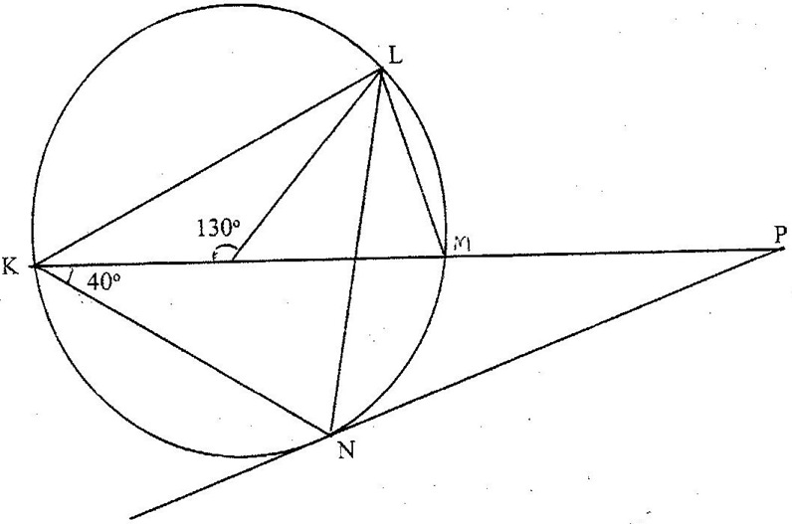
Q
M
O

Find the values of the following angles, stating the reasons in each case:
  - <MLN (2mks)

  - <OLN (2mks)

  - < LNP (2mks)

  - <MPQ (2mks)

  - <KNQ (2mks)

- Complete the table below for y = Sin 2x and y = Sin(2x+30)⁰ giving values to 2 d.p (1mk)
X⁰ | 0⁰ | 15⁰ | 30⁰ | 45⁰ | 60⁰ | 75⁰ | 90⁰ | 105⁰ | 120⁰ | 135⁰ | 150⁰ | 165⁰ | 180⁰
Sin 2x | 0.00 |  |  |  | 0.87 |  |  |  | -0.87 |  |  |  | 0.00
Sin (2x+30)⁰ | 0.50 |  |  |  | 0.50 |  |  |  | -1.00 |  |  |  | 0.50
  - Draw the graph of y = Sin 2x and y = Sin(2x+30)⁰ on the same axis (4mks)
  - Use your graph to solve Sin(2x+30)⁰ - Sin 2x = 0 (1mk)

  - Describe the transformation which maps the wave Sin 2x onto the wave Sin (2x +30) (2mks)

  - State the amplitude and period of y = a cos (bx +c) (2mks)

