NAME .................................................................................Index Number : ................................................

Candidate’s Signature ........................Adm. No:....................

Date: .......................................................................................

511/3

MUSIC THEORY PAPER 3

2 ½ HOURS

Instructions to candidates:
(a) Answer all the questions in this paper.
(b) In question 4 answer any two of the questions numbered (a), (b), (c) and (d). (c) All answers must be written in the spaces provided.
(d) This paper consist of 10 printed pages.
(e) Candidates should check the question paper to ensure that all the pages are printed as indicated and that no questions are missing.
(f) Candidates should answer the questions in English.
For Examiners Use Only

Section | Question | Maximum  Score | Candidate’s  Score
A | 1 | 15
 | 2 | 15
B | 3 | 14
 | 4 | 14
 | 5 | 10
 | 6 | 10
 | 7 | 06
C | 8 | 16
Grand Total |  | 100

SECTION A : M USIC BASIC SKILLS (30 M ARKS)

1. Melody writing.

a) Copy and continue the following opening to make a melody of 16 bars for voice incorporating a sequence and a duplet. Modulate to the dominant before returning to the tonic. Add phrase marks. (9 Marks)
            



b) Using staff notation, write a suitable melody and fit in the following text. (6 Marks)
Singing, playing and dancing together, Keeps the children united and happy.

2. Harmony
Harmonize the following melody for SATB. Choose appropriate chords from i, ii, iv, v and vi. Indicate the chord used. (15 Marks)

  

 


          

SECTION B : HISTORY AND ANALYSIS (54 M ARKS)

3. African Music

a) State any three relationships between music and dance in the performance of Africa folk dance. (3 Marks)
..............................................................................................................................................................

..............................................................................................................................................................

..............................................................................................................................................................

.............................................................................................................................................................. b) Outline any four roles played by sukuti ensemble in the performance of African folk songs.
(4 Marks)

..............................................................................................................................................................

..............................................................................................................................................................

..............................................................................................................................................................

..............................................................................................................................................................

..............................................................................................................................................................

c) Name two Kenyan dances named after the body part that execute the main dance movement. (2 Marks)
..............................................................................................................................................................

.............................................................................................................................................................. d) i) What is an idiophone? (1 Marks)
..............................................................................................................................................................

.............................................................................................................................................................. ii) State two methods of playing Chivoti. (2 Marks)
..............................................................................................................................................................

.............................................................................................................................................................. iii) Name any two parts of an African drum and state how each contribute to sound production.
(2 Marks)

..............................................................................................................................................................

..............................................................................................................................................................

..............................................................................................................................................................

4. Western Music

Answer any two of the following questions numbered (a) , (b), (c) and (d)

a) William Bryd.

i) In which period of music history did Byrd live? (1 Mark)

.............................................................................................................................................................. ii) Outline four contributions of William Byrd towards the development of music of the period he
lived. (4 Marks)

..............................................................................................................................................................

..............................................................................................................................................................

..............................................................................................................................................................

..............................................................................................................................................................

.............................................................................................................................................................. iii) Apart from William Byrd serving as an organist at the Lincoln, Cathedral, state any other two of
his appointments. (2 Marks)

..............................................................................................................................................................

..............................................................................................................................................................

b) Franz Joseph Haydn

i) Name any two composers who influenced Franz Joseph Haydn musically. (2 Marks)

..............................................................................................................................................................

.............................................................................................................................................................. ii) State any two characteristics features of Haydn’s music with reference to melodic style and
harmony. (2 Marks)

..............................................................................................................................................................

..............................................................................................................................................................

.............................................................................................................................................................. iii) Name titles of Haydn’s most oratorios. (2 Marks)
..............................................................................................................................................................

.............................................................................................................................................................. iv) What inspired Haydn to write the two oratorios? (1 Mark)
..............................................................................................................................................................

..............................................................................................................................................................

c) Franz Liszt

i) What is Liszt’s nationality? (1 Mark)

.............................................................................................................................................................. ii) Apart from list name any 4 composers who wrote symphonic poem. (4 Marks)
..............................................................................................................................................................

..............................................................................................................................................................

..............................................................................................................................................................

..............................................................................................................................................................

.............................................................................................................................................................. iii) What type of work is each one of the following? (3 Marks)
a) Christus ………………………………………………………………………………………….. b) Les Preludes……………………………………………………………………………………… c) Totentanz………………… ……………………………………………………………………....

d) Bella Bartok

i) In which musical period of history did Bella Bartok lived? (1 Mark)

............................................................................................................................................................. ii) Outline four characteristics of Bella Bartok’s music. (4 Marks)
..............................................................................................................................................................

..............................................................................................................................................................

..............................................................................................................................................................

..............................................................................................................................................................

.............................................................................................................................................................. iii) a) Define an opera. (1 Mark)
..............................................................................................................................................................

.............................................................................................................................................................. b) Name any title of Opera by Bella Bartok. (1 Mark)
..............................................................................................................................................................

5. Analysis of prescribed African music.

Chivoti by Diwani Nzaro from YouTube

a) i) What is the main medium of performance in this recording? (1 Mark)

.............................................................................................................................................................. ii) State any four roles played by the main medium in this recording. (4 Marks)
..............................................................................................................................................................

..............................................................................................................................................................

..............................................................................................................................................................

..............................................................................................................................................................

..............................................................................................................................................................

b) State five characteristics features of African Music in the performance in this recording.

(5 Marks)

....................................................................................................................................................................

....................................................................................................................................................................

....................................................................................................................................................................

....................................................................................................................................................................

....................................................................................................................................................................

....................................................................................................................................................................

....................................................................................................................................................................

6. Analysis of prescribe Western music.

Too much I once Lamented by Thomas Tomkins.

a) What type of work is Too Much I once Lamented? (1 Mark)

..............................................................................................................................................................

.............................................................................................................................................................. b) Name the composer of this work. (1 Mark)
..............................................................................................................................................................

c) Describe the metre used in this music. (1 Mark)

..............................................................................................................................................................

.............................................................................................................................................................. d) By use of bar numbers, describe the form of this music. (3 Marks)
..............................................................................................................................................................

..............................................................................................................................................................

..............................................................................................................................................................

.............................................................................................................................................................. e) In which key/ tonality is the 2nd soprano at 62 – 63? (1 Mark)
.............................................................................................................................................................. f) By use of bar numbers, identify the following compositional devices. (3 Marks)
i) Homophonic texture

.................................................................................................................................................. ii) Chromaticism
.................................................................................................................................................

iii) Scalic motion

.................................................................................................................................................

7. Unprepared Analysis

Study the piece of music below and answer the questions that follow:

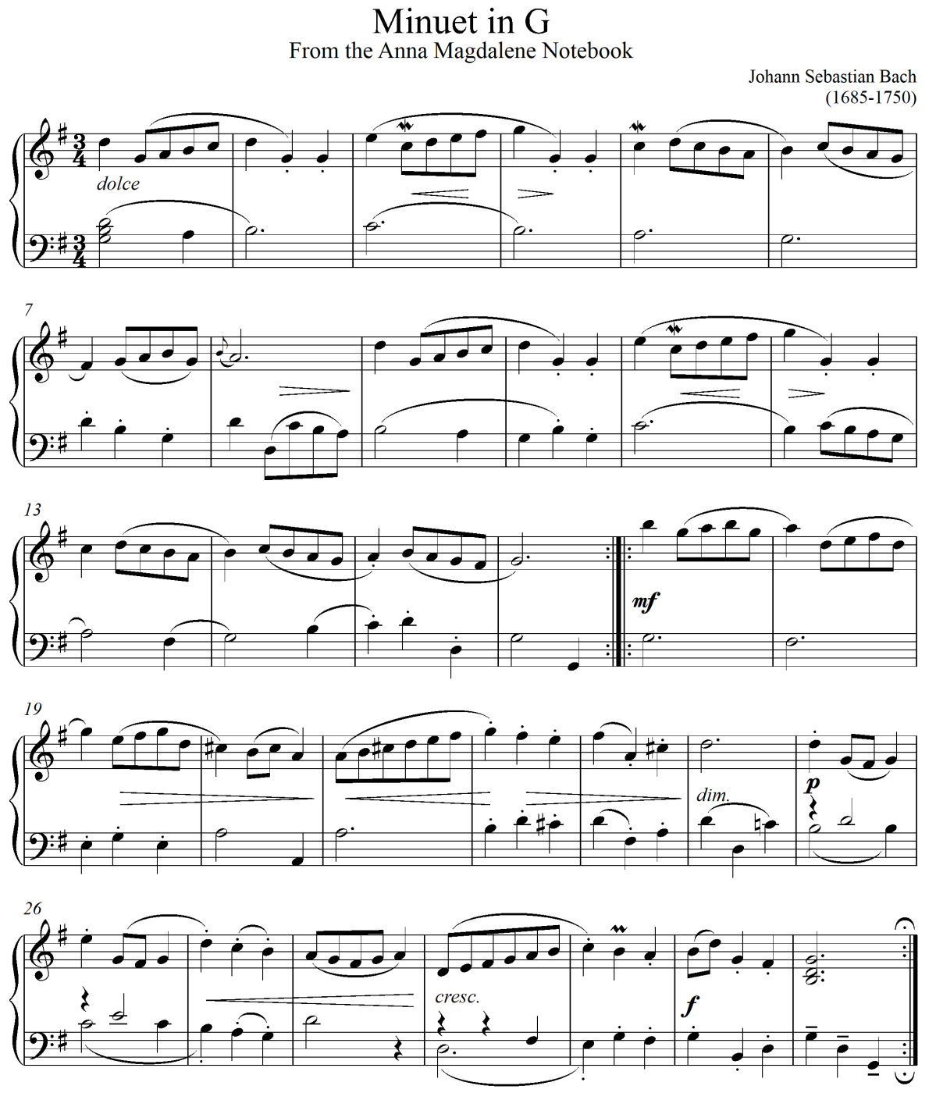

a) By use of bar numbers, describe the form of this music. (2 Marks)

..............................................................................................................................................................

..............................................................................................................................................................

..............................................................................................................................................................

b) For what medium is this music? Give a reason for your answer. (1 Mark)

..............................................................................................................................................................

.............................................................................................................................................................. c) Write the ornaments in bars 5, 8 and 30 in full. (3 Marks)

SECTION C : GENERAL M USIC KNOWLEDGE (16 M ARKS)

8. General knowledge questions .

a) State the meaning of each of the following terms as used in music. i) Drum major
..............................................................................................................................................................

.............................................................................................................................................................. ii) Tutti
..............................................................................................................................................................

.............................................................................................................................................................. iii) Mosso
..............................................................................................................................................................

.............................................................................................................................................................. iv) Arco
..............................................................................................................................................................

.............................................................................................................................................................. b) State four ways through which harmonic effect is achieved during the group performance of a
traditional African folk song. (4 Marks)

....................................................................................................................................................................

....................................................................................................................................................................

....................................................................................................................................................................

....................................................................................................................................................................

....................................................................................................................................................................

.................................................................................................................................................................... c) Name and explain the three basic textures used in Western Music. (3 Marks)
....................................................................................................................................................................

....................................................................................................................................................................

....................................................................................................................................................................

....................................................................................................................................................................

....................................................................................................................................................................

....................................................................................................................................................................

d) Translate the following music from staff to sol-fa notation. Remember to indicate the tonic.

(5 Marks)

     

   

 

  

     

....................................................................................................................................................................

