NAME:____________________________ INDEX NO:__________________
SCHOOL:_______________________________DATE:_______________________
P233/1
CHEMISTRY THEORY
PAPER 1
Sept/Oct 2021
TIME: 2 HOURS.

AMUKURA CATHOLIC JOINT EXAMINATION- CASPA
Kenya Certificate of National Exam
FORM FOUR
Instructions to Candidates.
a) Write your name, school and class in the spaces provided.
b) All working must be clearly shown.
c) Mathematical tables and electronic calculators may be used.
d) Answer all the questions.

1. Air is a mixture of several different gases, which parts of air;(3Mks)
a )Supports combustion?...............................................................................................................
b )Puts of a burning splint?.............................................................................................................
c)Makes up almost 80% of air?......................................................................................................
2.In an experiment a test tube full of chlorine water was inverted in chlorine water to as shown in the diagram below and the set up was left in sunlight.
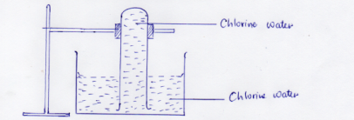
After one day, a gas was found to have collected in the test tube.
(a)Identify the gas.......................................................................................................(1Mk)
(b)What will happen to the PH of the solution in the beaker after one day? Give an explanation. (2Mks
.......................................................................................................................................................................................................................................................................................................................................................................................................................................................................................................................
3.Draw the structure and give names of three alkanes having themolecular formula of C₅H₁₀. (3Mks)

4.(a)Using electrons in the outermost energy level draw the dot(.)and cross(X )diagram for the molecules H₂O and CH₄(H=1, C=12 ) (2Mks)
(1)H₂O

(2)CH₄

5.The following chromatogram was obtained in an experiment to investigate the components present in certain dyes.
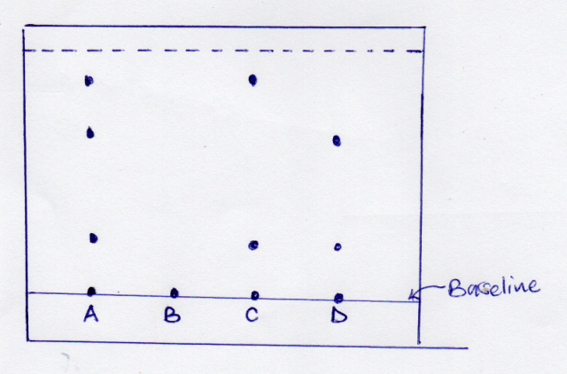
(a)Which two dyes when mixed would produce dyeA .(1Mk)
.....................................................................................................................................................
(b)Identify the pure dye.(1Mk)
....................................................................................................................................................... (C)Define solvent front?(1Mk)
..................................................................................................................................................................................................................................................................................................................................

B) Indicate the solvent front in the diagram using the letter E.
6.A given element F has atomic number 14 and consist of isotopes as shown below.
Isotopes | G | H | J
Isotopes Mass | 28 | 29 | 30
Percentage abundance | 92.2 | 4.7 | 3.4

(a)Determine the relative atomic mass of element F. (2Mks)
................................................................................................................................................................................................................................................................................................................................................................................................................................................................................................................................................................................................................................................................................................................................................................................................................................................................................................................................................................................................................................................
(b)State the group and the period to which element F belongs. (1Mk)
................................................................................................................................................................................................................................................................................................................................................
7.Hdrogen gas can be prepared by passing steam over heated magnesium ribbon as shown .
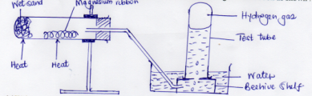
(a)Write an equation for the reaction that produce hydrogen gas. (1Mk)
........................................................................................................................................................................................................................................................................................................................................................................................................................................................................................................................
(b)Explain why the delivery tube must be removed from beneath the water before heating is stopped.(1Mk)
................................................................................................................................................................................................................................................................................................................................................
(c)Name the method of gas collection used in the experiment. Give a reason.(1Mk)
................................................................................................................................................................................................................................................................................................................................................
8.(a)State Charles’s law .(1Mk)
........................................................................................................................................................................................................................................................................................................................................................................................................................................................................................................................
(b)A gas occupies 450cm³ at 27⁰C.What volume would the gas occupy at 177⁰C.If its pressure remains constant? (Give the answer in Kelvin) (2Mks)
........................................................................................................................................................................................................................................................................................................................................................................................................................................................................................................................................................................................................................................................................................................................................................................................................................................................................
9.A certain match stick head contains potassium chlorate and sulphur. On striking, the two substances react to produce potassium chloride and sulphur(IV )oxide respectively.
(a)Write an equation to show formation of sulphur (iv )oxide.(1Mks)
........................................................................................................................................................................................................................................................................................................................................................................................................................................................................................................................
(b)Explain the environmental effect of using such matches in large numbers.(2MKS)
.......................................................................................................................................................................................................................................................................................................................................................................................................................................................................................................................................................................................................................................................................................................................................................................................................................................................................
10.The figure below shows a flame obtained from a Bunsen burner.
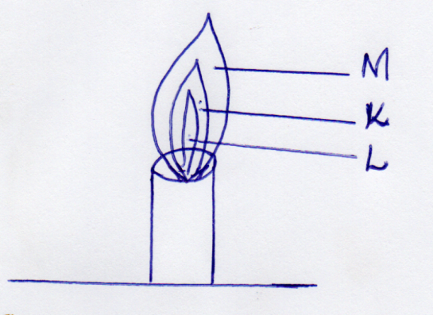
(a)Name the type of flame. (1Mk)
................................................................................................................................................................................................................................................................................................................................................
(b)A match stick head was placed at region L will not ignite. Explain(1Mk)

(c)Name region K .(1Mk)

11.Solutions can be classified as Acids, Bases or Neural. The table below shows solutions and their P^{H} values.
Solution | P^{H} values
N  Q  P | 1.5  7.0  13.0

(a)Select any pairs that would react to form a solution of P^{H} 7.0 (1Mk)
................................................................................................................................................................................................................................................................................................................................................
(b)Identify twosolution that would react with Aluminium hydroxide. Explain. (2Mks)
.......................................................................................................................................................................................................................................................................................................................................................................................................................................................................................................................
12.The diagram below shows part of a synthetic polymer. Study it and answer the questions that follows;
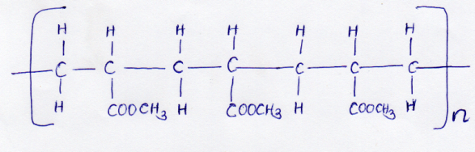

(a)Draw the structure of the monomer (1Mk)

13.The diagram below shows the radiation emitted by a radioactive isotope.
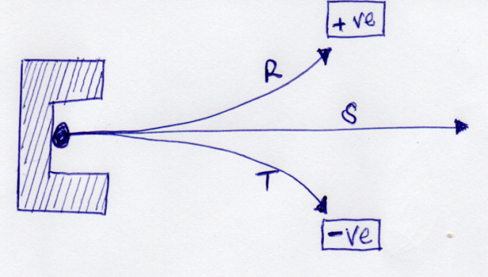
Name the radiations.(3mks)
R:.......................................................................................................................................................
S:........................................................................................................................................................
T:........................................................................................................................................................

14.(a)Distinguish between a deliquescent and a hygroscopic substance.(2Mks)
...............................................................................................................................................................................................................................................................................................................................................................................................................................................................................................................................................................................................................................................
(b)Give one use of a deliquescent substance In the laboratory. (1Mk)
....................................................................................................................................................................................................................................................................................................................................................................................................................................................................................

15.Study the flow diagram below and answer the question that follow.
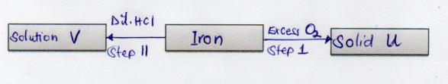
(a)Write an equation for the reaction taking place in step 1. (1Mk)
................................................................................................................................................................................................................................................................................................................................................
(b )Name solution V.(1Mk)
................................................................................................................................................................................................................................................................................................................................................
16. (a) state and exaplain two observations made when magnesium ribbon is lowered into a as jar full of carbon (iv) oxide (3mk)

b) Write a balanced chemical equation or the reaction that took place in a) above(1mk)

17. The energy level diagram below shows the effect of a catalyst on the reaction path.
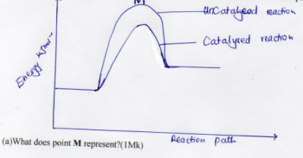
........................................................................................................................................................................................................................................................................................................................................................................................................................................................................................................................
(b)With reference to the energy level diagram, explain how a catalyst increases the rate of reaction. (2Mks)
...............................................................................................................................................................................................................................................................................................................................................................................................................................................................................................................................................................................................................................................................................................
18. The table shoes behaviour of metals R, X , Y and Z study it and answer the questions.
Metal | Appearance on exposure to air | Reaction in water | Reaction with dilute hydrochloric acid
R  X  Y  Z | Slowly tarnishes  Slowly turns white  No change  No change | Slow  Vigorous  Does not react  No reaction | Vigorous  Violet  Does not change  Reacts moderately
(a) Arrange the metals in the order of reactivity starting with the most reactive (2Mks)
.....................................................................................................................................................................................................................................................................................................................................................................................................................................................................................
(b)Name a metal which is likely to be ; (2Mks)
1)X:............................................................................................................................................
11)Y:...........................................................................................................................................

20. The following chart below shows some properties of two allotropes of element P
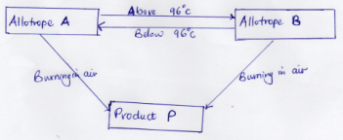
(a)Name allotrope A(1Mk)
............................................................................................................................................................
(b)Write an equation to show formation of product P (1Mk)
................................................................................................................................................................................................................................................................................................................................................
(c)What does 96 ⁰C represent? (1Mk)
......................................................................................................................................................................
21.Complete the following table by filling in the missing test and observations. (3Mks)

NO | Gas | Test | Observation
 | Ammonia | Put a moist red, then blue litmus into the gas
2 | Sulphuric(V) oxide |  | Paper turns green
3 | Butene | Add a drop of bromine water

22.An organic compound contains 24.24%carbon,4.04% hydrogen and the rest chlorine.If its relative molecular mass is 99.What is its molecular formula ?(C=12,H=1 ,Cl=35.5) (3Mks)

23.Study the diagram below and answer the questions that follows
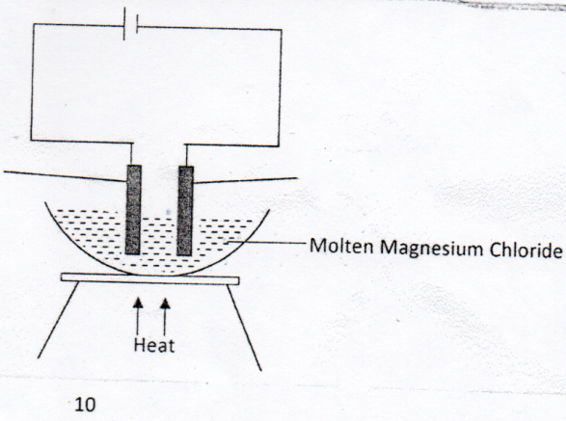
(a)Define the term electrolysis.(2mks)
....................................................................................................................................................................................................................................................................................................................................................................................................................................................................................
(b)On the diagram, label the Anode and the Cathode. (1Mks)
(c)Write the equation for reaction taking place at the Cathode. (1Mk)
....................................................................................................................................................................................................................................................................................................................................................................................................................................................................................
24.Hardness of water may be removed by either boiling or addition of chemicals
(a)Name the two types of water hardness. (2Mks)
........................................................................................................................................................................................................................................................................................................................
(b)A sample of river water was divided into three portions, the table shows the test carried out on the portion and observations made. Complete the table by filling the inferences. (3Mks)
Test | Observation | Inference
To the first portion,1cm³ of soap solution was added. | No lather formed
The second portion was boiled ,cooled and 1cm³ of soap solution was added. | No lather was formed
To the third portion ,3cm³ of aqueous sodium carbonate was added ,the mixture filtered and 1cm³ of soap solution added to the filtrate. | Lather formed immediately

25.The figure below shows an energy cycle diagram.
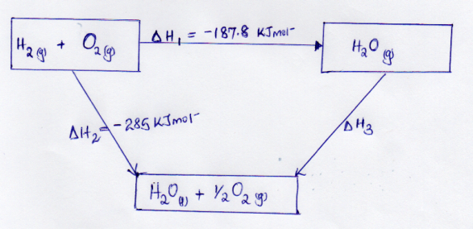
(a)Give the name of the enthalpy change H1 (1Mk)
........................................................................................................................................................................................................................................................................................................................
(b)Determine the value of H3 (2Mks)
....................................................................................................................................................................................................................................................................................................................................................................................................................................................................................
26.Dry ammonia and dry oxygen were reacted as shown in the diagram.
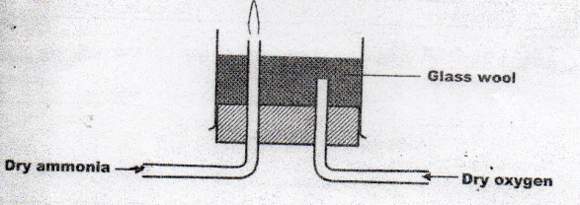

(a)What is the purpose of the glass wool? (1Mk)
....................................................................................................................................................................................................................................................................................................................................................................................................................................................................................
(b)What product would be formed if red- hot platinum was introduced in to a mixture of ammonia and oxygen? (1Mk)
....................................................................................................................................................................................................................................................................................................................................................................................................................................................................................
27.Study the diagram below.
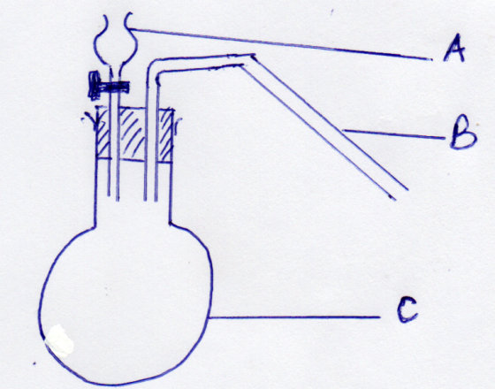
Identify apparatus A ,B and C. (3mks)

A:.....................................................................................................................................................
B:......................................................................................................................................................
C.........................................................................................................................................................
28.Explain why high temperature is required for Nitrogen to react with Oxygen. (2mks)
....................................................................................................................................................................................................................................................................................................................................................................................................................................................................................

(80 MARKS)

