BURAMU AGRICULTURE PP2 MARKING SCHEME
SEPTEMBER 2021
SECTION A: Answer ALL questions in this section. (30MARKS)
- Give two functions of albumen in an egg. 1mk
- Provide nutrients to the developing chick
- Cushions small movements of the inner egg content
- State four management practices in fish rearing. 2mks
- Cropping
- Changing water regularly/maintenance of water flow
- Routine feeding
- Controlling of predators
- State four factors that affect digestibility of a feedstuff in livestock. 2mks
- Chemical composition of feed
- Form in which feed is offered
- Amount of feed already present in the digestive system
- Species of the animal
- Age of the animal
- Give four disadvantages of inbreeding in livestock production. 2mks
- Leads to a decline in fertility which may lead to species extinction
- Leads to high rate of pre-natal mortality
- Reduces hybrid vigour
- Reduces performance in livestock
- Give the functional difference between a cross-cut saw and a rip saw 1mk
Cross cut saw cuts across the wood grains while the rip saw cuts along the wood grains
- State four reasons why bees may swarm. 2mks
- Sick/infertile queen
- Attack by predators
- Too much noise
- Bad smell
- Lack of food/water
- Overheating of the hive
- List two signs that would indicate that an animal has died of anthrax. 1mk
- Lack of rigor mortis/lack of stiffness of the carcass
- Production of tar-like watery blood from all body openings.
- Extensive bloating
- State four causes of egg eating in a flock of layers. 2mks
- Bright light in the poultry house
- Inadequate calcium in the diet

- Apart from the roof, name four other parts of a building that can be constructed using wood. 2mks
- Ceiling
- Window
- Door

- State two reasons why drenching alone is not an effective method of internal parasite control. 1mk

- Outline four benefits of steaming up in livestock. 2mks
- Provides nutrients for good foetal growth
- Builds up energy for parturition
- Ensures birth of healthy animals
- Ascertains good health of the mother
- Increases and maintains high milk yield after birth
- Name four breeds of rabbits. 2mks
- Flemish giant
- New Zealand white
- Chinchilla
- Earlope
- Carlifornia white
- List four functions of the rumen in the digestion of feed in ruminants. 2mks
- Temporary storage of feed
- Actions of microbial activities
- Synthesis of vitamin B complex
- Fermentation of feeds
- State two reasons why walls of a dairy shed should be white washed instead of painting. 1mk
- To avoid chemical poisoning
- To avoid tainting milk if the shed is used immediately after painting
- To discourage insects from inhabiting the shed.
- State four factors that determine the amount of food given to an animal. 2mks
- Body size or weight of the animal
- Environmental conditions
- Level of production
- Purpose for which the animal is kept
- Physiological condition of the animal
- Distinguish between inbreeding and line breeding as used in livestock production. 1mk
- Inbreeding is the mating of closely related animals while line breeding is the mating of distantly related animals with a common ancestry.
- Give two reasons why it is important to include additives in commercial feeds. 1mk
- To stimulate growth
- To improve food conversion efficiency
- To guard against disease and parasites
- State four factors considered when siting a farm structure. 2mks
- Drainage
- Security
- Accessibility
- Farmer’s taste and preferences
- Name the deficiency symptom for the following mineral elements;
  - Magnesium 1/2mk
Grass tetany/hypomagnecia
  - Copper 1/2mk
swayback

SECTION B: Answer ALL questions in this section (20marks)
- The following diagram shows parts of a roof. Study it carefully and answer the questions that follow
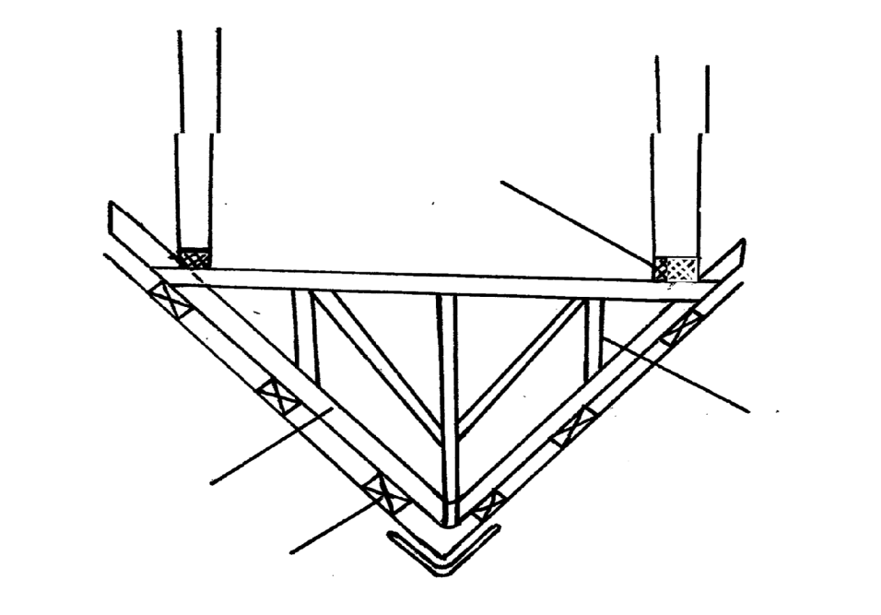
(a) Name the parts labelledO,P,Q and R 2mks
O - wall plate
P – rafter
Q - strut
R - purlin
(b) State the function of the part labeled O and R 1mk
O – supports the roof; support the end of the rafters
R – provides attachment for roofing materials
(c) Give two reasons for treating timber before use in the construction of farm structures 2mks
- To prevent warping
- To prevent rotting or damage by fungi
- To last longer

21. Diagram G, H and J illustrates some livestock parasites
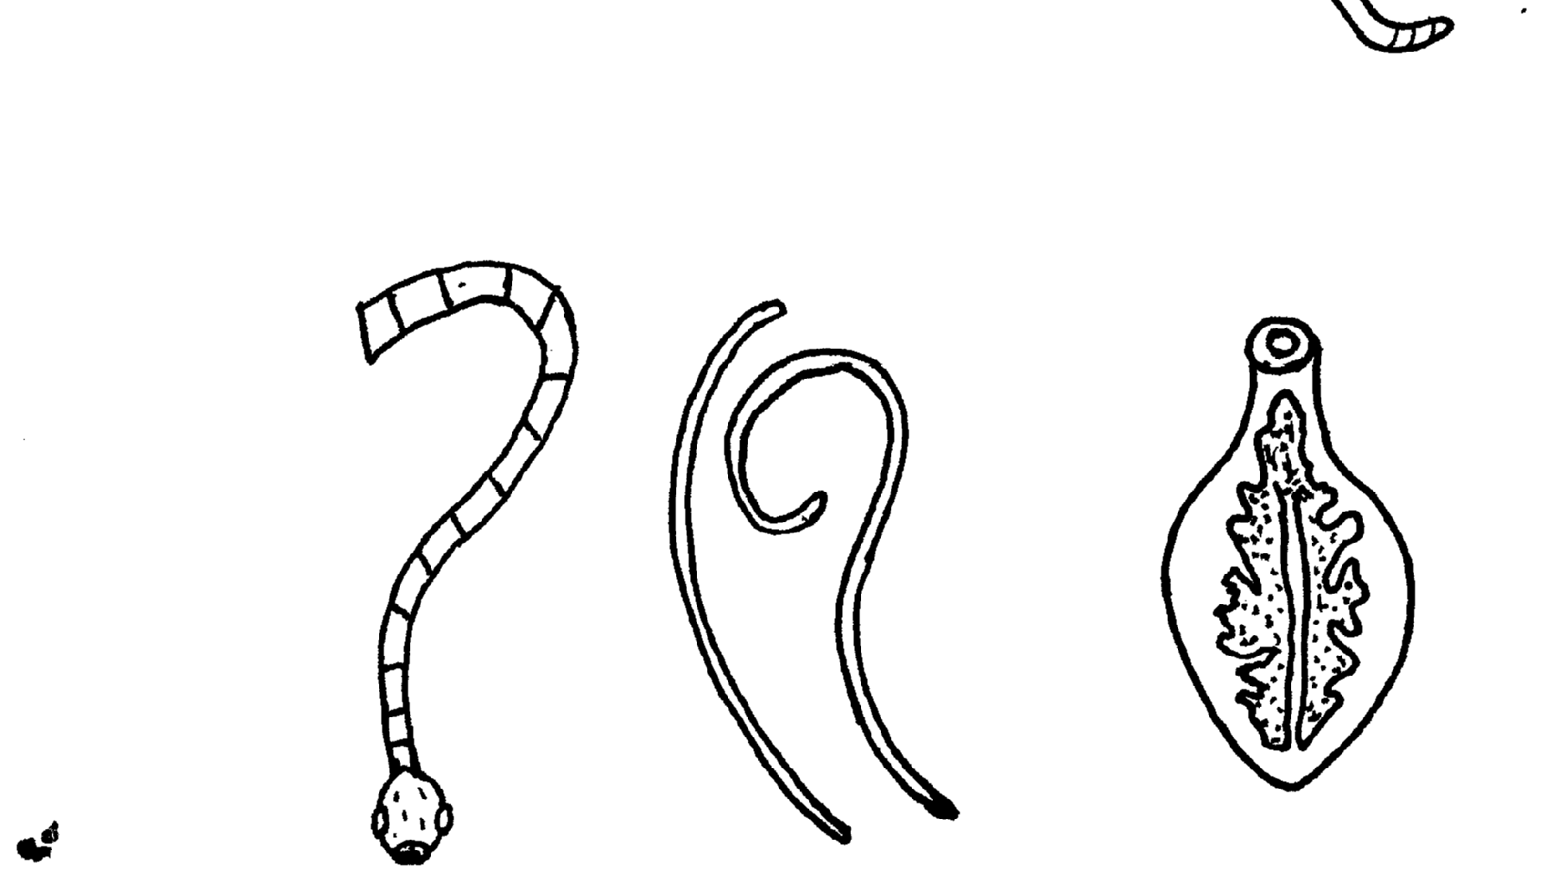

G
J
H

(a) Identify parasites G, H and J 3mks
G- (mature) liver fluke
H - Round worm
J – Tape worm
(b) Name the partof the host body where parasiteG is found 1mk
Liver; bile duct; gall bladder
(c) Name the intermediate host of parasites G and J 1mk
G – Fresh water snail/mud snail
J – Cattle; pigs

- Diagrams M, N, P and Q show some structures used in apiculture. Use them to answer the questions that follow.
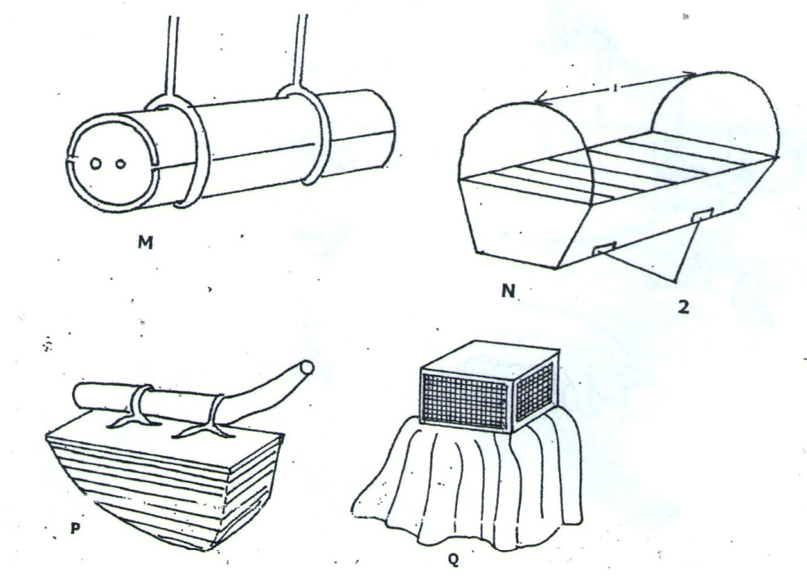

- Identify the structures labeled M, N, P and Q. 2mks
M – log hive
N – Kenya Top Bar Hive
P - Smoker
Q - Veil
- State the uses of equipment P and Q. 1mk
P – puffing smoke into the hive
Q – Protecting the head/face from bee stings to enable the handler see through without fear of bee stings.
- State two advantages of structure N over structure M. 2mks
- Produce high quality honey
- Honey combs can be removed without disturbing the brood
- Cheap/easy to construct
- Has bars that can be lifted in order to inspect the combs.

- State one function of a queen in a colony. 1mk
- Lay eggs
- Control the rest of the colony
- The diagrams N₁ and N₂ below show the fingers fitted between pelvic bones as a practice used in examining layers during culling.
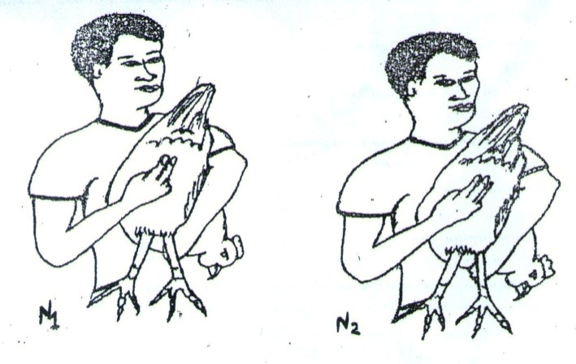
- Which layer would be culled? 1mk
N1
- Give two other characteristics that can be examined when culling. 2mks
- Yellow colour of the shank
- Glossy smooth feather
- Pale/dry/dull/shrunken wattle and comb
- Hard/stiff abdomen
- Dull eyes
- Other than using the characteristics of a layer, give another method that can be used to cull layers. 1mk
- Keep the layers in individual cages to be able to find out which cages have no eggs.
- Trap nesting

SECTION C: ANSWER ANY TWO QUESTIONS IN THIS SECTION(40MARKS)
24. (a) explain five reasons for keeping livestock healthy 10mks
Healthy animals grow well and fast enough to reach maturity quickly
Good health gives animals a longer economic and productive life
Healthy animals give maximum production or performance, they maintain high productivity
Healthy animals produce good quality products that fetch high market value
Healthy animals will not spread disease to either animals or human beings
Healthy animals are economical and easy to keep as farmer spends less money on disease treatment

(b) State five reason for maintaining farm tools and equipment
To increase durability
To reduce the replacement cot
Increase efficiency
Avoid injury to the user
To avoid damage to the tool
(c) Outline five characteristics for beef bred of cattle
Are blocky in shape, appear square or rectangular with compact bodies
Have deep well fleshed bodies
Grow fats leading to early maturity
Are efficient converters of food into meet and fats
Are able to maintain good weight even during adverse conditions search as drought
Are good foragers – reduced selective grazing
Are more tolerant to high temperatures
They breed regularly
They are more resistant to disease
Have short strong legs to support their heavy bodies

(d) Explain five factors to consider when selecting a dairy cattle breeding stock 10mks
- Age – Select young animals, more fertile, longer production period (10mks)
- Health- Good health, more fertility, more healthy off springs
- Level of production –high producer’s better give more yield
- Physical appearance –physical confirmation must suit the dairy animals.
- Physical fitness- strong fit, to enable mating and take foetal weight
- Temperament –Animals should be easy to handle, not hostile/docile animals are chosen
- Adaptability to local environment suit to existing climatic constraints
- Quality of milk; Higher –higher milk quality producers are better stocks

25 (i) State five advantages of battery cage system of poultry management 5mks
- Higher egg production due to less energy wastage
- Easy to keep individual production records
- Control cannibalism and egg eating
- No contamination of water and feed
- Birds are not exposed to predators parasites and diseases
- Facilitate culling and handling
- Easy to collect eggs
- Egg losses are reduced
- Many birds are kept/high stocking rate
- Eliminate broodiness
- Birds still have tender meat at culling due to confinement
- Keeps eggs clean
(ii) Explain five functions of water in nutrition 5mks
- Component of body cells and makes body fluids e.g. blood (5mks)
- Used in biochemical reactions in the body e.g. digestion
- Regulate body temperature through sweating and evaporation
- Excretion of metabolic wastes from the body
- Formation of products e.g. milk, eggs etc
- Make cells turgid to maintain their shape
- Transportation of nutrients from one point to another

- i. Describe poultry management under the following sub-headings:
- Causes of stress 5mks
- Sudden loud noise
- Sudden change of feeds
- Sudden change of weather
- Disease and parasite infestation
- Overcrowding
- Lack of water/feeds

- Control measures for cannibalism. 5mks
- Avoid bright light in the poultry house
- Control external parasite
- Keep birds busy by hanging green leaves to keep them busy
- Cull perpetual cannibals
- Keep birds according to their ages
- Provide birds with a balanced diet
- Debeak hens which peck others
ii. Describe East Coast Fever (ECF) under the following sub-headings:
- Animal attacked 1mk
Cattle
- Causal organism 1mk
Theileriaparva/protozoa
- Signs of infection 5mks
- Swollen lymph nodes
- Profuse salivation
- Lachrimation/tears come out of the eyes
- Fever
- Laboured breathing
- Haemorrhages
- Sight impairment/poor vision
- Coughing
- Control measures 3mks
- Control ticks (vectors)
- Treat using appropriate drugs
- Fencing to keep away strange animals and confine animals within

