NAME: ………………………………………… ADM. NO.…………..…. DATE…..…..…
SIGNATURE………………………

232/1
PHYSICS END TERM 1 2021
PAPER1 2 HOURS

TRIAL EXAM SERIES
FORM THREE

INSTRUCTIONS TO CANDIDATES

- Write your name and index number in the spaces provided above
- Sign and write the date of the examination in the spaces provided
- Attempt ALL questions in sections A and B.
- All your answers must be written in the spaces provided in this question paper.
- All working must be clearly shown
- Non programmable silent electronic calculators and KNEC mathematics table may be used except where stated otherwise
For Examiner’s Use Only
Section | Question | Maximum Score | Candidates’ Score
A | Q1 – Q13 | 25
B | Q16  Q17  Q18  Q19 | 12
 |  | 13
 |  | 16
 |  | 14
 |  | 80

SECTION A (25 MARKS) (Answer ALL the questions in the spaces provided)
- What is the reading on the micrometer screw gauge shown below with an error of +0.5mm? (1mk)
………………………………………………………………………………………………………………………………………………………………………………………………
- In a ball and ring experiment, the ball goes through the rings at room temperature. When it is heated it does not go through the ring, but when left on the ring for some time, it goes through. Explain this observation (2mks)
………………………………………………………………………………………………
………………………………………………………………………………………………………………………………………………………………………………………………………………………………………………………………………………………………
- In the study of free fall, it is assumed that the force F acting on a given body of mass, m, is gravitational, given by F = ma. State two other forces that act on the same body (1mk)
………………………………………………………………………………………………………………………………..…………………………………………………………….………………………………………………………………………………………………
- In the set up shown below, it is observed that the level of the water initially drops before starting to rise. Explain this observation (2mks)
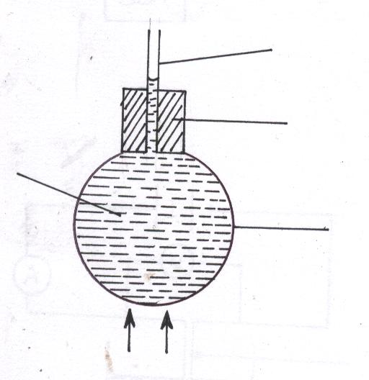
Heat
Glass
Coloured water
Cork
Tube
………………………………………………………………………………………………
………………………………………………………………………………………………
……………………………………………………………………………………………………………………………………………………………………………………………
- Distinguish between speed and velocity. (2mks)
………………………………………………………………………………………………
………………………………………………………………………………………………………………………………………………………………………………………………
- State how the pressure in a moving fluid varies with speed of the fluid. (1mk)
………………………………………………………………………………………………
………………………………………………………………………………………………
- A piece of metal weighs 3N in air and 2N when totally immersed in water. Calculate the volume of the metal (3mks)

- Explain how a person is able to drink a soda using a drinking straw. (2mks)
………………………………………………………………………………………………………………………………………………………………………………………………
- Give a reason why air is not commonly used as the fluid in a hydraulic lift. (1mk)
………………………………………………………………………………………………………………………………………………………………………………………………
- State one assumption made when estimating the size of an oil molecule in the oil drop experiment. (1mk)
………………………………………………………………………………………………
………………………………………………………………………………………………………………………………………………………………………………………………
- The figure below shows a swinging pendulum.
C
BA
A

State the energy conservation taking place as the pendulum moves from A to B and B to C (2mks)
………………………………………………………………………………………………
………………………………………………………………………………………………………………………………………………………………………………………………
- The identical springs of spring constant 3N/cm are used to support a load of 30N as shown.
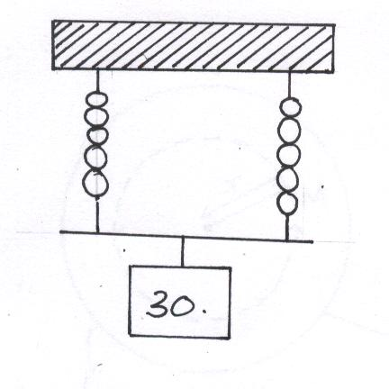
Determine the extension on each spring (3mks)
………………………………………………………………………………………………
………………………………………………………………………………………………
………………………………………………………………………………………………
………………………………………………………………………………………………
………………………………………………………………………………………………
………………………………………………………………………………………………
- In a vacuum flask, the walls enclosing the vacuum are silvered on the inside. State the reason for this. (1mk)
………………………………………………………………………………………………
………………………………………………………………………………………………
- State the features that govern the strength of a spiral spring of a given material. (2mks)
………………………………………………………………………………………………
………………………………………………………………………………………………
………………………………………………………………………………………………
- Sketch velocity-time graph of a body moving down a viscous fluid. (1mk)

SECTION B (55 MARKS)
(Answer ALL the questions in the spaces provided)
- (a) State the principle of conservation of linear momentum. (1mk)
………………………………………………………………………………………………
………………………………………………………………………………………………
  - Calculate the recoil velocity of a gun of mass 0.4kg which fires a bullet of mass 0.0045kg at a velocity of 400ms⁻¹ (3mks)

(i) State two factors which affect frictional force of a body (2mks)
………………………………………………………………………………………………
………………………………………………………………………………………………
………………………………………………………………………………………………
(ii) Suggest three ways in which friction can be minimized (3mks)
………………………………………………………………………………………………
………………………………………………………………………………………………
………………………………………………………………………………………………
………………………………………………………………………………………………
………………………………………………………………………………………………
(iii) State three advantages of friction (3mks)
………………………………………………………………………………………………
………………………………………………………………………………………………
………………………………………………………………………………………………
………………………………………………………………………………………………
………………………………………………………………………………………………

- Fig. 8 shows a cylindrical can filled with a liquid of density 0.8 gcm⁻³. A hole of diameter 2.0 cm is drilled at a depth of 2.8 m from the top of the can.
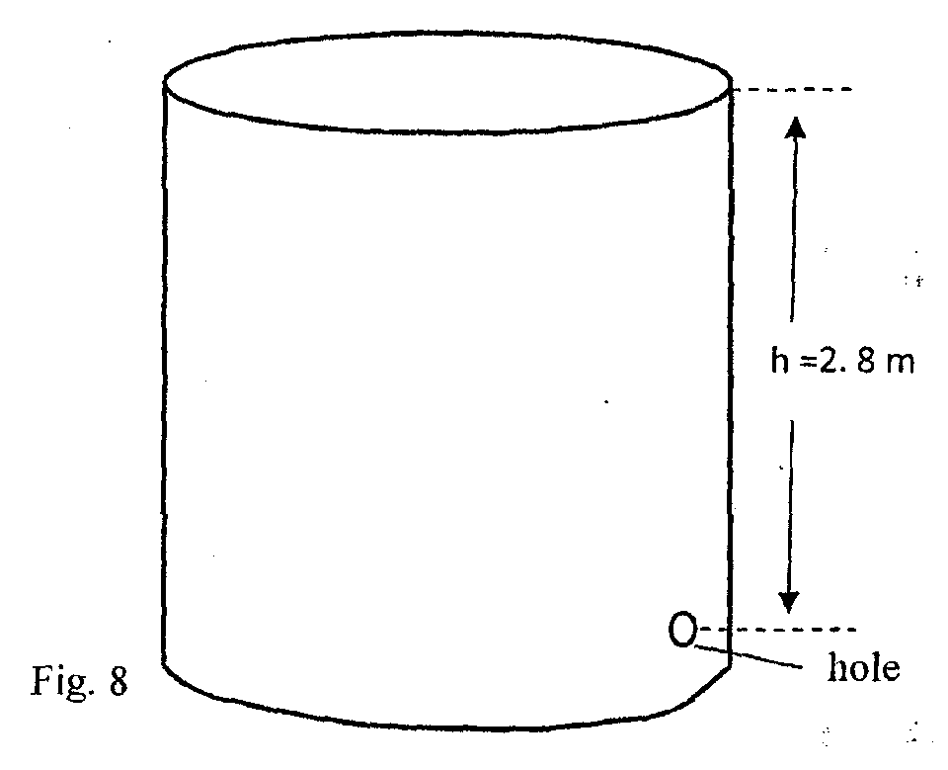
Determine:
- The cross-sectional area of the hole. (2mks)

- The maximum pressure exerted by the liquid at the hole. (2mks)

- The maximum force exerted on a jet of liquid through the hole. (2mks)

- State the principle of moments (1mk)
…………………………………………………………………………………………………………………………………………….………………………………………………………………………………………………………………………………………………
- A metre rule whose centre of gravity is at the 50cm mark balances at the 35cm mark when a mass of 500g is placed at the 25cm mark as shown in the figure 8 below
500g
0 cm
25cm
30cm
100cm
Meter rule

- Determine the mass of the meter rule (3 mks)

- With the metre rule remaining on the knife-edge at the 30 cm mark, a mass of 125g is suspended from the 70 cm mark. The mass of 500g is moved until the rule is balanced. Determine the new position of the 500g mass (3 mks)

- For a body moving with a constant acceleration, a , show that:
- V = u + at where v and u are the final and initial velocities respectively while t is the time taken (2mks)

- S = ut + ½at² where S is the distance covered (2mks)

- A car of mass 1200kg moving at 90km/h is brought to rest over a distance of 20m. Calculate the breaking force (3mks)

- An object is projected vertically upwards with a velocity of 200m/s. Calculate:
- Its velocity after 5 seconds (2mks)

- The distance covered in the first 8 seconds (2mks)

- The maximum height reached (2mks)

- The figure below shows a uniform cardboard in the shape of a parallelogram.

Locate the centre of gravity of the cardboard. (1 mk)
- Two samples of bromine vapour are allowed to diffuse separately under different conditions, one in a vacuum and the other in air. State with reasons the conditions in which bromine diffuse slower. (2 mks)

- State two factors affecting stability of body (2mks)
………………………………………………………………………………………………….………………………………………………………………………………………………….………………………………………………………………………………………………….
- The figure below shows a metal plate 2 m long, 1M wide and negligible thickness. A horizontal force of 50 N applied at point ‘A’ Just makes the plate tilt.
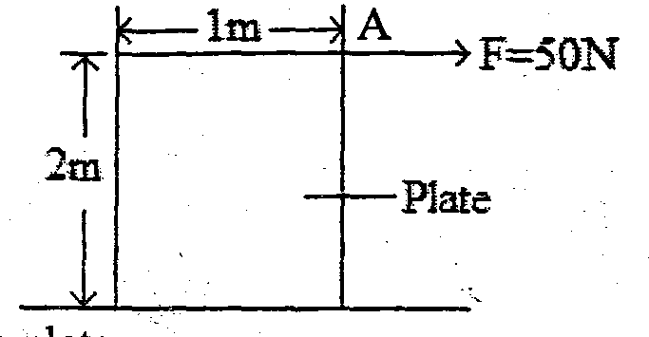

Calculate the weight of the plate. (3mks)

- Fig 4 shows an image I formed by an object placed in front of a convex mirror. C is the centre of curvature of the mirror. Using ray diagram, locate the object position. (3mks)
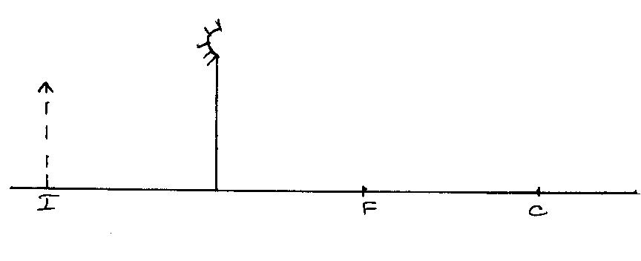

- Fig 6 (i) and (ii) show refraction of light at air-water interface. Determine angle Ø in figure 6(ii) (3mks)
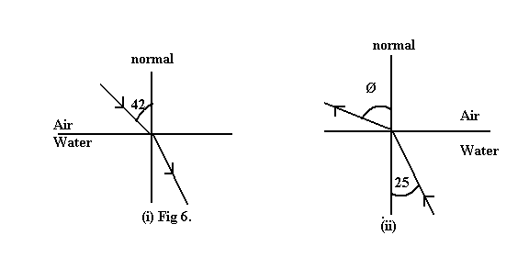
28̊
o

- A ray of light now travels through a transparent medium into the Perspex as shown in the figure below:

C

Transparent medium, n=2.4
Perspex

Calculate the critical angle (3mks)

