PHYSICS 232 MARKING SCHEME FORM 2

- Mass is the quantity of matter in a body while weight is the measure of the pull of gravity on the body.
weight S.I unit Newtons (N ) (½mk)
mass S.I unit Kilogram(kg) (½mk)

- Main scale reading = 7.4cm
Vernier scale reading = 4x0.01 = 0.04cm
Total reading = 7.4 + 0.04 = 7.44 cm (1mk)

- Density of mixture = mass of mixture
Volume of mixture
Mass of fresh water = 1800 x 1 =1800g
Mass of sea water = 2200 x 1.025 = 2255g
Density of mixture = 2255 + 1800
1800 + 2200
= 1.01375g/cm³

- Ice being less dense than water, floats on water. Water at 4ºC being the most dense, remains at the bottom of the lake and aquatic life survives.

- The two balloons move towards each other. On blowing air between the balloons, the speed of air increases and pressure reduces. The high atmospheric pressure on the sides pushes the balloons towards each other.
- Large currents can be drawn from them
They can be kept in a discharged condition for a very long time before the cells are ruined
They require very little attention to maintain
They are lighter (portable) than lead-acid accumulators
- The magnet towards on passing the current on the coil, the core XY is magnetized with the South Pole on Y thus attracting the North Pole of the permanent magnet.
- Convection is the transfer of heat through fluids
Diffusion – is the process by which particles spread from regions of high concentration to those of low concentration.
- The sphere acquires a positive charge by induction method.
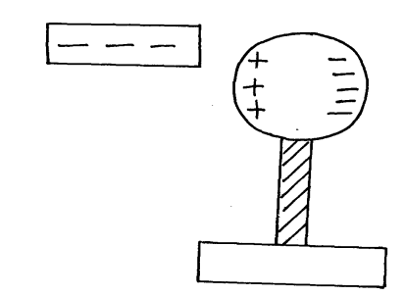
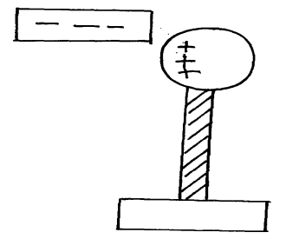
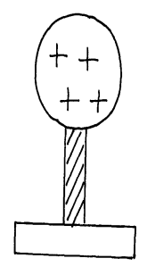
Negative charge to the ground

Earthing

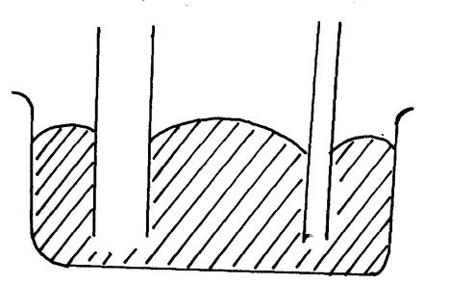
X Y
Y – is lower than x

- w-Mg
1200 = 60xg
g = 1200 = 20N/Kg
60
- -Easily visible
-Expand or contract uniformly
-Have a wide range of temperature
-Not stick to the walls of the glass

Section B

- Pressure is force per unit area S.I unit is N/m² or Pascals.

- -incompressible
-Low freezing point
-High boiling point
-Should not corrode the parts of the brake system
- P_{A} = P_{B}
F₁ = F₂
A₁ A₂
100 = F₂
15 50
F2 = 333.3 N

- P_{A} = P_{B}
Pressure in liquids is transmitted equally in all directions.
- Gas is compressible in liquid is incompressible.
Give reasons why it is n3ecessary to leave the caps of the cells open when charging an accumulator ( 1mk)

For free circulation of air i.e allow Hydrogen to escape.

ii) Define current and state its SI unit ( 2mks)

- is rate flow of charge in a circuit.
S.I unit is Amperes

iii) A charge of 120 coulombs flow through a 1 am every minute. Calculate the current flowing through the lamp. ( 3mks)

I = Ø = 120 = 2A
t 60

iv) What do you understand by open and closed circuits? ( 2mks)

open – no current flows
closed – current flows

a) State the polarities of
A- +ve
B- -ve (2mks)

b) Name the chemical substances in the parts labeled C and D ( 2mks)

C – Ammonium chloride paste
D – Carbon powder and manganese IV oxide.

17. i) The figure shows an arrangement of source of light, an opaque object and a screen. Using A,B and C as point sources, sketch on the same diagram labeled a ray diagram to show what is observed on the screen.

Umbra
penumbra

ii) In a certain pinhole camera, the screen is 10cm from the pinhole. When the pinhole is placed 6cm away from a tree, a sharp image of a tree 16cm high is formed on the screen. Find the height of the tree. ( 3mks)

hi = v
ho u

1.6 = 10cm
ho 6cm

ho = 6x16
10

= 9.6cm
iii) Figure (v) below shows two mirrors, AB and CD at right angles. The ray PO makes an angles of 300 with the mirror AB as shown

60⁰
30⁰
60⁰
Show the path of the ray after reflection from both mirrors indicating the angles of incidences and reflections.
Lunar – Earth in between the sun and the moon
Earth shadow is focused on the moon
Solar – moon in between the Earth and the moon
- moon shadow is focused on the Earth
- occur during new moon.

v) A girl stands 4m in front of a plane mirror.
a) What is the distance between the girl and her image? (3mks)
2x4 = 8m

iv) Distinguish between Lunar and Solar eclipse by sating events that lead to the formation of each. (4mks)
b) If the mirror is moved o.6 m away from the girl what will be the distance between her and the image? ( 4mks)

4 + 0.6 = 4.6 new distance
2 x 4.6 = 9.2m

c) The figure (VI) below shows two parallel mirrors, and an object between them, locate the images by the mirrors using appropriate ray diagrams ( 6mks)

a) correct images and ray diagram (1mk)

18. i) State the basic law of electrostatics ( 1mk)

like changes repel while unlike charges attract.

ii) Explain how you would use an electroscope to distinguish between a conductor
and an insulator ( 3mks)

- charge the electroscope
- touch the cap using the materials
- in case of collapsing of leaf then the material is a conductor but incase of remaining the same then the material is an insulator.

iii) Two conducting balls shown in the figure (VII) below identical and contain the number of excess elements indicated. The balls are made to touch. How much charge in coulombs will each have? (Charge of one electron = 1.6 x 10⁻¹⁹ coulombs) ( 3mks)

Total 12
each = 12 x 1.6 x 10 ⁻¹⁹C
2
= 6x 1.6 x 10 ⁻¹⁹ C

= 9.6 x 10 ⁻¹⁹C

iv) Fill in the table of charges appropriately ( 5mks)

Charge on Electroscope | Charge brought near cap | Effects on leaf divergence
+  - | +  - | Divergence increase  “ decrease
+ or - | Uncharged body | No effect

v) What is the name given to the method of charging an electroscope where it requires an opposite charge to the one of the charging materials?

By induction.

.
Basic physical quantity | Derived physical quantity
- quantities that cannot be obtained from any other physical quantity e.g. length, mass, time, electric current e.t.c | - quantities that can be obtained by multiplication or division of basic physical quantities e.g. area, volume and density (3mks)

2. – oiling
- greasing
- using rollers
- smoothening

3. – This is because cohesive forces between mercury molecules are stronger than adhesive force between molecules of mercury and glass (2mks)

4. This is because a parachute encounters higher resistance as it tails through the air due to large size while a stone experience less resistance due to its small size (2mks)

