Name: ………………………………………………………… Adm. No………..............................

Candidate’s sign: .............................Date……………………...

232
PHYSICS
(THEORY)END TERM 1
TIME: 2½ HOURS

EDUCATOR EXAM SERIES
FORM TWO

INSTRUCTIONS TO CANDIDATES:
- Write your name, admission number, date of examinationand the name of your school in the spaces provided above.
- Sign and write the date of examination in the spaces provided above.
- This paper consists of sections: A and B.
- Answer all the questions in section A and B in the spaces provided.
- All working must be clearly shown in the spaces provided.
- Mathematical tables and electronic calculators may be used.

For Examiner’s Use Only

SECTION | QUESTION | MAXIMUM SCORE | CANDIDATE’S SCORE
A | 1 – 12 | 25
B | 13 | 13
 | 14 | 12
 | 15 | 16
 | 16 | 14
TOTAL SCORE |  | 80

This paper consists of 8 printed pages. Candidates should check the question paper to ascertain that all the pages are printed as indicated and no questions are missing

SECTION A (25MARKS)
Answer all question this section
- Distinguish between mass and weight of a body stating the S.I units for each. (2mks)

- 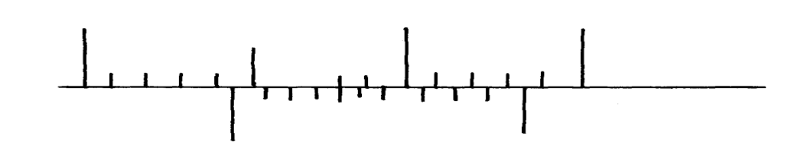The figure below shows part of scale of vernier calipers.
7cm
8cm
0
10

What is the reading indicated on the scale ………………………………………….. (1mk)
- 180cm³ of fresh water of density 100kg/m³ is mixed with 2200cm³ of sea water of density 1025kg/m³. Calculate the density of the mixture (4mks)

- Explain why fish can survive under water when the surface is already frozen (2mks)
……………………………………………………………………………………………………..
……………………………………………………………………………………………………..
……………………………………………………………………………………………………..
……………………………………………………………………………………………………..
- 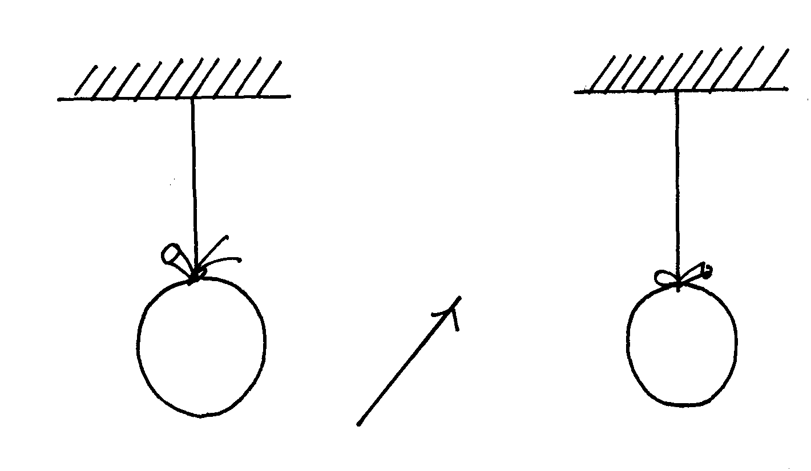Two inflated balloons are at the same level while suspended from threads a short distance apart as shown below;
Air blown

Some air is blown gently in the space between the balloon in horizontal direction. Explain
what happens to the balloons. (2mks)
……………………………………………………………………………………………………..
……………………………………………………………………………………………………..
……………………………………………………………………………………………………..
- State one advantage of an alkaline battery over a lead acid battery. (1mk)
……………………………………………………………………………………………………..
- 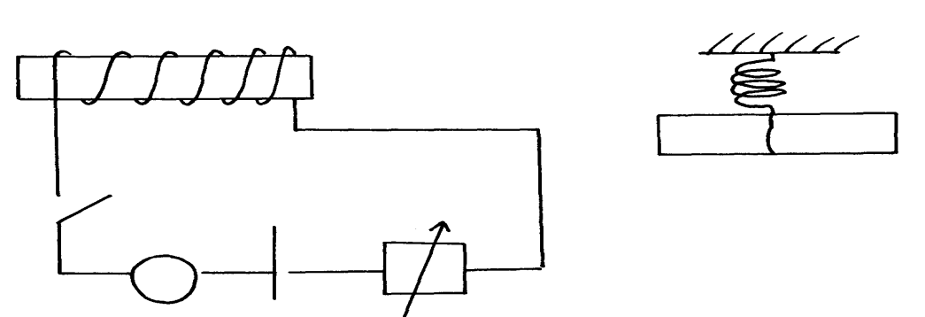The diagram below shows a permanent magnet suspended by a spring. State with reason the behaviour of the magnet when the switch is closed. (2mks)
Spring
S
A
Y
N S
X
+ -

……………………………………………………………………………………………………..
……………………………………………………………………………………………………..
- Convection and diffusion both involve motion of fluids. Distinguish between the two. (2mks)
……………………………………………………………………………………………………..
……………………………………………………………………………………………………..
……………………………………………………………………………………………………..
……………………………………………………………………………………………………..
- A negatively, charged rod is brought close to (but not touching ) an uncharged sphere. If the
sphere is momentarily earthed and then the rod is removed, briefly explain what happens. (2mks)
……………………………………………………………………………………………………..
……………………………………………………………………………………………………..
- Indicate on the diagram below, the level of mercury in the tubes X and Y (2mks)
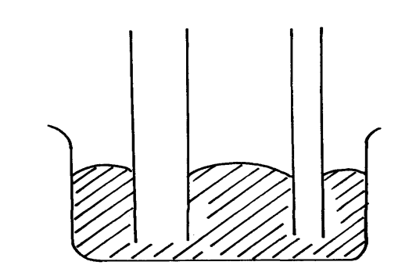
Mercury
X
Y

- An object weighs 1200N on a certain planet. What is the gravitational field strength of this
planet if the object is 60kg? (3mks)

- State two properties of a thermometric liquid. (2mks)
……………………………………………………………………………………………………..
……………………………………………………………………………………………………..
SECTION B (55MARKS)
Answer all question this section

- Define pressure and give its S.I nits. (2mks)
……………………………………………………………………………………………………..
……………………………………………………………………………………………………..
- The diagram below represents a motor car hydraulic braking system;
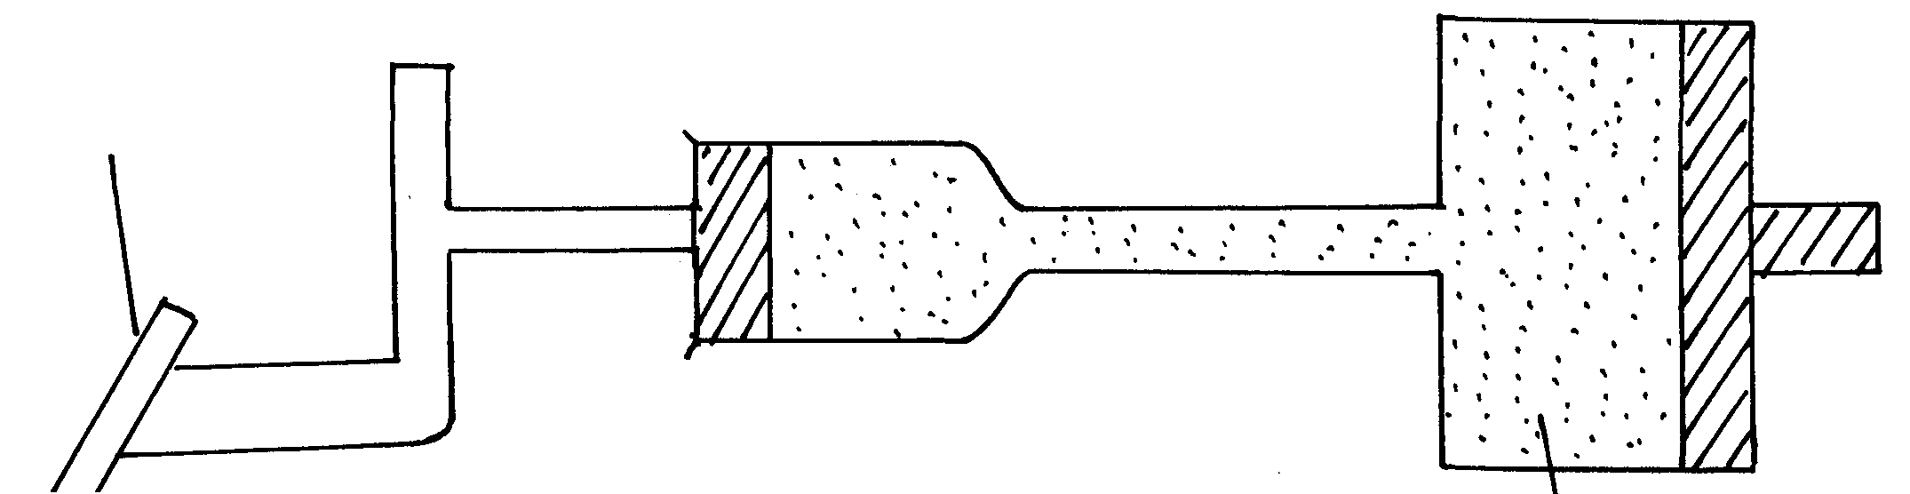
Brake pedal
Master piston
Slave piston brake fluid
B
A

- State two properties of the liquid used as a brake fluid (2mks)
……………………………………………………………………………………………………..
……………………………………………………………………………………………………..
- Given that in the diagram (b) above the master piston has an area of 15cm² and the slave
piston has an area of 50cm² a force of 100N is applied on the master piston. Find the force
used to stop the car. (3mks)

- Compare the values of pressure in the two pistons above and give a reason for your
answer. (2mks)
……………………………………………………………………………………………………..
……………………………………………………………………………………………………..
- Give a reason why gas is not suitable for use in place of the brake fluid. (1mk)
……………………………………………………………………………………………………..

- Xcm³ of substance A which has density of 800kg/m³ is mixed with 100cm³ of water with a
density of 1000kg/m³. The density of the mixture is 960kg/m³. Determine the value of X (3mks)

- Give reasons why it is necessary to leave the caps of the cells open when charging an accumulator ( 1mk)
……………………………………………………………………………………………………..……………………………………………………………………………………………...
- Define current and state its SI unit ( 2mks)
……………………………………………………………………………………………………………………………………………………………………………………………………..………………………………………………………………………………………………………………………………………………………………………………………………
- A charge of 120 coulombs flow through a 1 am every minute. Calculate the current flowing through the lamp. ( 3mks)

- What do you understand by open and closed circuits. ( 2mks)

C
B
D
D

- State the polarities of A and B. (2 mks)

……………………………………………………………………………………………………..
……………………………………………………………………………………………………..

- Name the chemical substances in the parts labeled C and D ( 2mks)

……………………………………………………………………………………………………..
……………………………………………………………………………………………………..

- The figure shows an arrangement of source of light, an opaque object and a screen. Using A, B and C as point sources, sketch on the same diagram labeled a ray diagram to show what is observed on the screen. (3mks)

A
B
C

- In a certain pinhole camera, the screen is 10cm from the pinhole. When the pinhole is placed 6cm away from a tree, a sharp image of a tree 16cm high is formed on the screen. Find the height of the tree. ( 3mks)

- Distinguish between Lunar and Solar eclipse by stating the events that lead to the formation of each (4mks)

……………………………………………………………………………………………………..
……………………………………………………………………………………………………..
……………………………………………………………………………………………………..
……………………………………………………………………………………………………..
……………………………………………………………………………………………………..
……………………………………………………………………………………………………..

- A girl stands 4 m in front of a plane mirror
- What is the distance between the girl and the mirror (3mks)

- Explain how you would use an electroscope to distinguish between a conductor and an insulator (3mks)
…………………………………………………………………………………………………..…..……………………………………………………………………………………………………..……………………………………………………………………………………………………..……………………………………………………………………………………………………..……………………………………………………………………………………………………..……………………………………………………………………………………

- Fill in the table of charges appropriately ( 5mks)

Charge on Electroscope | Charge brought near cap | Effects on leaf divergence
+  - | +  -
+ or - | Uncharged body

- What is the name given to the method of charging an electroscope where it requires an opposite charge to the one of the charging materials? (1mk)

……………..……………………………………………………………………………………
……………..……………………………………………………………………………………
- Distinguish between a basic physical quantity and a derived physical quantity giving an example of each. (3mks)
Physical quantity | Derived physical quantity

- State any two ways by which frictional force between two surfaces can be reduced. (1mk)
………………………………………………………………………………………………..……..………………………………………………………………………………………………

- Explain why large mercury drops form oral ball on a glass slide (2mks)
……………………………………………………………………………………………………..……………………………………………………………………………………………………..……………………………………………………………………………………………………………………………………………………………………………..…………………
…………………………………………………………………………………..………………
- Explain why a man using a parachute falls through air slowly while a stone falls through air very fast. (2mks)
………………………………………………………..……………………………………………..……………………………………………………………………………………………………..……………………………………………………………………………………………

