Name: ………………………………………………………..AdmNo.:………………CLASS:…...............

232/1
PHYSICS
PAPER 1
(THEORY)
TIME: 2 HOURS

SECTION A: (25 MARKS)
Answer all questions in this section.
1. A partially inflated balloon at sea level becomes fully inflated at higher altitudes. Explain this
observation (2mks)
…………………………………………………………………………………………………………
…………………………………………………………………………………………………………
2. Xcm³ of substance A of density 800kgm⁻³ is mixed with 100cm3 of water of density 1000kgm⁻³. The
Density of the mixture is 960kgm⁻³. Determine the value of x. (3mks)

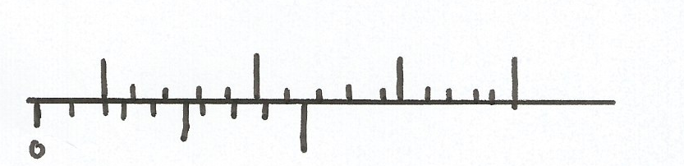
3. The figure below shows part of a vernier caliper when the jaws are closed without an object between
the jaws
0 cm
0
1

(a) What is the value of the zero error of the callipers? (1mk)
………………………………………………………………………………………………………
(b) A student used the same vernier calipers in (a) above to measure the diameter of a test tube
whose actual diameter is 2.15cm. what was the reading shown by the calipers. (1mk)
…………………………………………………………………………………………………………
4. The figure below shows a bimetallic wheel whose diameter is not affected by changes in
temperature. Briefly explain how the diameter of the wheel remain unchanged as the temperature
increases (3mks)
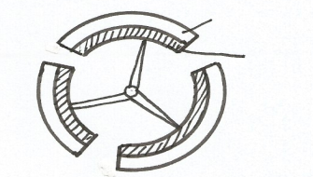
Brass
Iron

…………………………………………………………………………………………………………
…………………………………………………………………………………………………………
…………………………………………………………………………………………………………

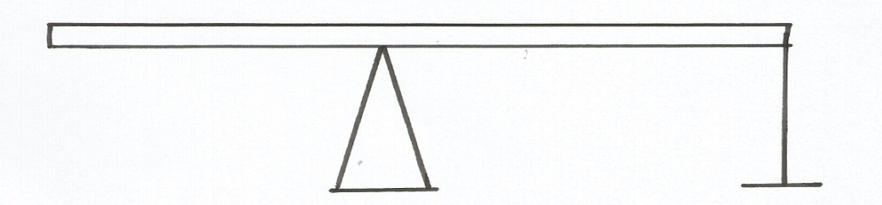
5. A uniform meter rule of mass 40g is pivoted at the 60cm mark and held horizontally with a vertical
0 60 100
String
String as shown below. Determine the tension in the string. (3mks)

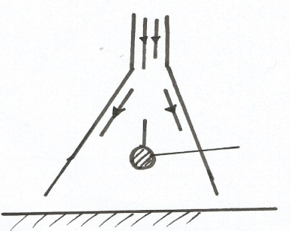
6. The figure below shows a pith ball being lifted into the funnel by blowing air into the funnel
Pith ball
Air blown

Explain this observation (2mks)
…………………………………………………………………………………………………………
………………………………………………………………………………………………………….
7. Explain why a hole in a ship near the bottom is more dangerous than the one near the top (1mk)
…………………………………………………………………………………………………………
………………………………………………………………………………………………………….
8. A bullet of mass log travelling at a speed of 400ms-1 hits a tree trunk, it penetrates the tree trunk and
stops inside the trunk after 4 cm.
(a) Calculate the average resistance force offered by the trunk to the bullet. (3mks)

(b) State the energy changes that takes place. (1mk)
………………………………………………………………………………………………………
9. State the effect on motion of smoke particles when the temperature inside the smoke cell is
lowered. (1mk)
…………………………………………………………………………………………………………
10. (a) Explain the washing effect of soap. (1mk)
…………………………………………………………………………………………………………
…………………………………………………………………………………………………………

(b)State one way of making surface tension of water stronger. (1mk)
…………………………………………………………………………………………………………

SECTION B (55 MKS)
Answer all questions in this section

11. (a) A modern car has a strengthened passenger cage but with front and back regions which can
collapse in a crash. Explain how this collapsible regions should reduce injury in a car crash.
(3mks)
…………………………………………………………………………………………………………
…………………………………………………………………………………………………………
…………………………………………………………………………………………………………
(b) An object of mass 150kg moving at 20m/s collides with a stationery object of mass 90kg. They
couple after collision. Determine;
(i) The total momentum before collision (2mks)

(ii) Total momentum after collision (1mk)

(iii) Their common velocity after collision (2mks)

12. (a) Distinguish between velocity and speed. (1mk)
…………………………………………………………………………………………………………
………………………………………………………………………………………………………….
(b) The velocity time graph in the figure below illustrates the motion of a ball which has been
projected vertically upwards from the surface of a planet. The weight of the ball on earth is 30N

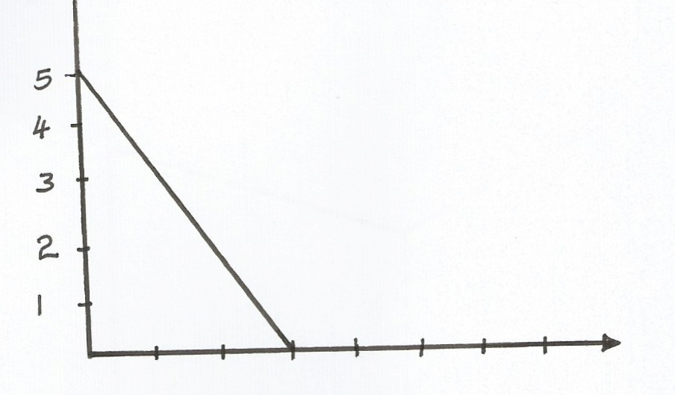
5
4
3
2
1
1 2 3 4 5 6 7 time (s)
V (m/s)

Determine the weight of a ball on the planet (3mks)

c) The figure below shows a section of a tape from a ten tick timer whose frequency is 50 Hz.
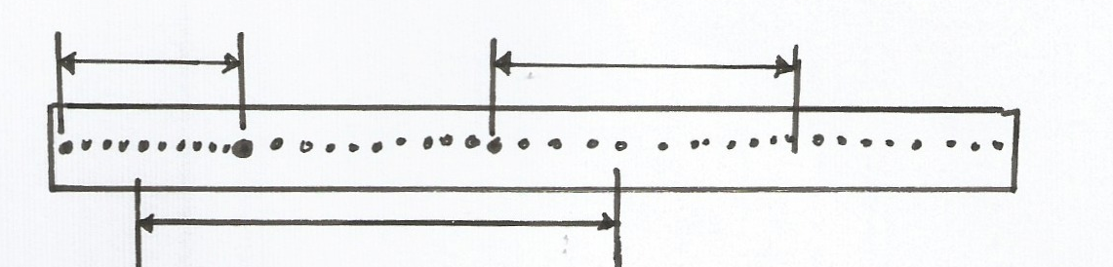
Y 10 ticks Z
30 ticks
W 10 ticks X
10cm
30cm

Calculate;
(i) The average velocity of the trolley between points
1. WX (2mks)

2. YZ (2mks)
(ii) Find the acceleration of the trolley. (2mks)

13. (a) State Hooke’s Law. (1mk)
…………………………………………………………………………………………………………
…………………………………………………………………………………………………………
(b) The figure below shows the variation force with extension for a steel coil spring.
(i) On the same axes, sketch the variation of force with extension for a wire form which the spring
is made. (1mk)

Force N
Extension cm

Explain the difference between the two lines drawn (2mks)
…………………………………………………………………………………………………………
…………………………………………………………………………………………………………

(c) A stone of mass 5g is released from a catapult. The catapult is stretched by 10cm. If the constant
of elasticity is 100N/cm. Calculate;
(i) The horizontal velocity with which the stone is released (3mks)

(ii) Sketch a graph of horizontal velocity against time from the time the stone is released to when it
reaches the ground. (1mk)

(d) The following results were obtained in a experiment to verify Hooke’s law when a spring was
extended by hanging various loads on it.
Load (N) | 0.00 | 1.00 | 2.00 | 3.00 | 4.00 | 5.00 | 6.00
Length of spring in cm | 10.00 | 11.50 | 13.00 | 14.50 | 16.00 | 18.00 | 24.00
Extension | 0.00
(I) Complete the table for the extension e above. (1mk)
(II) Plot a graph of load (y-axis) against extension (3mks)

(III) From the graph determine the springs constant. (2mks)

(IV) Calculate the energy stored when the spring is stretched to 16 cm. (3mks)

14. (a) State two advantages of mercury over alcohol as a thermometric liquid. (2 mks)
…………………………………………………………………………………………………………..
…………………………………………………………………………………………………………..
(b) When making the fixed points on a thermometer it is observed that at 0⁰c the mercury thread is of
length 2 cm and 8 cm at 100⁰c. What temperature correspond to a length of 6 cm. (3 mks)

(c) (i) The figure below shows how volume of a given mass of water varies with temperature.

Volume
4⁰c Temperature

On the graph provided, sketch a graph of density against Temperature.
Density
Temperature

(ii) Sate and explain one effect of the anomalous expansion of water. (2 mks)
……………………………………………………………………………………………………………………………………………………………………………………………………………………..
(d) The figure below shows a bimetallic strip made of copper and iron at room temperature.
Copper

iron

If copper expands more than iron. Identify A and B if the bimetallic strip is placed in a
refrigerator whose temperature is -70⁰c. (1 mk)

A ……………………………………………………………….
B ………………………………………………………………..
15. The figure below shows a system used to draw water from a well. An effort is applied on the handle
which turns on a radius of 70 cm. As the handle turns a rope is wound on the drum of diameter 28
cm, thus raising a bucket of water from a well.

- If an effort of 10N is needed to lift a bucket full of water of mass 4 kg.
Calculate:
i) The energy gained by the water and bucket when the drum turns through one revolution.
(3 mks)

ii) The work done by the effort during this one revolution. (3 mks)

- Calculate the velocity ratio of the system. (1 mk)

- Calculate the efficiency of the system. (3 mks)

