Kenya Certificate of Secondary Education (K.C.S.E.)
Physics
Paper 3
FORM 4 Marking scheme
- iii)
Length from A to B (cm) | 80 | 76 | 72 | 68 | 64 | 60
Time for 10 oscillations(s) | 10 | 11 | 12 | 13 | 14 | 15
Period time T (s) | 1.0 | 1.1 | 1.2 | 1.3 | 1.4 | 1.5
T²(S²) | 1.00 | 1.21 | 1.44 | 1.69 | 1.96 | 2.25
2θ | 150⁰ | 138⁰ | 130⁰ | 108⁰ | 104⁰ | 96⁰
θ | 75⁰ | 69⁰ | 65⁰ | 54⁰ | 520 | 48⁰
Cos θ | 0.2588 | 0.3883 | 0.4226 | 0.5878 | 0.6157 | 0.6691
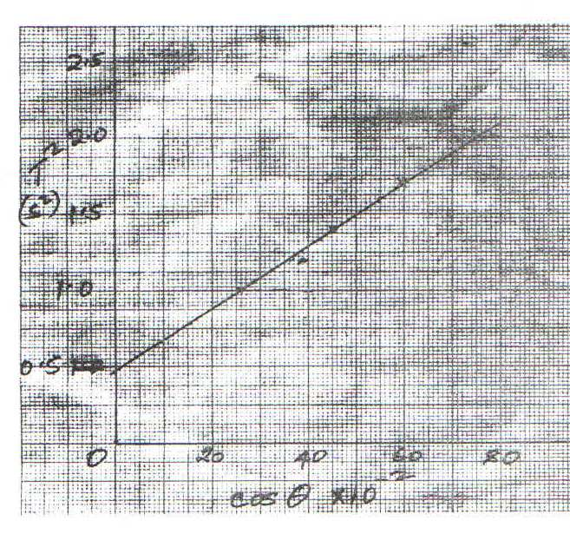
f)

g) $Slope s=\frac{change in y}{change in x}=\frac{∆y}{∆x}=\frac{1.5-1.0}{50-25}=2$
h) $K=\frac{1.6π^{2}}{s}=\frac{1.6x{\left(\frac{22}{7}\right)}^{2}}{2}=0.8x\left(\frac{22}{7}\right)=7.9$
2. a) ii) V=2.7volts
vi)
Length l(cm) | 10 | 20 | 30 | 50 | 80
Current | 0.86 | 0.48 | 0.43 | 0.255 | 0.205
p.d V(v) | 2.1 | 2.3 | 2.4 | 2.5 | 2.6
Y-V | 0.6 | 0.4 | 0.3 | 0.2 | 0.1
$$\frac{V}{Y-V}$$ | 3.5 | 5.75 | 8.0 | 12.5 | 26
$$\frac{V}{I}=R$$ | 2.442 | 4.792 | 5.581 | 9.804 | 12.683

vii) a)
5
10
15
20
25
30
-2
4
6
8
10
12
14

$$\frac{V}{Y-v}$$

b) $Slope M=\frac{R}{∆\left(\frac{V}{Y-v}\right)}=\left(\frac{26-0}{12.6-2.6}\right) =12.751(values extracted from the graph)$
c) d=2.6Ω intercept on R axis1
$m=Gradient x51=\left(12.75x5\right)=63.75$
Part B
L₁cm | L₂ | $$\frac{L_{1}}{L_{2}}$$
30 | 50.0±2 | 0.60
60 | 27.5±2 | 2.18

$f1=\frac{L_{1}}{m+1}=\frac{30}{1.6}=18.75$
$f2={60}/{3.18}=18.75$

$\frac{f_{1}+f_{2}}{2}=\frac{18.75+18.87}{2}=18.81$

