232/2
PHYSICS PAPER 2
(THEORY)
FORM FOUR
MARKING SCHEME

- - When the object distance from the pinhole is equal to the image distance.
- When the screen is as large as the object1(any 1) Give 1 mk
- i) Diffraction1
ii) Interference.1
The two opening acts as two source1 hence the two waves interfere producing soft and loud sound along the way1
- a) Transformer uses a.c only while induction coil uses d.c
b) Transformer produces a humming sound while induction coil is quiet1
- i) Region C 1
ii) Microwaves – for cooking in microwave ovens. (any 1x1 = 1 mk)
iii) For communication – satellite communication
- i) The electrons emitted from the zinc plate1 are attracted by the positive charge on the electroscope, hence the leaf does not fall.1
ii) Electrons emitted from the zinc plate are repelled by the 1 negative charge on the electroscope hence the leaf falls.
- a) Enlarged
Any 2 (2x1= 2 mks)
b) Virtual
c) Erect/ upright
- E = IR + Ir
3.0 = I $×$3.5 $×$I $×$0.51
$∴$ I = 0.75A;
- E = p $×$ t
3 $×\frac{180}{60}$1
= 9kWh1
- V = $\frac{d}{t}$
1500 = $\frac{d}{0.2}$1
d = 150 $×$ 2 = 300m1
- i) Soft iron1 since it is easily magnetized and demagnetized.
ii) - Increasing the amount of current 1
- Increasing the number of turns on the coil1
- Refractive index of perplex = $\frac{Sin {90}^{0}}{Sin {42.5}^{0}}$1
= $\frac{1}{Sin {42.5}^{0}}$1 = 1.481
- Period = $\frac{0.03}{3}$ = 0.011
f = $\frac{1}{T}$ = $\frac{1}{0.01}$1
f = 100Hz
- a) - Risk of electric shock in case pole collapses
- Can cause fires to vegetation and structures
- Harmful effects from e-m radiations due to effects of electric field.
b) i)
- Fuse is connected to the neutral wire instead of live wire.
- Bulbs are connected to the neutral wire which is at zero potential instead of the live1 wire
ii)
- So as to receive the full voltage 1 from the source.1
c) i) An a.c generator (dynamo)1
ii) A – armature1
B – slip rings1
iii) The voltage of the induced e.m.f 1 doubles1
d) i) f = $\frac{1}{T}$ = $\frac{1}{0.1}$1
= 10Hz1
ii) The slip rings have been replaced by split 1 rings (commuters)
- a) A – Cathode rays/ electrons/ electron beam
B – Anode / copper Anode (both correct 2 x ½ = 1 mk)
b) Change in p.d across PQ cause change in filament 1 current OR temperature of cathode increases. This changes the number of electrons released by the cathode1 hence intensity of X- rays.
c) High density1
d) Q = 1t
= 20 $×$ 10⁻³$×$1
Total change of electrons = ne
20 $×$10⁻³ = n $×$1.6 $×$ 10⁻¹⁹1
n = 1.25 $×$10¹⁷ electrons1

e) i) photo emmisive1
ii)
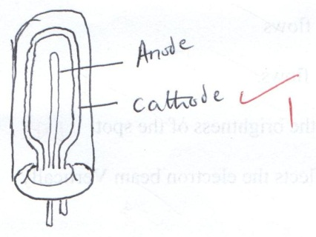
iii) E = hf
hf = hfo + K.E max
6.63 x 10⁻³⁴ x f = 6.63 x 10⁻³⁴ x 5x10¹⁴ + 9.95x 10⁻²⁰
= 3.315 x 10⁻¹⁹ + 9.95 x 10⁻²⁰1
6.63x10⁻³⁴f = 13.265 x 10⁻¹⁹1
f = 2.001 x 10¹⁵ Hz1
- a) i) In $\left({}_{6}^{12}C\right)$, the neutron to proton ratio is one1 thus stable, while $\left({}_{6}^{14}C\right)$ N/P$>$1 thus unstable.
ii) Actual rate = 82–10= 72c/s,19-10 = 9c/s1
4
3
1
72 →36 →18 →9
$\frac{2}{0}$→3 half lies
t½ = $\frac{210}{3}$ = 70 sec 1
b) The radiations ionize argon gas1 along their path. The alcohol vapour condense on the ions formed creating tracks.
c) i) Lower the temperature in the chamber thus making it possible for the alcohol vapour to condense.
ii) The nature of radiation1 can be identified
d) i) Doping in the introduction of an impurity1 into a pure semiconductor to improve its conductivity.
ii) Formed by adding a pentavalent atom (phosphorous) to a group 4 semi conductor (silicon) and an extra electron is left unpaired and is available for conduction. 1 It’s called n-type because the majority carriers are electrons.
e) Diode is forward- biased; current flows1
Diode- reverse- biased; no current flows1
- a) i) A – Grid….. Controls the brightness of the spot
B – Y- plates….. deflects the electron beam vertically.
iii) When the cathode is heated, electrons are emitted from it through thermionic emission which are then accelerated and focused by1 the anode to the fluorescent screen.
iv) Low work function1
b) i) T =4 X 100
= 400MS1
f = $\frac{1}{T}$ = $\frac{1}{400 × {10}^{-3}}$ = 2.5Hz1
ii) = n $×$Y-gain
= 2 $×$1201
= 240V1
- a)
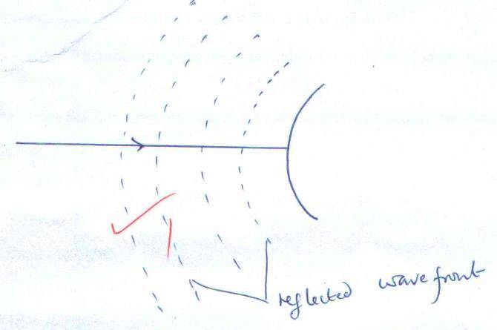
Reflected wavefront
b) Sound waves have longer wavelengths1 thus they cannot be diffracted by narrow slip. (2mks)
c) There is hot air high above the ground1 sound travels faster in hot air than in cold air 1 hence change in wavelength (2 mks)
d) i) Adjust the position of the lens until a sharp image of the flame is observed1
- Record the object distance (u) and the image distance (V)
- Repeat with different object positions1
- Use the relation f = $\frac{uv}{u+v}$ to determine f 1
ii) Diverging lens produces a virtual image which cannot 1 be formed on a screen
e) At $\frac{1}{u}$ intercept, $\frac{1}{v}$ = 2.5 $×$10⁻² cm⁻¹1
$\frac{1}{f}= \frac{1}{u}+ \frac{1}{v}$
= 2.5 $×$10⁻²
$∴$ f = $\frac{1}{2.5}×$ 10⁻² 1 $\frac{1}{0.025}=40cm$1

