NAME………………………………………………...………………………...……………….…
SCHOOL………………………………….……………………………………………….………
ADM NO.………………………………. DATE……………………..………………………..
STUDENT’S SIGN……………………....

GEOGRAPHY
END TERM 1 2021
Time: 2 Hours

TRIAL EXAM SERIES
FORM TWO

INSTRUCTIONS TO STUDENTS
1. Answer all questions in this question paper.
2. All your answers must be written in the spaces provided in this question paper.

1 (a) What is an eclipse? (2mks)

(b) State the characteristics of the earth’s core (4mks)

2. The diagram below shows the structure of the earth. Use it to answer question(a)

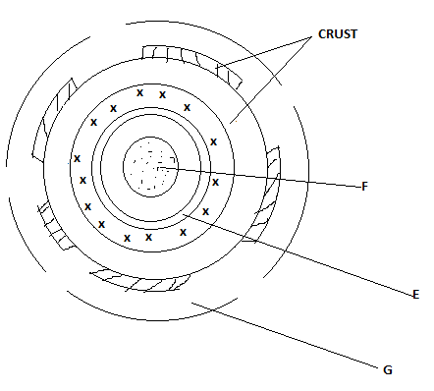
- Name the parts marked E,F and G (3mks)

- State four characteristics of the part labeled G. (4mks)

3. (a) Identify three forms of rock metamorphism. (3mks)
(b) State the extrusive equivalent of earth of the following intrusive igneous rocks (3mks)
(i) Granite
(ii) Diorite
(iii) Gabbro

4 (a) What is a seismic wave? (2mks)
(b) State 4 ways in which earthquake affects human activities (4mks)

5 (a) Differentiate between fissure and vent eruption (2mks)

(b) Describe how the following features are formed (i) Batholiths (6mks)
(ii) Volcanic plug (5mks)
- Explain 4 negative effects of Volcanicity on human activities (8mks)
- You are planning to carry out a field study on features formed by volcanicity on the landscape
- Formulate two null hypotheses (2mks)
- Name two drainage features you are likely to study (2mks)
6 (a) State four ways in which minerals occur (4mks)
(b)(i) Othe than shaft method name two other underground methods of mining (2mks)
(ii) Kenya recently discovered petroleum in Ngamia II Turkana. State five positive effects that Kenya is likely to benefit from (5mks)
(c) Explain four ways in which Kenya has benefited from the mining of soda ash from Lake Magadi (8mks)
(d) State six adverse effects of gold mining to the environment of South Africa (6mks)

