CHEM P2 F3
1.(a) (i) Element A and B
- Both have 6 electrons to achieve an octet.
(ii) Oxide of B forms an alkaline solution that turns red litmus blue.
Oxide of D forms acidic solution, that turns blue litmus red.
(iii) E has a bigger ionic radius than the ionic radius of C.
E forms ions / ionizes by gaining electrons; which C ionizes by lose of electrons.
(iv) Formula; GH₂1 (Rej H₂G)
(v) Oxide of D is molecular with weaker vander waals forces, while the oxide of B is a giant ionic structure with stronger ionic bonds.
(vi) GCO_{3(S)} GO_{(S)} +CO_{2(g)} 1
(b) B + Cl₂ BCl₂
1.5 litres of Cl₂ 5.9375 of BCl₂
24 litres of Cl₂ = (5.9375 × )g BCl₂
= 95g
RFM of BCl₂ = 95
RAM of BCl₂ = 95-71=24
Or
B + Cl₂ BCl₂
Moles of Cl₂ used = = 0.0625 moles
0.0625 moles Cl₂ = 5.9375g BCl₂
1 mole =
RAM of B = 95 – 71 =24. (a) Gas A – Carbon (iv) oxide ½
2.Gas B – Ammonia gas ½
(b) Liquid C – Ammonium Chloride Solution ½
Solid D - Sodium Hydrogen Carbonate ½
(c) NH₄HCO₃ _{(aq)} + NaCl _{(aq)} NaHCO₃ _{(s)} + NH₄Cl _{(aq)}
Ca (OH) _{2(aq)} + 2NH₄Cl _{(aq)} CaCl_{2 (aq)} ++ 2NH_{3 (g)} + 2H₂O _{(l)}
Penalize ½ if not balance
½ if there are no states
(d) Ammonia - Manufacture of fertilizers
- Manufacture of Nitric acid
- Refrigerant
- Softening water
CaCl₂ - Drying agent Name 1
Use 1
(e) - Making of glass
- Softening water
- Making sodium silicate used in making detergents any two1
- Paper Industry
3. (i) Condenser
(ii) To indicate when a liquid is boiling, a thermometer reads a constant temperature
(iii) A
(iv) Ethanol

Reason:- It has a lower boiling of 78ºC compared to water with a boiling point of 100ºC
or - The liquid with the lower boiling point boils first and its vapours are condensed

and the condenser to be collected as the first distillate

(v) Fractional distillation
(vi) - To separate components of crude oil
- To isolate O₂ and N₂ from air
- To manufacture spirits

(vii)- They are immiscible liquids
- They have different but close boiling points

4.a) To remove any magnesium oxide coating from the surface of magnesium// To remove any
oxide film on it

b) White solid which is magnesium oxide
c) Increase in mass was due to oxygen which combined with magnesium
d) 2Mg(s) + O_{2(g)} _______ 2MgO(s)
Penalize ½ for wrong or missing state symbols
e) The filtrate is magnesium hydroxide which is an alkaline
Red litmus paper changed blue, but blue litmus paper remained blue
II. a) N₂O 1 (Nitrogen (I) oxide) – Denitrogen Oxide.
b) K₂O 1 (Potassium oxide)
c) Al₂O₃ (Aluminium oxide)
(i) Yellow lead (II) oxide turned to red then grey.
(ii) I. H_{2(g)} + PbO_{(s)} H₂O_{(l)} + Pb_{(s)}
II. 2H_{2(g)} + O_{2(g)} 2H₂O_{(l)}
(iii) Reducing properties of hydrogen
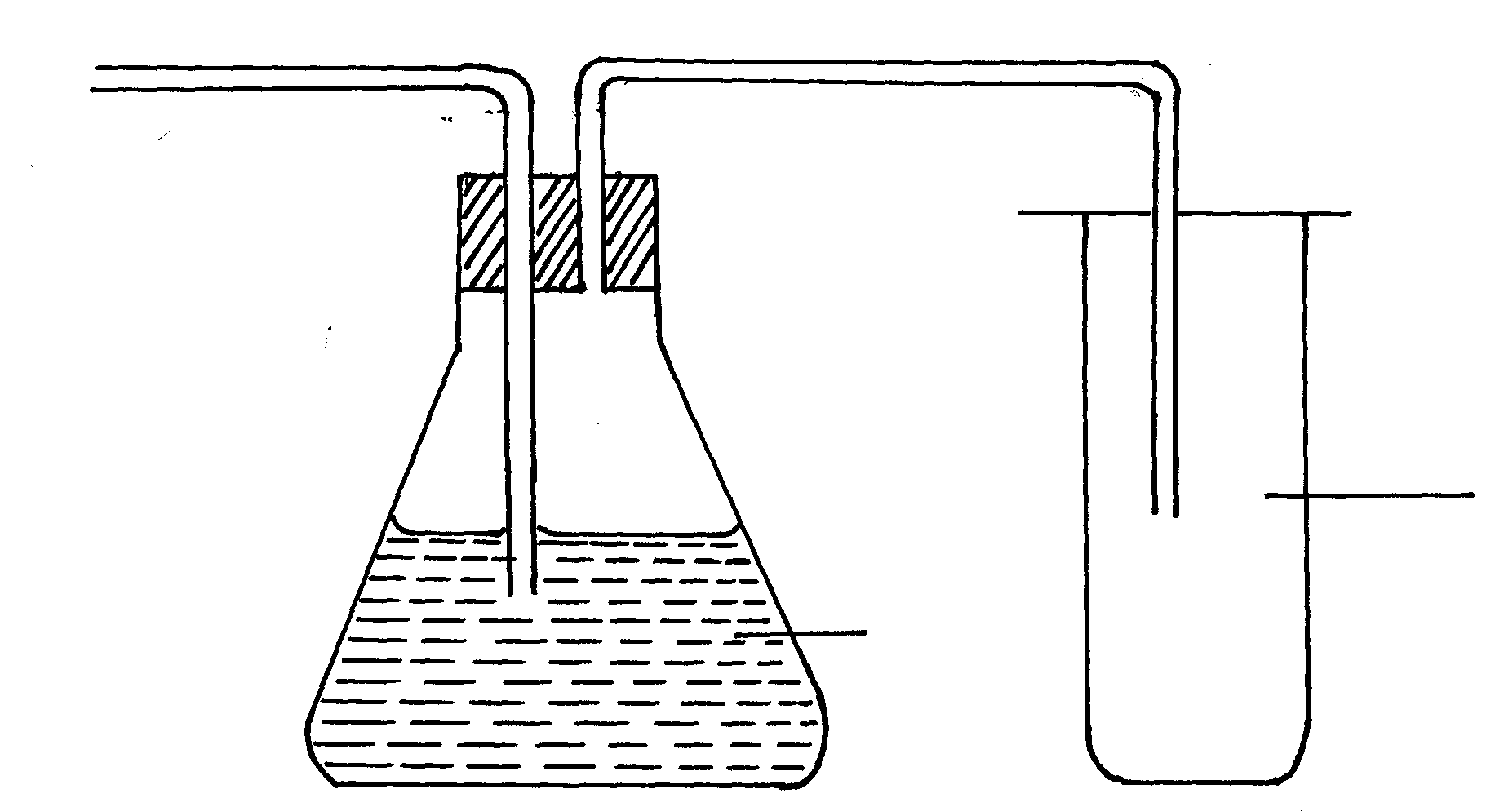 Combustion nature of hydrogen
Dry HCl
Conc. H₂SO₄
HCl_{(g)}
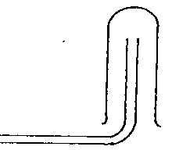
5. (a)

(b) M is hydrogen
(c) Conc. H₂SO₄ is a less volatile hence displaces a more volatile and from its salts i.e
(a) 5 electrons
(b) 11-5 = 6 neutrons
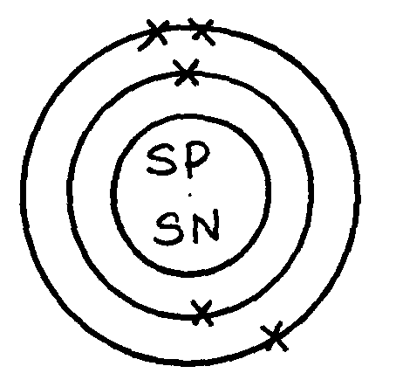
(c) ²⁰/₁₀₀ x 10 + ⁸⁰/₁₀₀ x 11 = 2+ 8.8 = 10.8

(d)
a) 3 M_{g} + N_{2 g} ________ M_{g 3} N_{2 g}
b) Argon
- It is inert
a) 3 M_{g} + N_{2 g} ________ M_{g 3} N_{2 g}
b) Argon
- It is inert
c)Haber process to manufacture ammonia
Hydrogenation
Welding
6.a) magnesium Oxide
b) 2Mg_{(s)} + O2_{(g)} _________ 2MgO_{(s)}
c) i) Sodium sulphate
ii) MgCO₃
d) MgO_{(s)} + H₂SO_{4(aq)} ________ M_{g}SO_{4(aq)} + H₂O_{(L)}
e) Mg²⁺_{(aq)} + CO²⁻ _{3(aq)}________ M_{g}CO_{3(s)}
f) M_{g}CO_{3(g)} _________ M_{g}O_{(g)} + CO_{2(g)}
g) Na⁺ ions and SO₄²⁻ ions
h) Precipitation/ double decomposition

7.
- Z- Anhydrous calcium chloride √1mk
Q- Water
- Reducing agent / effect √1mk
Combustible gases / burning of hydrogen in air.
- The flame should be blown out √½ mk first as the supply of hydrogen continues to avoid explosion.√ ½
Heating of CuO should be √½ mk stopped to prevent re-oxidation √½ mk of hot copper before √½ mk the supply of hydrogen is stopped.
- Hydrogen so produced is at once oxidized to water √1mk ( strong oxidizing agent )
Likelyhood of producing poisonous gases such as nitrogen (IV) oxide. √1mk

- Water molecules has lone pairs√1mk of electrons which can be donated √mk and be shared with H⁺ to form H₃O⁺
- Is less dense than air / lighter than air. √1mk

