COMPUTER STUDIES Paper 1 MARKING SCHEME
SECTION A (40 MARKS)
1. What is meant by:
(a) Analogue data: Data that is based on physical variations such as loudness and
pitch, electoral voltages etc
(b) Digital Data- Data, which use the computer‟s binary number systems 0 and 1

2. Distinguish between transcription and transportation types of errors and
give an example of each
- A transcription error is a specific type of data entry error that is commonly made
by human operators or by optical character recognition (OCR) programs
E.g. Name: Stamley (wrong) instead of Stanley (Correct)
- A transposition error is an error caused by reversing two or more digits of an
amount while posting transactions. These are almost always human in origin
An Example is ZIP code: 57429 (wrong) instead of 54729 (correct)

3. (a) What are peripheral devices? (1mks)
- Any device connected externally to the CPU
(b) Give two examples of peripheral devices (1mk)
- Mouse, Monitor, Keyboard, printer etc

4. (a) What is meant by the term user – friendly as used in software
development?
- Software that is easier to use or work with (1mk)
(b) Distinguish between the terms single- tasking and multi- user as used in
operating systems (1mks)
Single tasking – the O/S allows one program to be processed at a time
Multi – user an O/S that allows several tasks/ programs to be simultaneously

5. What actions should be taken in case of a fire outbreak in the computer
laboratory? (4mks)
- Switch off main electrical supply
- Vacate the room
- Inform master in charge
- Call for help
- Try to extinguish using the appropriate fire extinguisher (not water)

6. (a) What is an internet service provider?
- A company that provides internet services. Connects users to the internet
(b) An employee in a business company is charged with the responsibility of
putting the company advertisement on the internet
(i) State the professional title of the employee (1 mk)
- Web administrator, web designer
(ii) Give an example of software used by this employee to carry out the
above task (1 mk)
- HTML, Dream weaver, MS Front Page

7. Differentiate between COM ports and LTP ports
- COM port also known as a serial port transmits data bit by bit
- LTP port also known as a parallel port transmits multiple bits
simultaneously at a time.

8. Explain two ways in which ICT can enhance commerce
- Through better advertisement on the internet
- Through better services in retail shops via point of sale terminals
- Through electronic funds transfer

9. Explain the following software terms
(a) Portability (1mk)
- Ability of a software to work/ function in several computer hardware
and O/S platforms (
(b) Modularity
- Ability of software to be broken down into several sections for easier
understanding and maintenance.

10. (a) State two applications areas of desktop publishing software. (2mks)
- Posters
- Book publishing
- Card design
(b) Explain the following graphic terms
- Rotate- to turn an image through an angle (1mk)
- Crop – to trim the edges of an angle (1mk)

11. Distinguish between margins and borders as used in word processing
(2mks)
A border is a decorative frame that surrounds a page or elements on a
page. The border can be a simple rule line or an elaborate set of lines and
curves. A border can be composed of repeating graphic elements. Borders
can be used to set apart, draw attention or unify disparate elements.
Margin The blank space that surrounds the text on a page or the
boundary line or the area immediately inside the boundary or the blank
space that surrounds the text on a page.

12. (a) List two arithmetic operations that can be performed on a row of
numeric data in a word processing table
+,-,x,/
b) In each case of (a) above, write the expression used (2mks)
= Function name (left) or = function name (right) e.g. = sum (left) (2mks)

13. List two methods of gathering information during system developments
process. (2mks)
- Observations - Interviews
- Automatic data capture - Studying reports

14. Name three types of optical disks ( 3 mks)
- CD- ROM
- CD- RW
- CD- R
- CD – W

15. The diagram below shows a formatted plate surface of a storage disk
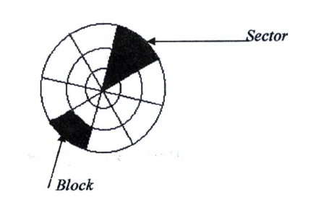

SECTION B (60 MARKS)
Answer question 16 and any other THREE questions from this section ill the spaces
provide*
16. Study the flowchart below and answer the questions that follow
i) Name the control structures used in the flowchart.
- Selection
-Sequencing
ii) Determine the values of M, N, P and Q.
M………17………………..N……………….17…………………..
P………..17………………..Q……………….17………………….
iii) Write the pseudo code for the flowchart
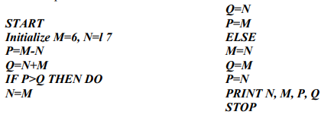
17. (a) Distinguish between the following sets of terms as used in
spreadsheets
(i) Worksheet and workbook
Worksheet – The working area in an electronic spreadsheet on which a
user enters the spreadsheet data.
Workbook – A spreadsheet file. A workbook can obtain several
worksheets
(ii) Filtering and sorting
Data filtering is a way of organizing spreadsheet data for ease of analysis.
Often spreadsheet filters are used to “hide” rows of data that do not meet
certain specified criteria. This allows you to analyze (e.g. count, observe
etc) only certain “Filtering” groups of data.

Data sorting: Is a way of arranging record according to one of the fields
in either ascending or descending order.

(b) State one way in which a user may reverse the last action taken in a
spreadsheet package (1 mks)
- Use the undo command (ctrl + z)
(c) The following is a sample of a payroll. The worksheet row and column
headings are marked 1, 2, 3, and A, B, C respectively.
(d)Write formulae using cell references for the following cells
(i) D2 = B2 * C2
(ii) E4 = 10% * D4 or 10% * (B4 * C4)
(iii) F10 = D10 + E10
(iv) G7 = 20% * F7
(v) H5 = H5 – G
(d) (i) State three ways of moving round the page in desktop publishing window
(3 mks)
- Use cursor keys
- use mouse scroller
- Use scroll buttons (horizontal and vertical)
(ii) State two ways on how information & communication technology (ICT) can
be used to reduce the spread of HIV/ AIDS ( 2 mks)
- Through advertisements on the Internet
- Through creation of posters
- Through discussion groups on the internet

18. (a) Describe the following terms with reference to security of data:
(i) Log files
- A file that lists actions that have occurred. For example, web servers
maintain log files listings every request made to the server. With log file
analysis tools, its possible to get a good idea of where visitors are
coming from, how often they return and how they navigate through a site.

ii) Firewalls. (1mark)
- A firewall is an information technology (IT) security device which is
configured to permit, deny or proxy data connections set and configured
by the organization's security policy. Firewalls can either be hardware
and/or software based.

A firewall!\s basic task is to control traffic between computer networks
with different zones of trust. Typical examples are the Internet which is
a zone with no trust and an internal network which is (and should be) a
zone with high trust. The ultimate goal is to provide controlled interfaces
between zones of differing trust levels through the enforcement of a
security policy and connectivity model based on the least privilege
principle and separation of duties

(i) State the primary key field for each table.
Student table- Admission Number
Fees Received table - Receipt Number
ii) State the field, which should serve as the linking field for the two tables.
Admission number
(Note: Make Admission Number a foreign key in the fees table)
c) Describe the following terms with respect to computer security:
i) Logic bombs (2 Marks)
- A computer virus that is activated after a series of event/commands/date
ii) Physical security (2 Marks)
Threats that threaten the physical nature of computer equipment e.g. Fire,
Lightening water, building access etc
iii) Tapping. (2 Marks)
Telephone tapping (or wire tapping/wiretapping) is the monitoring of
telephone and Internet conversations by a third party, often by covert
means. The telephone tap or wire tap received its name because
historically, the monitoring connection was applied to the wires of the
telephone line of the person who was being monitored and drew off or
tapped a small amount of the electrical signal carrying the conversation

(d) List three functions of antivirus software.
- Identify a virus/Warn
- Heal/Clean a virus
- Prevent/Protect infection
- Quarantine infected file

19.a) Define the following web related terms:
i) Web browser (1 mark)
A browser is an application program that provides a way to look at and
interact with all the information on the World Wide Web.
ii) Hyperlink (1 mark)
This is the clickable link in text or graphics on a Web page that takes you
to another place on the same page, another page, or whole other site.
iii) Hypertext document (1 mark)
A document usually web document (file) where the user interacts with the
whole document using hyperlinks

b) List six activities performed on the web (3 marks)
- Browsing for information
- Communication via email and chat groups
- Electronic commerce.
- Advertising of goods and services.
- Transfer of information thro' FTP

c) An institution has ten stand alone computers.
i) Suggest with reasons the most appropriate topology required to interconnect the computers. (3 marks)
a) Bus
Reason: Easy to set up, Low cost in terms of cabling QR
b) Star
Reason:
Speed of data transmission is high, Easy to troubleshoot via central
hub or switch
ii) State the necessary steps required to connect the computers to the Internet.
(4 marks)
- Connect server to modem (router) and telephone/or use satellite dish/or
radio
- Get an ISP to configure the Internet protocol
- Configure the rest of the computers to Internet access through a peer-topeer configuration or a client-server configuration.

d) Below is an email address:
ggitau @moest. edu.ke
Name the parts labeled:
i) The local-part of the address/username
ii) host name domain-part
iii) generic (organizational) top level domain
iv) country code top level domain

20.
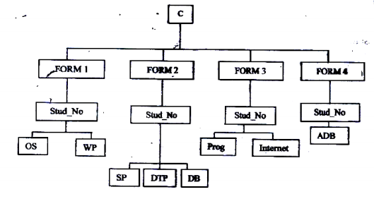
c) i) A form four student wants to create a folder to store to project State the
path for flat project folder. (2 marks)
C:\FORM4\STUDNO\ADB\PROJECT
ii) Suggest how the student can ensure that: - work is not lost in case the hard
disk fails. (1 marie)
- Keep backup copies of the project on offline secondary storage media.
- The project is not copied by other students. (1 mark)
- Use passwords for opening and modifying the project
d) Other than I/O devices, list other three devices under the control of the
operating
- Main memory
- CPU/Processor
- Secondary storage
- Communication device
ii) Explain any one of the devices named in c(i) above. (1mrk)
e) Define the term trouble shooting
Systematic approach to locating the cause of a fault in an electronic
circuit or system

