NAME: ………………………………… ADM NO: …………… CLASS: ……….

233/2
CHEMISTRY
PAPER 1
FORM 4
END TERM 1 EXAM 2021
TIME: 2 HOURS
1. The set-up below was used to investigate the effect of steam on copper turnings.

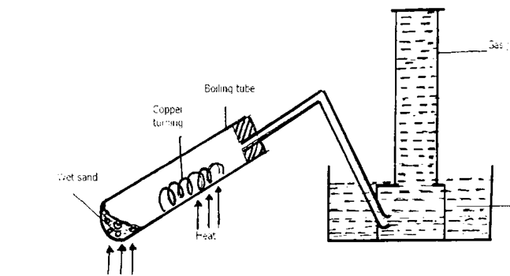

(a) What was observed in the boiling tube? Explain (2mks)

(b) Suggest one other metal that would behave as copper turnings in the above set up if used. (1mk)

2. (a) State Graham’s law of diffusion. (1 mk)

(b) A certain volume of gas S takes 180 seconds to diffuse through a porous plug. Molar mass of S is 18. Equal volume of gas Q takes 240 seconds to diffuse through the same plug.
Calculate the molar mass of Q. (2mks)

3. A student set-up the apparatus shown below attempting to collect oxygen gas.

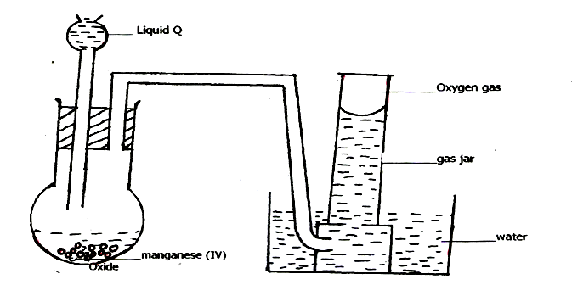

(a) State one mistake the student made. (1 mk)

(b) Identify liquid Q. (1 mk)

(c) What property enables the gas to be collected as shown above? (l mk)

4. Sodium chloride is accidentally mixed with lead( II) sulphate. Explain how sodium chloride crystals can be obtained from the mixture. (3mks)

5. The molecular formula of a hydrocarbon is C₁₁H₂₄,
The hydrocarbon can be converted into other hydrocarbons as shown below.

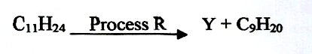
(a)Name process R ………………………………………………………………… (½ mk)
(b) Draw the structural formula of Y and give its name. (1 ½ mks)

6. The third number of the alkenes is converted to its corresponding saturated hydrocarbon by hydrogenation. Using the bong energy values given below, answer the questions that follow.

Bond Bond energy kJ/Mol
H-H 432
C=C 610
C-C 346
C-H 413
Determine the enthalpy change for the conversion of the third member of the alkenes to its corresponding saturated hydrocarbon by hydrogenation. (3mks)

7. Use the information in the energy cycle below to answer the questions that follow.

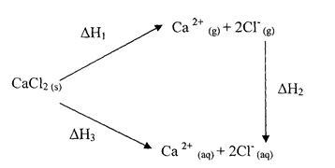

(i) What is the name given to the energy changes? (3mks)

H1. ………………………………………………………………………….

H2. ………………………………………………………………………….

H3. …………………………………………………………………………

(ii) Given that ∆ H1= 2237KJ/Mol and ∆H2=-2378KJ/Mol, calculate the value of ∆H3. (l mk)

8. When solid Zinc carbonate was added to a solution of hydrogen chloride in methylbenzene, there was no observable change. On addition of some water to the mixture there was effervescence. Explain these observations. (2mks)

9. Study the chart below and answer the questions that follow.

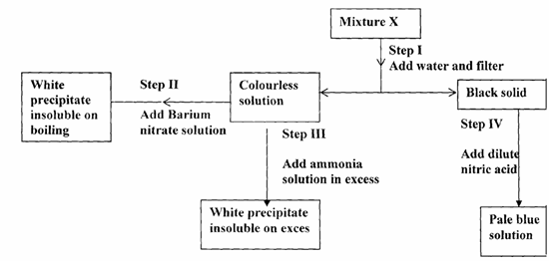

(a) Name:
(i) Cations present in mixture X. (1mk)

(ii) Anions present in the solution. (1mk)

(b) Write an equation to show how the white precipitate in step III dissolves. (1mk)

(c) Name the process outlined in step IV above. (1mk)

10. An element X has two naturally occurring isotopes ²² X1 and ²⁰ X2. If its relative atomic mass is 21.8, calculate the percentage abundance of the more stable isotope. (2mks)

11. State two conditions that would make the boiling point of water to be higher than 100ºC.
(2 marks)

12. Study the following equilibrium equation.
2X₂ (g) + Y₂ (g) 2X₂Y (g) ∆H = -197kJ/mol
(a) Suggest two ways of increasing the yield of X₂Y. (1 mark)

(b) Draw the energy level diagram for the forward reaction. (2 marks)

13. 5.0g of calcium carbonate were allowed to react with 25cm3 of 1.0M hydrochloric acid until there was no further reaction. Calculate the mass of calcium carbonate that remained unreacted. (3 marks) (Ca = 40, C = 12, O = 16)

14. A student fetched water from a river in a limestone area. He used it for washing and realized that it did not lather easily.
(i) Name the two ions that prevent lathering. (1 mark)

(ii) Given that the structure of soap is C17H35COONa.

Explain by means of ionic equations how the above ions prevent lathering. (2 marks)

15. M grams of a radioactive isotope decayed to 5 grams in100 days. The half-life of the isotope is 25 days.
(a) What is meant by half life? (1 Mark)

(b) Calculate the initial mass M of the radioactive isotope. (2 Marks)

16. 20cm³ of a dibasic acid required 25cm³ of 0.1M NaOH for complete neutralization.
(a) How many moles of sodium hydroxide reacted with the dibasic acid? (1 mark)
(b) Calculate the concentration of the dibasic acid in moles per litre. (2 marks)

17. When 25cm³ of 0.5M HCl is added to 25cm³ of 0.5M NaOH the temperature of the solution rose from 23 ®C to 26 ®C. Given that the density of the solution is 1gcmˉ³ and its specific heat capacity is 4.2Jgˉ¹Kˉ¹.
(a) Determine the amount f heat evolved that caused the temperature rise. (1 mark)

(b) Work out the molar enthalpy of neutralization for this reaction. (2 marks)

18. The figure below shows a burning splint that was put across the middle of a non-luminous flame. Explain the results. (2 marks)

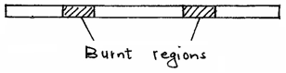
19. 3.22g of hydrated sodium sulphate, Na2SO4.XH2O were heated to a constant mass of 1.42g. Determine the value of X in the formula. (Na = 23.0, S = 32.0, O = 16.0, H = 1). (3 marks)

20. The following chromatogram was obtained in an experiment to investigate the components present in certain dyes.
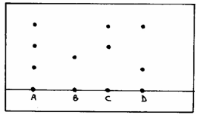
- Which two dyes when mixed would produce A? (1 mark)

- Which dye is pure? (1 mark)

- Indicate on the diagram the solvent front. (1 mark)

21. The following are electrode potentials of the half cells.
Half-cell E® volts
M²⁺ (aq)/M(s) -0.76
C²⁺ (aq)/C(s) +0.34
a) Calculate the potential difference of the following cell. (1 mark)
M(s)/M²⁺ (aq) //C²⁺ (aq) /C(s)

b) Draw an electrochemical cell for the cells in (a) above. (3 marks)

c) Show the electrode which represents the anode. (1 mark)

22. The diagram below shows the reaction of zinc granules with hydrochloric acid.
On the diagram sketch the graph that would be obtained if zinc powder of same quantity was used and label it C2. Explain. (2 marks)

23. A copper spoon was coated with silver metal as shown below.

- Write an equation for the reaction that occurs at the copper spoon cathode. (1 mark)

- How many grams of silver would be deposited on the spoon in two hours using steady current of 0.03A? (1 F = 96500C, Ag = 108.0) (3 marks)

24. Copper (II) sulphate solution was electrolyzed using graphite electrodes.
- State the observations made at the electrodes. (2marks)

Anode

Cathode

b. Write the equation for the anode reaction. (1mark)

25. Write down a balanced equation to show the effect of heat on each of the following substances.
i) Anhydrous copper (II) sulphate (1mark)

ii) Potassium nitrate salt (1mark)

iii) Silver nitrate (1mark)

26. A compound with the formula X (OH)3(not its actual chemical formula) reacts as shown below
X(OH)₃(s) + OH⁻(aq) X(OH)₄(aq)
X(OH)₃(s) + 3 H⁺(aq) X³⁺⁽aq) + 3H₂O(l)
a) State the name of compounds that behave like X (OH)₃ in the two reactions above. (1mark)

b) Name two elements whose hydroxides behave like that of X. (2marks)

27. Chlorine water was exposed to sunlight for one day using the set up below.

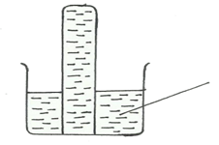 Chlorine water
After one day a gas was collected
a) Identify the gas that was collected. (1mark)

b) State the observations made in the liquid. (2mark)

c) What will happen to the pH of the solution after one day? (1mark)

