BIOLOGY PAPER 2 FORM 3 MARKING SCHEME
1.
Natural | Acquired
Inherited/transmitted from the parent to the offspring; | Developed after suffering from a disease/through vaccination

b) Allergy-Drastic reaction of the body seen in a few individuals towards foreign substances that are normally harmless to the rest population/hypersensitive reaction of the body to the harmless substances;
c) i) Platelets/Thrombocytes;
ii) Fibrin clot; reject clot alone
d) i) High temperature in the atmosphere causes temperature of the leaf to rise; thus increasing
the vapour pressure in the intercellular air spaces this causes increase in transpiration rate;
- Low humidity in the atmosphere/dry air results to high vapour in the intercellular air space than the air surrounding the leaf; hence increase diffusion gradient hence higher transpiration rate
- Low atmospheric pressure causes an increase in evaporation from a wet surface/less opposing to evaporating molecules thus higher rate of transpiration;
2.(a) Osmosis; (1 mark)
(b) Solution Y is hypertonic/ high concentrations; water moved from cell to solution (2marks)
(Y);
Cell became flaccid/ shrinks; (1mark)
- (i)
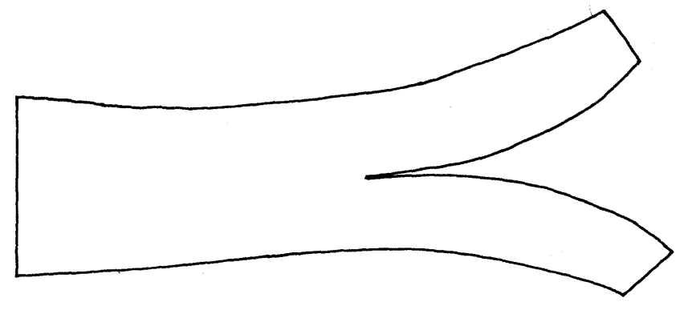

(ii) Cortex cells/ cortical cells absorbs water; expanding /curving away to the
epidermis; epidermal cells are water proof; (3 marks)

3. )Approximate population =
i.e ;
=; 540 ants;
(b) Does not consider migration of organisms into and out of study area.
- Does not consider the effect of paint used in marking on the animals behaviour
- Released animals may not mix freely with the remaining population.
- Marked organism may not have adequate time to mix with the rest.
- Does not consider the effect of weather on the organisms behaviour (any 4)
(c) - Quardrat method
- Belt transect method
- Line transect method X

4.
- – Vacuole / Sap vacuole
Y – Tonoplast;
Z – Chloroplast; (3marks)
- Cellulose (1mark)
- Active transport (1mark)
- The cell sap is hypertonic to the solution / distilled water; hence water molecules move into the cell; by osmosis; making it to swell and eventually burst; (3marks)

5.
- Pneumatophores / Aerial breathing roots;
      - Stomata; (2marks)

  - A – Gill rakers;
B – Gill bar / arch;
C – Gill filaments; (3marks)
(ii)Trap food / solid particles hence prevent them from clogging the gill filaments; (1marks)

    - Highly vascularised to transport away oxygen that has diffused in;
    - Thin epithelium to reduce the distance gases diffuse across;
    - Numerous to increase surface area for maximum absorption of oxygen.
    - Ability to spread singly when in water, further increasing the surface area. mark any 2; (2 marks)
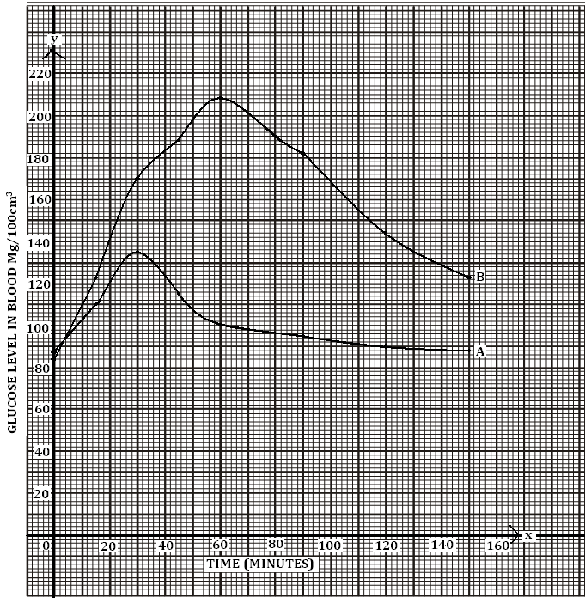
Question 6

- Label axis – 2mks
- Smooth curves labeled – 2mks
- scale – 1mk
- plots – 1mk

- A – 120 ± 1
- B- 140 ± 1
- Person A is capable of regulating sugar while person B is likely to be diabetic

- In person A; insulin is released which stimulates the liver to convert excess glucose to glycogen in the liver.
- In person B; insulin is not released; thus the decline is due to glucose being released in urine.
- ATP (Adonosine triphosphate)

- Body size
- Occupation
- Age
- Sex gender
- Environmental condition e.g temperature
- BMR
- State of the body viz ill; expectant mother;
- Liver

.7(a) - Highly vascularised/network of blood capillaries;
- Large surface area for gaseous exchange;
- Thin membrane/ epithelium/ one cell thick wall/ thin lining;
- Moist (lining); (4mks)
(b) Breathing in:
- External intercoastal muscles contract; internal intercoastal muscles relax;
lifting/raising the ribcage upwards and outwards; muscles of diaphragm contract; hence it flattens; the volume of the thoracic cavity/lungs increases; while the pressure decreases; higher air pressure in the atmosphere forces air into the lungs( through nose);
Breathing Out:
- External intercoastal muscles relax; while internal intercoastal muscles contract;
moving the rib cage downwards and inwards; the muscles of diaphragm assumes dome shape; the volume of thoracic cavity decreases; while pressure increases; High pressure forcing air out of the lungs(through nose); (l6mks)
(20mks)

8. (a) Digestion is the enzymatic breakdown of food; into products that can be absorbed; (2mks)
(b) - Bile contains bile salts (sodium taulocholate and sodium glycocholate); which emulsify fats thus increasing the surface area for the action of lipase;
- Bile also contains sodium bicarbonate; which neutralizes acid from the stomach;
- The sodium bicarbonate creates alkaline conditions necessary for the action of digestive enzymes in the duodenum and the small intestines; (5mks max4)
(c) - In the mouth, the protein is chewed by the action of the teeth and mixed with the
saliva for easy swallowing; (No digestion of protein occurs in the mouth)
- In the stomach, the gastric glands in the stomach wall secrete gastric juice;
- Gastric juice contains hydrochloric acid; pepsinogen and rennin;
- Hydrochloric acid activates pepsinogen into pepsin;
- HCL creates the acidic conditions necessary for pepsin to digest protein into polypeptides;
- Rennin hydrolyses the soluble milk protein/ Casein; into an insoluble curd; which is then digested by pepsin;
- in the duodenum, the acidic PH created by the HCL is neutralized by the sodium
bicarbonate; present in the pancreatic juice;
- This creates alkaline conditions required by the trypsin; to digest proteins into polypeptides;
- Trypsin is also secreted here in its inactive precursor trypsinogen;
- Trypsinogen is converted into trypsin by the enzyme enterokinase;
- In the small intestine / ileum alkaline conditions prevails;
- The wall of ileum secretes intestinal juice; which contains peptides;
- Peptides complete the digestion of protein breaking polypeptides into amino acids; (l9mks max 14)

