NAME:…………………………………………………………………………………...…………
SCHOOL:…………………………………………………………………………………………..
A.D.M NO:……………………………………….. DATE:………………………………………
SIGNATURE:……………………………………

231/1
BIOLOGY
END TERM 1 2021
PAPER 1

TRIAL EXAM SERIES
FORM THREE

Question | Maximum score | Candidate’s score
1-29 | 80

1. The scientific name of the cat is FelisCatus classify the cat into; (3mks)
i) Kingdom………………………………………
ii) Genus…………………………………………
iii) Species…………………………………………
2. The figure below shows a structure of a tooth:
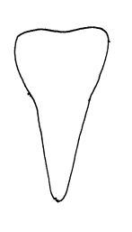
(a) Identify the tooth: - (1 mk)

(b) State how the tooth named in (a) is modified to perform its function:- (1 mk)

3. a) Name the hormone secreted in the human body when one takes in a large amount of
water:- (1 mk)

(b) Which disease results from inadequate production of the hormone named in (a) above?
(1mk)

4. Give two structural features that can be used to separate a housefly, a millipede, and a tick into their respective classes. (2mks)

5. State three main functions of the stomach in human beings:- (3 mks)……………………………………………………………………………………………..………….…………………………………………………………………………………….…………………………………………………………………………………………………………..
6. It was found that during germination of bean seeds, 9.2 cm³ of carbon IV Oxide was produced while 9.0 cm³ of oxygen was used up.
(a) (i) Calculate the respiratory quotient of the reaction:- (2 mks)
……………………………………………………………………………………………………….……………………………………………………………………………………………………….…………………………………………………………………………
(ii) Identify the substrate being met abolished:- (1 mk)
……………………………………………………………………………………………………….……………………………………………………………………………………
(b) In which part of the cell does glycolysis occur? (1 mk)

7. State three functions of the mammalian blood other than transport (3mks)

8. Other than sexual intercourse name the other ways by which HIV/AIDS is spread (3mks)

9. State three characteristics features of an efficient respiratory surface (3mks)

10. State three environmental factors that affect the rate of stomatal transpiration (3mks)

11. The cells shown below are adapted for transport in flowering plants.
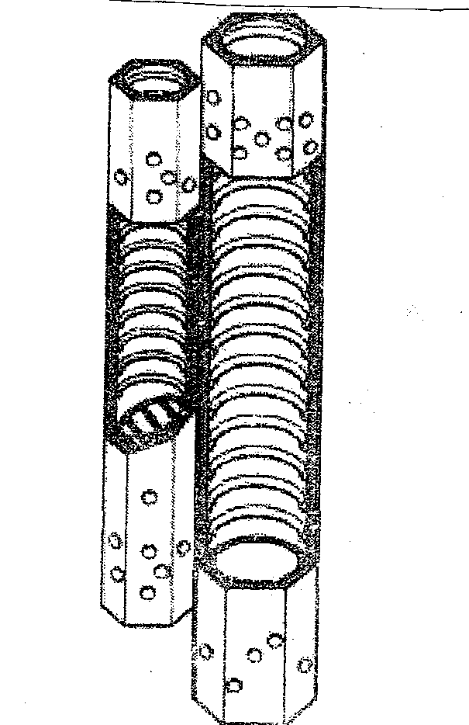
(a) Name the tissue in which these cells are found. (1 mk)
………………………………………………………………………………………………
………………………………………………………………………………………………
(b) Identify and explain two observable features of these cells that adapt them to their role in transport. (2mks)
………………………………………………………………………………………………
…………………………………………………………………………………………….
………………………………………………………………………………………………
12. Name two areas in human body where active transport takes place. (2mks)

13. State the functions of the following cell organelles: (2mks) (a) Nucleolus.

(b) Plasma membrane

14.Distinguish between guttation and transpiration (2mks)

15. What are the functions of the following parts of a light microscope? (3mks)
(a) Eye piece lens

(b) Condenser

(c) Diaphragm

16. (a) What is peristalsis? (1mks)

(b) Explain how the process above is brought about. (2mks)

17. (a) State three structural differences between arteries and veins in mammals (3mks)

(b) Name a disease that causes thickening and hardening of arteries (1mk)
18. Identify two forces that help in upward movement of water in plants (2mks)

19. State two reasons why lipids are rarely used as a respiratory substrate compound to
Carbohydrates. (2mks)

20. The equation below represents a metabolic process that occurs in the mammalian liver:
(2mks)
Amino acids organic compound + urea
(a) Name the process

(b) What is the importance of the process to the mammals?

21. (a) Definethe term balanced diet. (2mks)
……………………………………………………………………………………………………………………………………………………………………………………………………
(b) Statethe importance of roughage in a diet. (1mark)
………………………………………………………………………………………………………………………………………………………………………………………………
22. (a) Howdo the following factors affect the rate of diffusion? (3marks)
  - Surface area to volume ratio
………………………………………………………………………………………………………………………………………………………………………………………………
  - Diffusion gradient
………………………………………………………………………………………………………………………………………………………………………………………………
(iii)Temperature
………………………………………………………………………………………………………………………………………………………………………………………………
23. Name any three specialized plant cells. (3marks)
……………………………………………………………………………………………………………………………………………………………………………………………………………………………………………………………………………………………………….
24. Name three sites where gaseous exchange takes place in terrestrial plants. (3 marks)
……………………………………………………………………………………………………………………………………………………………………………………………………………………………………………………………………………………………………
25. A student in form three caught an organism which had the following characteristics
i) Body divided into two parts.
ii) Simple eyes.
iii) Eight legs.
Classify the organism up to the class level. (3 marks)

26. (a) Distinguish between the counter flow and parallel flow system in gaseous exchange(1mk)

(b) Which of the two systems mentioned in (a) above is efficient? Give a reason (2mks)

27. Name the enzyme, the vitamin and the metallic ions required in the clotting of blood. (3mks)
- Enzyme

ii) Vitamin
iii) Metallic ion

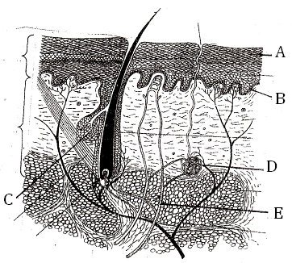28.The figure below is a photomicrograph of a section of mammalian skin. Study it and answer the questions that follow.

- State two functions of the secretion from the gland labeled C (2marks)
…………………………………………………………………………………………………
…………………………………………………………………………………………………
- Explain the behaviour of structure E when environmental temperature falls to 10⁰c. (2marks)

29. Astronauts from the outer space brought a material to earth. Explain how you would establish if the material is living or non-living. (2marks)

