NAME………………………………………………...……………………………………………………..
SCHOOL………………………………….…………………………………………………….…………..
ADM NO.………………………………. DATE………………………………………………………..
STUDENT’S SIGN……………………....

BIOLOGY
END TERM 1 2021
Time: 2 Hours

TRIAL EXAM I
FORM ONE

INSTRUCTIONS TO STUDENTS
1. Answer all questions in this question paper.
2. All your answers must be written in the spaces provided in this question paper.

1. State the functions of the following parts of alight microscope: (2mks)
a) Objective lens
……………………………………………………………………………………………………
b) Diaphragm
……………………………………………………………………………………………………
2. State the functions of the following cell organelles:
a) Ribosomes (1mk)
……………………………………………………………………………………………………
b) Lysosomes (1mk)
……………………………………………………………………………………………………
3 a) Distinguish between diffusion and active transport. (2mks)
……………………………………………………………………………………………………
……………………………………………………………………………………………………
b) State one hole that is played by osmosis in:
i) Plants. (1mk)
……………………………………………………………………………………………………
ii) Animals (1mk)
……………………………………………………………………………………………………

4. The diagram below a red blood cell that was subjected to a certain treatment.

At start at the end of experiment

a) Account for shape of the cell at the end of the experiment. (2mks)
……………………………………………………………………………………………………
……………………………………………………………………………………………………

b) Draw a diagram to illustrate how a plant cell would appeared if subjected to t he same
treatment. (1mk)

5. Plant cells do not burst when immersed in distilled water. Explain (2mks)
……………………………………………………………………………………………………
……………………………………………………………………………………………………
6. State three functions of Golgi apparatus. (3mks)
……………………………………………………………………………………………………
……………………………………………………………………………………………………
…………………………………………………………………………………………………

7. Name one cell organelle found in the actively respiring tissues. (1mk)
……………………………………………………………………………………………………

8. Distinguish between hypertonic and hypotonic solutions. (2mks)
……………………………………………………………………………………………………
……………………………………………………………………………………………………
9. The following is a diagram of a light microscope.
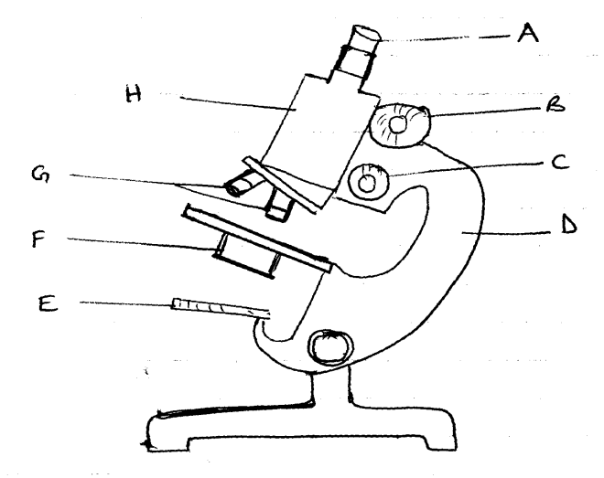

a) Name the parts labeled A, B, C, D,E , (5mks)
A…………………………………………………………………………………………….
B…………………………………………………………………………………………….
C…………………………………………………………………………………………….
D…………………………………………………………………………………………….
E…………………………………………………………………………………………….
b) State the functions of parts labeled E and F (2mks)
E…………………………………………………………………………………………….
F…………………………………………………………………………………………….
10. Name the organelle that:
a) Manufacture and transport lipids and steroids in a cell (1mk)
……………………………………………………………………………………………………
……………………………………………………………………………………………………
b) Contain enzymes that are capable of destroying old damaged cells. (1mk)
……………………………………………………………………………………………………
c) Control all the processes in a cell. (1mk) ……………………………………………………………………………………………………
d) Form Cilia and flagella in cells that have them (1mk)
……………………………………………………………………………………………………
11. State the branch of biology that deals with the study of : (2mks)
(i) Insects
……………………………………………………………………………………………………
(ii) The relationship between organisms and their environment.
……………………………………………………………………………………………………
12. Name the filed of science that specializes in the study of cells. (1mk)
……………………………………………………………………………………………………

13. State the use of the following apparatus.
i) Pooter. (1mk)
……………………………………………………………………………………………………
ii) Sweep net (1mk)
……………………………………………………………………………………………………

14. The scientific name for beans is phosedus vulgaris.
a) What taxan does the term phoseodusrepresent. (1mk)
……………………………………………………………………………………………………

b) State two rules that are followed when giving a scientific name to an organism (2mks)
……………………………………………………………………………………………………
……………………………………………………………………………………………………

15. Compare the structure of plant and animal cells. (4mks)
……………………………………………………………………………………………………
……………………………………………………………………………………………………
……………………………………………………………………………………………………
……………………………………………………………………………………………………
16. List seven life processes/characteristics that must take place in all living organisms. (7mks)
……………………………………………………………………………………………………
……………………………………………………………………………………………………
……………………………………………………………………………………………………
……………………………………………………………………………………………………
……………………………………………………………………………………………………
……………………………………………………………………………………………………
……………………………………………………………………………………………………

17. List seven major taxonomic units of classification on living things. In descending order. (7mks)
……………………………………………………………………………………………………
……………………………………………………………………………………………………
……………………………………………………………………………………………………
……………………………………………………………………………………………………
……………………………………………………………………………………………………
……………………………………………………………………………………………………
……………………………………………………………………………………………………
18. Classify the following organisms into their kingdoms (4mks)
Organisms Kingdom
a) Maize,Beans ………………………………………..
b) Mushrooms,Yeast ……………………………………….
c) Protoza, algae ……………………………………….
d) Bacteria ……………………………………….
19.A student was preparing a section of a plant cell to be viewed on a light microscope. Give a reason for each of the following steps:-
(i)Cutting a very thin section (1mrk)
……………………………………………………………………………………………………………………………………………………………………………………………………………………

(ii)Staining the section (1mrk)
……………………………………………………………………………………………………………………………………………………………………………………………………………………
(iii)Putting the section in water (1mrk)
……………………………………………………………………………………………………………………………………………………………………………………………………………………………………

20.Explain the following terms.
a) Taxonomy (1mrk)
…………………………………………………………………………………………………………………………………………………………………………………………………………………………………………………………………………………………………………………………

b) Species (1mrk)
…………………………………………………………………………………………………………………………………………………………………………………………………………………………………………………………………………………………………………………………
21. State two main functions of a microscope. (2mrks)
………………………………………………………………………….
(a) What is a cell. (1mk)
……………………………………………………………………………………………………..
……………………………………………………………………………………………………..
(b) Define the meaning of the following terms
(i) Entomology (1mk)
……………………………………………………………………………………………………..
……………………………………………………………………………………………………..
(ii) Genetics (1mks)
……………………………………………………………………………………………………..

