- You are provided with an unknown mixture labelled J
You are also provided with Benedict’s solution, dilute hydrochloric acid solution, iodine solution, Dichlorophenol-Indophenol (DCPIP) solution. Sodium hydrogen-carbonate solution, means of heating, test tubes, test tube holder and a test tube rack.
- Using the reagent provided only, test for the food substances in mixture J. Record in the table below the chemical test, the procedure of the test, your observations and conclusions. 8mks
Chemical test | Procedure | Observations | Conclusions
Non-Reducing Sugar | To about 2ml of solution J add 4drops of dilute HCl and heat .cool then add NaHCO3 solution dropwise until fizzing stops. Add Benedict’s solution and heat to boil. | Colour changes to yellow,orange,brown | Non-Reducing sugar present.
Reducing sugar | To about 2ml of solution J add equal volume of Benedict’s solution. Shake the mixture and heat to boil. | Blue colour of Benedict’s solution remains | Reducing Sugar absent.
Vitamin C | To about 2ml of DCPIP add solution J dropwise | DCPIP is decolourised | Vitamin C present.
- ……………vitamin C………………………………………………………………
- i)Name a deficiency disease that may result from a deficiency of the component identified in (b) above. Vitamin C 1mk
…………………………………SCURVY……………………………………………………
- Name a common carbohydrate that could be present in mixture J. 1mk
……………………………………SUCROSE………………………………………………
- State the role of hydrochloric acid and sodium hydrogen carbonate in the experiment. 2mks
Hydrochloric Acid
hydrolyseses the non-reducing sugars to the food substances into reducing sugars
Sodium Hydrogen Carbonate
Neutralizes the hydrochloric acid
- The photographs below show a flower specimen. Study it carefully and use to answer the questions that follow.
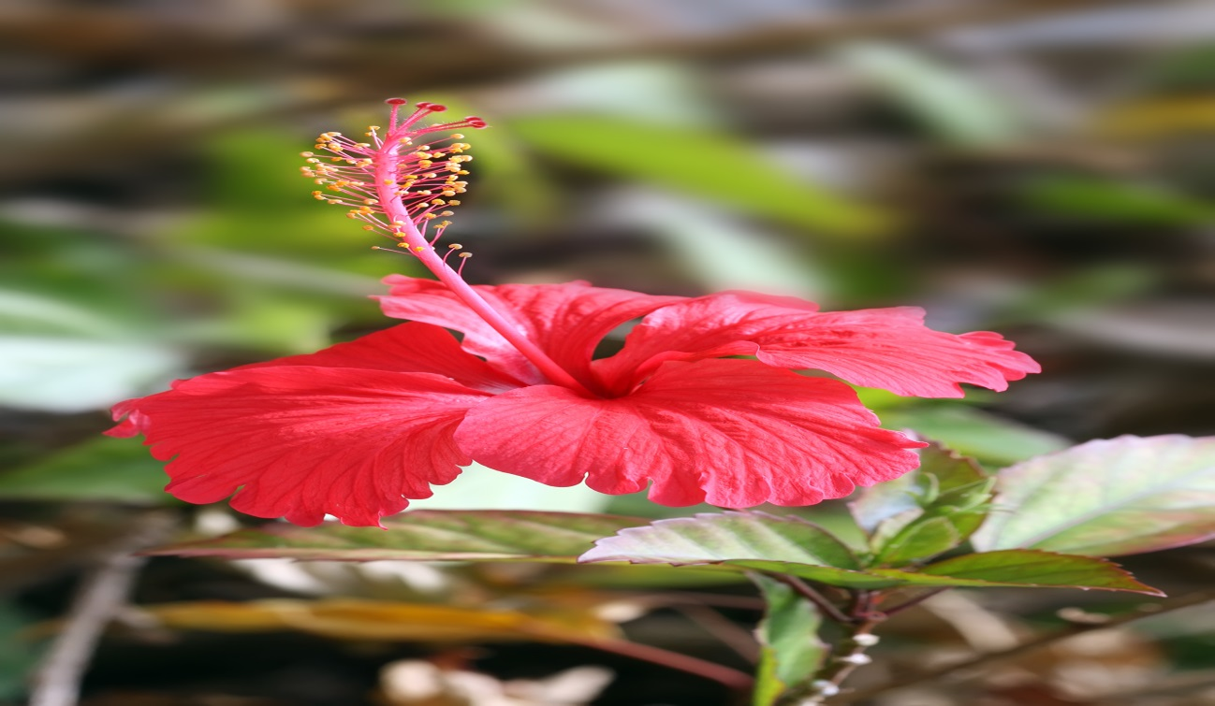
- On the photograph, label the following parts 3mks
- Stigma
- Style
- Staminal tube
- i) Classify the plant from which the flower was picked into the taxonomic groups listed below. 4mks
Kingdom
…………plantae………………………………………………………………………………
Division
………………spermatophyta…………………………………………………………………
Sub division
……………angiospermae…………………………………………………………………
Class
…………………………………dicotyledon…………………………………………………
ii) Name three observable features from the photograph of the class you named in (a) (i) above. 3mks
-broad network veined leaves
-flowers
c)Suggest the pollination agent of this flower. Give reasons for your answer.
Pollinating agent 1mk
…………………insects………………………
Reasons 2mks
-they are brightly coloured
-large and conspicous
- Below are photographs of two specimens, J and K. Both of them belong to the same Phylum and Class. Observe them carefully before you answer the questions that follow.
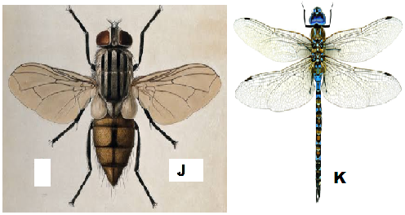

- Name the class to which J and K belong and support your answer with two reasons.
Class 1mk
………………………insecta…………………………………………………………………

Reasons 2mks
-3 pairs of jined legs
-presence of wings
Three body parts

- Suggest why the transport fluid in J and K has no haemoglobin. 2mks
-insect-blood doesn’t transport respiratory gases,hence doesn’t contain haemoglobin
- The actual drawing of specimen K is 8cm, given that both J and K are under the same magnification, determine the actual length of J 3mks
Actual length=drawing length
Magnification
- Below is a diagram showing the life cycle of specimen J.
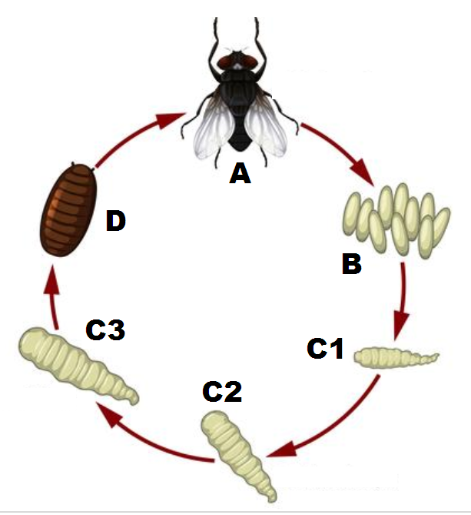
- Identify the stage labeled D. 1mk
…………………pupa……….………………………………………………………………
- Name the hormone responsible for the change from D to A. 1mk
…………………………moulting hormone………………..
- Explain the differences in the change from C2 to C3 and from C3 to D. 2mks
C2 to C3
-this stage eats a lot, grows rapidly and sheds its cuticle several times
C3 to D
-this stage is inactive ,non-feeding stage
State the importance of the process illustrated above in the life cycle of the organism 2mks
-allows the insects to survive unfavourable conditions
-larva occupies different niche from adult thus reducing competition.

