NAME: ……………………………………. ADM NO: ………… CLASS: ……….
FORM 4 GEOGRAPHY
MID TERM EXAMS
TERM 1 2021
MARKING SCHEME

1. (a) Describe any three characteristics of an age-sex pyramid. (3 mks)
- Has a title
- Represents the age, sex and structure of a population
- Males are represented on the left while the females are on the right.
- The vertical axis shows the age-groups/cohorts
- The horizontal axis shows the population in numbers/percentages
- The length of the bars is determined by either the number of people in a certain
agegroup or the percentage contribution to the population.

(b) Identify two demerits of using a population pyramid in data representation.
(2 mks)
- It is difficult to draw
- It is not possible to tell the exact numbers represented at a glance as they are given
as percentages/given as per the chosen scale.
- The data represented can only make sense after analysis and interpretation.

2. (a) Explain four ways in which land is being rehabilitated in Kenya. (4 mks)

- By filling open pits/quarries in order to be used for farming/settlement
- By construction terraces thereby reducing the speed of surface run-off/soil erosion.
- By planting trees on damaged land, thereby protecting it against the agents of
erosion
- By building dykes along river banks/dams across rivers inorder to control floods
- By applying manures on degraded land in order to restore its fertility.
- By mulching/growing cover crops to retain moisture
- By controlling grazing to allow regeneration of pasture/control erosion.

(b) Draw a map of Kenya and on it, locate the following;
(i) Mwea-Tebere irrigation scheme
(ii) Perkerra irrigation scheme
(iii) Bura irrigation scheme
(iv) Ahero irrigation scheme (5 mks)

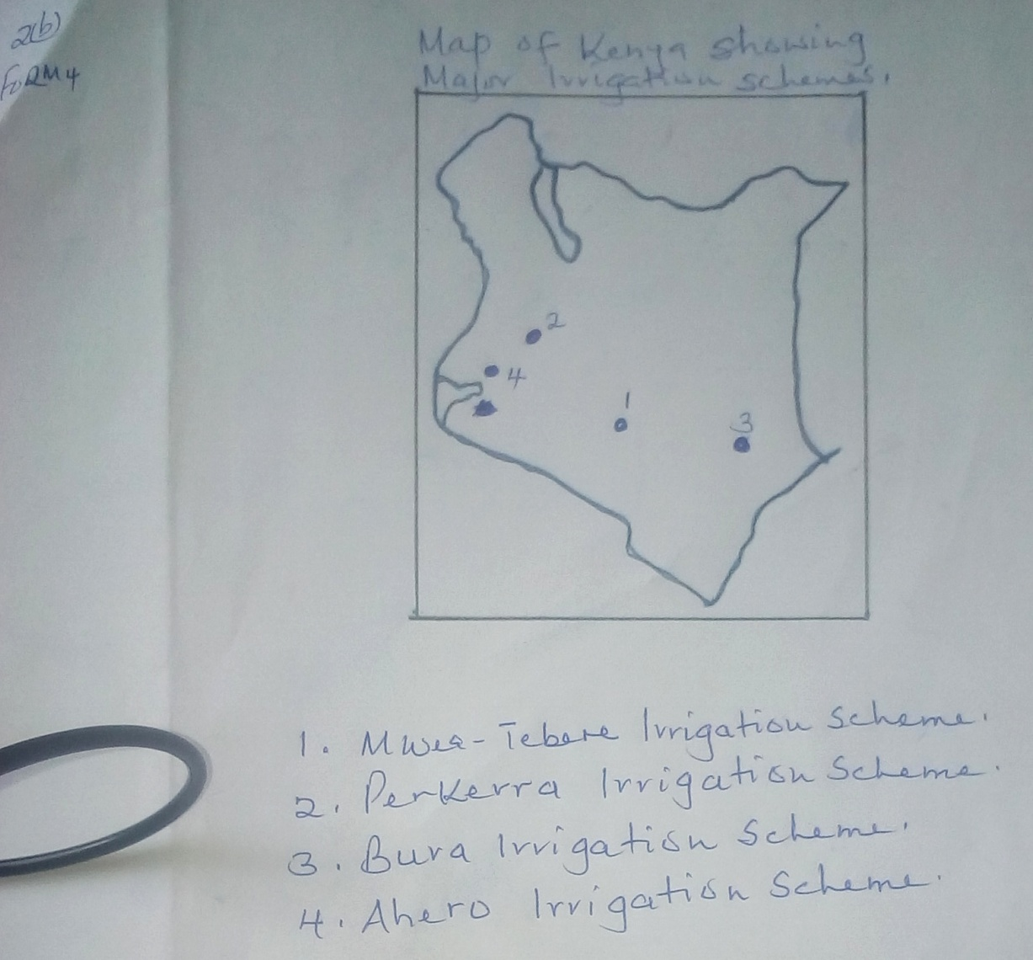

(c) Describe rice cultivation in Mwea-Tebere scheme under the following
headings:-
(i) Harvesting (2 mks)
- The rice is mature after about 5 ½ months
- The fields are drained to allow ripening
- Harvesting is done by hand using sickles
- The rice is then dried in the sun

(ii) Threshing (2 mks)
- When the stalks are completely dry, they are threshed
- The threshing is done manually by hitting the paddy against the ground
- The grains are separated from the stalk.

(iii) Winnowing (3 mks)
- Involves removing of the chaff from the gain
- Done by pouring the rice from a height to a large mat spread on the ground.
- Done on a windy day
- The heavier paddy falls on the mat while the light materials are blown away.
- The paddy is then taken to the mill.

3. (a) Give any three physical conditions that favour maize growing in Kenya.
(3 mks)
- Moderate temperature/18ºC – 27ºC
- Moderate rainfall/600-1100mm for optimum growth
- Deep, well drained volcanic soils
- Undulating terrain

(b) Apart from Trans-Nzoia county, name any other two counties where maize is
grown on large scale in Kenya. (2 mks)
- Narok
- Nakuru
- Uasin Gishu
- Bungoma
- Kakamega

(c) Identify four characteristics of horticulture in Kenya. (4 mks)
- The farms are mainly small
- The land is intensively cultivated to maximize production
- Advanced scientific techniques of crop production are used to ensure high yields
- It is labour intensive
- The products are mainly for sale
- Mainly practiced near urban areas.

4. (a) Describe how trawling method is used to catch fish. (5 mks)
- A bag shaped/trawl net is attached to a ship/trawler
- The net is cast into the water by the trawler
- The net’s mouth is kept open by otter boards.
- The upper part of the net is kept a float by corks/floats
- Weights are used to keep the lower part of the net at the sea bed
- The trawler drags the net along the sea bed.
- After sufficient fish has been caught, the net is hauled onto the trawler to empty the
fish.

(b) List five methods used to preserve fish. (5 mks)
- Canning
- Freezing
- Smoking
- Salting
- Sun drying

(c) Why should the government of Kenya encourage fish farming? (5 mks)
- Fish farms occupy less space
- Fish supply proteins
- To create job opportunities
- Some fish from the farms are exported to earn foreign exchange
- May lead to the development of fish related industries
- It is free from international disputes

5. (a) Give five tourist attractions found at the coast of Kenya . (5 mks)
- Marine parks
- Historical sites
- Sandy beaches
- Water sports
- Hotels of international standards
- Terrestrial wildlife/parks
- Traditional culture
(b) State five factors which influence the distribution of wildlife in East Africa. (5 mks)
- The distribution/variation of vegetation influence the type of wild game found in an area
- The drainage of an area influences the distribution/population of different wildlife
- Human activities-conservation/destruction of wildlife habitats
- The soils of a place determine the plant life which influence the type of
animals/birds found in a place
- The different types of climate influence the distribution of wildlife
- Relief/fairly level ground favours some animals while rugged terrain discourage
them
- Change in altitude leads to variations in vegetation types/types of animals

(c) Your Geography class carried out a field study on wildlife in Lake Nakuru
National Park.
(i) State five methods the class may have used to gather data. (5 mks)
- Administering questionnaires
- Interviewing/Asking questions
- Taking photographs
- Taking measurements
- Counting
- Content analysis
- Collecting samples

(ii) During the field study, the class collected data on the number of tourists
visiting the Game part state five methods the class may have used to
present data.
- Drawing pie charts showing tourists from different countries
- Drawing tables
- Drawing graphs
- Drawing diagrams
- Oral presentation

6. (a) Name three exotic dairy cattle breeds reared in Kenya. (3 mks)
- Jersey
- Friesian
- Guernsey
- Ayrshire
- Brown Swiss
- Sahiwal

(b) Explain three human factors that favour dairy farming in the Kenyan
highlands. (6 mks)
- The high population in region offers ready market for milk and other dairy products,
thus favouring dairying

- There are milk processing factories which help in milk processing/storage, thus
favouring dairying
- The region is served by good road network which enhances transportation of milk
- There is adequate provision of vet services which ensure the animals are in good
health
- Farmers have formed co-op societies, enhancing procurement of inputs, credit and
marketing of the produce.

7. (a) Explain how hydraulic action causes coastal erosion through the following:-
(i) Water hitting against rocks. (2 mks)
- Water pushed by the waves hits the cliff face
- Since the water hits the rocks repeatedly, the rocks are loosened,
disintegrating and falling into the sea.

(ii) Water pushing air in cracks. (4 mks)
- Water is pushed into the cracks by the waves
- Air in the cracks is compressed increasing in volume
- Water withdraws and the air expands suddenly enlarging the cracks
- The process is repeated severally causing the weakening of the rocks along
the cracks
- Eventually, the rocks break/disintegrate

(b) Name four features of wave erosion at the coast. (4 mks)
- Bays
- Headlands
- Caves
- Arches
- Stumps
- Stacks
- Blow holes/Gloups
- Geos
- Cliffs

(c) Describe the formation of a ria coast. (5 mks)
- River draining into the sea/ocean is submerged by sea water
- Occurs where the hills and a river valley meet the coastline more or less at right
angle
- The entrance to the river valley is widened by the invading sea/ocean water
- A funnel shaped drowned river valley wider and deeper at the entrance than inland is
formed.
- This is a ria coast.

8. (a) Describe the stages of land reclamation in the Netherlands. (6 mks)
- Dykes are constructed to enclose part of the low-lying land covered by sea water.
- Ring canals are constructed on the interior sides
- Water is pumped into the ring canals using electric pumps
- Ditches are dug to drain excess water
Drainage pipes are laid below the soil
- Chemicals are added to the soil reduce salinity
- Reeds are planted to drain the excess water
- Area is divided into regular portions using inner dykes and ring canals.
- Fresh water is pumped into the enclosed land to remove salt
- Pumping out of water from the polder is a continuous process to prevent water from
accumulating again

(b) State four uses of polder lands in the Netherlands. (4 mks)
- Farming/crops and livestock
- Setting up recreational facilities
- Setting up settlements
- Industrial development
- Development of transport lines
- Tourist attractions.

