NAME: ………………………………. ADM NO: ……….. CLASS: …………….
233
FORM THREE CHEMISTRY
MID TERM 1 EXAMS 2021
TIME: 1 ½ HOURS

Answer all the questions in the spaces provided.
1. What is the temperature on the Kelvin scale for each of the following? (3 marks)
(a) 100ºC – 373K

(b) -100ºC – 173K

(c) 22ºC – 295K

2. State any three differences between luminous and non-luminous flame. (3 marks)
Luminous | Non-Luminous
Sooty | Not sooty
Not very hot | Very hot
Not steady | Steady

3. The table below shows liquids that are miscible and those that are immiscible.
Liquid | L₃ | L₄
L₁ | Miscible | Miscible
L₂ | Miscible | Immiscible
(i) Name the method that can be used to separate L₁ and L₃ from a mixture of the two.
(1 mk)
Fractional distillation

(ii) Describe how a mixture of L₂ and L₄ can be separated. (2 mks)
- Since the two liquids are immiscible, pour both the liquids in a separating
funnel and allow to settle. The denser liquid will settle down and the less dense will form a second layer on top. Open the tap and run out the liquid
in the bottom layer leaving the liquid in the second layer in the funnel.

4. A gas occupies 450cm³ of 27ºC. What volume would the gas occupy at 177ºC if its
pressure remains constant? (3 mks)
V1 = V2
T1 T2

450 = X
350 450

= 675cm³

5. The electron arrangement of ions X⁺³ and Y²⁻ are 2.8 and 2.8.8
(a) Write the electronic arrangement of the elements X and Y. (2 mks)
X – 2.8.3
Y – 2.8.6

(b) Write the formula of the compound that would be formed between X and Y.(1 mk)

X₂Y₃

6. Explain why there is general increase in the first ionization energies of the elements in
period 3 of the periodic table from left to right. (2 mks)

- Across the period, there is a gradual increase in number of protons in the
nucleus. This increases the force attraction between the nucleus and the
electrons.

7. How would you obtain a sample of pure iodine from a mixture of iodine and lead sulphate?

- Heat the mixture. Iodine sublimes and can be collected on the cooler parts of the
test tube.

8. (a) State Gay Lussacs law. (1 mk)

- When gases react, they do so in volumes that bear a simple ratio to one another
and to their products of gaseous temperature and pressure are kept constant.

(b) 10cm³ of a gaseous hydrocarbon (C₂H_{x}) required 30cm³ of oxygen for complete
combustion. If 20cm³ steam and 20cm³ of carbon (iv) oxide were produced, what
is the value of X. (3 mks)
C₂H_{X} = 3O₂ 2CO₂ + 2H₂O

10cm³ 30cm³ 20cm³

X = 4

9. Explain how conduction of electricity take place in the following: (2 mks)
(a) Iron metal – delocalized electrons

(b) Molten lead (II) iodide – mobile ions

10. Study the set up below and answer the questions that follow.

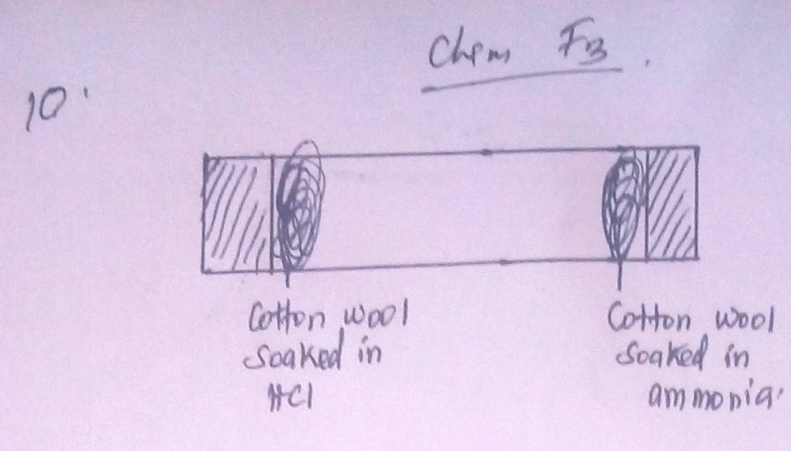
(a) What observation would be made in the tube? (1 mk)
- White dense fumes of ammonium chloride would be formed.

(b) Indicate with a cross (x) on the diagram the likely position where observations
stated in (a) above would be made. (1 mk)

11. An organic compound had the following composition 37.21% carbon, 7.75% hydrogen
and the rest chorine. Determine the molecular formula of the compound given that the
molecular mass of the compound is 65 (C = 12, H = 1), Cl = 35.5) (5 mks)

Element | C | H | Cl
Mass % | 37.21 | 7.75 | 55.04
RAM | 12 | 1 | 35.5
Moles | 37.21  12 | 7.75 = 7.75  1 | 55.05 = 1.55  3.5
D.S.R | 3.1  = 2  2.55 | 7.75  = 5  1.55 | 1.55  = 1  1.55
M.R | 2 | 5 | 1

E.F = C₂H₅Cl
(E.F)_{n} = 65
(C₂H₅Cl)_{n} = 65
(24 + 5 + 35.5)n = 65

(65.5)_{n} = 65
64.5 64.5

n = 1

M.F = C₂H₅Cl

12. Write an ionic equation for the reaction between an aqeous solution of Sodium hydroxide
and dilute hydrochloric acid. (3 mks)
- An aqeous solution of Sodium hydroxide and dilute hydrochloric acid.
NaOH_{(aq)} + 2HCl NaCl_{(aq)} + H₂O_{(l)}

Na+_{(aq)} + OH⁻(aq) + H⁺_{(aq)} + Cl(aq) Na+_{(aq)} + Cl_{(aq)} + H₂O_{(l)}

OH⁻_{(aq)} + H⁺_{(aq)} H₂O(l)

13. Use the scheme below to answer the questions that follow.
Carbon (iv) Oxide
Solid H
heat
H₂O
Ca(OH)_{2(aq)}
Solid J

(a) Identify the solids H and J. (2 mks)
H – Calcium carbonate

J – Calcium oxide

(b) State one commercial use of solid J. (1 mk)
Used as a drying agent

14. The diagram below shows a ‘Jiko’ when in use. Study it and answer the questions that
follow.

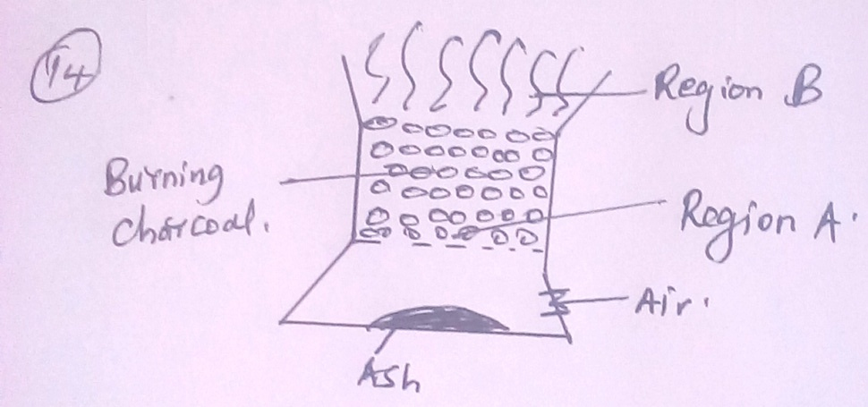

(a) Identify the gas formed at region A. (1 mk)
Carbon (iv) oxide

(b) State and explain the observation made at region B. (2 mks)
- Blue flame, because carbon (II) oxide is burning and usually burns with a blue flame.

15. (a) Diamond and graphite are allotropes of carbon. What is meant by an allotrope?
- These are two or more forms of the same element existing under standard
conditions.

(b) Explain why graphite can be used as a lubricant while diamond cannot. (2 mks)
- Graphite atoms are bonded by covalent bonds to form layers which are in turn
held by weak van der waals forces making the layers slide easily over each other. In diamond there are only covalent bonds.

16. (a) Distinguish between a covalent bond and co-ordinate bond. (2 mks)
- Covalent bond is formed by equal contribution of the shared electrons by the
atoms. Co-ordinate bond is where the shared electrons are contributed by one
of the atoms.

(b) Draw a diagram to show bonding in ammonium ion (N = 7, H = 1) (2 mks)

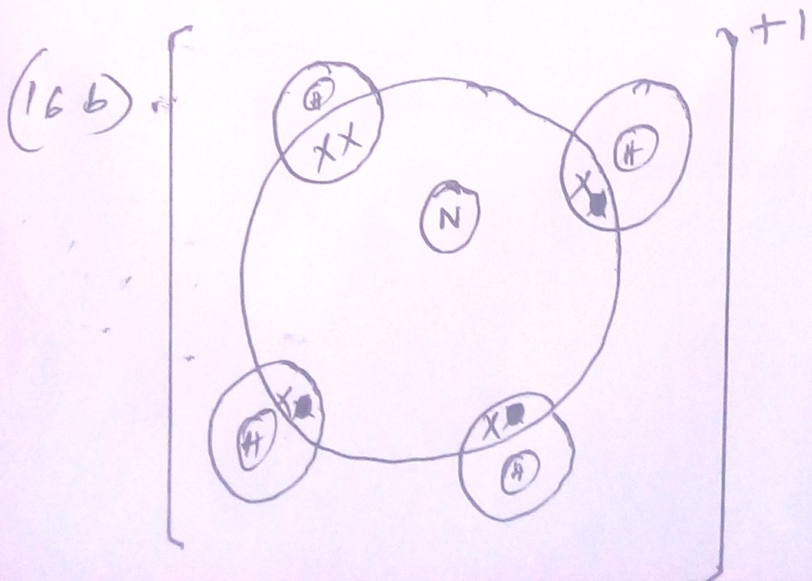

17. Study the information given in the table below and answer the questions that follow. The
letters do not represent the actual symbols of the elements.
Element | Atomic number | Boiling point(k)
S | 3 | 1603
T | 13 | 2743
U | 16 | 718
V | 18 | 87
W | 19 | 1047

(a) Select the elements which belong to the same;
(i) Group - (S, W) (1 mk)

(ii) Period - (T, U, V) (1 mk)

(b) Which element;
(i) Is in gaseous state at room temperature? Explain. (1 mk)
(Room temperature = 298K)
V – has a boiling point of below 298K.
(ii) does not form an oxide. (1 mk)
V

(c) Write the;
(i) formula of the nitrate of element T. (1 mk)
T(NO₃)₃
(ii) equation for the reaction between element S and U.
2S_{(s)} + U_{(S)} S2u_{(s)}

(d) What type of bond would exist in the compound formed when U and T react? Give
a reason for your answer. (2 mks)
- Ionic bond – because T is a metal while U is a non metal. T loses
electrons to U.

18. The table below shows the relative atomic masses and the percentage abundances of the
isotopes L₁ and L₂ of element L.
 | Relative atomic mass | % abundance
L1 | 62.93 | 69.09
L2 | 64.93 | 30.91
Calculate the relative atomic mass of element L. (3 mks)
(62.93 x 69.09) + (64.93 x 30.91)
100

= 4347.8337 + 2006.9863
100

= 64

19. When magnesium metal is burnt in air, it reacts with both oxygen and nitrogen gases
giving a white ash. Write two equations for the reactions taking place. (2 mks)
2Mg_{(s)} + O_{2(g)} 2MgO_{(s)}

3Mg_{(s)} + N_{2(g)} Mg₃N_{2(s)}

20. The chromatogram below was obtained from a contaminated food sample P.
Contaminants Q, R, S and T are suspected to be in P. Use it to answer the following
questions.

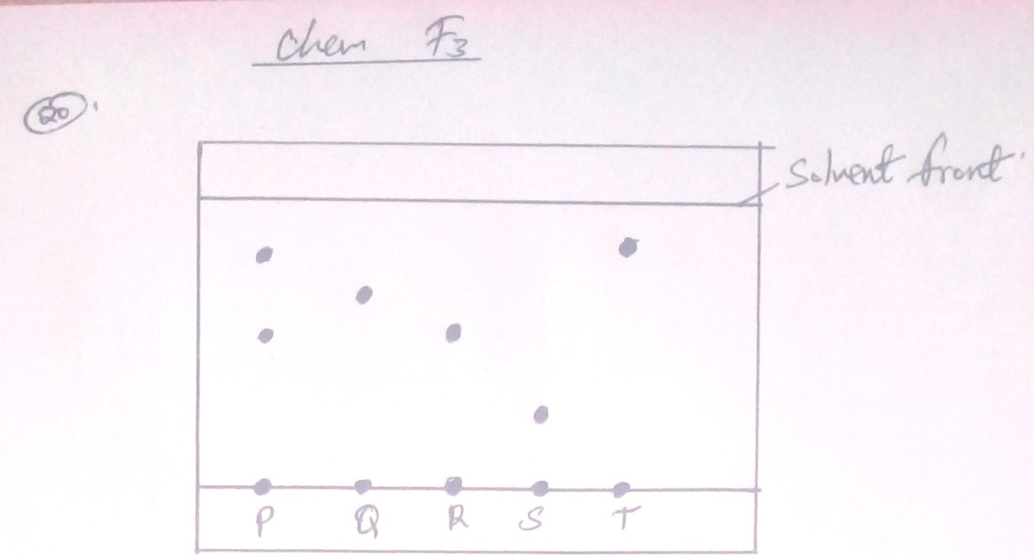

(a) Identify the contaminant in mixture P. (1 mk)
R and T

(b) Which is the most soluble contaminant in P? (1 mk)
T

21. Classify the following processes as either chemical or physical. (3 mks)
Process | Type of change
(a) Heating copper (II) sulphate crystals | Chemical
(b) Obtaining kerosene from crude oil | Physical
(c) Souring of milk | Chemical

22. Name two amphoteric oxides. (2 mks)
Lead (II) oxide
Zinc (II) oxide
Aluminium oxide

23. (a) What is the chemical name for rust. (1 mk)
Hydrated ion (III) oxide.

(b) State one condition that accelerates rusting. (1 mk)
Salty conditions

24. (a) State Charles law. (1 mk)
The volume of a fixed mass of a gas is directly proportional to its absolute temperature at a constant pressure.

(b) Draw a sketch graph to illustrate Charles law. (2 mks)

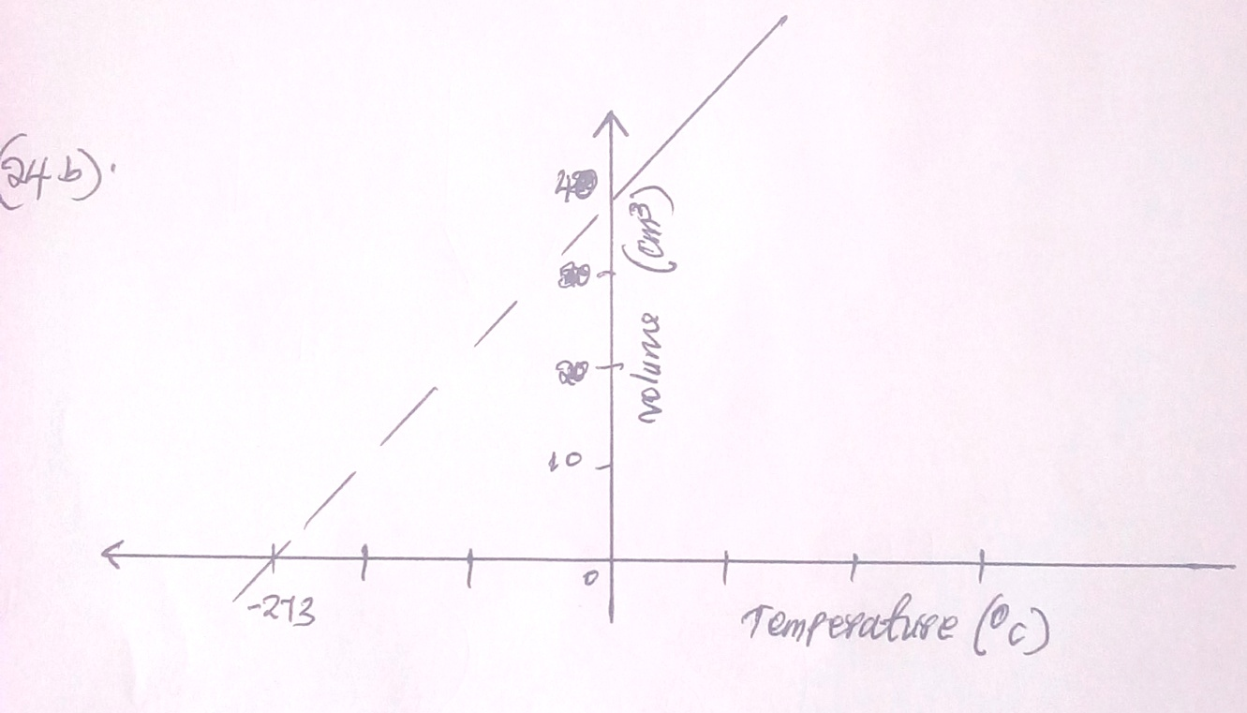

25. (a) Define the term molar solution. (1 mk)
This is a solution that contains one mole of a solute in one litre of the solution.

(b) In a class of 30 students, each student requires 100cm³ of 0.1M sodium hydroxide
solution for a titration experiment. Calculate
(i) The total volume of sodium hydroxide required for the class.
(K = 39, O = 16, H = 1) (2 mks)
(30 x 100) = 3000cm³

= 3L

(ii) The total mass of sodium hydroxide required to prepare the total volume of solution
for the class. (3 mks)
M = moles
Vol (1)

3 x 0.1 = x
X 3
3

X = 0.3 moles
Moles = mass
RFM

4 x 0.3 = x
X 40
40

X = 12g

26. The table below shows the values of solutions A, B, C and D.
Solution | A | B | C | D
pH value | 2 | 7 | 12 | 14

(a) Which solution is likely to be that of magnesium hydroxide? (1 mk)
C
(b) Select the solution that reacts with calcium carbonate powder. Give a reason. (1 mk)
A – Its acidic
27. Determine the volume of 2.0M NaOH which when diluted to 250cm³ would produce a
0.8M NaOH solution. (2 mks)
M₁V₁ = M₂V₂

2X x = 250 x 0.8

2x
= 200
2
2

X = 100
= 100cm³

