NAME …………………………………………………………………ADM No……………… CLASS……..
233
CHEMISTRY
(THEORY) 2021
TIME: 2 HOURS

- A student set up the following apparatus in order to determine percentage of Oxygen by volume of air.
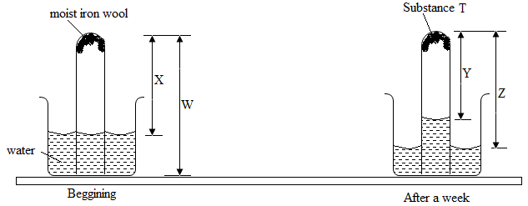

- State and explain the observations made on the moist iron wool at the end of theexperiment (after a week). (1mk)
……………………………………………………………………………………………………………………………………………………………………………………………………………………
- Give the expression of the percentage of oxygen by volume in the air in terms of the letter X, W,YandZinthediagram. (1mk)
……………………………………………………………………………………………………………………………………………………………………………………………………………………
- Write the formula of substance T. (1mk)
……………………………………………………………………………………………………………………………………………………………………………………………………………………
- The paper chromatography below shows the identification of unknown metal ion E and F. Thereference ions are K,L,M and N are shown. The experiment was done in ascending method.

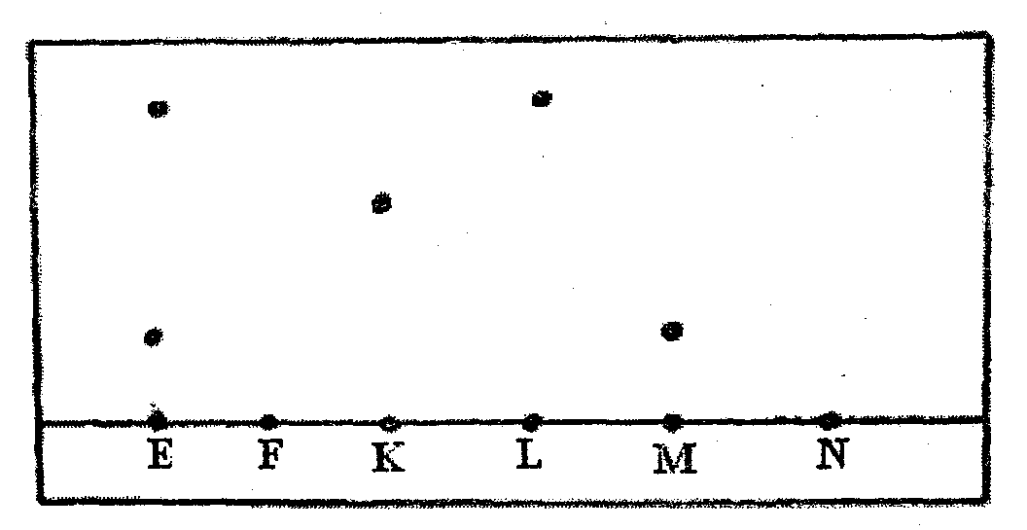

- Name the ions in the mixture E. (1mk)
…………………………………………………………………………………………………………

- Mixture F contains all the three ions. On the diagram show the chromatogram of F. (1mk)

- Comment on the ion N in the diagram. (1mk)
……………………………………………………………………………………………………………………………………………………………………………………………………………………
- The following data gives pH values of solutions A, B and C.
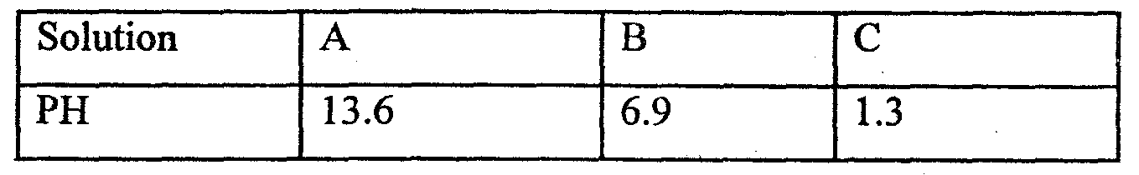

(i) Which solution named produce carbon (IV) oxide where reacted with a carbonate? (1mk)
…………………………………………………………………………………………………………
(ii) Write an ionic equation to show how the above reaction a(i) would be represented (1mk)
………………………………………………………………………………………………………… (iii)What would be the colour of solution A after adding a few drops of phenolphthalein? (1mk)
…………………………………………………………………………………………………………
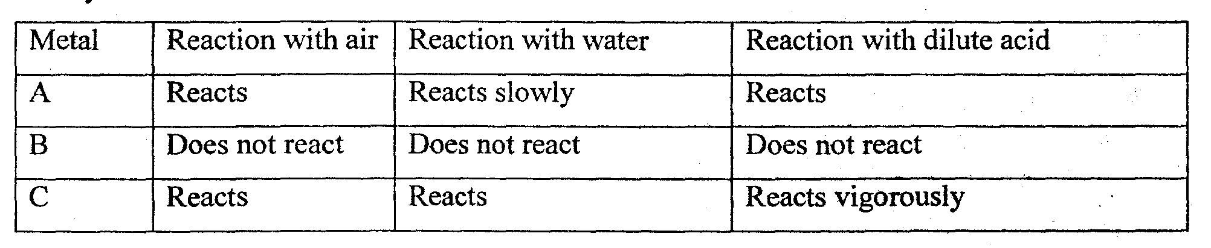
- Study the table below.

- Which metal is likely to be magnesium? (1mk)
…………………………………………………………………………………………………………
- Which metal may be used as a cooking pot? (1mk)
…………………………………………………………………………………………………………
- Arrange the metals in order of reacting starting with the most reactive. (1mk)
………………………………………………………………………………………………………
- An element Q has atomic number 3, relative atomic mass 6.94 and consists of two isotopes of mass 6.0 and 7.0.
- What is the mass number of the more abundant isotope of Q? Give a reason for your answer. (1mk)
……………………………………………………………………………………………………………………………………………………………………………………………………………………
- Calculate the percentage abundant of the isotope which is more abundant. (2mks)

- Below is a scheme of some reactions starting with but-2-ene. Study it and answer the questions that follows.
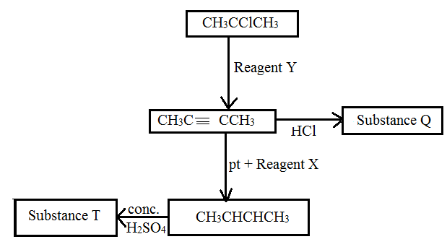

a)Name Y, X and T. (1 ½ mks)
Y…………………………………………………………………………………………………………
X…………………………………………………………………………………………………………
T………………………………………………………………………………………………………….
b)i) Give the name of the following organic compounds. ( 1 ½ mks)
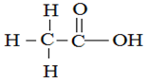
……………………………………………………………………………………………………………….
ii)
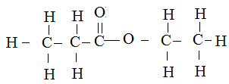
………………………………………………………………………………………………………………
iii)
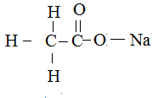
………………………………………………………………………………………………………………
- An element Y has the electronic configuration of 2.8.5.
(a) Write the formula of the most stable anion formed when element Y ionizes. (1mk)
…………………………………………………………………………………………………………
(b) Write the formula of the compound formed by X and Y if the ion of x is represented as X²⁺ (1mk)
………………………………………………………………………………………………………….
(c) Explain the difference between the atomic radius of element Y and its ionic radius. (1mk)
………………………………………………………………………………………………………………………………………………………………………………………………………………………………………………………………………………………………………………………………………………………………………………………………………………………………………………………………
- Using dots(.) and crosses (x) diagram show he bonding in the following compounds.
(a) Lithium oxide ( Li= 3, O=8). (1mk)

(b) Carbon(II) oxide ( C =6, O=8) (1mk)

4. Starting with zinc sulphate solution describe how a sample of zinc oxide can be obtained (3mks)
……………………………………………………………………………………………………………………………………………………………………………………………………………………..………..………………………………………………………………………………………………………………………………………………………………………………………………………………………………
………………………………………………………………………………………………………………

- The diagram below shows a set up that can be used for preparation of solid T in the laboratory.
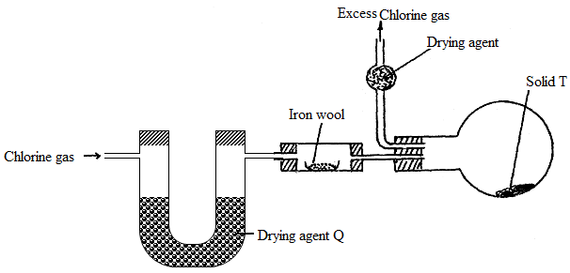

- What condition must be included in the above apparatus for solid T to be formed? (1mk)
………………………………………………………………………………………………………
- Name the solid:
- Q…………………………………………………………………………………………. ( ½ mk)
- T………………………………………………………………………………………… ( ½ mk)
- Why is it possible to collect T as shown? (1mk)
……………………………………………………………………………………………………………………………………………………………………………………………………………………
- Below is a table showing elements in group II of the periodic table. Study it and answer the questions that below.
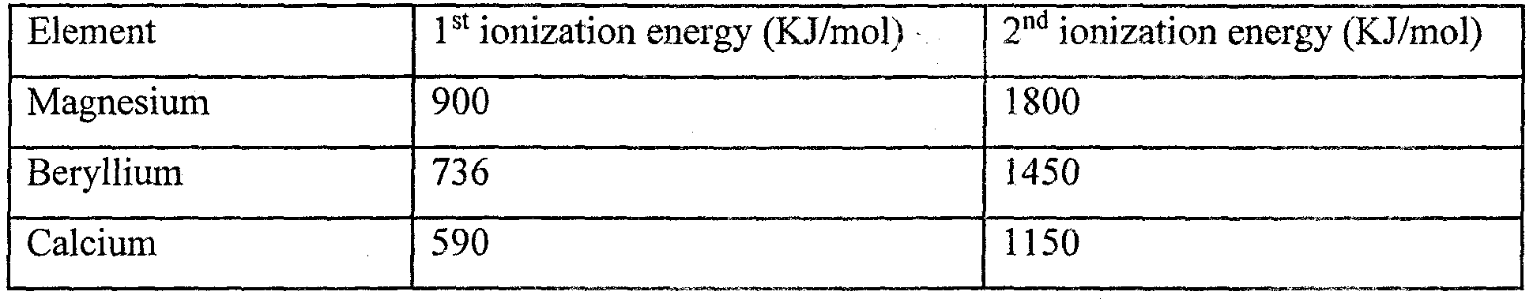

(a) What is ionization energy? (1mk)
………………………………………………………………………………………………………………………………………………………………………………………………………………………………
(b) Explain why 2nd ionization energy of the elements is larger compared to 1st ionization. (2mks)
………………………………………………………………………………………………………………………………………………………………………………………………………………………………………………………………………………………………………………………………………………

- Use the thermo chemical equations below to answer the questions that follow.
C₂H₂ + O₂(g) 2 CO₂(g) + 3H₂O(l)H = -1560KJ/mol
C(s) + O₂(g) CO₂ (g) H = -394KJ/mol
H₂(g) + ½ O₂(g) H₂O (g) H= -286KJ/mol
Draw an energy cycle diagram to represent the information above and use it to calculate the heat of formation of ethyne (3mks)

- A student prepared ammonia gas and let it into a solution of zinc sulphate using the arrangement shown below.
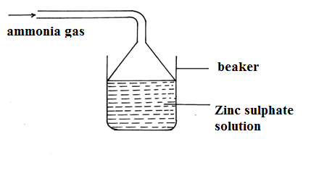

- State and explain the observations that were made in a beaker. (2mks)
……………………………………………………………………………………………………………………………………………………………………………………………………………………………………
…………………………………………………………………………………………………………………
- Write the ionic equation involving zinc ions. (1mk)
…………………………………………………………………………………………………………………

- The melting point of phosphorus trichloride is 90°C while that of magnesium chloride in 715°C in
terms of structures and bonding explain the differences in their melting point. (3mks)
………………………………………………………………………………………………………………………………………………………………………………………………………………………………………………………………………………………………………………………………………………………………………………………………………………………………………………………………
- (a) Name one property of Neon that makes it possible to be used in electric lamps. (1mk)
………………………………………………………………………………………………………………
(b) Name any other use of Argon other than in electric lamps. (1mk)
………………………………………………………………………………………………………………………………………………………………………………………………………………………………
- A compound with molecular C₂ H₆O reacts with sodium metal forming a basic solution.
(a) Draw and name the structure of the compound. (2mks)

(b) To which homologous series does the compound C₂ H₆ O belong? (1mk)
………………………………………………………………………………………………………………
- a) In the fractional distillation of liquid air explain how each of the following components
are removed prior to liquifaction of air.
i) Dust particles (1mk)
………………………………………………………………………………………………
………………………………………………………………………………………………
ii) Carbon (iv) Oxide (1mk)
……………………………………………………………………………………………
………………………………………………………………………………………….
iii) Water Vapour (1mk)
………………………………………………………………………………………………
………………………………………………………………………………………………

- A sample of water is suspected to contain Zinc ions and chloride ions. Give a test on how you can identify the presence of the ions. (3mks)
………………………………………………………………………………………………………………………………………………………………………………………………………………………………………………………………………………………………………………………………………………………………………………………………………………………………………………………………………………………………………………………………………………………………………………………………………………………………………………………………………………………………

- The mass of a solution of salt of sodium chloride is 70.0g. This solution has 10.0g of sodium chloride dissolved in it. The solubility of this salt 30g/l00g of water at 25°C. 6.0g of sodium chloride salt are added to the solution at 25°C. How much sodium chloride will remain undissolved? (3mks)

- When 23 .2g of a hydrocarbon whose empirical formula is C₂H₅ was allowed to evaporate it occupied 9.6dm³ at R.T.P what is its molecular formula? (molar gas volume= 24dm³ at R.T.P) (3mks)

- Study the information below and answer the questions that follow.
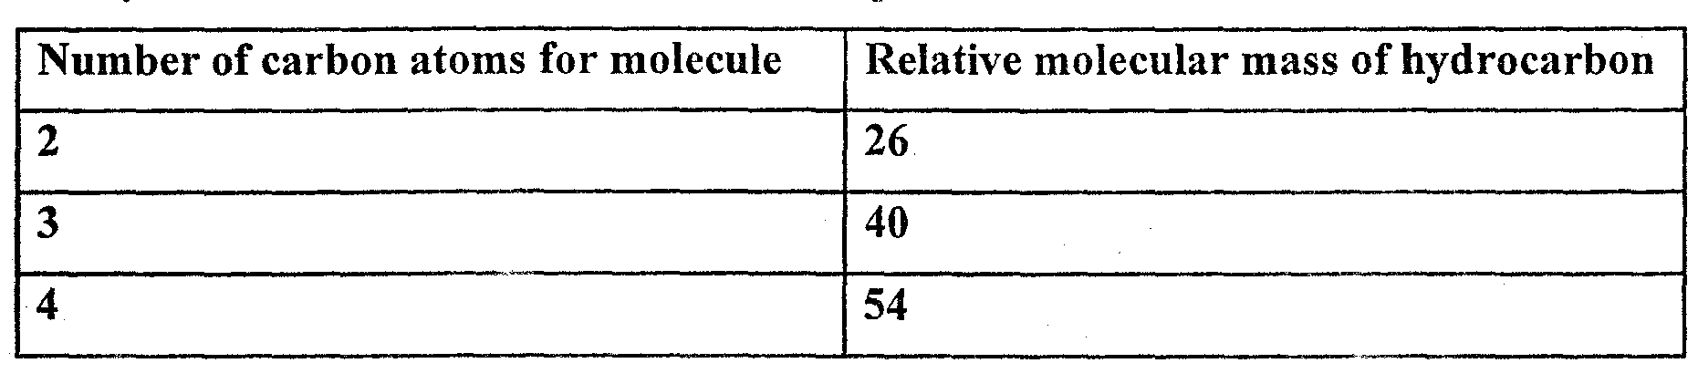

(a) Write the general formula of hydrocarbon in the table. ( ½mk)
……………………………………………………………………………………………………….
(b) Predict the relative molecular mass of the hydrocarbon with 5 carbon atoms. ( ½mk)

……………………………………………………………………………………………………….

(c) Determine the molecular formular of hydrocarbon in (b) and draw its structural formula (H=1, C=12). (2mks)

- X g of sodium hydroxide were dissolved in distilled water to make 100cm³ of solution. 50cm³ of this solution required 50cm³ of 2M nitric(v) acid for complete neutralization. Calculate the mass x of sodium hydroxide dissolved. (Na = 23, O = 16, H=1) (3mks)

- When the oxide of element H was heated with powdered carbon, the mixture glowed and carbon(IV)oxide gas was formed. When the experiment was repeated using the oxide of element
J, there was no apparent reaction.
(a) Suggest one method that can be used to extract element J from its oxide. (1mk))
………………………………………………………………………………………………………………………………………………………………………………………………………………………………

(b) Arrange the elements H, J and carbon in the order of their decreasing reactivity. (1mk)
………………………………………………………………………………………………………………

- When a sample of concentrated sulphuric (IV) acid was left in an open beaker in a room for two days the volume was found to have increased slightly.
(a) What property of concentrated sulphuric (IV) acid is shown by the above reaction? (1mk)
………………………………………………………………………………………………………………………………………………………………………………………………………………………………
(b) State one use of concentrated sulphuric(IV) acid that depends on the property namedabove. (1mk)
……………………………………………………………………………………………………………

- The diagram below shows a set used to prepare gas Z.
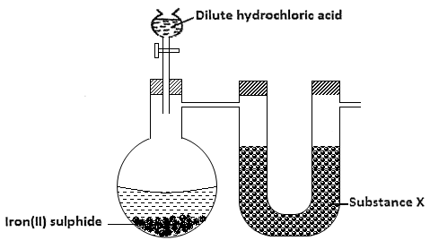
- Complete the diagram to show how gas z is collected. (1mk)

- Write an equation for the reaction between iron(II)sulphide and dilute hydrochloric acid. (1mk)
………………………………………………………………………………………………………
- Name substance x. (1mk)
………………………………………………………………………………………………………

- A beaker contained 75.0cm³ of acqueouscopper(ii) sulphate at 23.7⁰c, when a scrap iron was added to the solution the temperature rose to 29.3⁰c. if 5.83g of copper were deposited, calculate molar enthalpy change in kj/mol.(specific heat capacity of solution = 4.2Jg⁻¹k⁻¹, density of solution = 1g/cm³, Cu = 64) (2mks)

- Butane burns in air according to the equation below.
2C₄H_{10(g)} + l3O_{2(g)}—> 8 CO_{2(g)} + 10H₂0_{(I)}
What volume of butane must be burnt in oxygen to give 11 g of carbon (IV) oxide at r.t.p? (Molar gas volume at r.t.p= 24.01; C= 12; 0= 16; H=1.0) (3mks)

- When magnesium ribbon is burnt in air, two compounds were formed, one of which is
magnesium oxide:
(i) Name the other compound. (1mk)
………………………………………………………………………………………………………………
(ii) Describe an experiment to identify the solid you have named in (i) above. (1mk)……………………………………………………………………………………………………………………………………………………………………………………………………………………………………………………………………………………………………………………………………………………………………………………………………………………………………………………………………………………………………………………………………………………………………………

- The structures below represent two cleaning agents M and P.

$R {COO}^{-}{Na}^{+}R {OSO}_{3}^{{-Na}^{+}}$

M P
Which cleaning agent would be most suitable for use with water containing calcium sulphate. Give a reason. (2mks)

…………………………………………………………………………………………………………………………………….………………………………………………………………………………………………………………………………………………………………………………………….

