MID TERM 1 EXAMS
FORM 3.BUSINESS STUDIES
TIME:2 HOURS
NAME………………………………………………………CLASS……….ADM NO………….
Answer All Question in Section A & B
Section A
- State four limitation of direct production. (4mks)
i……………………………………………………………………………….………………
ii……………………………………………………………………………….………………
iii……………………………………………………………………………….………………
iv……………………………………………………………………………….………………

- Highlight four roles of an entrepreneur to the economy of a country. 4mks)
i……………………………………………………………………………….………………
ii……………………………………………………………………………….………………
iii……………………………………………………………………………….………………
iv……………………………………………………………………………….………………

- Highlight four reasons why the Mau escarpment is an important Natural resource. (4mks)
i……………………………………………………………………………….………………
ii……………………………………………………………………………….………………
iii……………………………………………………………………………….………………
iv……………………………………………………………………………….………………

4. State four roles of intermediaries in the chain of distribution (4marks)
i) ................................................................................................................................................
ii) ................................................................................................................................................
iii) ................................................................................................................................................
iv) ................................................................................................................................................
5.Highlight the purpose of each of the following documents. (4mks)
Document | Purpose
a)Delivery note
b)A debit note
c)An invoice
d)A statement of account
6.Juma a newly employed teacher has joined Mwalimu Sacco in Bungoma. Outline four benefits of membership to the society. (4mks)
i……………………………………………………………………………….………………
ii……………………………………………………………………………….………………
iii……………………………………………………………………………….………………
iv……………………………………………………………………………….………………
7.State four ways in which a business should do to maintain acceptable ethnics (4marks)
i) ................................................................................................................................................
ii) ................................................................................................................................................
iii) ................................................................................................................................................
iv) .................................................................................................................................................
8.Highlight four measures taken by producers to ensure consumers are protected when using their products. (4mks)
i……………………………………………………………………………….………………
ii……………………………………………………………………………….………………
iii……………………………………………………………………………….………………
iv……………………………………………………………………………….………………

9.State four advantages of using E-mail for communication by a given enterprise. (4mks)
i……………………………………………………………………………….………………
ii……………………………………………………………………………….………………
iii……………………………………………………………………………….………………
iv……………………………………………………………………………….………………

10.Highlight four reasons why all motor vehicles are required to have insurance cover.(4mks)
i……………………………………………………………………………….………………
ii……………………………………………………………………………….………………
iii……………………………………………………………………………….………………
iv……………………………………………………………………………….………………
11. State four strategies that a small firm would adopt to expand its operations so as to enjoy economies of scale
i) ................................................................................................................................................
ii) ................................................................................................................................................
iii) ................................................................................................................................................
iv)
12.Highlight four limitations of adopting a new technology in business (4marks)
i) ................................................................................................................................................
ii) ................................................................................................................................................
iii) ................................................................................................................................................
iv) ................................................................................................................................................
iv………………………………………………………………………………………………
13.State four reasons why it may be necessary for the Government to encourage new firms to be located in the rural areas. (4mks)
i.………………………………………………………………………………………………..
ii………………………………………………………………………………………………
iii………………………………………………………………………………………………
iv………………………………………………………………………………………………

14.Highlight four provisions of partnership Act 1963 (4marks)
i) ................................................................................................................................................
ii) ................................................................................................................................................
iii) ................................................................................................................................................
iv) ................................................................................................................................................
15.State four recent trends adopted by many firms in product promotion. (4mks)
i……………………………………………………………………………….………………
ii……………………………………………………………………………….………………
iii……………………………………………………………………………….………………
iv……………………………………………………………………………….………………

Section B

16(a) Explain five features that differentiate a private limited company from a public limited
company. (10 mks)

(b) Explain five factors that are considered when carrying out evaluation of business
opportunities. (10 mks)

17a) Explain five principles of insurance. (10mks)

b) The following diagram shows a shift in the supply curve from S₀ to S₁. Explain briefly Five factors that would cause such a shift (10mks)
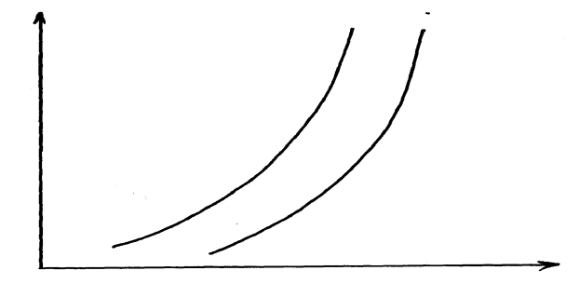
S0
S1

Price

S1
S0

Quantity supplied

