NAME: ……………………………………. ADM NO: …………CLASS:
Form 3
MID TERM EXAMS
TERM 1 YEAR 2021
MARKING SCHEME

Answer all the questions in the spaces provided.

1. Name three tissues in plants that provide mechanical support. (3 mks)
Collenchymas
Xylem vessels
Salerenchymas

2. State the mode of feeding of lion in the food web. (1 mk)
Carnivorous (rej carnivore)

3. Name the fluid that is produced by sebaceous glands. (1 mk)
Sebum or Cebum

4. Name the end product of light stage in photosynthesis. (2 mks)
- hydrogen/hydrogism ions/hydrogen atom (rej gas)
-Oxygen gas (rej ions or atom)
- Energy/ATP

5. Name four ways in which respiratory surfaces are suited to their function.(4 mks)
- They have thin walls for faster diffusion of gases or to reduce the distance for faster diffusion of gases
- They are moist for dissolving gases
- Large surface area for maximum diffusion/gaseous exchange
- Highly vascularised to facilitate easy diffusion/or to enhance diffusion gradient.

6. Distinguish between diffusion and osmosis. (2 mks)
- Osmosis is the movement of water molecules from their highly concentration region to low concentration region across the semi-permanent membrane.
- Diffusion is the movement of substances/molecules/particles from a region of high concentration to a region of low concentration.

7. An experiment was set up as shown below. Study it and answer the questions that follow.

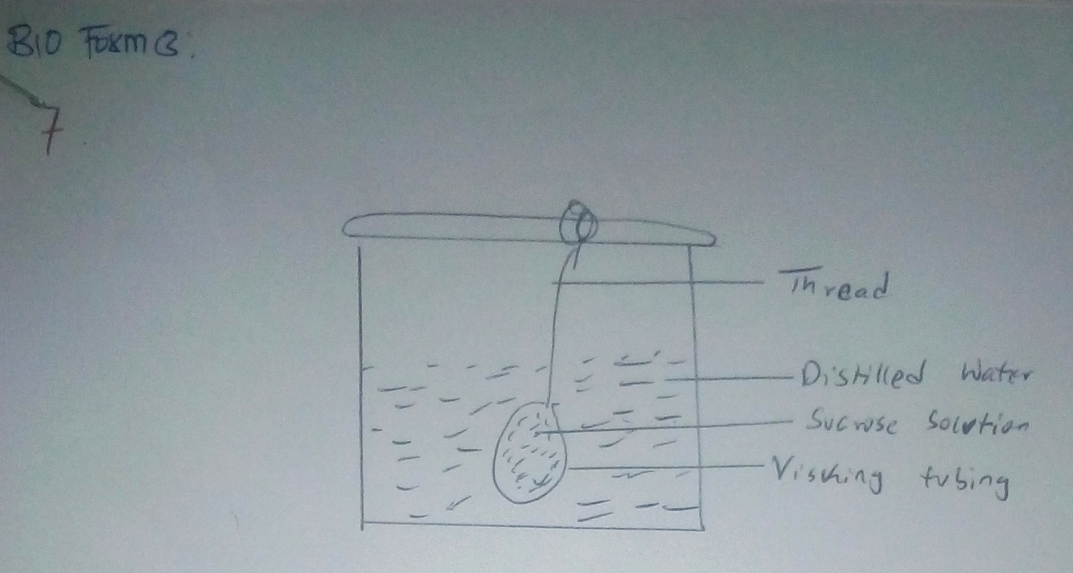

(i) The set up was left for 20 minutes. State the expected results. (1 mk)
The risking tubing will become turgid (rej flaccid)

(ii) Explain your answer in (i) above. (2 mks)
- Water moves from this beaker into the visking tubing by osmosis through semi-
permeable visking tubing. Sucrose is hypertonic/water is hypotonic thus
making the visking tubing big/larger.

8. Give the function of the following cell organelle. (1 mk)
(i) Ribosome – This is for the site for protein synthesis

(ii) Lysosome – (2 mks)
- Dark spherical vesicles containing lytic enzymes
- It involves an intracellular digestion
- Breakdown of worn out cell organelles

9. Name the type of carbohydrates (polysaccharides) found in the following parts of living
organisms.
(i) In the exoskeleton of arthropods
Chitin

(ii) In the xylem vessels –
Lignin

(iii) In the animals blood –
Glycogen

10. The diagram below represents a transverse section through a plant organ. Study it and
answer the questions that follow.

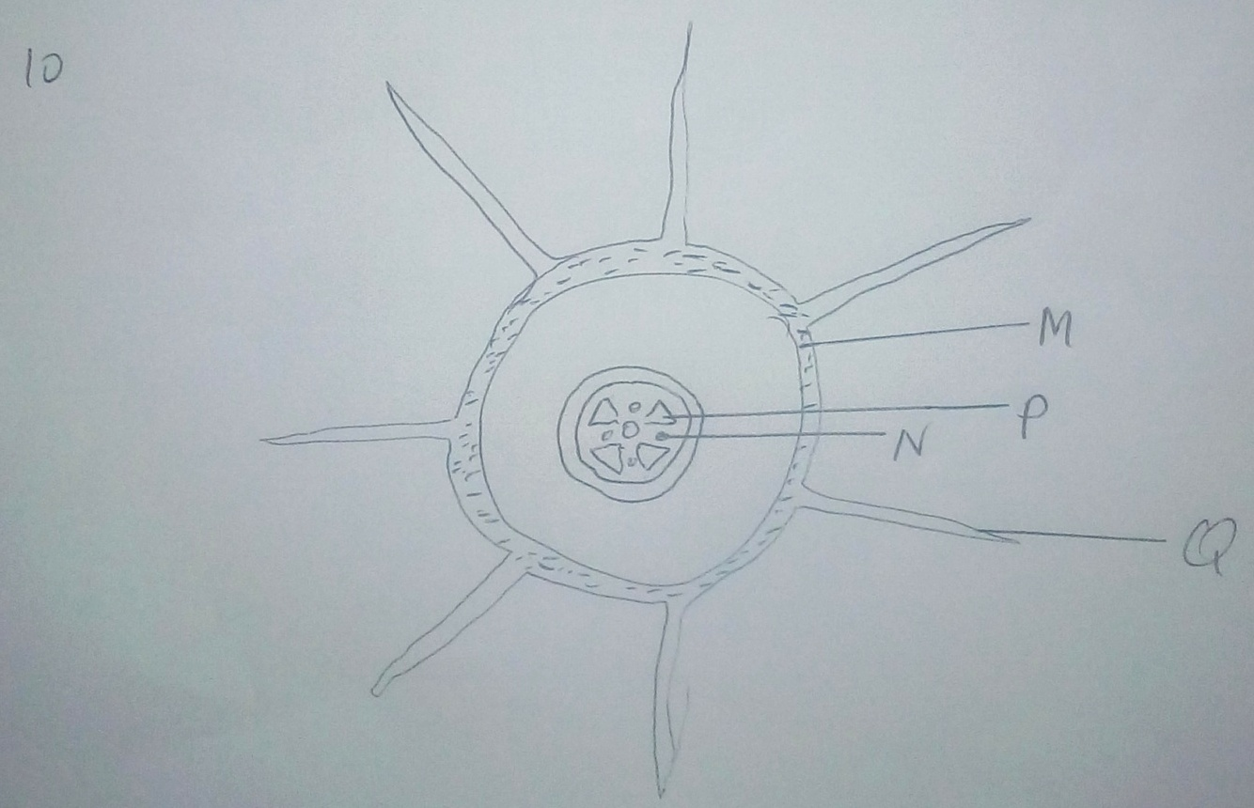

(a) From which plant organ was the section obtained. (1 mk)
Monocotyledonous roots

(b) Name the parts labeled Q, N and P. (3 mks)
Q – root hair
N – Phloem
P – Xylem

11. How are leucocytes adapted to their functions? (2 mks)
- Phacocytes are amoeboid which enables them to engulf pathogens and move through
this capillary wall.
- Lymphocytes produce antibodies against antigens

12. The diagram below illustrates the structure of a gill from bony fish.

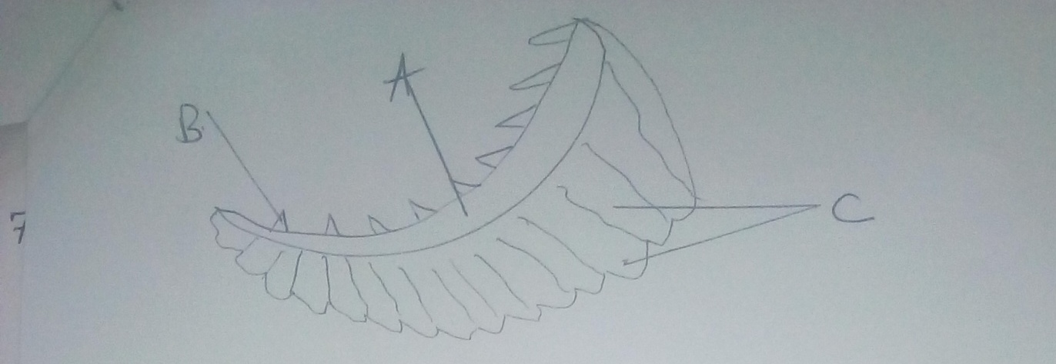

(a) Name the structures labeled A, B and C and give their functions. (3 mks)
A – Gill bar
B – Gill raker
C – Gill fillaments

(b) In what ways are the structures labeled C adapted for their function? (3 mks)
- They are highly folded and very many thus providing a large surface area for
gaseous exchange
- They have a thin epithelial lining thus reducing the distance over which gases have to
diffuse.
- They have a rich capillaries of blood vessels/vascularized.

13. (a) Which substance accumulates in the muscles when respiration occurs in absence of
oxygen. (1 mk)
Lactic acid

(b) Which physiological changes occur in the body that enable the body to break down the
substance named in (a) above. (2 mks)
- Increase the heart beat and breathing rate which supplies more oxygen to the tissues to
break down the poisonous lactic acid into the water and carbon(iv) oxide or converted
it into glucose.

14. Name the product of anaerobic respiration in:
(i) Plants (2 mks)
Ethanol, carbon(iv) oxide, and energy/2ATP/210KJ

(ii) Animals (2 mks)
Lactic acid and energy/2ATP/150kJ

(b) Explain the term Basal Metabolic Rate. (2 mks)

- Is the minimum amount of energy that an organism requires at rest to maintain life
processes

15. Name three organic waste products in plants. (3 mks)
Tannins, resins, gums

16. Give the advantages of excreting nitrogenous waste products in the form of Uric acid as
compared to urea. (2 mks)

Uric acid is insoluble and less toxic than urea and therefore require very little water to eliminate animals that excrete do not need to carry a lot of water.

17. What is homeostasis? (1 mk)
It is the maintenance of a constant internal body environment.

(b) State the importance of ultra-filtration in the nephrone of human kidney. (2 mks)
- Helps to remove excretory products and other toxic substances from the blood.

18. (a) Name the hormone whose deficiency may lead to the excretion of glucose in urine.
(1 mk)
Insulin

(b) Name the hormone that controls the reabsorption of sodium ions in the kidney tubules.
- Aldosterone (1 mk)

19. Name the only plant subdivision, which produces flowers. (1 mk)
- Angiospermae

20. Besides the abdomen, name the other body part of members of Arachnida. (1 mk)
- Cephalthorax

21. Name the phylum whose members possess a notochord. (1 mk)
- Chordata/Vertebrata

22. The diagram below shows a mould of the genus Rhizopus. Study it and answer the
questions that follow.

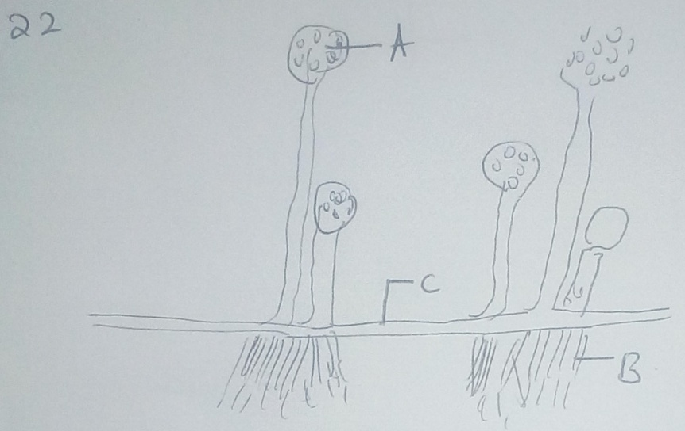

(a) Name the kingdom to which it belongs. (1 mk)
- Fungi

(b) Name the structure labeled A, B and C.
A – Sporangium
B – Rhizoids
C – Stolon

23. Give three characteristics of kingdom montra. (2 mks)
- They are prokaryotic (those nucleus not membrane bound)
- They are unicellular organisms (single celled)
- They have cell wall but not made up of cellulose.

24. State three characteristics of phylum chordate not found in other kingdom.(3 mks)
- Dorsal nerve chord
- Endoskeleton
- Closed circulatory system

25. (a) Name the class to which centipede belongs. (1 mks)
- Chilopoda

(b) Give one structural feature that can be used to differentiate crustaceans and arachnids.
(1 mk)
- Crustaceans have two pairs of antennae while arachnids have none.

26. State the organism shown below and answer the questions that follow.

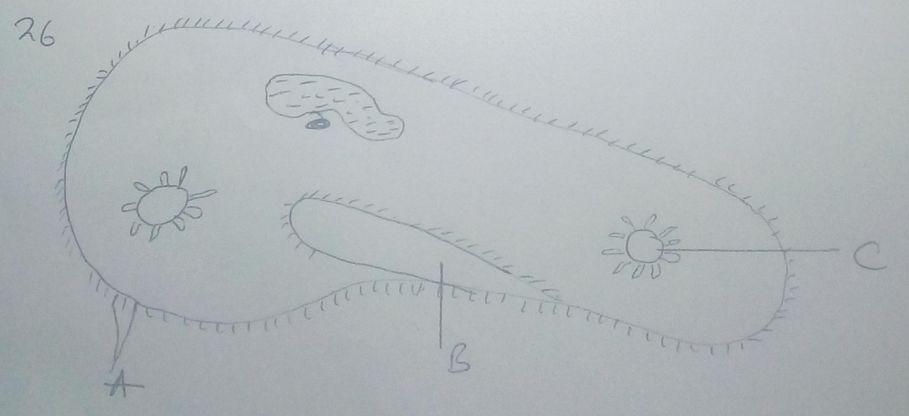

(a) Name the kingdom to which organism belong and give a reason for your answer.
(2 mks)
- Protoctista
- Is a unicellular organisms with a membrane bound nucleus and several other
membrane bound organelles.

(b) Name the structures labeled A, B and C (3 mks)
A – cilia
B – Oral groove
C – contractile vacuole

(c) Give the function of the structure labeled C. (1 mk)
- Osmoregulation

27. In an investigation, the pancreatic duct of a rat was blocked by tying it with a string.
Explain how this affected the following processes.
(a) Digestion of food. (2 mks)
- Digestion of food was impred. The blockage prevent pancreatic juice
containing digestive enzymes e.g amylase trypsin and lipase from reaching the
duodenum.

(b) Regulation of blood glucose level. (2 mks)
Regulation of blood glucose level proceeded normally. This is because, the pancreatic hormones, insulin and glucogen, which are involved in the regulation
of blood glucose level are secreted directly in the bloodstream.

28. Give three differences between class chilopda and diplopoda. (3 mks)
Diplopoda | Chilopoda
Members have cylindrical body | The body is – centrally flattened
Each segment has two pair or walking legs except for this first thoragic segment | Each segment has a pair of walking legs
They do not have poison claws | They have poison claws which secretes substance

