NAME:………………………………………………………………ADM:………CLASS:…………
BIOLOGY
MID TERM 1 2020
FORM 2
- The diagrams below show a red blood cell that was subjected to a certain treatment.

At the end of experiment
At start
- Account for the shape of the cell at the end of the experiment. (2mks)

- The red blood cell was placed in a hypertonic solution. It lost water by osmosis and become evenate

- Draw a diagram to illustrate how a plant cell would appear if subjected to the same treatment. . (2mks)
Cell wall

Cell membrane
cytoplasm

vacuole

- The diagram below shows a human tooth.

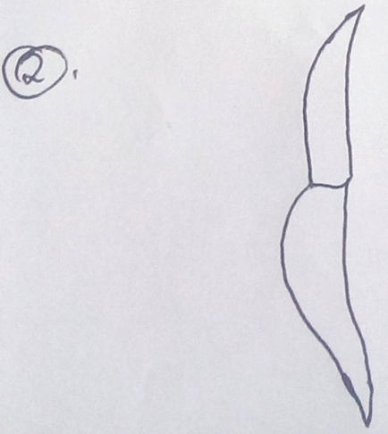

- Identify the tooth. (1mk)
Canine

- How is the tooth adapted to its functions. (2mks)
Pointed/sharp for cutting flesh.
Has a long root to support it into the jaw bone.
- The diagram below represents a transverse section through a plant organ.

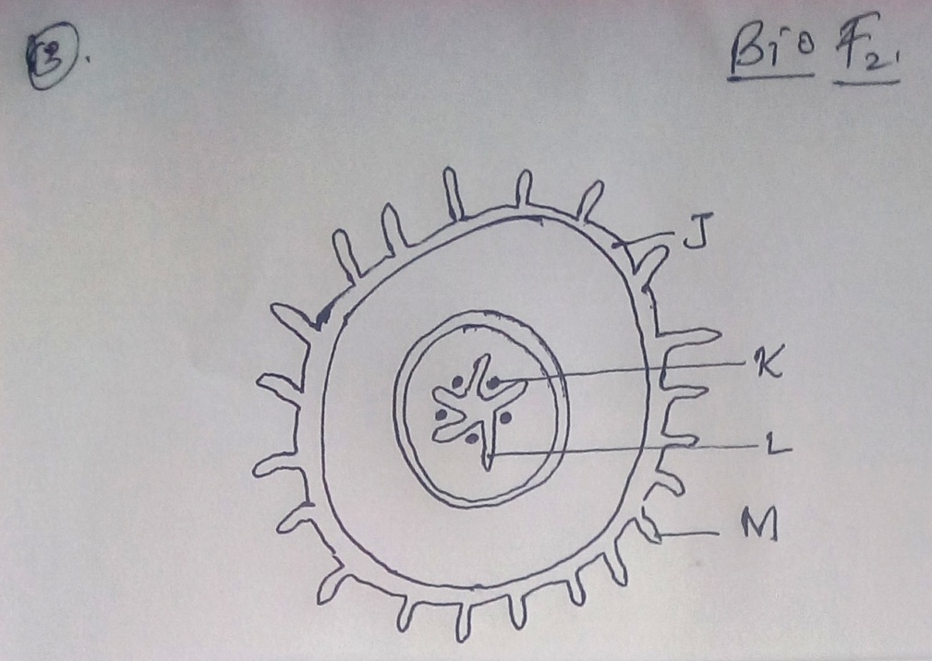

- From which plant organ was the section obtained. (1mk)
- Dicotyledonous root. (1mk)

- Give two reasons for your answer in (a) above (2ks)
- Presence of root hairs.
- Presence of endodermis
- Xylem is star shaped at the centre while the phloem is in between the arms of the xylem.

- Name the parts labeled J K and L. (3mks)
J - epidermis
K- phloem
L- Xylem

- State two functions of the part labeled M. (2mks)

Absorpation of water
Absorption of mineral salts.

- Explain how each of the following factors affects the rate of photosynthesis
- Temperature (2mks)

Photosynthesis is an enzyme controlled reaction. Low temperatures inactivate enzymes rises enzymes are activated and rate of photosynthesis increases

- Chlorophyll concentration. (2mks)
Chlorophyll molecules traps light energy from the sun necessary for photosynthesis, low amount of chlorophyll molecules lowers the rate of photosysnthesis.

- Name the tissues in plants responsible for: (2mks)
- Transport of water and mineral salts
xylem

- Transport of carbohydrates

phloem

- State one adaptation of xylem vessels to their functions . (1mk)
- Lignified
- Has dead cells

- (a) Why are people with blood group O universal donors? (2mks)
Blood type O has no antigens and does not cause agglutination with other blood groups

(b)A person whose blood group is AB requires a blood transfusion. Name the blood groups of the donors. (2mks)

- A, B, AB, O
- Name the organelles that performs the following functions in a cell (2mks)

Protein synthesis - ribosomes
Transport of cell secretions – lysosomes

- State one use for each of the following apparatus in the study of living organisms. (2mks)
- Pooter
For sucking small animals from rocks surfaces or bark of trees.

- Pitfall trap

- For catching crawling animals.

- A ‘dolf’ is an offspring between a wolf and a dog. This animal is infertile. Give a reason for this. . (1mk)
- Wolf and dog belong to different species.

- State the role of light in photosynthesis (2mks)
- Provided energy required for splitting water molecules into hydrogen ions and oxtgen gas.

- Name a disease caused by lack of each of the following in human diet. (2mks)

- Vitamin D – rickets, osteoporosis
- Iodine- goitre
- The following is the dental formula of a certain mammal.
I 0/3 C 0/1 pm 3/3, molar 3/3

- State the likely mode of feeding for the mammal. (1mk)
- Herbivorous
- Give a reason for your answer in (a) above. (1mk)
- Lack incisors, canines on the upper jaw

- Explain why the rate of transpiration is reduced when humidity is high? (2mks)

- When humidity is high the concentration of water vapour in the atmosphere is higher thus reducing the rate of transpiration

- Why are plants able to accumulate most of their waste products for long. (1mk)
- The waste products one loss toxic

- State two ways by which acquired immune deficiency syndrome (AIDS) virus is transmitted. . (2mks)

- Having unprotected sex with infected persons
- Sharing of sharp objects e.g needles

- State three structural differences between arteries and veins. (3mks)

- Arteries veins
- Thick muscular walls thin less muscular walls
- Narrow lumen Wide lumen
- Elastic walls Less elastic walls
- No values except at the bases of Have values at regular intervals
pulmonary artery and aorta

- State three difference between open and closed circulatory systems. (3mks)
OPEN CLOSED
- Fluid is in direct contact with tissues - blood is not in direct contact with tissues.
- Fluid flow under low pressure hence slow - Blood flow under high pressure hence faster
- Transport fluid conveyed in general body - Transport fluid conveyed in special tubules
Cavity
- Explain two protection functions of blood. (2mks)
- Contains phagocytes that engulf and digest pathogens through photosynthesis.
- Contains platelets whose role is blood clotting when vessels are injured.
- Contains lymphocytes that produce anti-bodies that protect the body from infections

