MID-TERM EXAM
TERM ONE FORM THREE
AGRICULTURE
TIME:2 HOURS
NAME……………………………………………….. ADM……………….. CLASS……...

SECTION A: (30 MARKS)

Answer ALL questions in this section in the spaces provided.

- Differentiate between selection and culling in animals.(1mark)

- State two methods of stocking a beehive. (1marks)

- What term is used to describe a case where during parturition the hind legs come out first?(1mark)

- Give the two breeding system used in livestock improvement. (1 mark)

- Name two breeds of sheep kept for dual purpose.(1mark)

- Give any four advantages of artificial insemination.(2marks)

- State four methods of identification in livestock. (2marks)

- Give reasons why roughage is necessary in ruminant animals(1mark).

- Define the following terms.
  - Fishing(1mark)

  - Crutching(1mark)

  - Ringing(1mark)

  - Raddling(1mark)

- State three methods of dehorning .(1 ½ mark)

- Give four desirable features of a rabbit hutch.(2marks)

- Distinguish between inbreeding and out crossing in livestock production (2marks)

- State four uses of a crush in livestock production.(2marks)

- Define the term feed additives. (½ mark)

- State three importance of feed additive.(1½marks)

- State four functions of the worker bee in a bee colony. (2marks)

- Give three methods of selection. ( 1½ marks)

SECTION B (20MARKS)
Answer all the question in this section in the spaces provided

- The diagram below illustrates a breeding management practice.

a) Identify the practice. (1mark)

b) Outline three reasons for carrying out this practice. (3marks)

c) Give three causes of infertility in farm animals. (3marks)

19. Below is the diagram of a digestive system, use it to answer the question that follows.

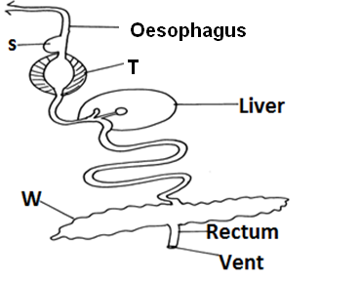

a) Which farm animal has a digestive system similar to the above system.(1mark)
b) Name the parts labeled S, T and W. (3marks)

c) Explain the work of the parts S and T. (2marks)

20. Study the diagram below of a permanent foundation and answer the question that follows:

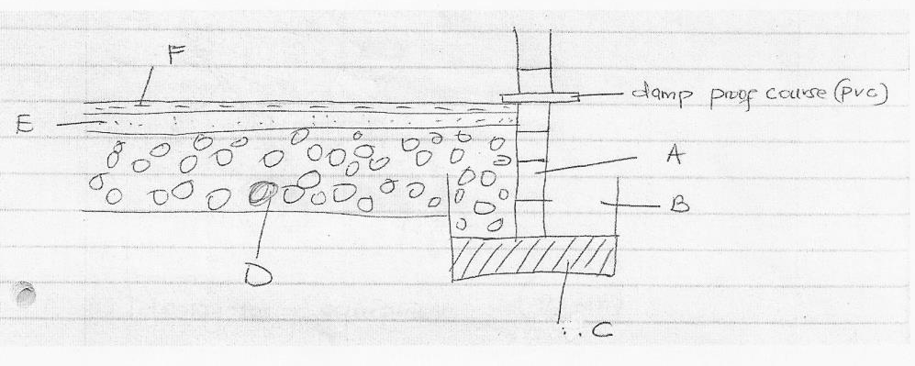

  - Name the following parts labeled A, B, C and D.(4 marks)

  - What is the mixing ratio used to make part F? (1 mark)

  - State two uses of the damp proof course (PVC) (2 marks)

SECTION C (40MARKS)
Answer only two questions in this section
21. a) State five factors considered when selecting construction materials. (5marks)
b) Give five uses of a crush in a farm. (5 marks)
c) State and explain parts of a zero grazing unit. (10marks)
22. a) Describe five factors considered when selecting a breeding stock. (10marks)
b) Give the advantages of artificial insemination. (10 marks)
23. a) Name four method used in preservation of fish. (4 marks)
b) State six factors considered when culling a cow for breeding. (6 marks)
c) State and explain five qualities of a good store. (10 marks)

