1. The mass of a density bottle is 20g when empty and 45g when full of water. When full of mercury, its mass is 360g. Calculate the density of mercury.
SOLUTION
Mass of water = 45-20 =25g
Volume of water=25g/1g/cm³
=25cm³
Volume of bottle = 25cm³
Mass of mercury = 360-20 =340g
Volume of mercury= 25cm³
Density of mercury=340/25
=13.6g/cm³ or
=13600kg/m³
2.100cm³ of fresh water of density 1000kg/m³ is mixed with 100cm³ of sea water of density 1030kg/m³. Calculate the density of the mixture.
Solution
Mass of fresh water= density x volume
=1g/cm³ x100cm³
=100g
Mass of sea water = 1.03 x 100
=103g
Mass of the mixture= 100+103
=203g
Volume of the mixture=100+100
=200cm³
Density of the mixture =203/200
=1.015g/cm³

3.Find the weight of an object whose mass is 50 kg.
W=mg
50 x10 =500 N
4.Find the mass of an object whose weight is 900N
W =mg
900/10=10/10M
M=90kg
5.Determine f₂ in the figure below. Density of the liquid =800kg/m³ and g=10N/kg
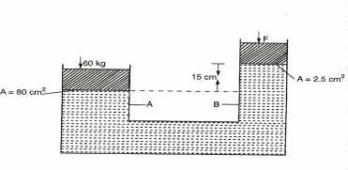
P_{A} = P_{B}
(60 x 10)/0.008 = (F₂/0.00025)+ (0.15 x 800 x 10)
0.00025(7500 -1200) = F₂
F₂=18.45N
6.The distance between the pinhole and screen of a pinhole camera is10cm. The height of the screen is 20cm.At what distance from the pinhole must a man
1.6m tall stand if a full length is required
h_{i}=20cm, h_{o}=1.6m and v=10cm
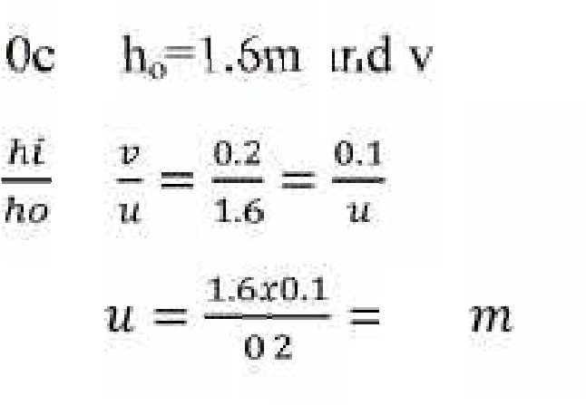
M = = == ... . =. =. 0.8

7.Calculate the amount of current flowing through a bulb if 300 coulombs of charge flows through it in 2.5 minutes.
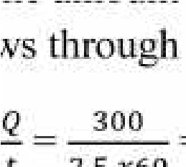
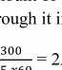
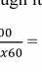
I = = . = 2A
8. cells of electromotive force (e.m.f) 1.2V are connected in series. What is the effective voltage?
V_{T}=(5 x 1.2)V= 6V
9.Give seven ways of maintenance of accumulators.
a)The level of the electrolyte should be checked regularly and maintained above the plate.
b)The accumulator should be charged when the e.m.f of the cell is below
1.8V and when the relative density of the acid is below 1.12.
c)Large currents should not be drawn from the battery for a very long time.
d)The accumulator should not be left in a discharged condition for a long period.
e)Shorting or overcharging the accumulator the accumulator should be avoided.
f)The terminals should always be kept clean and greased.
g)The accumulator is not placed directly on the ground but not on an insulator.
10. The diagram below shows the magnetic field pattern between two magnets, P and Q
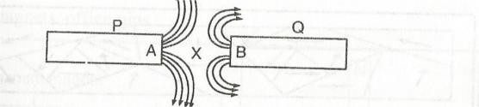
- Identify the poles of P and Q
- State which of the two magnets P and Q is stronger. Explain

