PHYSICS FORM 2 MID TERM 1 EXAMS
FIRST TERM 2021
NAME………………………………..ADM NO…………… CLASS…….

- The mass of a density bottle is 20g when empty and 45g when full of water. When full of mercury, its mass is 360g. Calculate the density of mercury. (3mks)

2.100cm³ of fresh water of density 1000kg/m³ is mixed with 100cm³ of sea water of density 1030kg/m³. Calculate the density of the mixture. (4mks)

3.Find the weight of an object whose mass is 50 kg. (3mks)

4.Find the mass of an object whose weight is 900N (3mks)

5.Determine f₂ in the figure below. Density of the liquid =800kg/m³ and g=10N/kg (7mks)
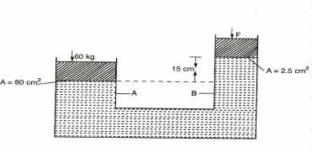

6.The distance between the pinhole and screen of a pinhole camera is10cm. The height of the screen is 20cm.At what distance from the pinhole must a man
1.6m tall stand if a full length is required (5mks)

7.Calculate the amount of current flowing through a bulb if 300 coulombs of charge flows through it in 2.5 minutes (3mks)

8. cells of electromotive force (e.m.f) 1.2V are connected in series. What is the effective voltage? (3mks)

9.Give seven ways of maintenance of accumulators. (7mks)

10. The diagram below shows the magnetic field pattern between two magnets, P and Q (4mks)
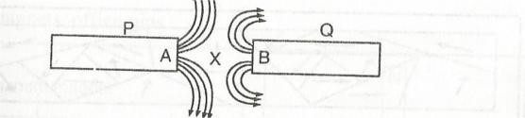
- Identify the poles of P and Q

- State which of the two magnets P and Q is stronger. Explain
11. Give 5 branches of physics (5mks)

12. State the Relationship between physics and other subjects. (3mks)

