FORM 3 GEOGRAPHY EXAMS 2021
MARKING SCHEME
1.The table below shows the number of visitors in ‘000 to selected national parks in Kenya for the years 2006-2008.Use it to answer the questions that follows;
PARK/YR | 2006 | 2007 | 2008
Nairobi | 102 | 093 | 092
Amboseli | 153 | 156 | 082
Tsavo | 354 | 372 | 182
Lake Nakuru | 327 | 347 | 138
Total | 946 | 968 | 497
A)What is the difference in the number of visitors who visited the parks in 2006 and those in 2007?(1mk)
968,000 – 946,000=22,000 visitors
B)Calculate the percentage increase in the number of visitors who visited lake nakuru national park between 2006 and 2007.(2mks)
347,000-327,000=20,000
20,000 ×100 = 6.12 percent
327,000
C)Draw a compound bar graph to represent the number of visitors to selected national parks in kenya.Use the scale of 1cm to represent 100,000 visitors.(10mks)
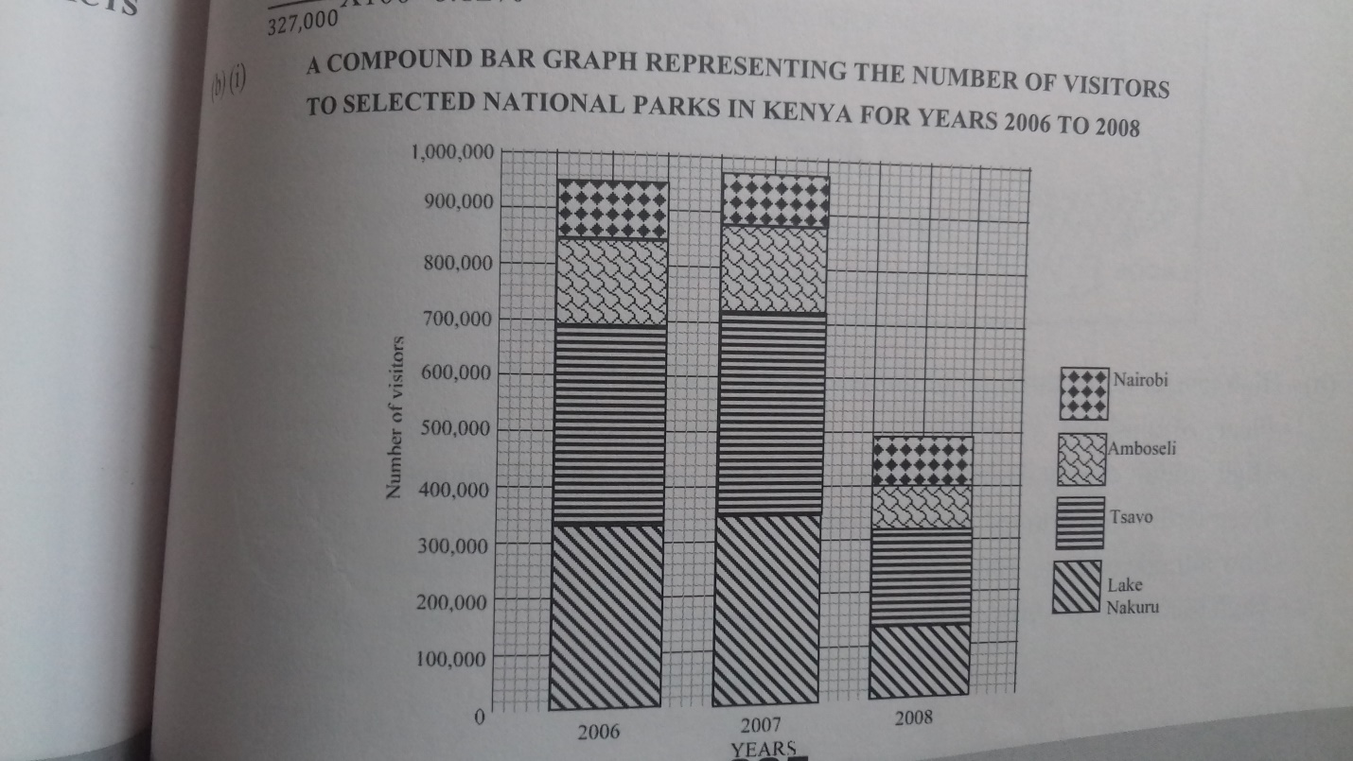

D)State two advantages of using a compound bar graphs to represent geographical data(2mks)
Provides a clear visual impression of the total values.
Easy to read highest and lowest totals at a glance by comparing the sizes of segment in each individual bar
2)The table below shows the approximate population of four districts in central province in 1999.Use it to answer questions that follows.
District | population
Murang’a | 350,000
Maragua | 390,000
Nyandarua | 470,000
Thika | 650,000
Total | 1,860,000

A)Using a radius of 5cm draw a pie chat to represent the data above (10mks)
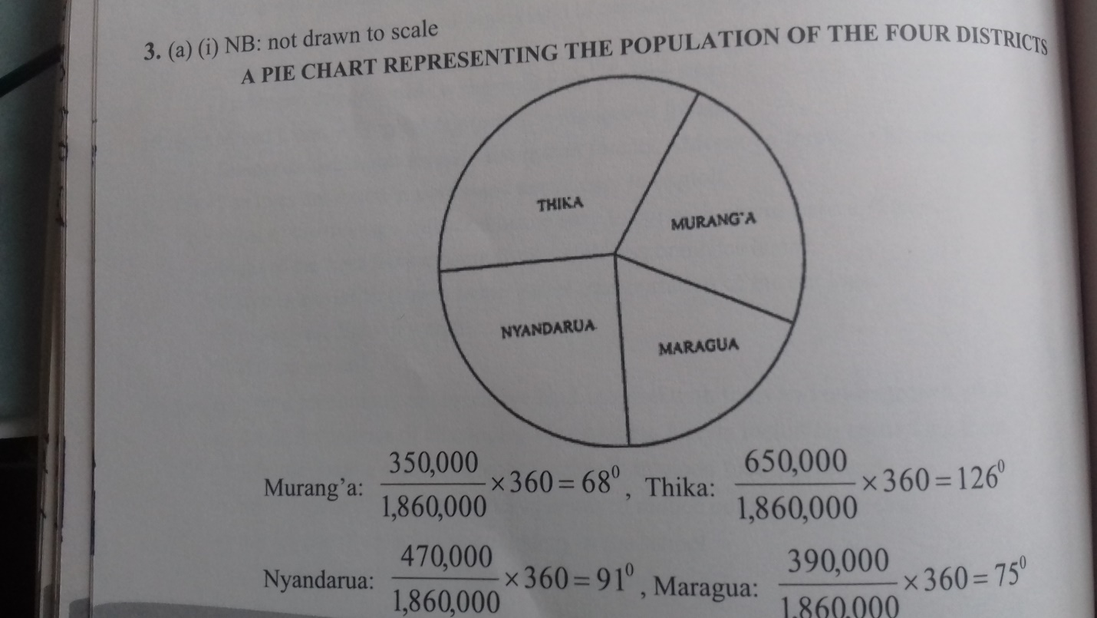

B)Apart from pie charts ,name two other statistical methods that can be used to represent data in the table(2mks)
Divided rectangles
Simple bar graph
Compound bar graph
Propotional circles
C)Give three advantages of using a pie chart to represent data (3mks)
It is easy to interpret
Gives clear visual impression
It is easy to compare
It is easy to read
3)A. What is forestry?(2mks)
Is science of planting caring and using trees/forests and their associated
resources or the practice of managing and using trees/ forests and their associated
resources.
4) Explain four measures that the government of Kenya is taking to conserve forests
in the country.(8mks)
Legislations aimed of curbing encouraging public to participate in
conservation of forests.
Legislations aimed of curbing encroachment in forested areas.
Encouragement in frosted areas
Encouraging public to participate in conservation of forests.
setting up of buffer zones to hinder human encroachment into forested areas
(Nyayo Tea Zones)
Creation of forest reserves
Encouraging agro-forestry
Setting up presidential commission with the mandate of rehabilitation
destroyed forested areas.
5)Use the map below to answer questions (a) and (b)
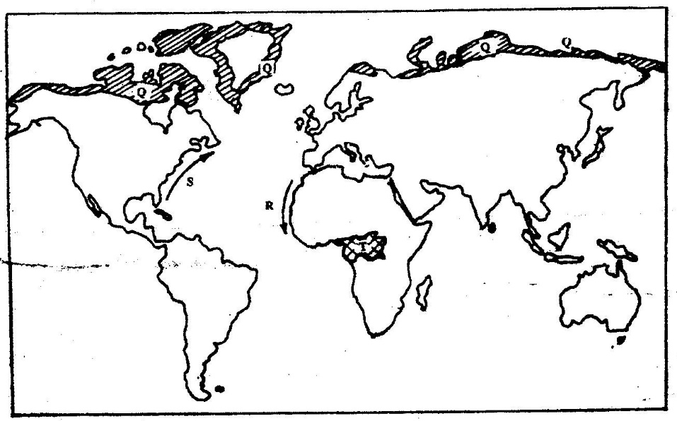

(a) Name:
(i) The type of climate found in the shaded area marked Q (1mk)
Polar climate

(ii)Describe the characteristics of the type of climate found in the shaded areamarke T (9mks)
High temperatures all year about 27 0 C
Low diurnal range of temperature of approximately 6 0 C
High rainfall of between 1500mm and 2000mm throughout the year.
High humidity due to high rainfall and high evaporation
Major winds are S. east and North East trade winds
Thick cloud covers throughout the year.
Rainfall is mainly convectional accompanied by thunderstorms
Long hours of sunshine.
Low atmospheric pressure.

