**NAME………………………………………………………..FORM……. …………………**

**STUDENT’S SIGN………….….….….…..DATE……….…………………………………**

**MID TERM 1- 2021**

**CHEMISTRY**

**FORM TWO**

**(THEORY)**

**TIME: 1 HR 15 MIN**

**INSTRUCTIONS TO STUDENTS:**

1. Write your **name** and **form** in the spaces provided **above**.
2. **Sign** and write the **date** of examination in the spaces provided **above**.
3. Answer **ALL** the questions in the spaces provided.
4. All working **must be** clearly shown where necessary
5. Candidates should check the question paper to ascertain that all the pages

are printed as indicated and that no questions are missing

1. Candidates should answer the questions in English.

**For Examiner’s Use Only**

|  |  |  |
| --- | --- | --- |
| **Questions** | **Maximum Score** | **Candidate’s Score** |
| **1 – 12** | **50** |  |

1. Wooden splints **F** and **G** were placed in different zones of a Bunsen burner flame. The diagram below gives the observations that were made.

**G**

**F**

Burnt parts

Burnt part

(a) Explain the difference between **F** and **G** (2marks)

(b) Name the type of flame that was used in the above experiment (1mark)

1. A mixture of hexane and water was shaken and left to separate as shown in the diagram below

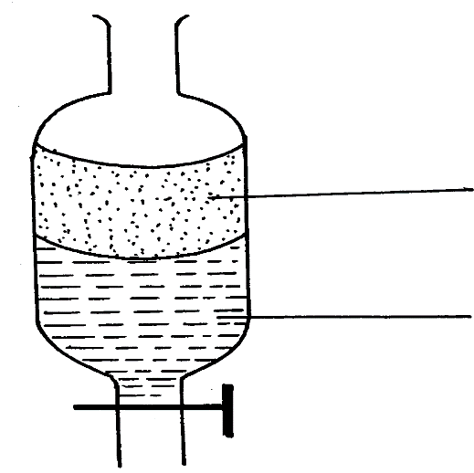

**P**

**W**

State the identity of; (2marks)

(i) **P** ………………………………..…….. (ii) **W** ………………………………….…

3.) Rusting is a destructive process in which iron is converted to hydrated iron (III) oxide.

a) State

i) Two conditions necessary for rusting to occur. (2 marks)

ii) Two methods used to protect iron from rusting other than galvanizing. (2 marks)

b) Explain why it is not advisable to wash vehicles using sea water. (2 marks)

c) Explain why galvanized iron objects are better protected even when scratched. (2 marks)

d) The set-up below was used to prepare oxygen gas. Complete the diagram to show how a sample of the gas can be collected. (2marks)



i) Write a word equation for the reaction producing oxygen gas. (1 mark)

ii) How can the rate of production of gas be increased using the set-up above? (1 mark)

4. Study the diagram below and answer the questions that follow. The diagram shows the method used to separate component of mixture P.



**a)** Name X ..........................................................................................................(1mark)

**b)** What is the name given to the method used in separation of mixture P ? (1mark)

**c)** What would happen if the inlet and outlet of water were interchanged ?(1mark)

**d)** Which physical property is used to separate mixture P? (1 mark)

5. Solutions may be classified as strongly basic, weakly basic neutral weakly acidic, strongly acidic. The information below gives solution and their pH values. Study it and answer the questions that follow.

|  |  |
| --- | --- |
| Solution | pH value |
| B | 0.5 |
| C | 6 |
| D | 14.5 |

Classify the solution in the table above using the stated classification B, C & D (3 marks)

6. The following diagram shows the effects of heat on the physical states of substances.



1. Identify the processes represented by the letters A, B, C, D, E and (6marks)

  (b) Name two substances that undergo the process labelled E and F. (1mark)

(c) Name a method that can be used to extract the following:-

 (i) Common salt from a salt solution. (1 mark)

(ii) Paraffin from crude oil. (1 mark)

7.) State two reasons why most of the laboratory apparatus are transparent. (2 marks)

8.) Explain why flower extracts cannot be used as reliable acid base indicators. (2 marks)

9.)What is meant by the terms: (2 marks)

(i) Atomic number

(ii) Mass number

10.) A mixture contains Iron (III) Chloride, calcium chloride and iron filings. Describe how one can separate and recover the substances in the mixture.(3marks)

11. Hydrogen can be prepared by reacting zinc with dilute hydrochloric acid.

a) Write a word equation for the reaction. (1mark)

b) Name an appropriate drying agent for hydrogen gas (1mark)

c) Explain why copper metal cannot be used to prepare hydrogen gas (2marks)

d) Hydrogen burns in oxygen to form an oxide.

(i) Write a word equation for the reaction (1mark)

e) Give **two** uses of hydrogen gas. (2marks)

12.) Determine the number of neutrons in 24 12Mg (1mark)