BIOLOGY FORM THREE.
TERM ONE 2021
MID TERM 1 YEAR 2021
NAME……………………………………………………………………..ADM NO………… CLASS…………
1.a} Explain the meaning of each of the following terms. {2mks}
i) Cell
ii) Tissue
b) Name the two structures which are present in plant cells but absent in animal cells. {2mks

c)The diagrams below represent two plant cells A and B placed in two different solutions. Study the diagrams and answer questions that follow:

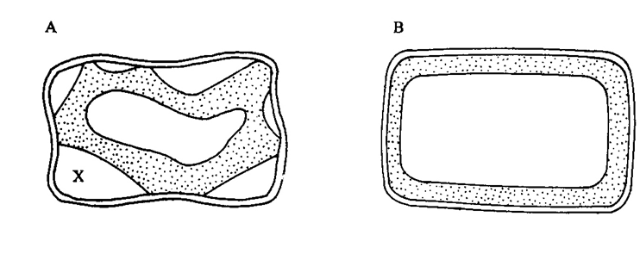

i) Identify the nature of solution into which each cell was placed. (2marks)
A
B

ii) Name the physiological process responsible for the observed results. (1mark)

iii) Give the correct biological term used to describe cell A. (1mark)

iv) Describe what would happen if a red blood cell was placed in the solution in which cell B was placed. (2 marks)

2.) a) i) Define nutrition. {1mk

ii) State the importance of nutrition. {3mks

b) Differentiate the various modes of feeding. {2mks
i) Autotrophism
ii) Heterotrophism.

3. State the importance of photosynthesis. {1 mk

4.a i) Name the transport structures of a flowering plant. {2mks

ii) State the ways in which xylem vessels are adapted to their function. {2mks

5) i) What is transpiration? {1mk
ii) Name the sites through which transpiration takes place in a plant. {3mks}

6) a}What is counter current-flow system? {2mks}
b) What is the advantage of counter-flow system? {2mks

7) i) What is aerobic respiration. {1mk}

ii) State why accumulation of lactic acid during vigorous exercise lead to an increase in heartbeat. {1mks

iii)State the economic importances of anaerobic respiration.{2mks

iv)What is oxygen debt? {1mks}

5. a) Define the following terms. {2mks}
i) Excretion

ii) Homeostasis

6. State two functions of the liver. {2mks}

7.a) State the importance of osmoregulation. {2mks}

b) State the ways by which desert mammals conserve water. {2mks}

c) Explain why some desert animals excrete uric acid rather than water. {2mks}

d) Explain why eating a meal with too much salt leads to production of a small volume of
concentrated urine. {2mks}

e) Explain the role played by antidiuretic hormone in homeostasis. {2mks}

f) Distinguish between diabetes mellitus and diabetes insipidus. {2mks}

g) How can high blood sugar level in a person be controlled? { 1mk}

h) Why does glucose not normally appear in urine even though it is filtered in the mammalian
Bowman’s capsule? { 1mk}

