BIOLOGY FORM TWO EXAM

Marking scheme
- Explain the following terms:
Taxonomy (1mk)study of classification

Species (1mk)Smallest unit of classification whose members can freely interbreed giving rise to viable offsprings

- State the function of the following organelles
Lysosomes Contains lytic enzymes for breakdown of wornout organelles (1mk)

Golgi apparatus (2mk) formation of lysosomes

    - Packaging and transport of glycoprotein

- The chemical equation below represents a physiological process that takes place in living organisms:
R
  - C₆H₁₂O₆ + C₆H₁₂O₆ C₁₂H₂₂O₁₁ + Q 2mrks

  - Name the process R a) Condensation;
  - Name the substance Q b) water;

- Name the diseases caused by deficiency of: 2mrks
      - Iodine Goitre;
      - Vitamin C) Scurvy;

- The following experiment was set up to demonstrate a physiological process. Two tubes A and B made of sheep’s bladder were filled with different liquids and placed in a basin containing a liquid
Liquid
Basin
b B
a A

After 20 minutes, it was found that tube A felt hard and the liquid in it had increased. Tube B was soft and contained less liquid.
a)Explain what took place in tubes A and B (4mks)
A liquid A is hypertonic to the surrounding;absorbed water via osmosis through the semipermeable sheep’s bladder

B liquid B is hypotonic to the surrounding;lost water via osmosis

What does the sheep’s bladder correspond to?

    - Semipermeable membrane

- The diagram below shows chemical reactions A and B which are controlled by enzymes x and y respectively.
Glucose + Fructose
Reaction A in presence
of enzyme x
Sucrose + Water
Reaction B in
presence of enzyme y

  - Name: (i) Reaction A– condensation; 2mrks
  - . (ii) Enzyme y– Sucrase;

- What are the two functions of bile salts during the process of digestion 2mrks
        - To emulsify fats;
        - To provide an alkaline condition for enzyme activities;
- Name the component of a people’s diet that is essential for peristalsis. 1mrk
Fruits and vegetables.
b) Give two groups of food which are reabsorbed along the mammalian digestive system without undergoing digestion 2mrks
vitamins,mineral salts ,water

- Give the roles of light in photosynthesis. 2mrks

  - a) What is peristalsis? 1mrk

- Study the dental formula below:
2
3
3
3
0
0
0
4
- I ; C ; ; PM ; M

a)Identify with reasons the mode of feeding of the animals whose dental formula is given above. (2mks)
        - Mode of feeding is herbivorous. Reject Herbivore
        - Absence of upper incisors but have hony pad
(b) Calculate the total number of teeth in the mouth of the above animal 1mrk

  - (b) 30
c)Explain why small mammals such as moles feed more frequently than larger ones such
    - as elephants 2mrks
    - Small mammals have large surface area to volume ratio; hence lose heat quickly to environment; to replace the heat , lost, their metabolism is high making them to feed more frequently

- State the differences between plants and animals (3mks)
PLANTS | ANIMALS
Make their own food through the process of photosynthesis | Depend on plants and other animals for food;
They do not move from one place to another | They move from one place to another;
Respond slowly to stimuli | Respond faster /quickly to stimuli;

- Name three photosynthetic cells in plants (2mks)
Guard cells
Pallisade cells
Spongy mesophyll cells

- Name the elements present in carbohydrates (3mks)
Carbon,hydrogen and oxygen

- The following diagram of a leaf shows what happens in a pant leaf during photosynthesis: -

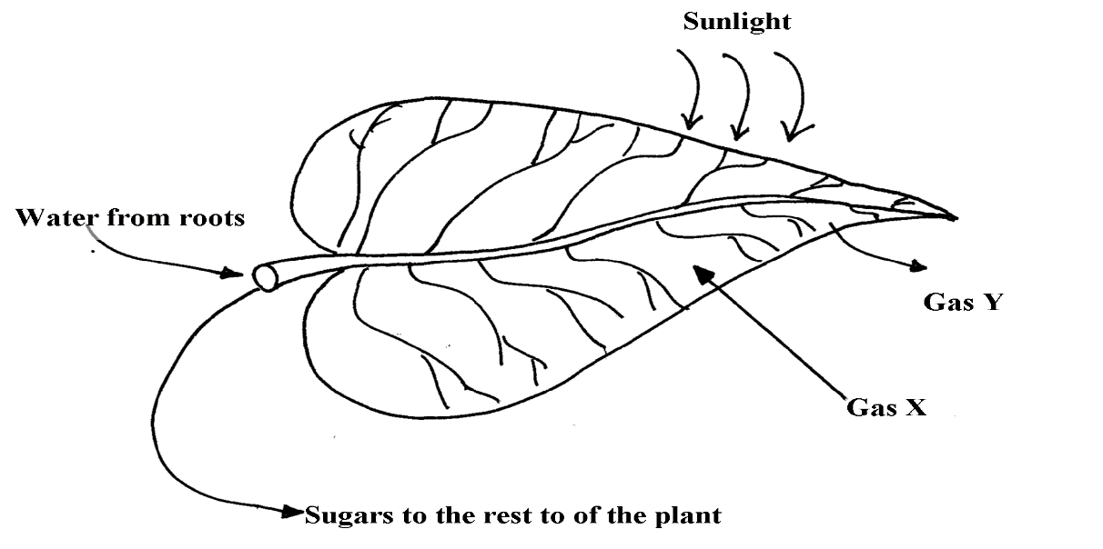

\(a) Give two ways in which leaves are adapted to absorb light 2mrks
  - Broad and flat to absorb maximum light
  - Have chloroplast with chlorophyll to trap light.
  - Transparent cuticle to allow light to pass through

(b) Name the gases labelled X and Y 2mrks
  - ) X – Carbon (IV) Oxide
  - Y – Oxygen

(c) Name the tissue that transports water into the leaf and sugars out of the leaf 2mrks
Xylem – Transports water
Phloem – Sugars out of the leaf

  - (d) Explain why it’s an advantage for the plant to store carbohydrates as starch rather than as sugars 2mrks(d) Starch is insoluble in water, hence osmotically inactive; This reduces effect on absorption of water.

- . (a) What is meant by digestion? 1mrk
breakdown of complex food, substance; into simple diffusible substances;
(b) Describe how mammalian small intestine is adapted to its function. 6mrks
coiled/ folded to allow food (enough) time/; Is relatively long; increase surface area for absorption of digested food and for digestion
Lumen has projection called villi; villi has projections called microvilli; to increase surface area for absorption
Walls have glands which secret enzymes for digestion; e.g. maltase/ sucrose/ lactase/ enterokinase/ peptidases
Some glands/ goblet cells produce mucus; which protects the intestinal wall from being digested and also reduce friction
Have openings of ducts which allow bile/ pancreatic juice into the lumen
The intestines have circular and longitudinal muscles; whose contraction and relaxation/ peristalsis leads to mixing of food with enzymes/ juices; facilitating rapid digestion; and helps push food along the gut
Intestines are well supplied with blood vessels/ highly vascularized; to supply oxygen/ remove digested food
Lacteal vessels; transport fats/ lipids
have thin epithelia; to facilitate fast/ rapid absorption/ diffusion

