BIOLOGY FORM TWO MID TERM EXAM

NAME------------------------------------------------ ADM.---------------------------------- CLASS
- Explain the following terms:
Taxonomy (1mk)

Species (1mk)

- State the function of the following organelles
Lysosomes (1mk)

Golgi apparatus (1mk)

- The chemical equation below represents a physiological process that takes place in living organisms:
R
  - C₆H₁₂O₆ + C₆H₁₂O₆ C₁₂H₂₂O₁₁ + Q 2mrks

  - Name the process R
  - Name the substance Q

- Name the diseases caused by deficiency of: 2mrks
      - Iodine
      - Vitamin C)

- The following experiment was set up to demonstrate a physiological process. Two tubes A and B made of sheep’s bladder were filled with different liquids and placed in a basin containing a liquid
Liquid
Basin
b B
a A

After 20 minutes, it was found that tube A felt hard and the liquid in it had increased. Tube B was soft and contained less liquid.
a)Explain what took place in tubes A and B (4mks)

What does the sheep’s bladder correspond to? 1mrk

- The diagram below shows chemical reactions A and B which are controlled by enzymes x and y respectively.
Glucose + Fructose
Reaction A in presence
of enzyme x
Sucrose + Water
Reaction B in
presence of enzyme y

  - Name: (i) Reaction A 2mrks
  - . (ii) Enzyme y

- What are the two functions of bile salts during the process of digestion 2mrks

- Name the component of a people’s diet that is essential for peristalsis. 1mrk

b) Give two groups of food which are reabsorbed along the mammalian digestive system without undergoing digestion 2mrks

- Give the roles of light in photosynthesis. 1mrks

  - a) What is peristalsis? 1mrk

- Study the dental formula below:
2
3
3
3
0
0
0
4
- I ; C ; ; PM ; M

a)Identify with reasons the mode of feeding of the animals whose dental formula is given above. (2mks)

(b) Calculate the total number of teeth in the mouth of the above animal 1mrk

c)Explain why small mammals such as moles feed more frequently than larger ones such as elephants 1mrks

- State the differences between plants and animals (3mks)

- Name three photosynthetic cells in plants (3mks)

- Name the elements present in carbohydrates (3mks)

- The following diagram of a leaf shows what happens in a pant leaf during photosynthesis: -

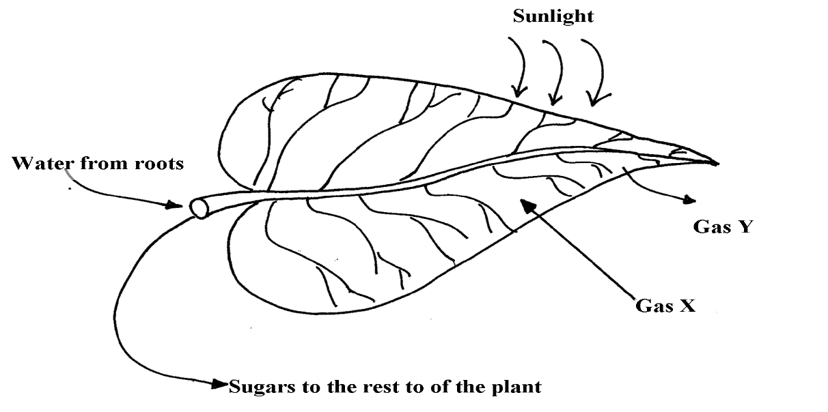

\(a) Give two ways in which leaves are adapted to absorb light 2mrks

(b) Name the gases labelled X and Y 2mrks

(c) Name the tissue that transports water into the leaf and sugars out of the leaf 2mrks

  - (d) Explain why it’s an advantage for the plant to store carbohydrates as starch rather than as sugars 2mrks

- . (a) What is meant by digestion? 1mrk

(b) Describe how mammalian small intestine is adapted to its function. 6mrks

